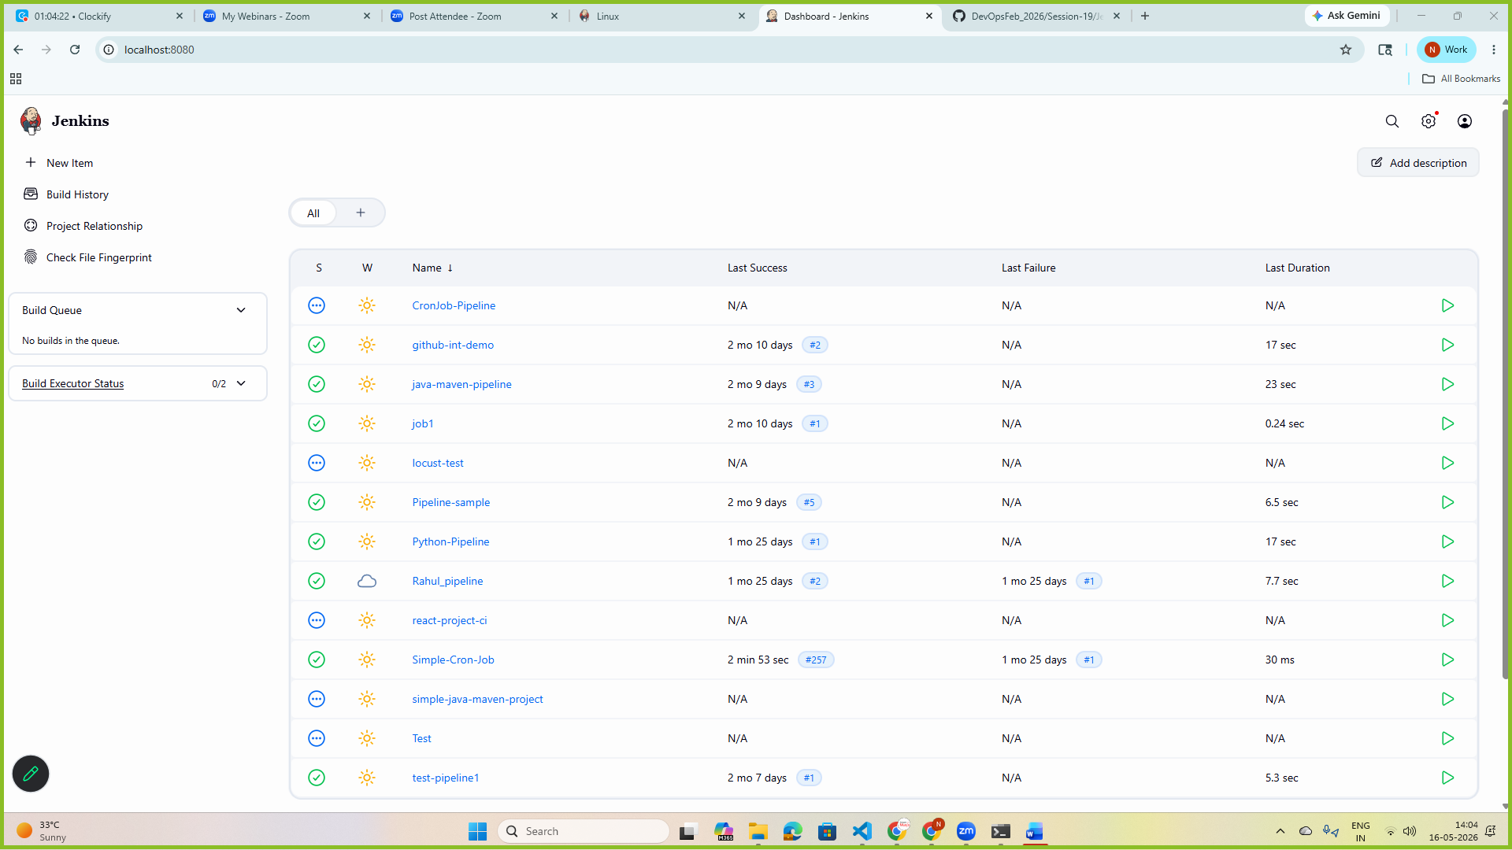

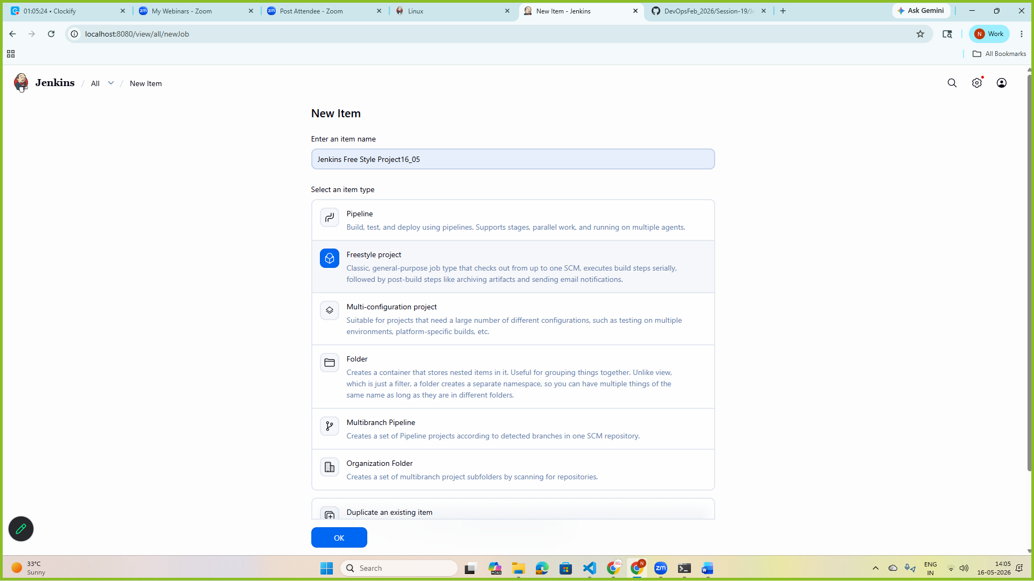
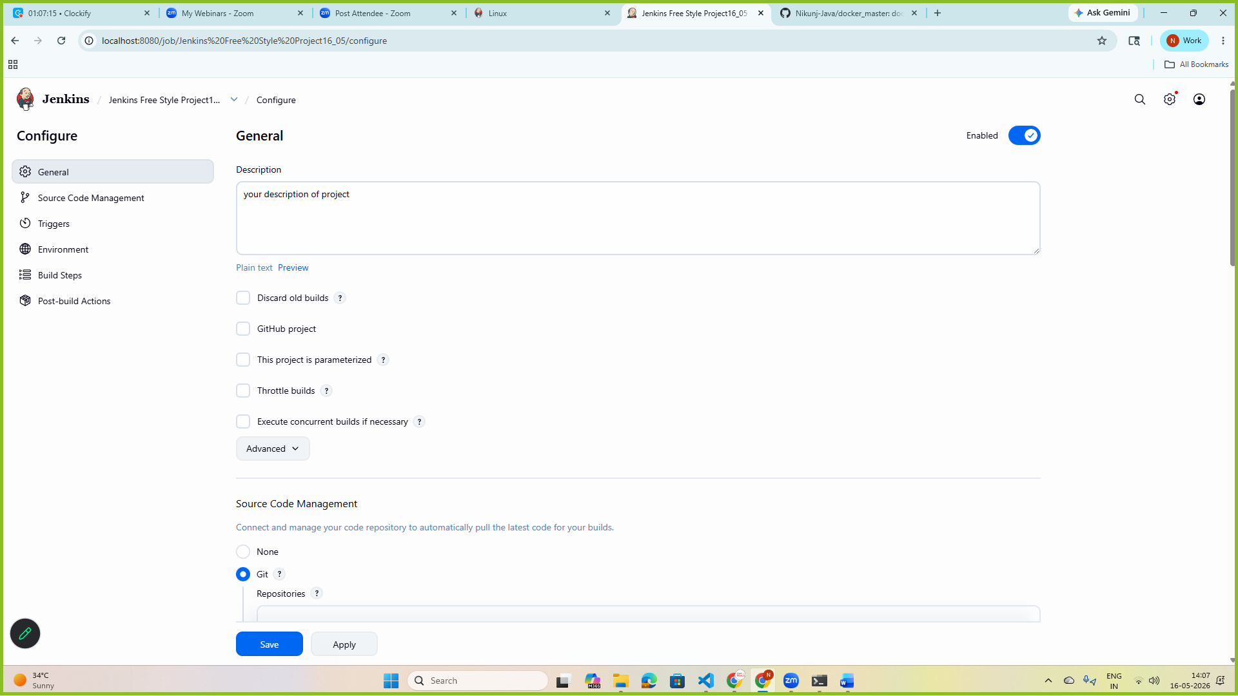
Goto> source code management> choose git> add your repository
Git: https://github.com/Nikunj-Java/docker_master.git
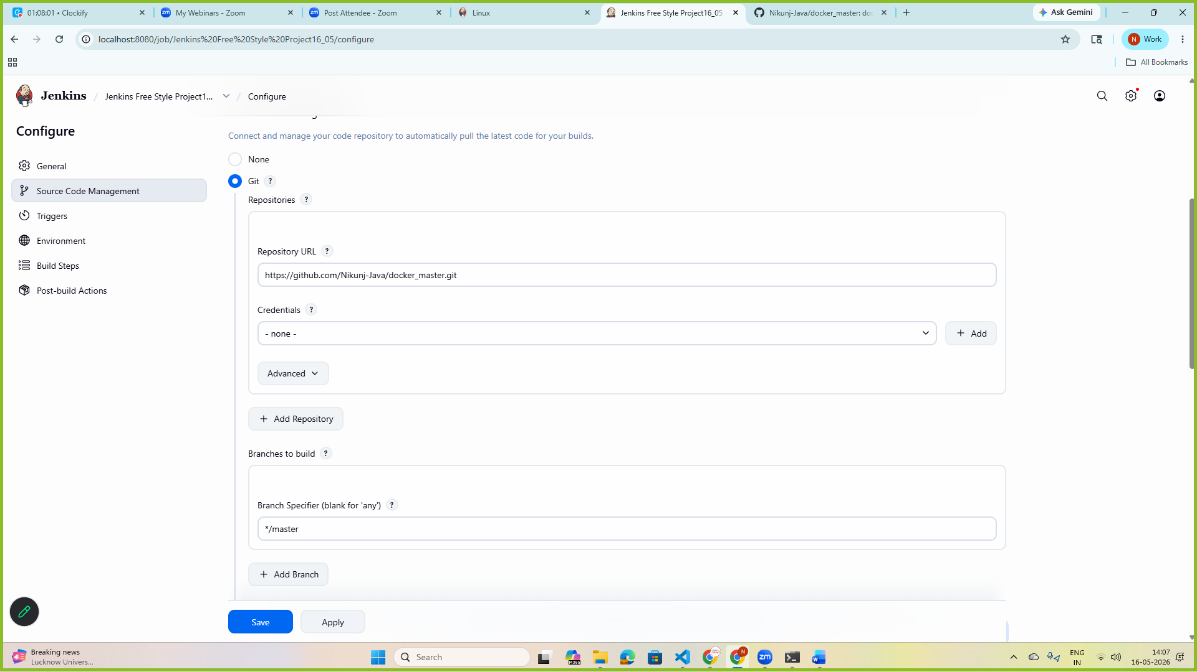
Branches to build: *master/main
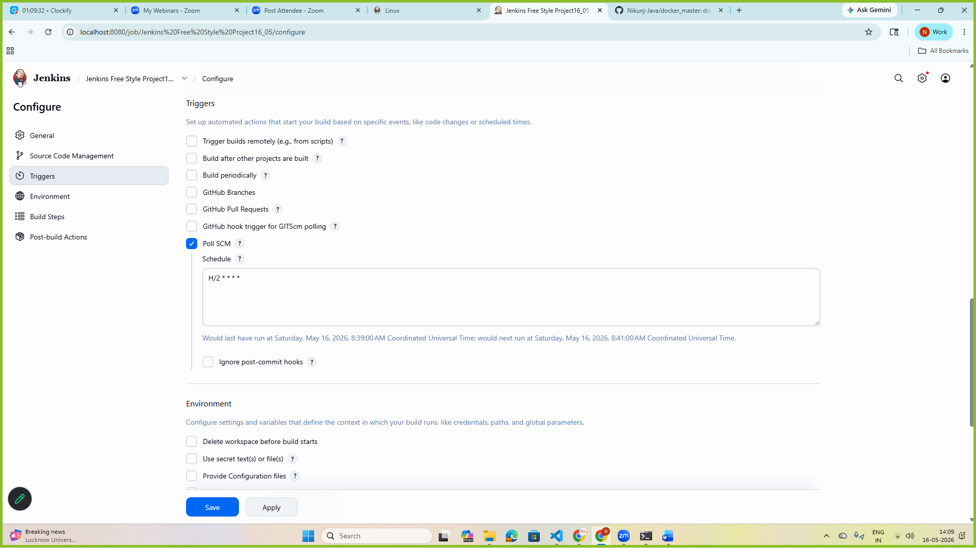
POLL SCM:H/2 * * * *
Click Apply and Save
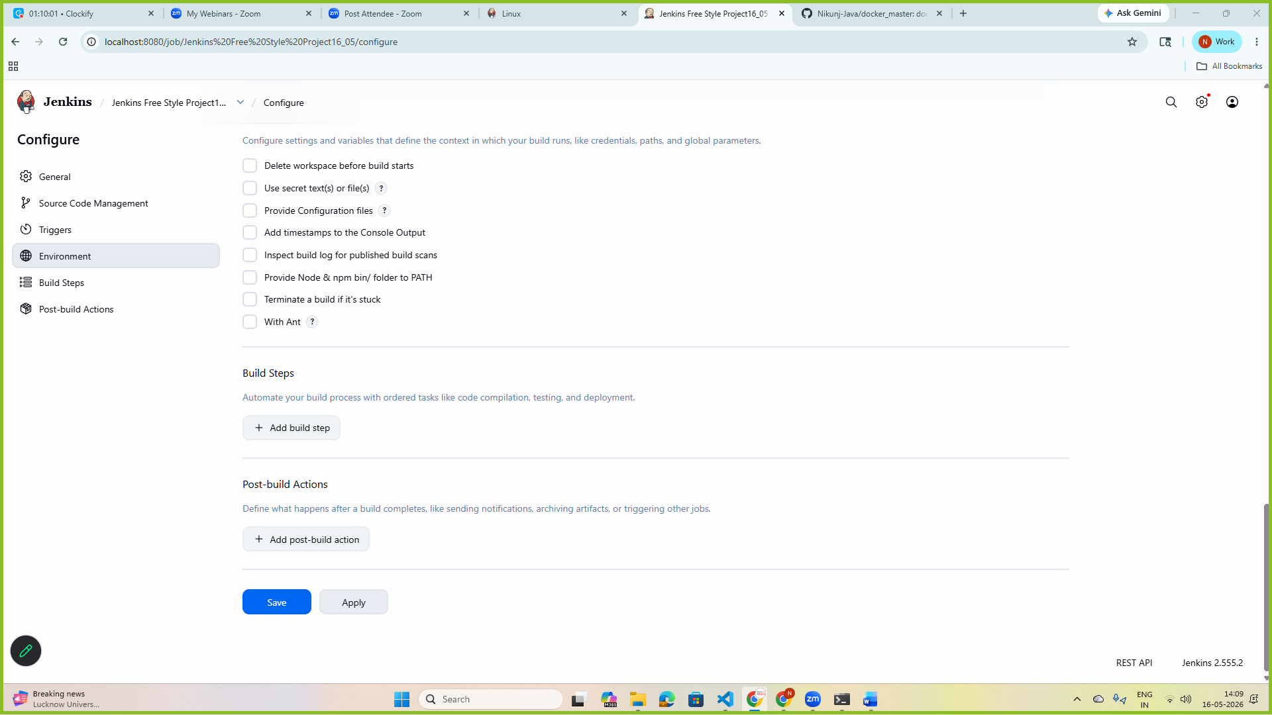
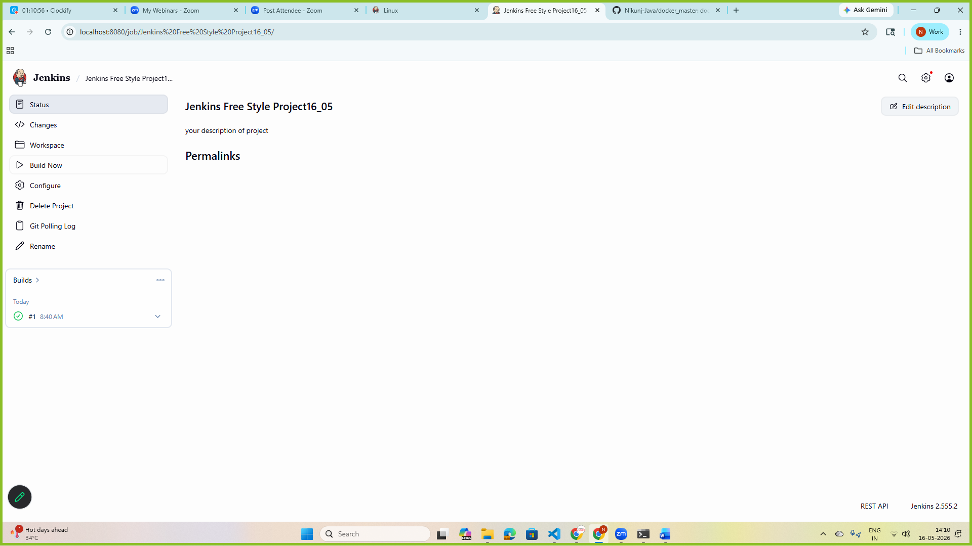
Click on Build
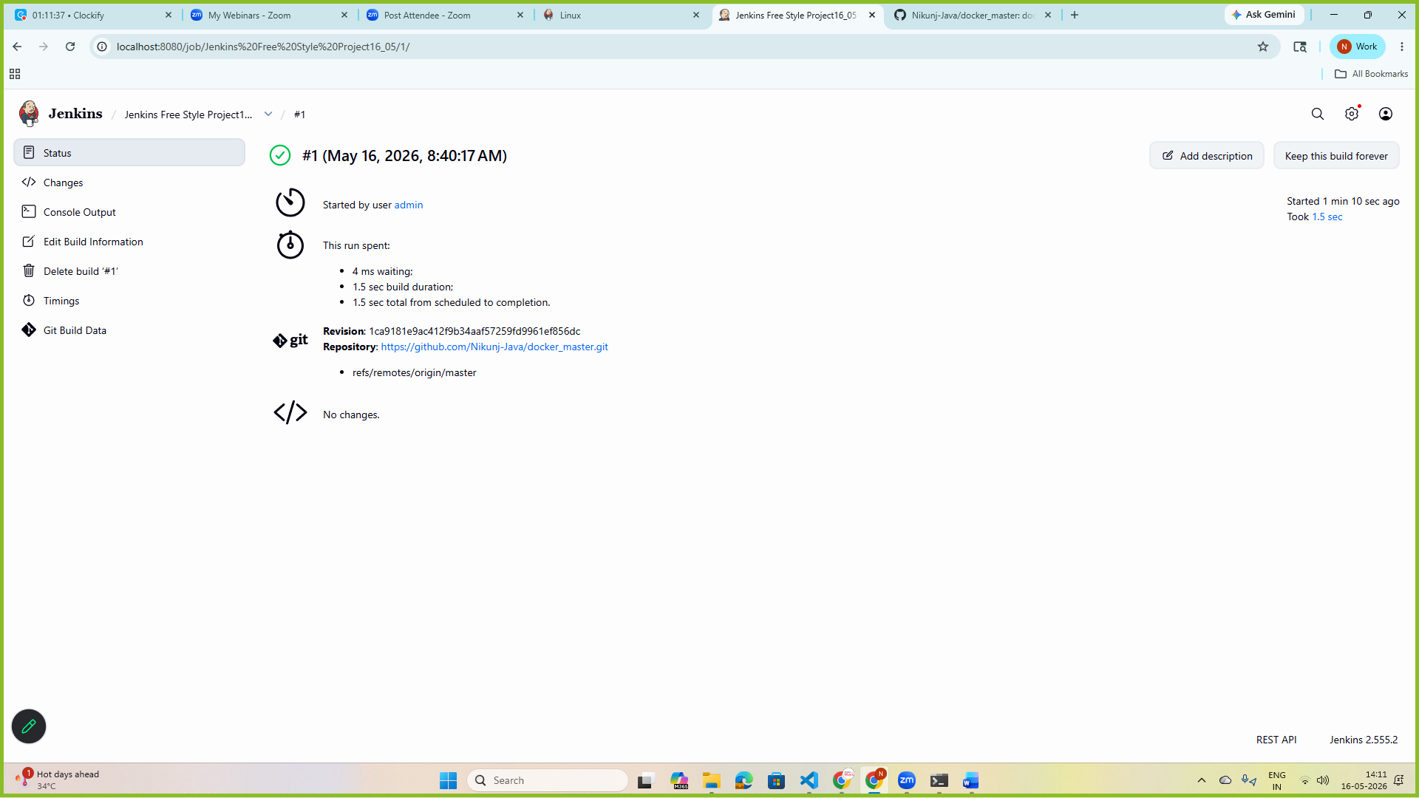
> now goto your repository and make some changes and check the Jenkins dashboard.
> it will automatically build the project again
Note: here H/2 means---> H is representing some Hash, 2 represents 2 minutes
*---> Hours
*---> Day
*---> Month
*---> Every Day of Week

