Create maven webapp

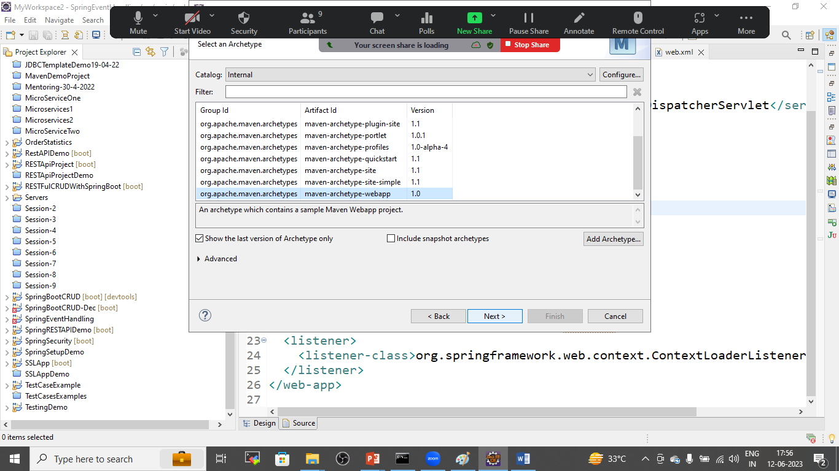

Provide project name

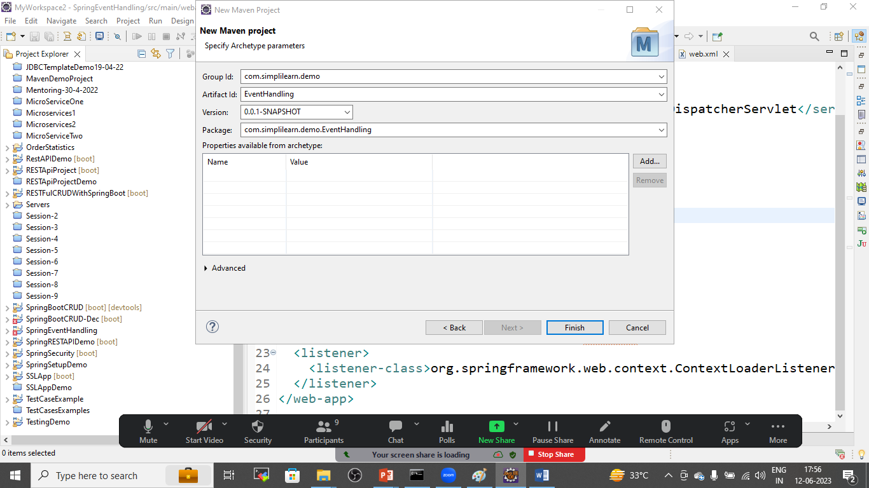

Add the dependencies to pom.xml files

Pom.xml

<project xmlns="http://maven.apache.org/POM/4.0.0" xmlns:xsi="http://www.w3.org/2001/XMLSchema-instance" xsi:schemaLocation="http://maven.apache.org/POM/4.0.0 http://maven.apache.org/maven-v4_0_0.xsd">

<modelVersion>4.0.0</modelVersion>

<groupId>com.simplilearn</groupId>

<artifactId>EventHandling</artifactId>

<packaging>war</packaging>

<version>0.0.1-SNAPSHOT</version>

<name>EventHandling Maven Webapp</name>

<url>http://maven.apache.org</url>

<properties>

<org.springframework.version>5.3.17</org.springframework.version>

</properties>

<dependencies>

<dependency>

<groupId>junit</groupId>

<artifactId>junit</artifactId>

<version>3.8.1</version>

<scope>test</scope>

</dependency>

<dependency>

<groupId>javax.servlet</groupId>

<artifactId>javax.servlet-api</artifactId>

<version>4.0.1</version>

<scope>provided</scope>

</dependency>

<dependency>

<groupId>org.springframework</groupId>

<artifactId>spring-core</artifactId>

<version>${org.springframework.version}</version>

</dependency>

<dependency>

<groupId>org.springframework</groupId>

<artifactId>spring-expression</artifactId>

<version>${org.springframework.version}</version>

</dependency>

<dependency>

<groupId>org.springframework</groupId>

<artifactId>spring-beans</artifactId>

<version>${org.springframework.version}</version>

</dependency>

<dependency>

<groupId>org.springframework</groupId>

<artifactId>spring-context</artifactId>

<version>${org.springframework.version}</version>

</dependency>

<dependency>

<groupId>org.springframework</groupId>

<artifactId>spring-context-support</artifactId>

<version>${org.springframework.version}</version>

</dependency>

<dependency>

<groupId>org.springframework</groupId>

<artifactId>spring-jdbc</artifactId>

<version>${org.springframework.version}</version>

</dependency>

<dependency>

<groupId>org.springframework</groupId>

<artifactId>spring-orm</artifactId>

<version>${org.springframework.version}</version>

</dependency>

<dependency>

<groupId>org.springframework</groupId>

<artifactId>spring-web</artifactId>

<version>${org.springframework.version}</version>

</dependency>

<dependency>

<groupId>org.springframework</groupId>

<artifactId>spring-webmvc</artifactId>

<version>${org.springframework.version}</version>

</dependency>

</dependencies>

<build>

<finalName>EventHandling</finalName>

<plugins>

<plugin>

<groupId>org.apache.maven.plugins</groupId>

<artifactId>maven-war-plugin</artifactId>

<version>3.3.1</version>

</plugin>

</plugins>

</build>

</project>

In index.jsp file

<html>

<body>

<h2>Hello World!</h2>

<a href=*"eventhandling"*>Event handling</a>

<br>

<br>

</body>

</html>

Create controller using web.xml file

Web.xml file

<web-app>

<display-name>Archetype Created Web Application</display-name>

<!-- To Prepare main Controller -->

<servlet>

<servlet-name>main</servlet-name>

<servlet-class>org.springframework.web.servlet.DispatcherServlet</servlet-class>

</servlet>

<!-- To Prepare main Controller -->

<servlet-mapping>

<servlet-name>main</servlet-name>

<url-pattern>/</url-pattern>

</servlet-mapping>

<!-- To Declare Spring Bean File -->

<context-param>

<param-name>contextConfigLocation</param-name>

<param-value>/WEB-INF/bean.xml</param-value>

</context-param>

<!-- To Load Bean File We will Create Listner -->

<listener>

<listener-class>org.springframework.web.context.ContextLoaderListener</listener-class>

</listener>

</web-app>

Create beans.xml file

<?xml version=*"1.0"* encoding=*"UTF-8"*?>

<beans xmlns=*"http://www.springframework.org/schema/beans"*

xmlns:xsi=*"http://www.w3.org/2001/XMLSchema-instance"*

xmlns:context=*"http://www.springframework.org/schema/context"*

xsi:schemaLocation=*"*

*http://www.springframework.org/schema/beans*

*http://www.springframework.org/schema/beans/spring-beans-3.0.xsd*

*http://www.springframework.org/schema/context*

*http://www.springframework.org/schema/context/spring-context-3.0.xsd*

*"*>

<!-- To work with annotation -->

<context:annotation-config/>

<!-- To scan the controller -->

<context:component-scan base-package=*"com.eventhandling.demo"*></context:component-scan>

<!-- To find out the view for response -->

<bean id=*"jspViewResolver"* class=*"org.springframework.web.servlet.view.InternalResourceViewResolver"*>

<property name=*"prefix"* value=*"/WEB-INF/view/"*></property>

<property name=*"suffix"* value=*".jsp"*></property>

</bean>

<!-- To get objects of class -->

<bean id=*"startEventHandler"* class=*"com.eventhandling.demo.StartEventHandler"*></bean>

<bean id=*"stopEventHandler"* class=*"com.eventhandling.demo.StopEventHandler"*></bean>

</beans>

Create java class

StartEventHandler.java

package com.eventhandling.demo;

import org.springframework.context.ApplicationListener;

import org.springframework.context.event.ContextStartedEvent;

public class StartEventHandler implements ApplicationListener<ContextStartedEvent>{

public void onApplicationEvent(ContextStartedEvent event) {

System.out.println("ContextStartedEvent Received");

}

}

Create StopEventHandler.java

package com.eventhandling.demo;

import org.springframework.context.ApplicationListener;

import org.springframework.context.event.ContextStartedEvent;

public class StartEventHandler implements ApplicationListener<ContextStartedEvent>{

public void onApplicationEvent(ContextStartedEvent event) {

System.out.println("ContextStartedEvent Received");

}

}

Create Main Controller

package com.eventhandling.demo;

import org.springframework.beans.factory.annotation.Autowired;

import org.springframework.context.ConfigurableApplicationContext;

import org.springframework.stereotype.Controller;

import org.springframework.ui.ModelMap;

import org.springframework.web.bind.annotation.GetMapping;

@Controller

public class MainController {

@Autowired

ConfigurableApplicationContext appContext;

@GetMapping("/eventhandling")

public String eventHandling(ModelMap map) {

appContext.start();

appContext.stop();

return "success";

}

}

Goto>WEB-INF/view/success.jsp

Success.jsp

<%@ page language=*"java"* contentType=*"text/html; charset=ISO-8859-1"*

pageEncoding=*"ISO-8859-1"*%>

<!DOCTYPE html>

<html>

<head>

<meta charset=*"ISO-8859-1"*>

<title>Insert title here</title>

</head>

<body>

<h1>Event Handled Successfully, check console</h1>

</body>

</html>

Run the project

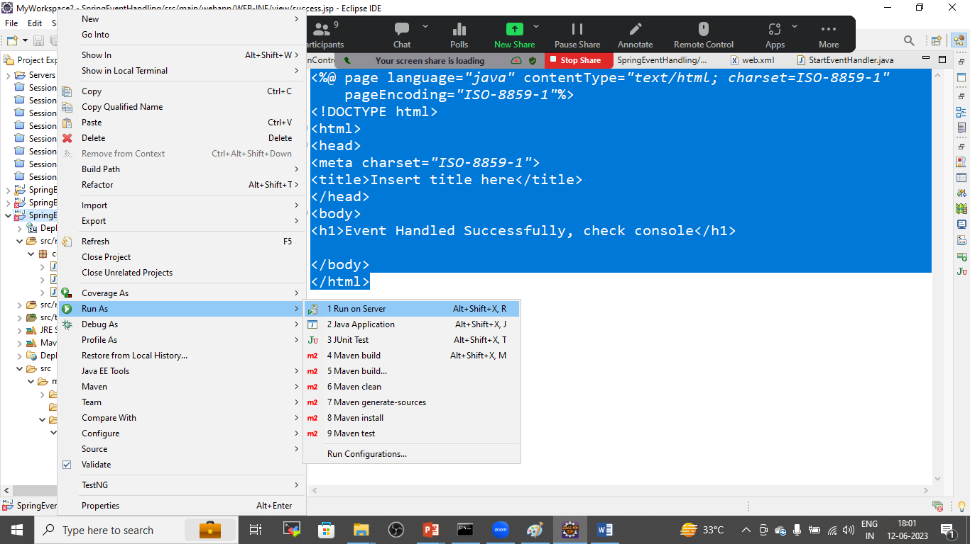

SAVE THE PROJECT AND CHECK THE OUTPUT IN BROWSER AS WELL AS IN CONSOLE