Create new app

>**ng new app**

Create new service

>**ng g s user**

Once the service is ready it will prepare two files

1. User.service.ts
2. User.service.spec.ts

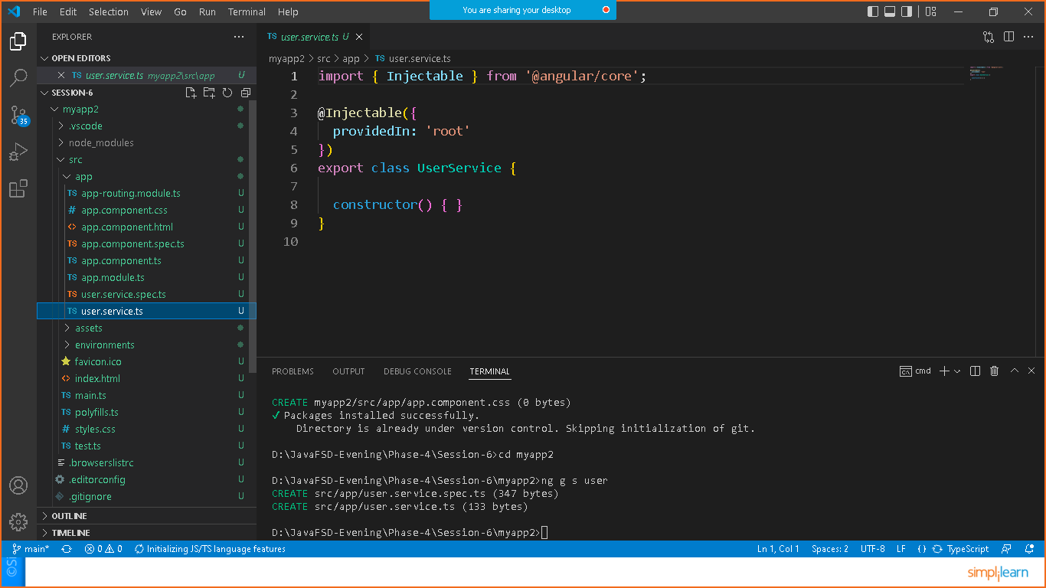

Once the service is ready we need to register the service in to **app.module.ts**

import { NgModule } from '@angular/core';

import { BrowserModule } from '@angular/platform-browser';

import { AppRoutingModule } from './app-routing.module';

import { AppComponent } from './app.component';

import { UserService } from './user.service';

@NgModule({

  declarations: [

    AppComponent

  ],

  imports: [

    BrowserModule,

    AppRoutingModule

  ],

  providers: [UserService],

  bootstrap: [AppComponent]

})

export class AppModule { }

now lets inject the service in any component that you can have already prepared in the app

or else you generate one component and inject the service

**>ng g c demo**

Now goto **demo.component.ts** and add the below command

import { Component, OnInit } from '@angular/core';

import { UserService } from '../user.service';

@Component({

  selector: 'app-demo',

  templateUrl: './demo.component.html',

  styleUrls: ['./demo.component.css']

})

export class DemoComponent implements OnInit {

  constructor(private service:UserService) { }

  ngOnInit(): void {

  }

}