1. Download log4j and slf4j jar files from java2s.com

Slf4j: <http://www.java2s.com/Code/Jar/s/Downloadslf4jjar.htm>

Log4j: <http://www.java2s.com/Code/Jar/l/Downloadlog4jjar.htm>

1. Extract it and add to the any existing Dynamic Webapp

Goto> src>main>webapp>WEB-INF>lib>copy both the jar files

1. Goto> resource folder and create log4j.properties file

Log4j.properties

# Direct log messages to a log file

log4j.appender.file=org.apache.log4j.RollingFileAppender

log4j.appender.file.File=D:/hibernate.log (give_your_path)

log4j.appender.file.MaxFileSize=1MB

log4j.appender.file.MaxBackupIndex=1

log4j.appender.file.layout=org.apache.log4j.PatternLayout

log4j.appender.file.layout.ConversionPattern=%d{ABSOLUTE} %5p %c**{1}**:%L - %m%n

# Direct log messages to stdout

log4j.appender.stdout=org.apache.log4j.ConsoleAppender

log4j.appender.stdout.Target=System.out

log4j.appender.stdout.layout=org.apache.log4j.PatternLayout

log4j.appender.stdout.layout.ConversionPattern=%d{ABSOLUTE} %5p %c**{1}**:%L - %m%n

# Root logger option

log4j.rootLogger=INFO, file, stdout

# Log everything. Good for troubleshooting

log4j.logger.org.hibernate=INFO

# Log all JDBC parameters

log4j.logger.org.hibernate.type=ALL

save it and run the project

you will see hibernate.log file is created on your directory as below

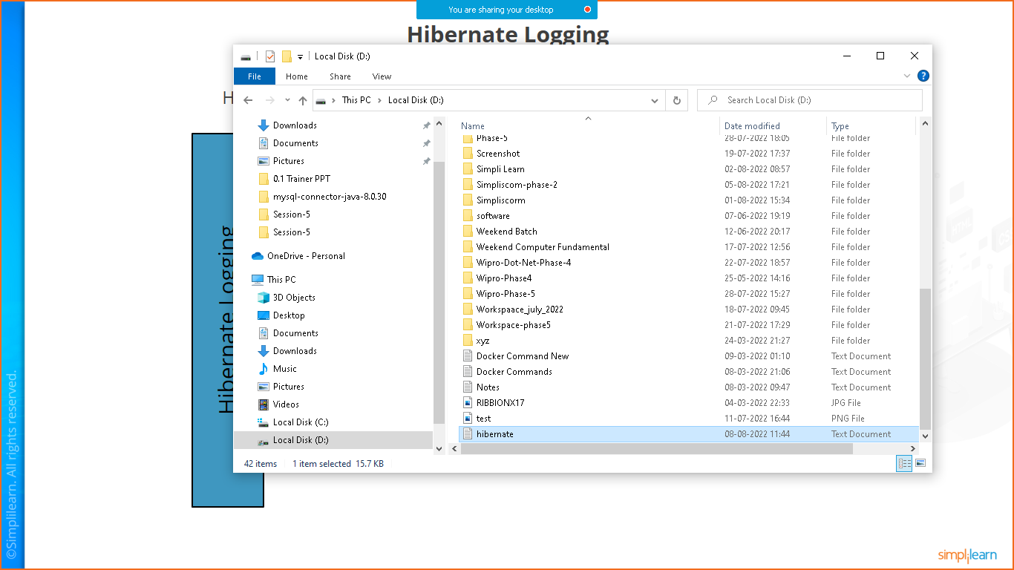

Open it and check all process

