Angular Pipes Example

There are two types of pipes are available with angular

1. Inbuilt pipe
2. Custompipes
3. **INBUILT PIPES**

Create new app

* ng new myapp

create new component

* ng g c pipes

goto > **pipe.component.ts** file and add below command

import { Component, OnInit } from '@angular/core';

@Component({

  selector: 'app-pipes',

  templateUrl: './pipes.component.html',

  styleUrls: ['./pipes.component.css']

})

export class PipesComponent implements OnInit {

  constructor() { }

  ngOnInit(): void {

  }

  name:string="My Name is Nikunj And i am a JAVA FSD Trainer";

  pi: number=3.1415927;

  a=0.12345;

  b=9876.5432;

  today=new Date();

  object= {name:"Nikunj",email:"nikunj@gmail.com",address:"Mumbai"};

}

Goto >**pipe.component.html** file and add below code

<h1>Pipes Demo</h1>

<div class="jumbotron">

    <div class="container">

        <h2>Inbuilt Pipes demo</h2>

        <hr>

        <p><b>UPPERCASE DEMO: </b>{{name | uppercase}}</p>

        <hr>

        <p><b>lowercase demo: </b>{{name | lowercase}}</p>

    </div>

</div>

<div class="jumbotron">

    <div class="container">

        <h2>Number Pipes</h2>

        <hr>

        <p><b>pi: </b>{{pi | number:'5.5-5'}}</p>

        <hr>

        <p><b>pi: </b>{{pi | number:'.3-3'}}</p>

        <hr>

        <p><b>pi: </b>{{pi | number:'.10-10'}}</p>

    </div>

</div>

<div class="jumbotron">

    <div class="container">

        <h1>Currency Pipes</h1>

        <hr>

        <p><b>USD : </b>{{a | currency : 'USD':true :'3.3-3'}}</p>

        <hr>

        <p><b>USD : </b>{{a | currency : 'USD':false :'.3-3'}}</p>

        <hr>

        <p><b>EURO : </b>{{b | currency : 'EURO':false}}</p>

        <hr>

        <p><b>EURO : </b>{{b | currency : 'EURO':true}}</p>

        <hr>

        <p><b>INR : </b>{{a | currency : 'INR':true}}</p>

        <hr>

        <p><b>INR : </b>{{a | currency : 'INR':true :'4.4-4'}}</p>

    </div>

</div>

<div class="jumbotron">

    <div class="container">

        <h1>Date Pipes</h1>

        <hr>

        <p><b>Today is: </b>{{today}}</p>

        <hr>

        <p><b>Today is: </b>{{today | date}}</p>

        <hr>

        <p><b>Today is: </b>{{today | date: 'dd/MM/yyyy'}}</p>

    </div>

</div>

<div class="jumbotron">

    <div class="container">

        <h1>JSON Pipes</h1>

        <hr>

        <p><b>Without JSON Pipe: </b>{{object}}</p>

        <hr>

        <p><b>With JSON Pipe: </b>{{object | json}}</p>

    </div>

</div>

Goto>**pipe.component.ts** file and copy the selector tag and add it to **app.component.html** file

<h1>My App</h1>

<app-pipes></app-pipes>

Goto> index.html and add bootstrap link and css script

<!doctype html>

<html lang="en">

<head>

  <meta charset="utf-8">

  <title>Myapp</title>

  <base href="/">

  <meta name="viewport" content="width=device-width, initial-scale=1">

  <link rel="icon" type="image/x-icon" href="favicon.ico">

  <link rel="stylesheet" href="https://cdn.jsdelivr.net/npm/bootstrap@4.6.2/dist/css/bootstrap.min.css" integrity="sha384-xOolHFLEh07PJGoPkLv1IbcEPTNtaed2xpHsD9ESMhqIYd0nLMwNLD69Npy4HI+N" crossorigin="anonymous">

</head>

<body>

  <app-root></app-root>

  <script src="https://cdn.jsdelivr.net/npm/jquery@3.5.1/dist/jquery.slim.min.js" integrity="sha384-DfXdz2htPH0lsSSs5nCTpuj/zy4C+OGpamoFVy38MVBnE+IbbVYUew+OrCXaRkfj" crossorigin="anonymous"></script>

<script src="https://cdn.jsdelivr.net/npm/bootstrap@4.6.2/dist/js/bootstrap.bundle.min.js" integrity="sha384-Fy6S3B9q64WdZWQUiU+q4/2Lc9npb8tCaSX9FK7E8HnRr0Jz8D6OP9dO5Vg3Q9ct" crossorigin="anonymous"></script>

</body>

</html>

Save it and run the app

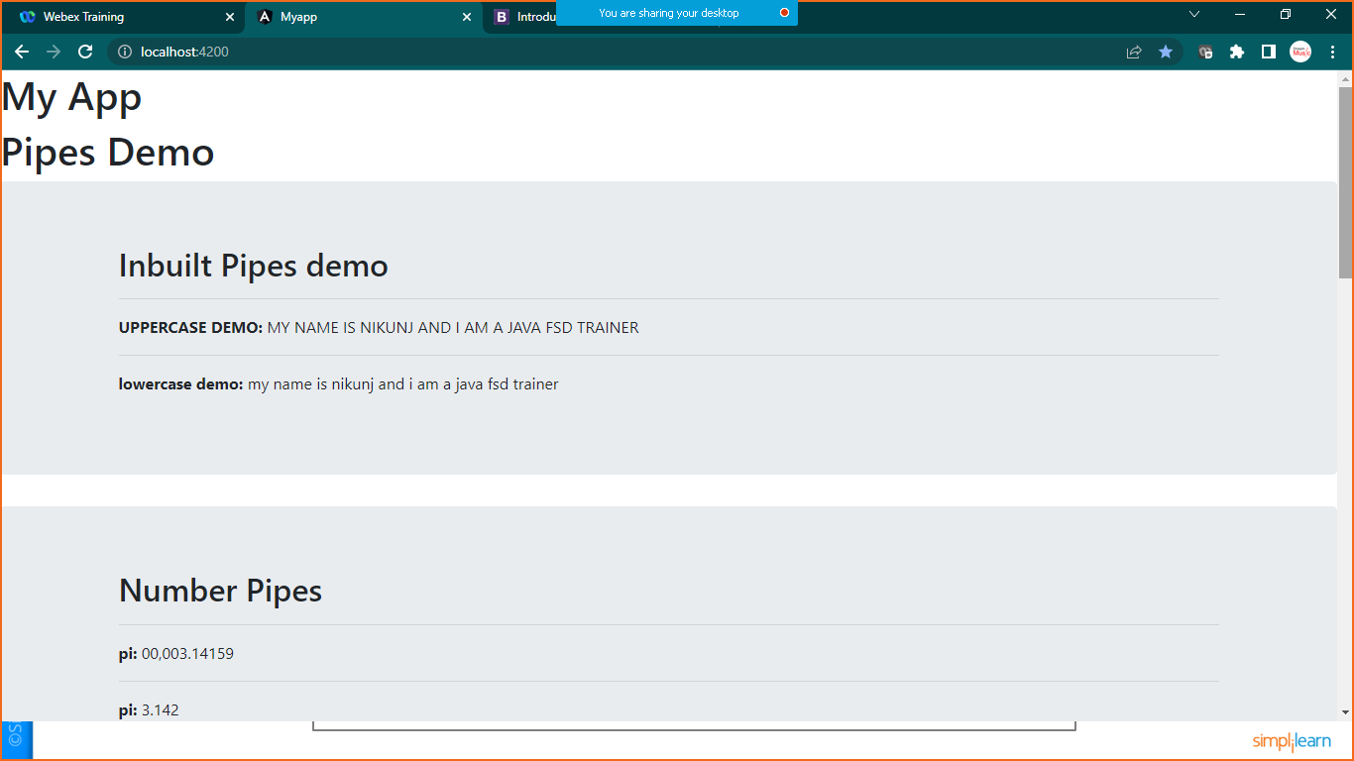

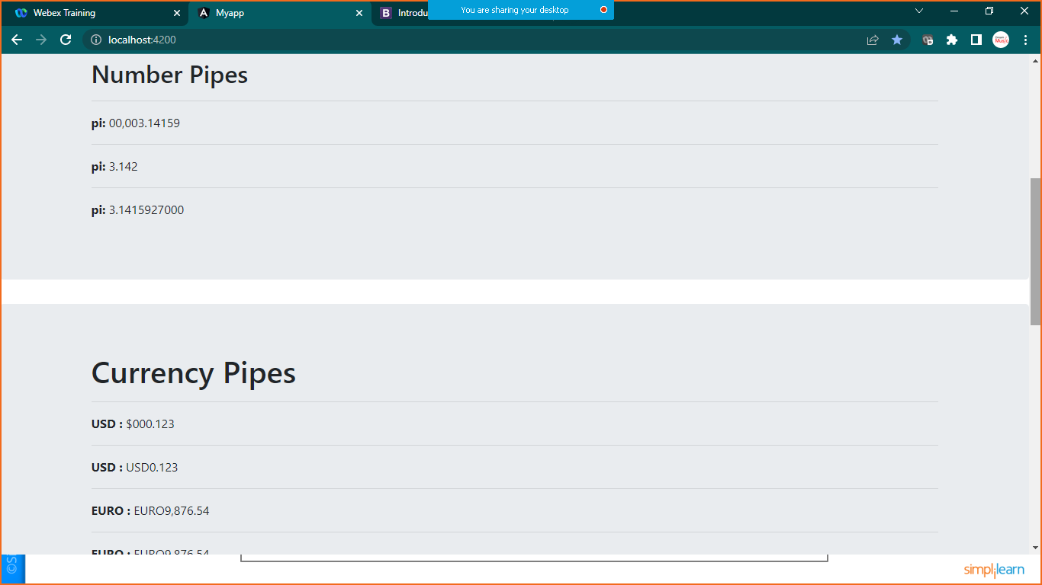

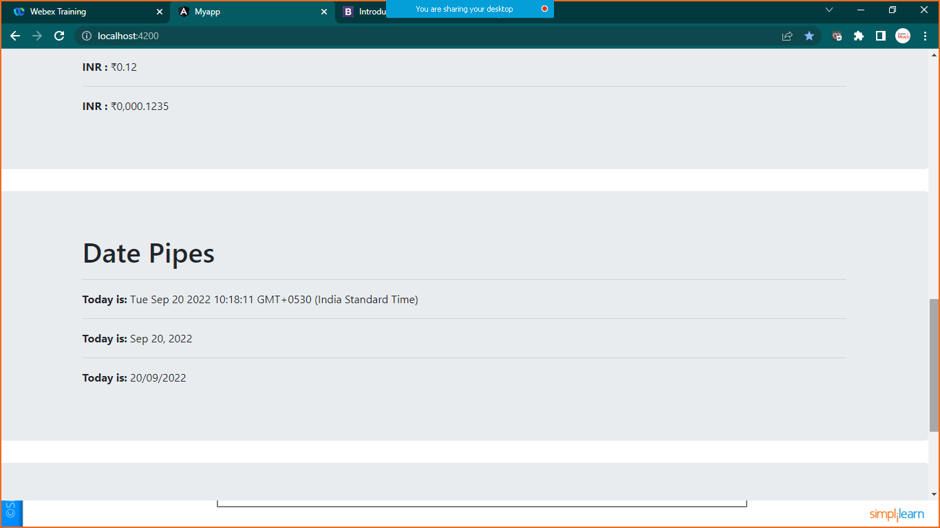

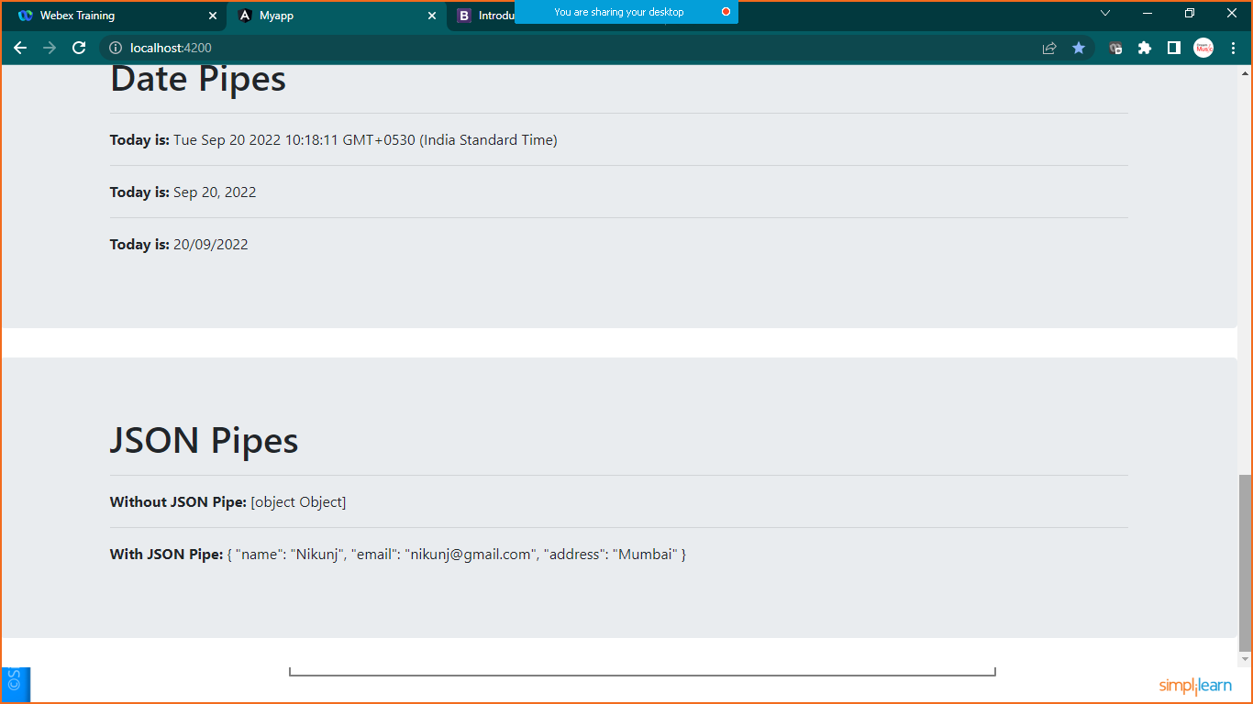

1. **CUSTOM PIPES**

Prepare one string in **pipe.component.ts** file

import { Component, OnInit } from '@angular/core';

@Component({

  selector: 'app-pipes',

  templateUrl: './pipes.component.html',

  styleUrls: ['./pipes.component.css']

})

export class PipesComponent implements OnInit {

  constructor() { }

  ngOnInit(): void {

  }

  name:string="My Name is Nikunj And i am a JAVA FSD Trainer";

  pi: number=3.1415927;

  a=0.12345;

  b=9876.5432;

  today=new Date();

  object= {name:"Nikunj",email:"nikunj@gmail.com",address:"Mumbai"};

  //custompipes

  cust:string="Welcome to the world of customPipes";

}

Create new file **CustomPipe.ts**

Goto>src>app>rightclick>new >give name

import {Pipe,PipeTransform} from "@angular/core"

@Pipe({name:'changestring'})

export class CustomPipe implements PipeTransform{

    transform(value: string,character:string) {

        return value.split(character).join("-")

}

}

Now register this in **app.module.ts** file

import { NgModule } from '@angular/core';

import { BrowserModule } from '@angular/platform-browser';

import { AppRoutingModule } from './app-routing.module';

import { AppComponent } from './app.component';

import { CustomPipe } from './CustomPipe';

import { PipesComponent } from './pipes/pipes.component';

@NgModule({

  declarations: [

    AppComponent,

    PipesComponent,

    CustomPipe

  ],

  imports: [

    BrowserModule,

    AppRoutingModule

  ],

  providers: [],

  bootstrap: [AppComponent]

})

export class AppModule { }

now we are ready to use custom pipe in component

goto>**pipe.component.html** file

<div class="jumbotron" style="background-color: yellow;">

    <div class="container">

        <h1>Custom Pipes</h1>

        <p><b>Original String </b>{{cust}}</p>

        <p><b>Custom Pipe : </b>{{cust | changestring:' '}}</p>

        <hr>

        <p><b>Inbuilt & Custom Pipe : </b>{{cust | uppercase| changestring:' '}}</p>

        <hr>

    </div>

</div>

Save it and check the out put

