**Http Service**

http service is used to fetch API from other source to angular app

let’s get started

Link: <https://jsonplaceholder.typicode.com/users>

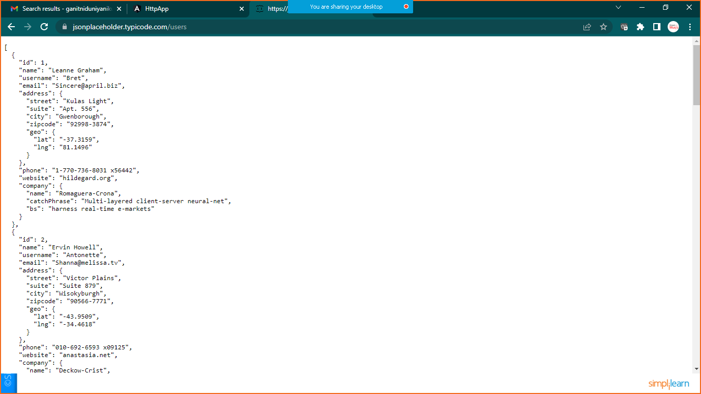

STEP:1 Generate App

* ng new HttpApp

Step:2 Generate Component

* ng g c listuser

Step:3 Generate Service

* ng g s data

Step:4 Generate Userclass and declare the datatype

**Goto>src>app>right click >new >give name**

**UserClass.ts** file

export class UserClass{

    id:number;

    name:string;

    username:string;

    email:string;

}

If you are getting error in latest angular version goto **tsconfig.json** file and add below highlighted command

/* To learn more about this file see: https://angular.io/config/tsconfig. */

{

  "compileOnSave": false,

  "compilerOptions": {

    "baseUrl": "./",

    "outDir": "./dist/out-tsc",

    "forceConsistentCasingInFileNames": true,

    "strictPropertyInitialization": false,

    "strict": true,

    "noImplicitOverride": true,

    "noPropertyAccessFromIndexSignature": true,

    "noImplicitReturns": true,

    "noFallthroughCasesInSwitch": true,

    "sourceMap": true,

    "declaration": false,

    "downlevelIteration": true,

    "experimentalDecorators": true,

    "moduleResolution": "node",

    "importHelpers": true,

    "target": "es2020",

    "module": "es2020",

    "lib": [

      "es2020",

      "dom"

    ]

  },

  "angularCompilerOptions": {

    "enableI18nLegacyMessageIdFormat": false,

    "strictInjectionParameters": true,

    "strictInputAccessModifiers": true,

    "strictTemplates": true

  }

}

Step:5 import HttpClient Mannually from ‘@angular/common/http’ in **DataService.ts** file

import { Injectable } from '@angular/core';

import {HttpClient} from '@angular/common/http';

import {Observable} from 'rxjs'

import { UserClass } from './UserClass';

@Injectable({

  providedIn: 'root'

})

export class DataService {

  url:string="https://jsonplaceholder.typicode.com/users";

  //inject the DI

  constructor(private http:HttpClient) { }

  getAllUsers():Observable <UserClass[]>{

    return this.http.get<UserClass[]>(this.url);

  }

}

Step:6 Inject the Service in **listuser.component.ts** file

import { Component, OnInit } from '@angular/core';

import { DataService } from '../data.service';

import { UserClass } from '../UserClass';

@Component({

  selector: 'app-listuser',

  templateUrl: './listuser.component.html',

  styleUrls: ['./listuser.component.css']

})

export class ListuserComponent implements OnInit {

  //inject the service

  constructor(private service:DataService) { }

  users:UserClass[];

  ngOnInit(): void {

    this.service.getAllUsers().subscribe(result=>this.users=result);

  }

}

Step:7 Register the HttpClientModule in app.module.ts file

import { HttpClientModule } from '@angular/common/http';

import { NgModule } from '@angular/core';

import { BrowserModule } from '@angular/platform-browser';

import { AppRoutingModule } from './app-routing.module';

import { AppComponent } from './app.component';

import { ListuserComponent } from './listuser/listuser.component';

@NgModule({

  declarations: [

    AppComponent,

    ListuserComponent

  ],

  imports: [

    BrowserModule,

    AppRoutingModule,

    HttpClientModule

  ],

  providers: [],

  bootstrap: [AppComponent]

})

export class AppModule { }

Step:8 prepare navigation on **app.component.html**

<nav class="navbar navbar-expand-sm bg-dark navbar-dark">

    <a href="#" class="navbar-brand">Simplilearn</a>

    <ul class="navbar-nav">

        <li class="nav-item">

            <a href="#" class="nav-link" routerLink="home">Home</a>

        </li>

        <li class="nav-item">

            <a href="#" class="nav-link" routerLink="about">About Us</a>

        </li>

        <li class="nav-item">

            <a href="#" class="nav-link" routerLink="contact">Contact Us</a>

        </li>

        <li class="nav-item">

            <a href="#" class="nav-link" routerLink="http">Http Service</a>

        </li>

    </ul>

</nav>

<h1>Http Service Example</h1>

<router-outlet></router-outlet>

**And import bootstrap in index.html file**

**Step:8 Give routes to the components**

**Goto>app-routing.module.ts file**

import { NgModule } from '@angular/core';

import { RouterModule, Routes } from '@angular/router';

import { ListuserComponent } from './listuser/listuser.component';

const routes: Routes = [

  {"path":"http",component:ListuserComponent}

];

@NgModule({

  imports: [RouterModule.forRoot(routes)],

  exports: [RouterModule]

})

export class AppRoutingModule { }

Step: 9 prepare html file in **listusercomponent.html** to show the data

<h2>User Details</h2>

<table class="table table-bordered table-striped">

    <thead>

        <tr>

            <th>Id</th>

            <th>Name</th>

            <th>UserName</th>

            <th>Email</th>

        </tr>

    </thead>

    <tbody>

        <tr *ngFor="let u of users">

            <td>{{u.id}}</td>

            <td>{{u.name}}</td>

            <td>{{u.username}}</td>

            <td>{{u.email}}</td>

        </tr>

    </tbody>

</table>

**Save it and run the app**

