**RUN ELK STACK ON DOCKER**

**Pulling the Image**

To pull the ELK image from the Docker registry, open the terminal and run:

sudo docker pull sebp/elk

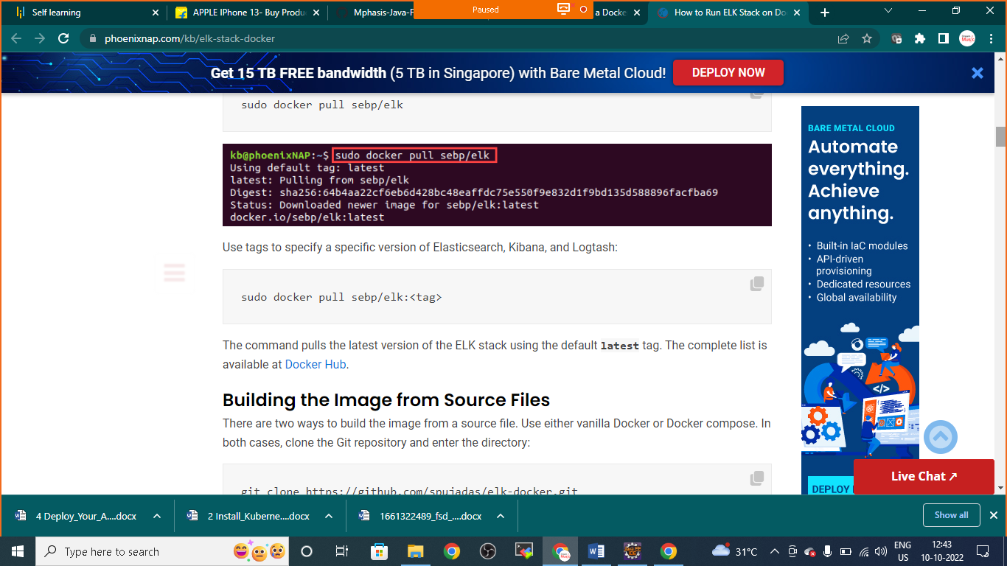

Use tags to specify a specific version of Elasticsearch, Kibana, and Logtash:

sudo docker pull sebp/elk:<tag>

### Building the Image from Source Files

There are two ways to build the image from a source file. Use either vanilla Docker or Docker compose. In both cases, clone the Git repository and enter the directory:

git clone https://github.com/Nikunj-Java/ELK-STACK.git

cd elk-docker

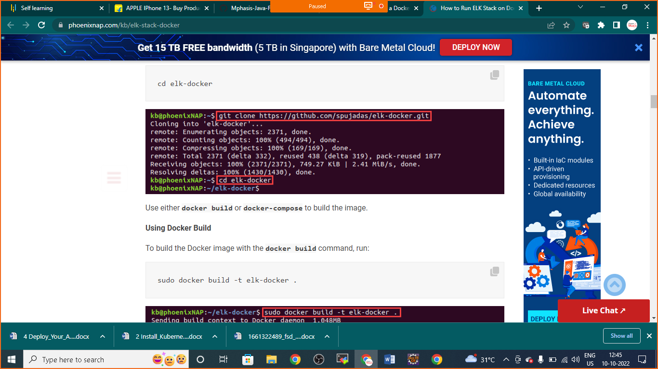

Use either **docker build** or **docker-compose** to build the image.

**Using Docker Build**

To build the Docker image with the **docker build** command, run:

sudo docker build -t elk-docker .

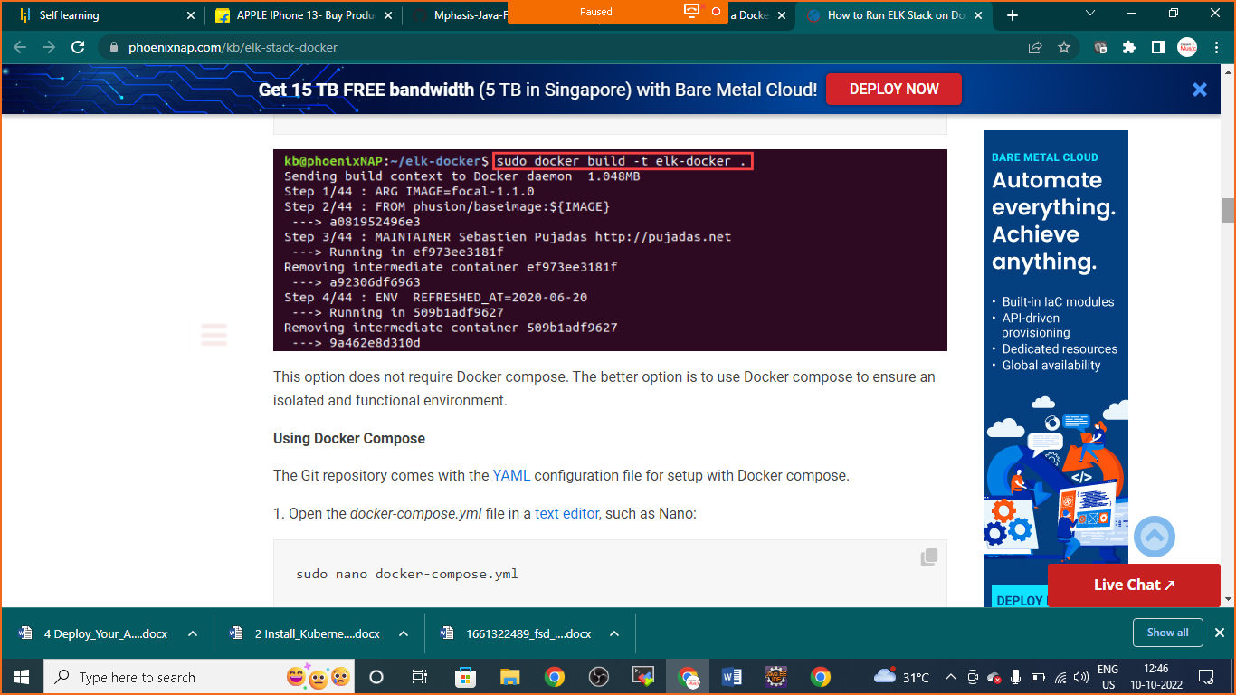

### From the Image via Command

To start the whole ELK stack container via **docker run**, use the following:

sudo docker run -p 5601:5601 -p 9200:9200 -p 5044:5044 -it --name elk sebp/elk

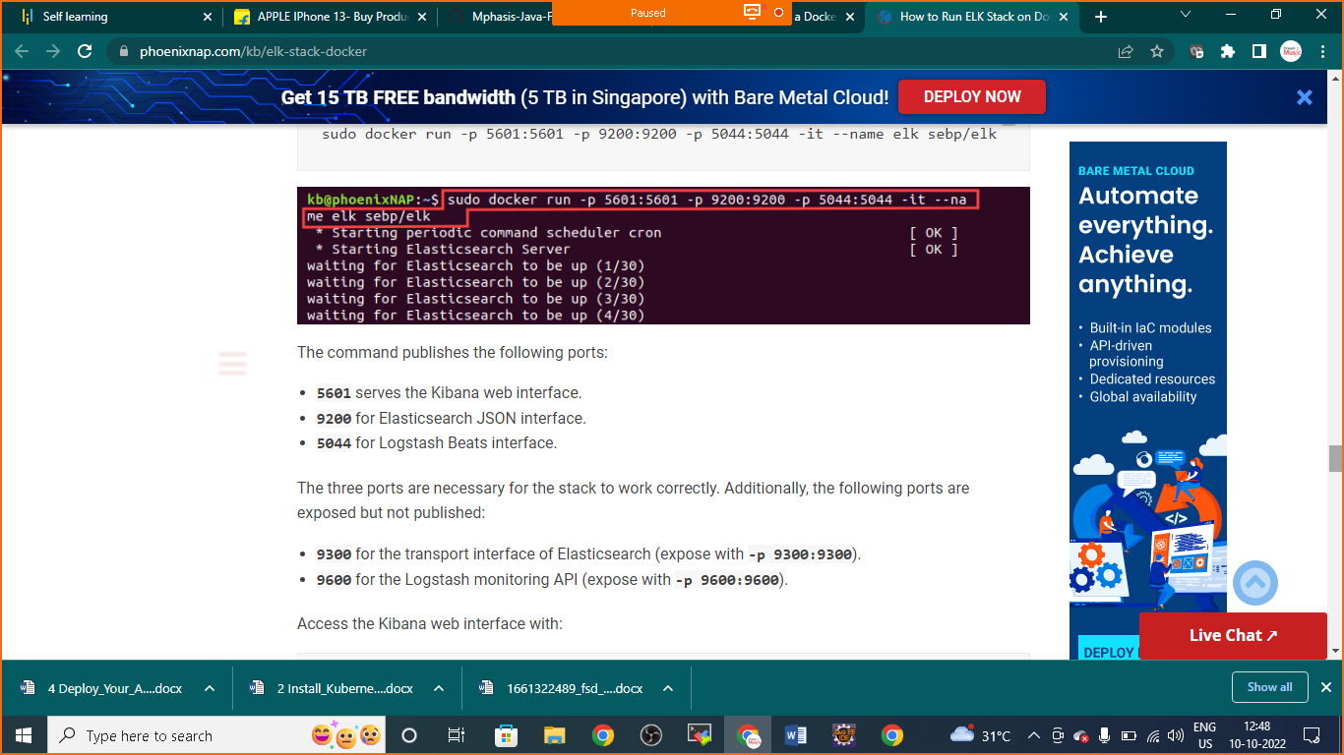

The command publishes the following ports:

* **5601** serves the Kibana web interface.
* **9200** for Elasticsearch JSON interface.
* **5044** for Logstash Beats interface.

The three ports are necessary for the stack to work correctly. Additionally, the following ports are exposed but not published:

* **9300** for the transport interface of Elasticsearch (expose with **-p 9300:9300**).
* **9600** for the Logstash monitoring API (expose with **-p 9600:9600**).

Access the Kibana web interface with:

http://<host>:5601

