**Pom.xml** file

<project xmlns="http://maven.apache.org/POM/4.0.0" xmlns:xsi="http://www.w3.org/2001/XMLSchema-instance" xsi:schemaLocation="http://maven.apache.org/POM/4.0.0 http://maven.apache.org/xsd/maven-4.0.0.xsd">

<modelVersion>4.0.0</modelVersion>

<groupId>com.simplileaern.testng</groupId>

<artifactId>TestNgExample</artifactId>

<version>0.0.1-SNAPSHOT</version>

<packaging>jar</packaging>

<name>TestNgExample</name>

<url>http://maven.apache.org</url>

<properties>

<project.build.sourceEncoding>UTF-8</project.build.sourceEncoding>

</properties>

<dependencies>

<dependency>

<groupId>junit</groupId>

<artifactId>junit</artifactId>

<version>3.8.1</version>

<scope>test</scope>

</dependency>

<dependency>

<groupId>org.testng</groupId>

<artifactId>testng</artifactId>

<version>7.5</version>

<scope>test</scope>

</dependency>

<dependency>

<groupId>org.seleniumhq.selenium</groupId>

<artifactId>selenium-java</artifactId>

<version>4.4.0</version>

</dependency>

<!--ReportNg 1.1.4-->

<dependency>

<groupId>org.uncommons</groupId>

<artifactId>reportng</artifactId>

<version>1.1.4</version>

<scope>test</scope>

</dependency>

<!--Velocity-dep 1.4-->

<dependency>

<groupId>velocity</groupId>

<artifactId>velocity-dep</artifactId>

<version>1.4</version>

</dependency>

<!--Guice 3.0-->

<dependency>

<groupId>com.google.inject</groupId>

<artifactId>guice</artifactId>

<version>3.0</version>

</dependency>

</dependencies>

</project>

Now goto>project>right click>properties>testng>

Check the checkbox   
: disable default listner

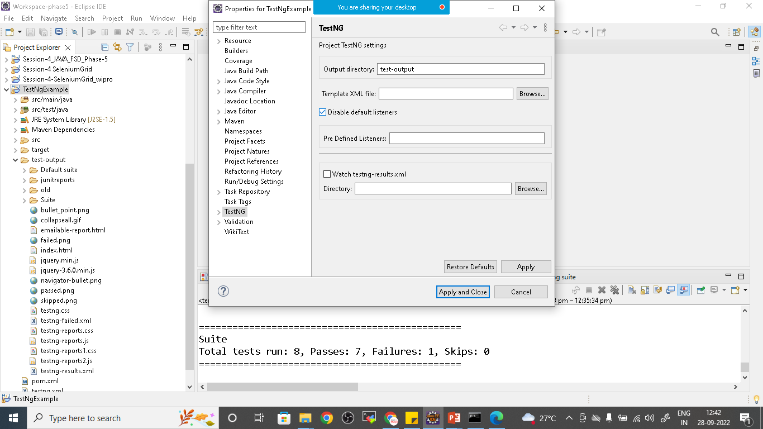

Click on apply and close

Maven update

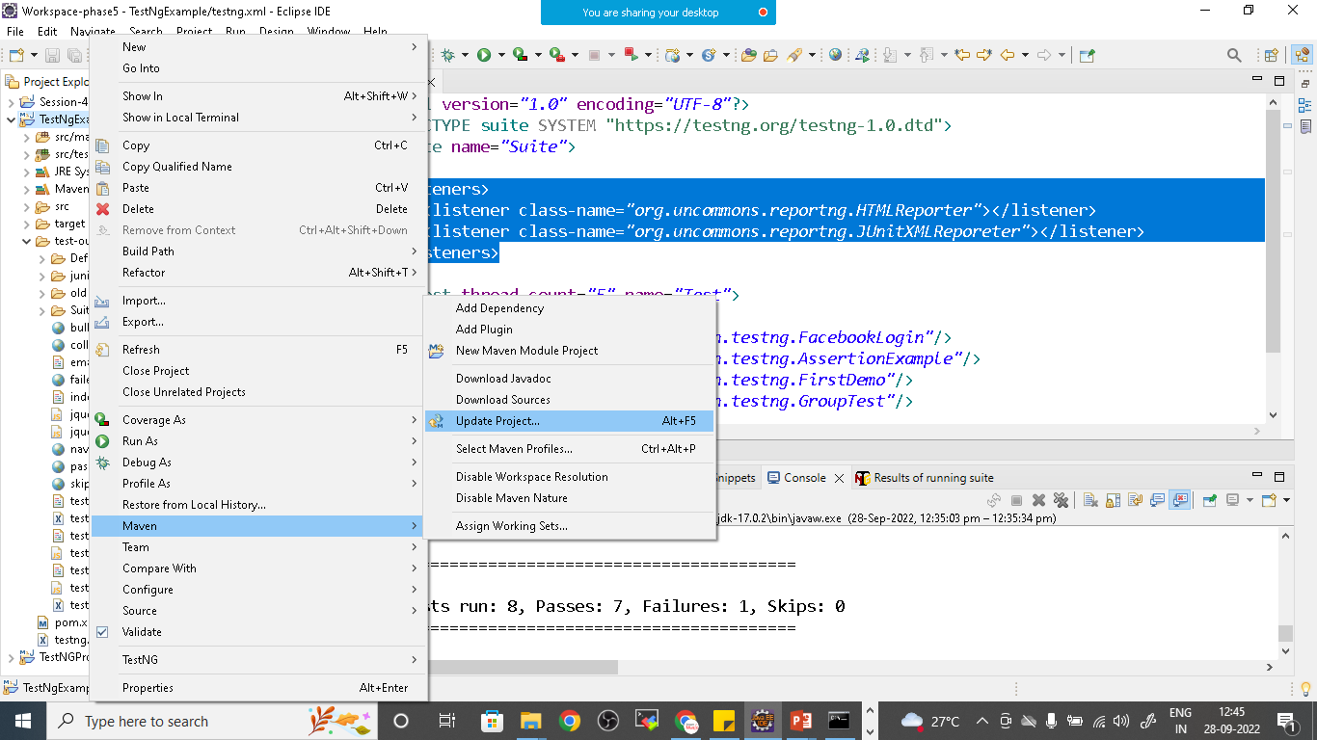

Right click on it and run as testNg suite

TestNg.Xml

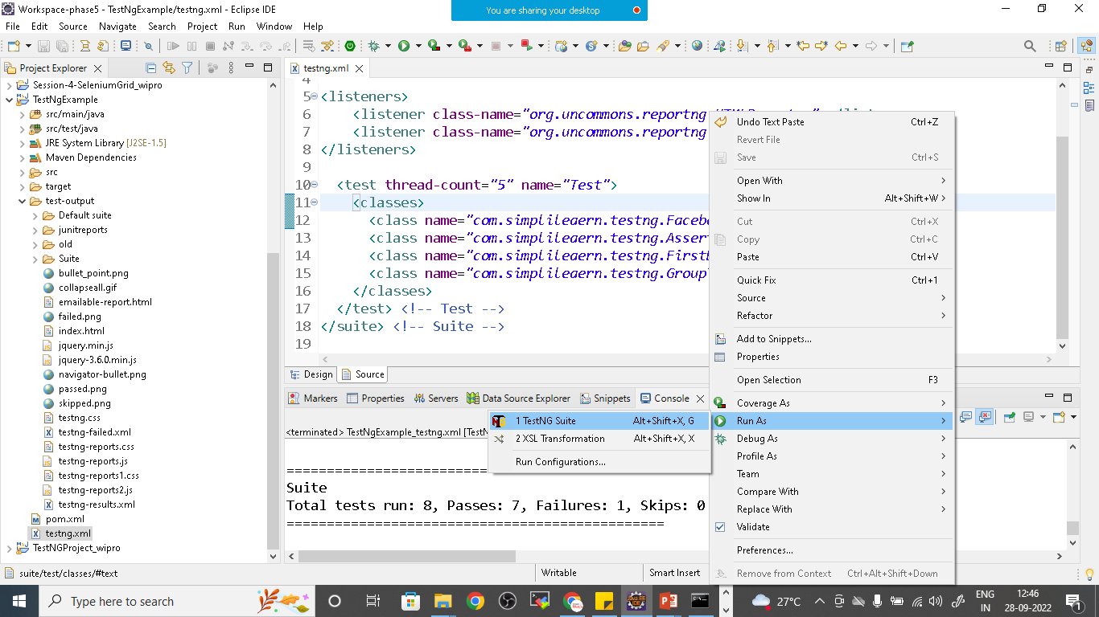

Once all testcases got executed refresh the project and open index.html file from testoutput>html>index.html

