Ansible

Step:1 Create AWS Ubuntu Instance and try connecting it with aws cli
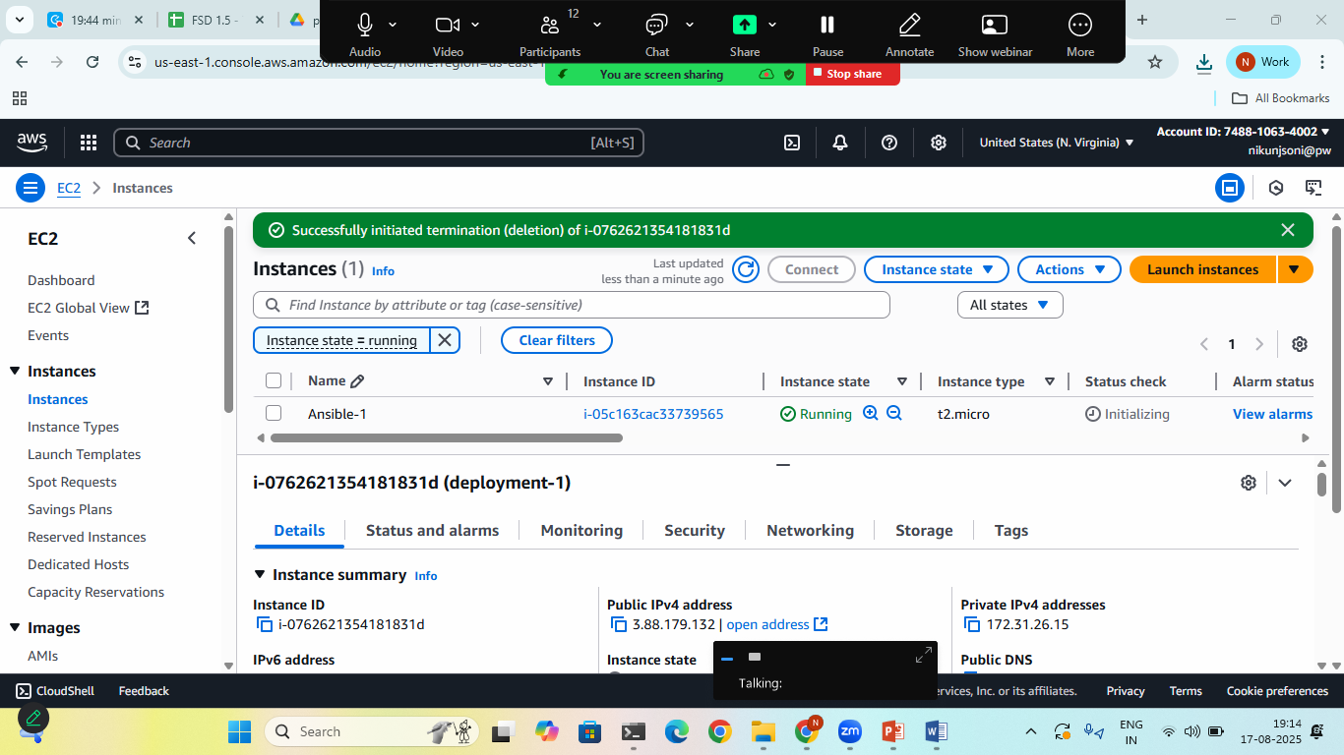
Save the .pem Key at some safe place

Step:2 Install Ansible in WSL
- sudo apt update
- sudo apt install ansible –y
- ansible –version
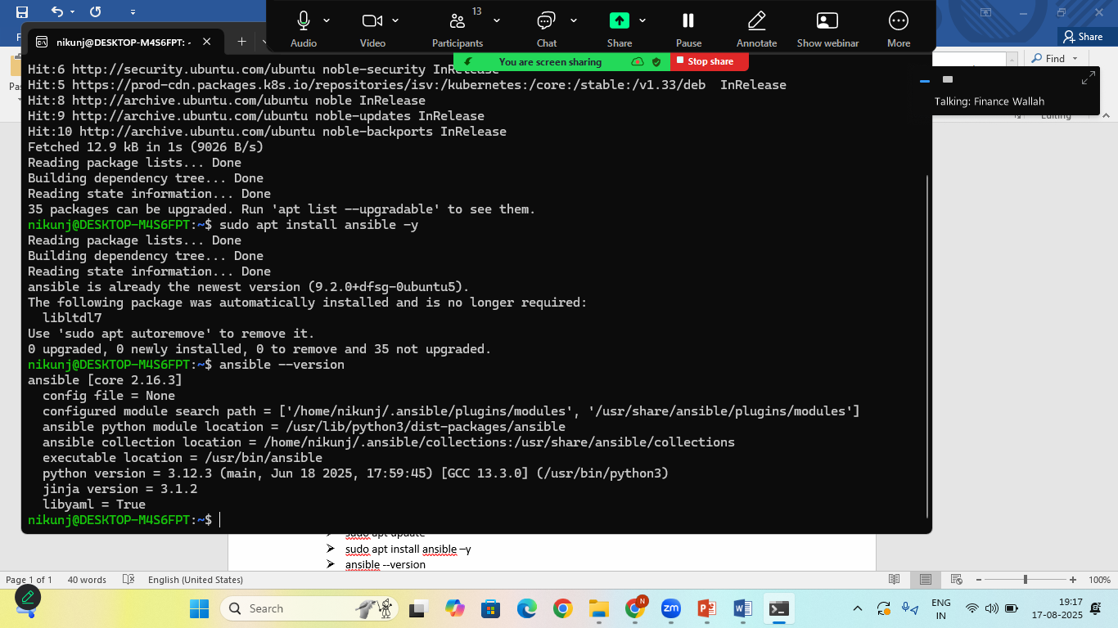
Step:3 Create One Folder and move your .pem key to it and create playbook
playbook.yml (or playbook.yaml)
---
- name: Test Ansible Playbook
hosts: localhost
tasks:
- name: Print Simple Message
debug:
msg: "Hello Ansible! if Working"

once playbook is ready > open the terminal in the same folder
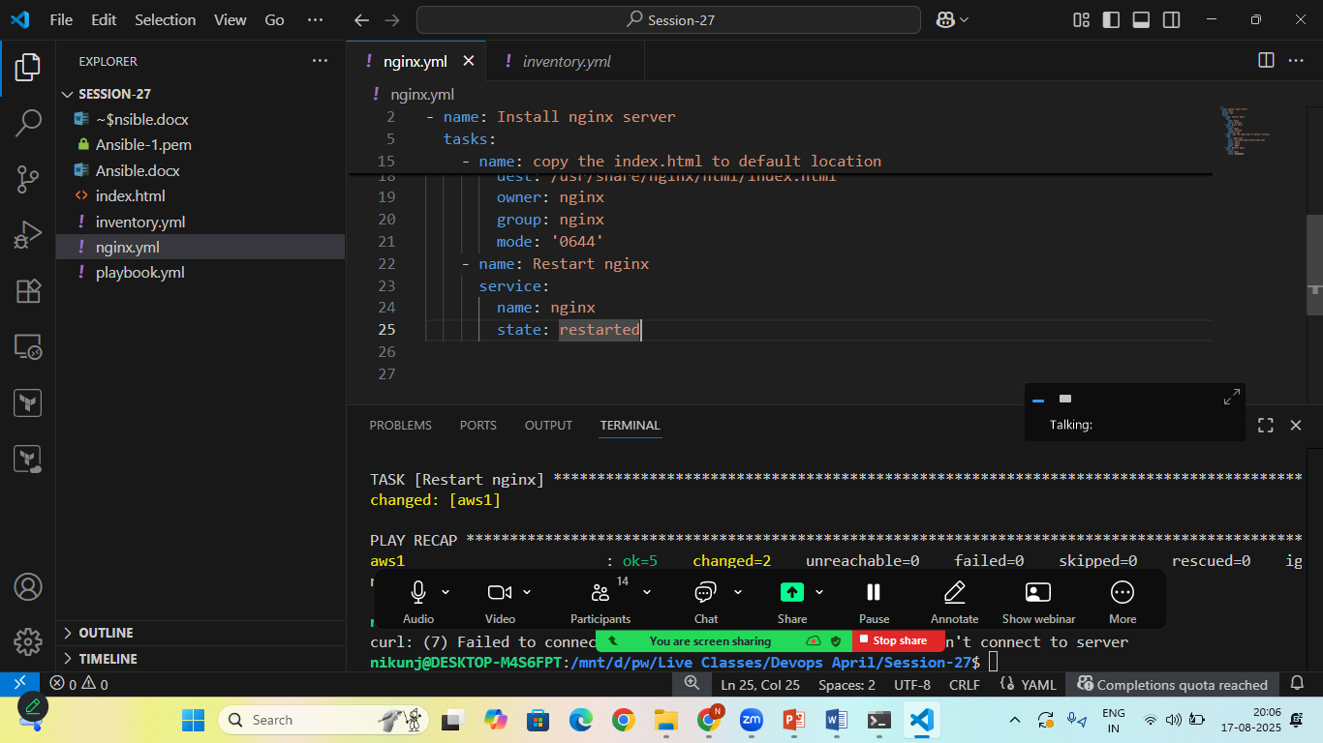
to Run this playbook:
- ansible-playbook playbook.yml
output:
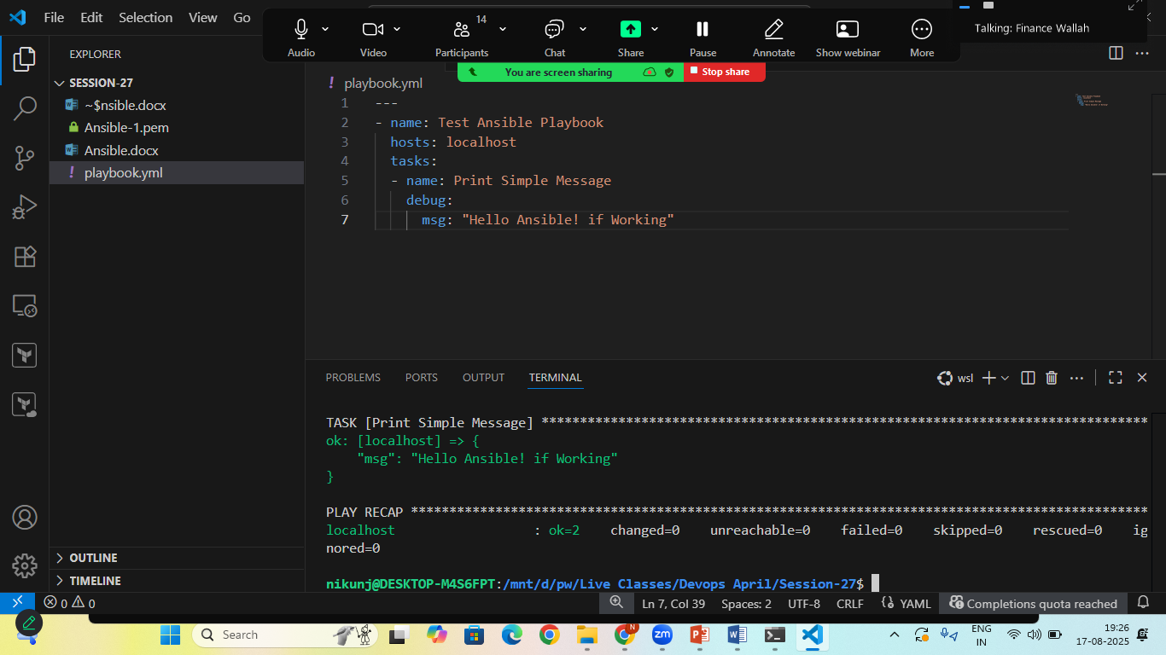
Lets create an Ansible Script for AWS automation

inventory.yml
all:
hosts:
aws1:
ansible_host: 54.234.14.104
ansible_user: ec2-user
ansible_ssh_private_key_file: Ansible-1.pem

nginx.yml
---
- name: Install nginx server
hosts: aws1
become: yes
tasks:
- name: Install nginx
yum:
name: nginx
state: present
- name: Start nginx
service:
name: nginx
state: started
enabled: yes
- name: copy the index.html to default location
copy:
src: index.html
dest: /usr/share/nginx/html/index.html
owner: nginx
group: nginx
mode: '0644'
- name: Restart nginx
service:
name: nginx
state: restarted

Step:4 Check the status:
- sudo ansible all --list-host -i inventory.yml
this command will give you the number of active host
Step:5 Run the Nginx Installation and Create index.html file
- sudo ansible-playbook -i inventory.yml nginx.yml
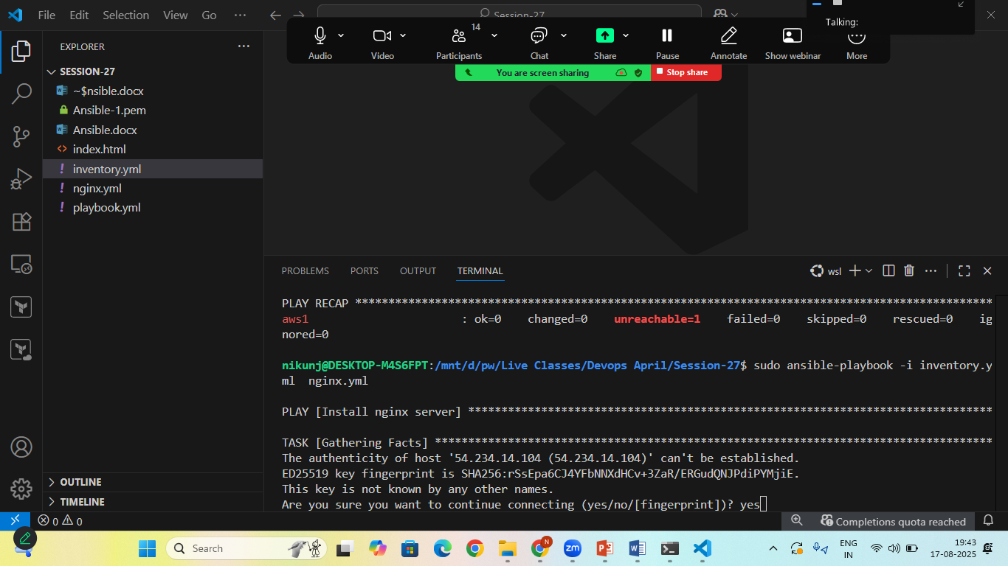

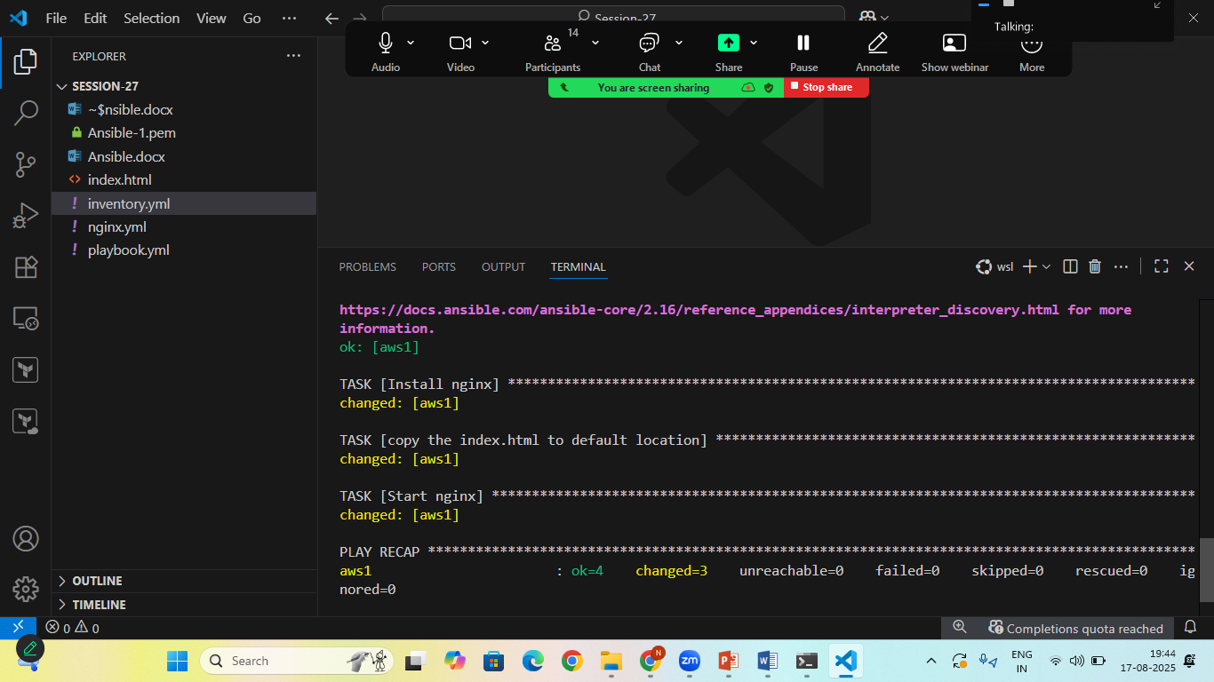
Goto> AWS instance> copy public IP Address> goto> Browser> ip_add:80

