Ansible
Step: 1 Create AWS Ubuntu Instance with Ansible25.pem Key
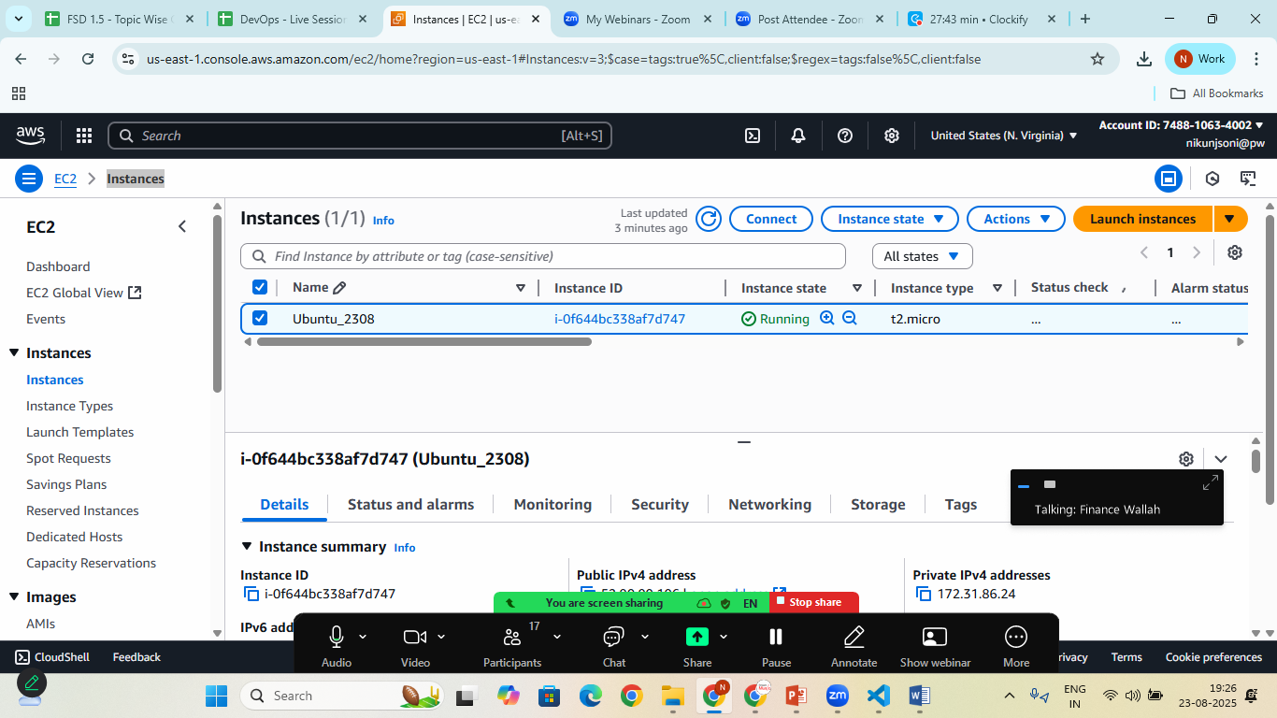

Step.2 connect using awsCLI and check the connection

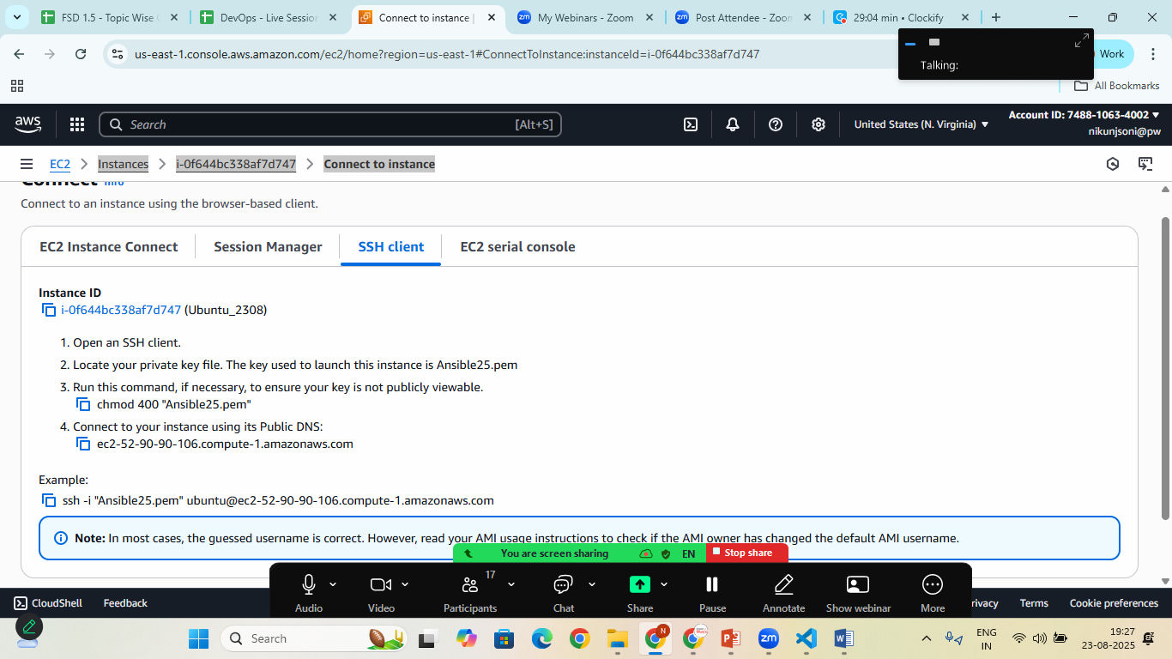
Copy the ssh and paste to your Terminal/CMD where Ansible25.pem key is Available and connect using AWS Cli
Step:3 create Project
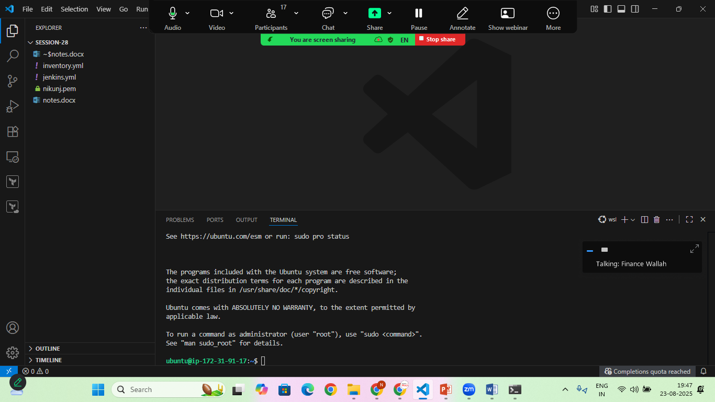

Step:4 Create inventory.yml
all:
hosts:
aws1:
ansible_host: 13.222.243.30
ansible_user: ubuntu
ansible_ssh_private_key_file: nikunj.pem

Step:5 Create Jenkins.yml File
---
- name: Install Jenkins on Ubuntu
hosts: aws1
become: yes

tasks:
- name: Install Java (open JDK 21)
apt:
name: openjdk-21-jre
state: present
update_cache: yes
- name: Add Jenkins repository key
apt_key:
url: https://pkg.jenkins.io/debian-stable/jenkins.io-2023.key
state: present
- name: Add Jenkins Repository
apt_repository:
repo: deb https://pkg.jenkins.io/debian binary/
state: present
- name: Update apt Cache
apt:
update_cache: yes
- name: Install Jenkins
apt:
name: jenkins
state: present
- name: Start Jenkins Service
service:
name: jenkins
state: started
enabled: yes
- name: Ensure port 8080 is open for Jenkins
ufw:
rule: allow
port: 8080
proto: tcp
when: ansible_facts['os_family'] == 'Debian'

Step:6 Run the Ansible Playbook
- sudo ansible-playbook –i inventory.yml Jenkins.yml

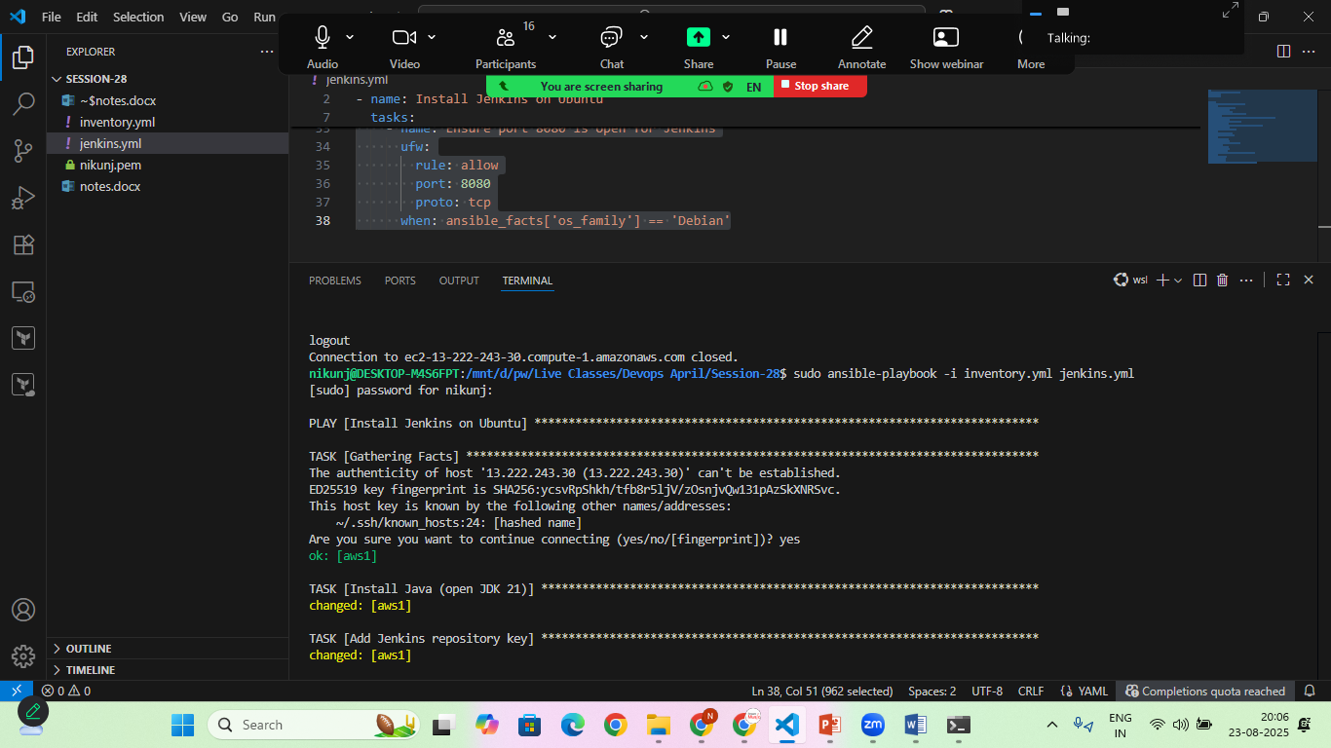
Once the process is completed! Goto> aws>ec2 instance> copy public ip address> browser>
