# **Setting up Performance Testing in JMeter**

Step:1 Install Java 8 or higher version

Step:2 install JMeter from apache: <https://jmeter.apache.org/download_jmeter.cgi>

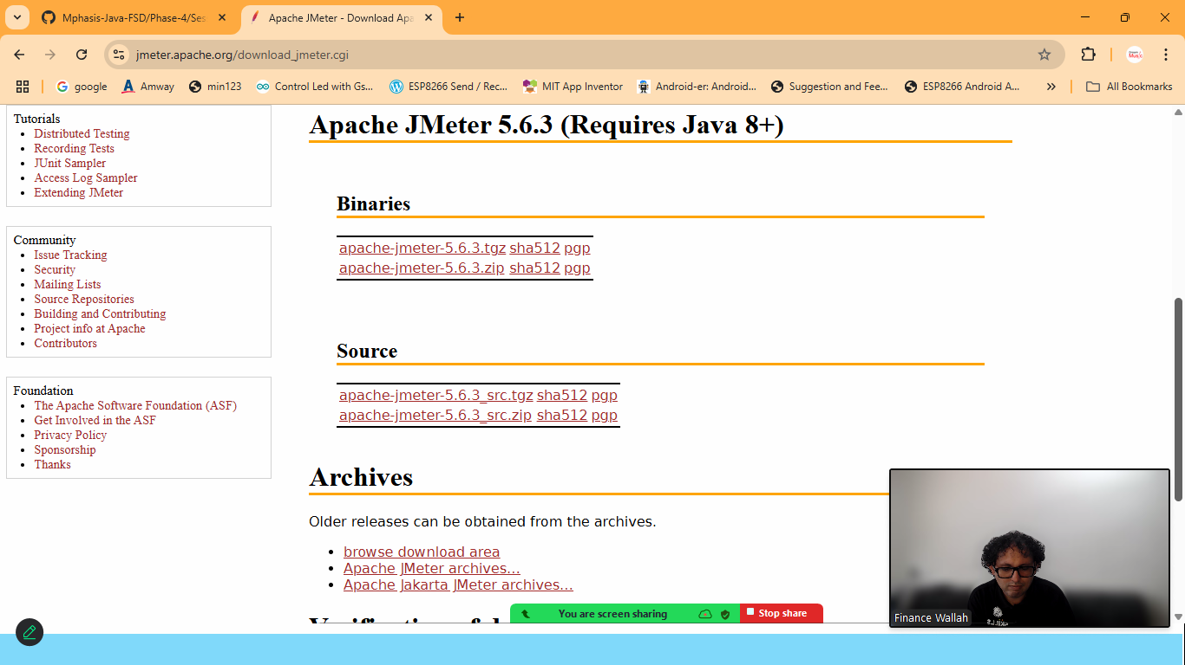

Download zip from Binary section

Step:3 Extract it> goto> bin folder> double click on jmeter.bat file

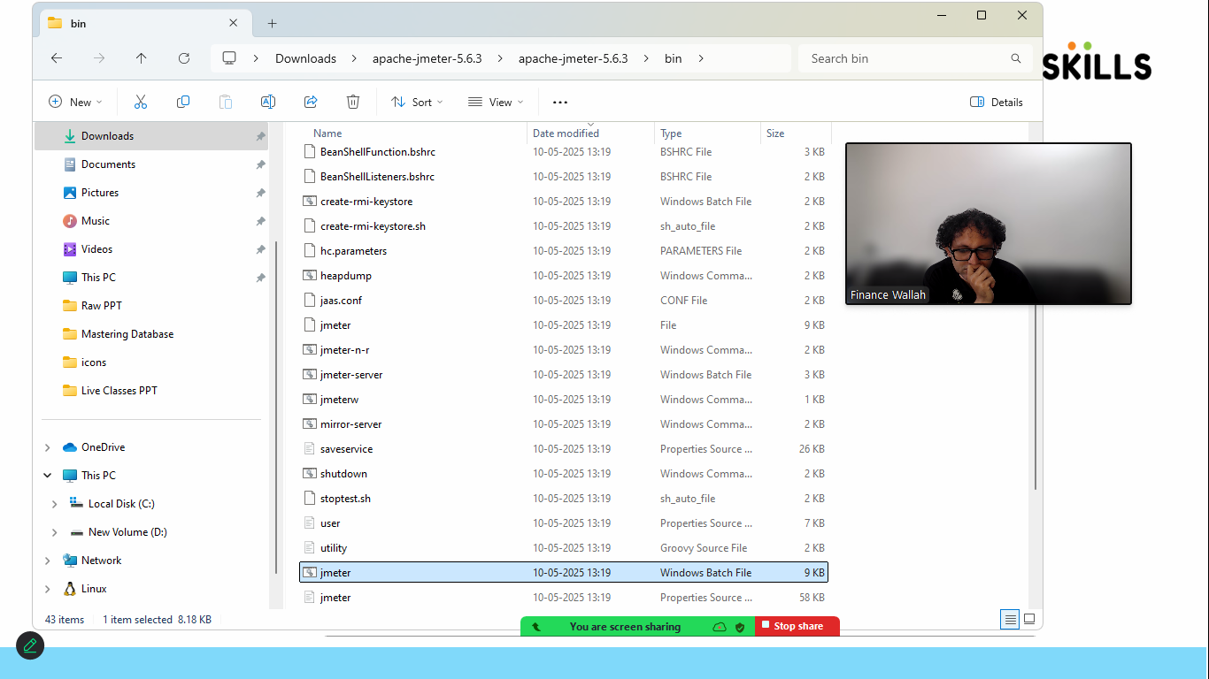

Step:4 JMETER DASHBOARD

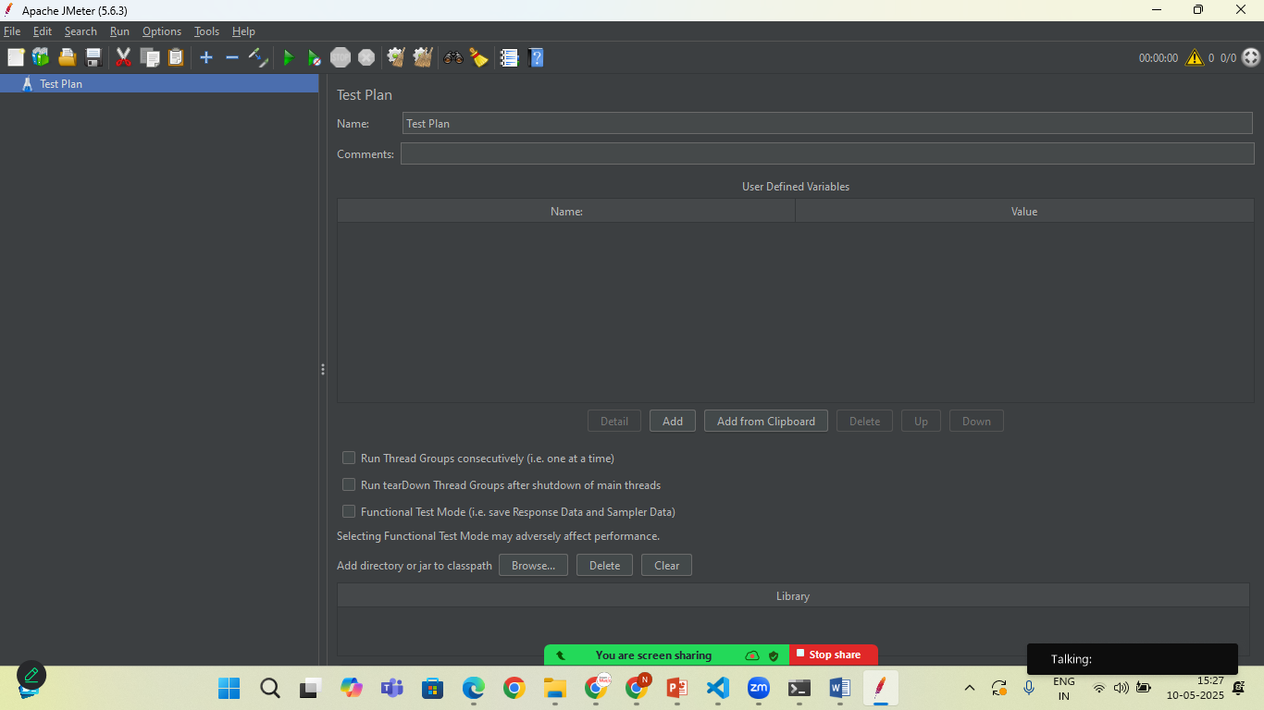

Rename it to Basic Load Test

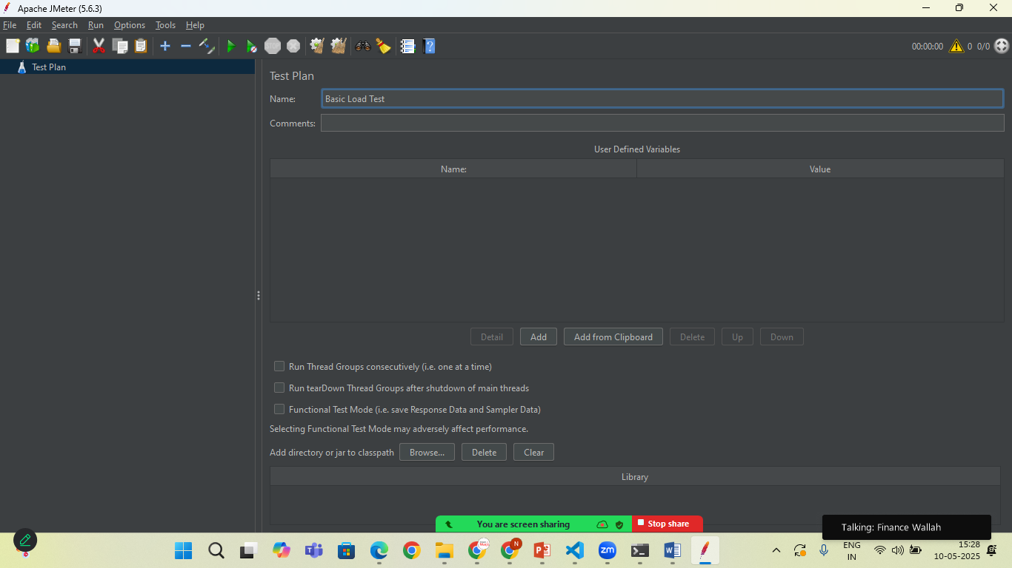

Right click to Basic Load Test> **Threads> Thread Group**

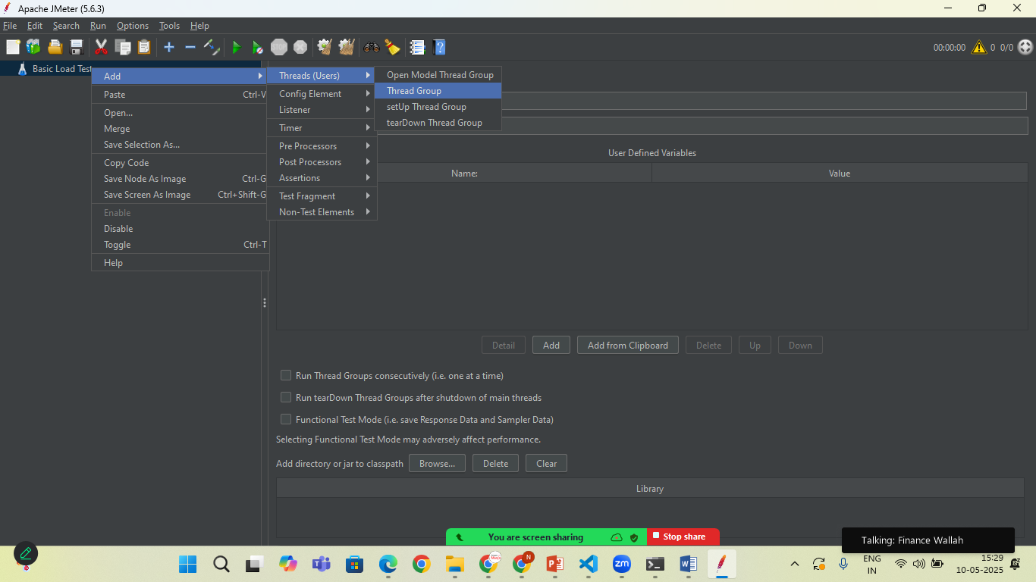

**Set the Numbers of Thread(users):** 10

**Ramp-Up Perios (in Seconds):** 5 (jmeter will start 2 users per seconds)

**Loop Count:** 1(each users will make 1 request)

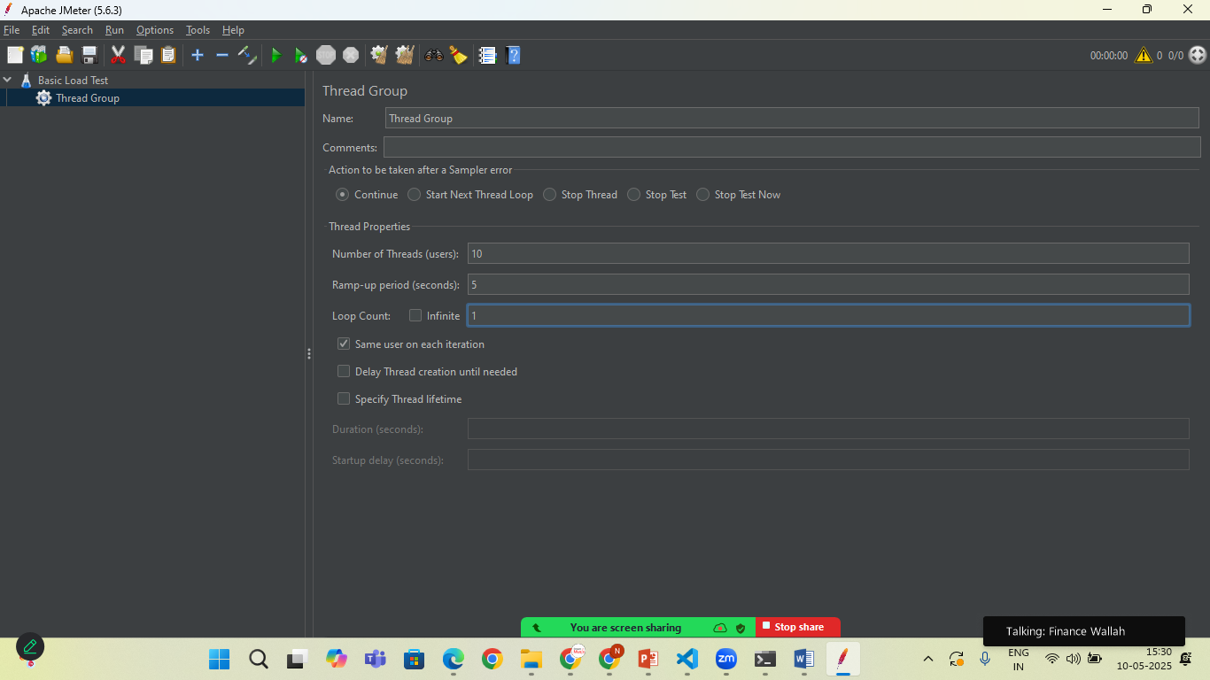

Add the HTTP Request Sampler

Right click on Thread Group>**add> Sampler> HTTP Request**

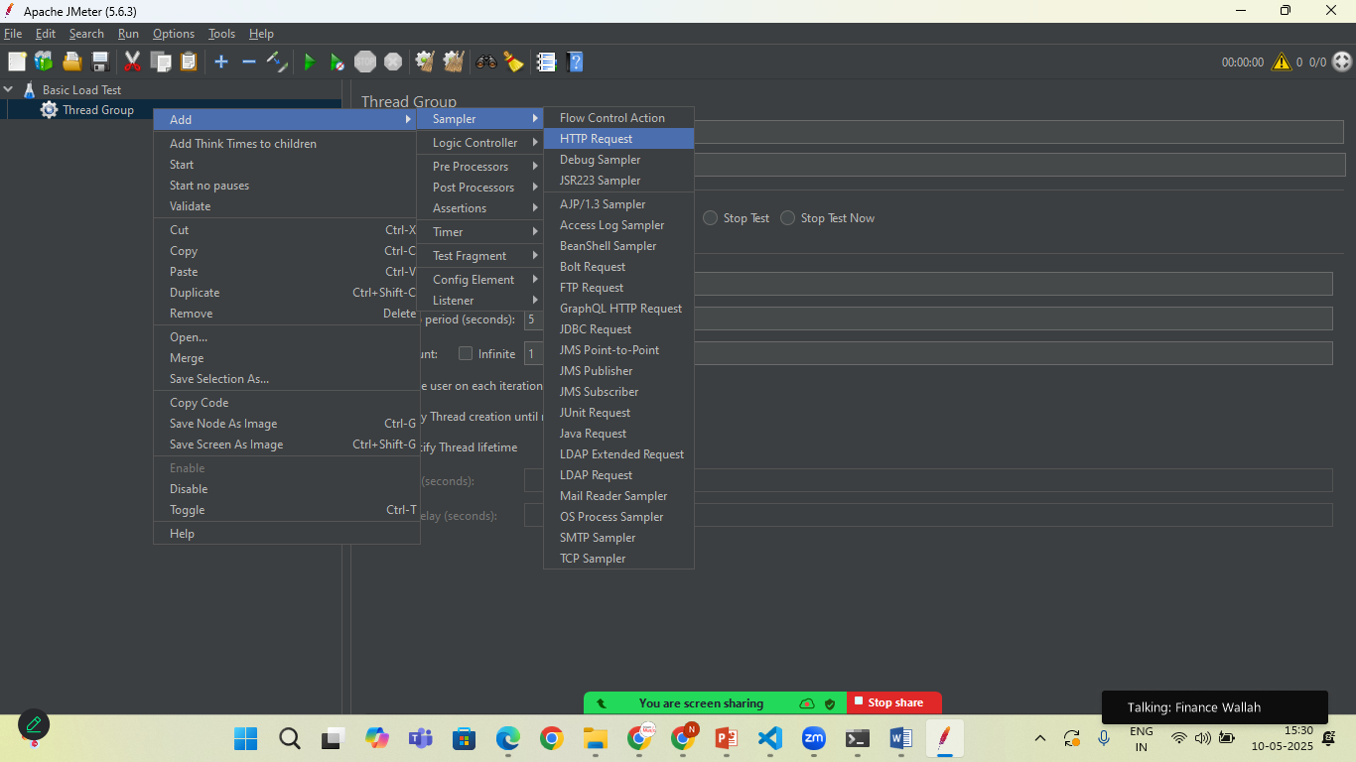

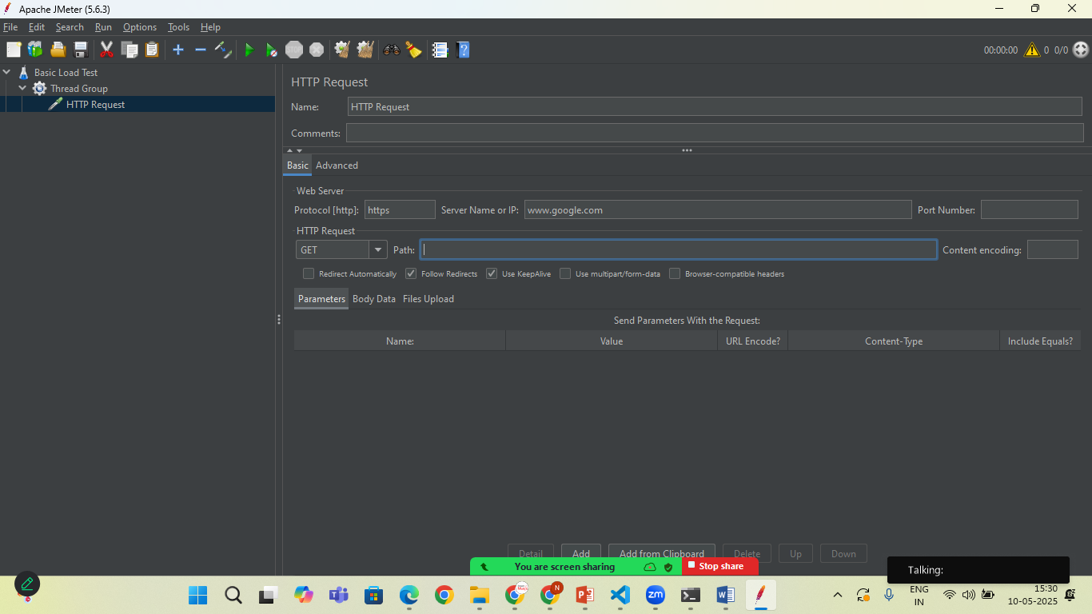

In path: your_domain.com

In path: give your child path like /users or /api

Click on : Green Start Button to Start the Testing

