Ansible

# Step:1 create aws ec2 ubuntu instance

# Step:2 connect using aws cli and check the connections

# Step:3 download/move the pem key to the folder where we will prepare inventory.yml and Jenkins.yml file

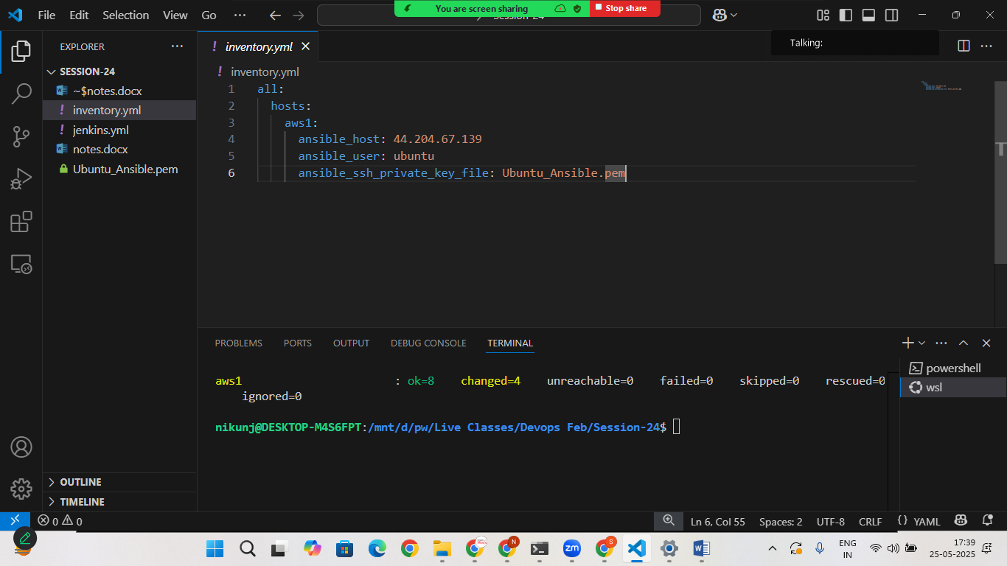

# Step:4 Create Inventory.yml file

all:

  hosts:

    aws1:

      ansible_host: your_aws_public_ip_add

      ansible_user: aws_user_name

      ansible_ssh_private_key_file: <your_pem_key_name>

# Step:5 Create jenkins.yml file

---

- name: Install Jenkins on ubuntu

  hosts: aws1

  become: yes

  tasks:

    - name: Install Java (Open JDK 21)

      apt:

        name: openjdk-21-jre

        state: present

        update_cache: yes

    - name: Add jenkins repository key

      apt_key:

        url: https://pkg.jenkins.io/debian-stable/jenkins.io-2023.key

        state: present

    - name: Add jenkins repository

      apt_repository:

       repo: deb https://pkg.jenkins.io/debian binary/

       state: present

    - name : Update apt cache

      apt:

        update_cache: yes

    - name : Install Jenkins

      apt:

        name: jenkins

        state: present

    - name: start jenkins service

      service:

        name: jenkins

        state: started

        enabled: yes

    - name: ensure port 8080 is open in UFw

      ufw:

        rule: allow

        port: 8080

        proto: tcp

      when: ansible_facts['os_family'] == 'Debian'

# Step:6 run the ansible playbook

* sudo ansible-playbook -i **inventory.yml** **jenkins.yml**

once Jenkins is ready

goto> aws>copy public ip address> goto> browser

