HTTP SERVICE

http Service is used to fetch API from other source to angular app

LINK: <https://jsonplaceholder.typicode.com/users>

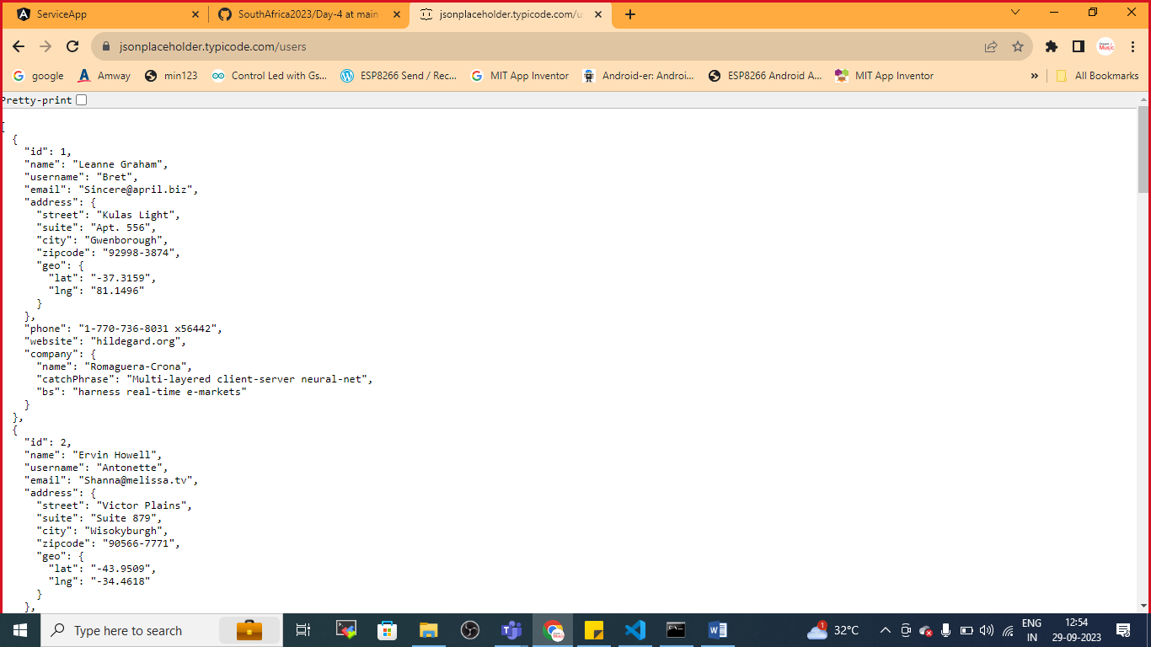

Generate component

* ng g c http

Generate Service

* ng g s data

Generate Class( UserClass.ts)

UserClass.ts

export class UserClass {

    id:number;

    name:string;

    username:string;

    email:string;

}

If you are getting any error

Goto>tscongif.json file and add below code

 "strictPropertyInitialization": false,

Save the file

Import the http client module

Manually in service

Dataservice.ts file

import { Injectable } from '@angular/core';

import {HttpClient} from '@angular/common/http';

import {Observable} from 'rxjs';

import { UserClass } from './UserClass';

@Injectable({

  providedIn: 'root'

})

export class DataService {

  url:string="https://jsonplaceholder.typicode.com/users";

  //DI

  constructor(private http:HttpClient) { }

  getAllUsers():Observable<UserClass[]>{

    return this.http.get<UserClass[]>(this.url)

  }

}

Inject the service in any component that you wish to

http.component.ts

import { Component, OnInit } from '@angular/core';

import { DataService } from '../data.service';

import { UserClass } from '../UserClass';

@Component({

  selector: 'app-http',

  templateUrl: './http.component.html',

  styleUrls: ['./http.component.css']

})

export class HttpComponent implements OnInit {

  users:UserClass[];

  //DI

  constructor(private service:DataService){}

  ngOnInit(): void {

    this.service.getAllUsers().subscribe(result=>this.users=result);

  }

}

Registre the HttpClientModule in app.module .ts file in imports:[]

App.module.ts

import { NgModule } from '@angular/core';

import { BrowserModule } from '@angular/platform-browser';

import { AppRoutingModule } from './app-routing.module';

import { AppComponent } from './app.component';

import { UserComponent } from './user/user.component';

import { MydataService } from './mydata.service';

import { HttpComponent } from './http/http.component';

import { HttpClientModule } from '@angular/common/http';

@NgModule({

  declarations: [

    AppComponent,

    UserComponent,

    HttpComponent

  ],

  imports: [

    BrowserModule,

    AppRoutingModule,

    HttpClientModule

  ],

  providers: [MydataService],

  bootstrap: [AppComponent]

})

export class AppModule { }

http.component.html file

<div class="container">

    <table class="table  table-bordered table-striped table-dark">

        <thead>

            <tr>

                <th>ID</th><th>NAME</th><th>USERNAME</th><th>EMAIL</th>

            </tr>

        </thead>

        <tbody>

            <tr \*ngFor="let u of users">

                <td>{{u.id}}</td>

                <td>{{u.name}}</td>

                <td>{{u.username}}</td>

                <td>{{u.email}}</td>

            </tr>

        </tbody>

    </table>

</div>

App.component.html

<h1>Service App</h1>

<app-user></app-user>

<app-http></app-http>

Save and check the output

