Download AutoIt from :

<https://www.autoitscript.com/site/autoit/downloads/>

Open AutoIt

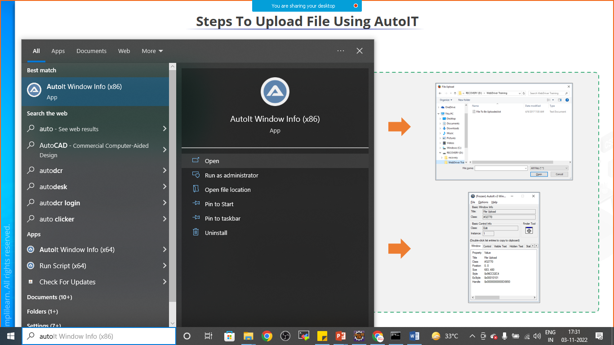

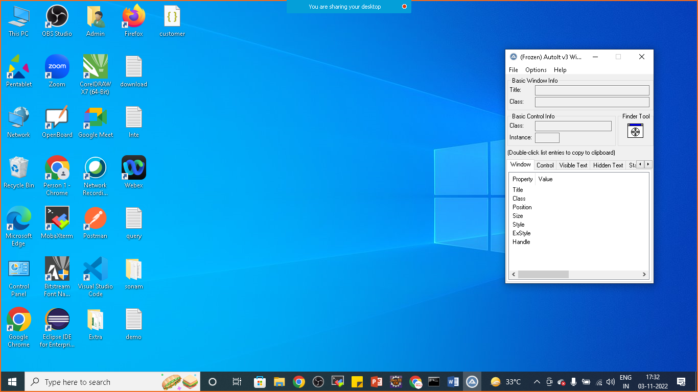

Drag and drop the finder tool on the windows GUI that you want to automate

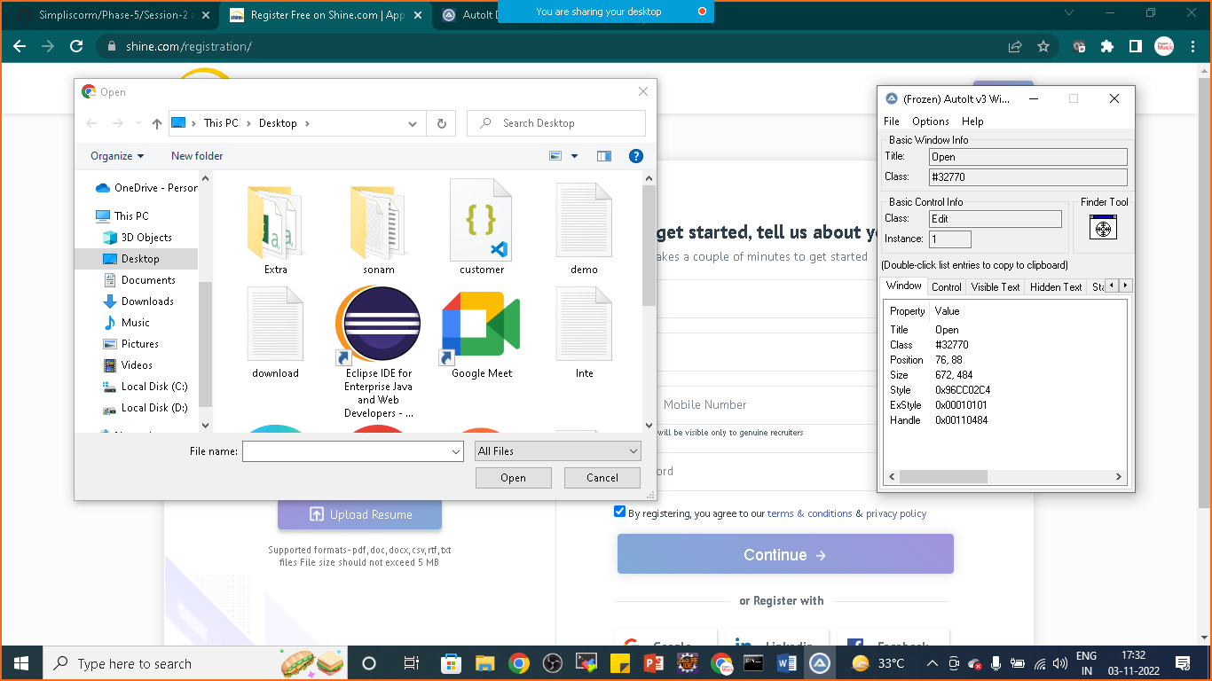

Once you will drag and drop the finder tool on **Filename**

**TITLE : Open**

**CLASS : Edit**

**INSTANCE : 1**

**Again drag and drop the finder tool on open button**

**TITLE : Open**

**CLASS : Button**

**INSTANCE : 1**

**Now we will use this information to write auto it script**

**Now Goto>** C:\Program Files (x86)\AutoIt3\SciTE

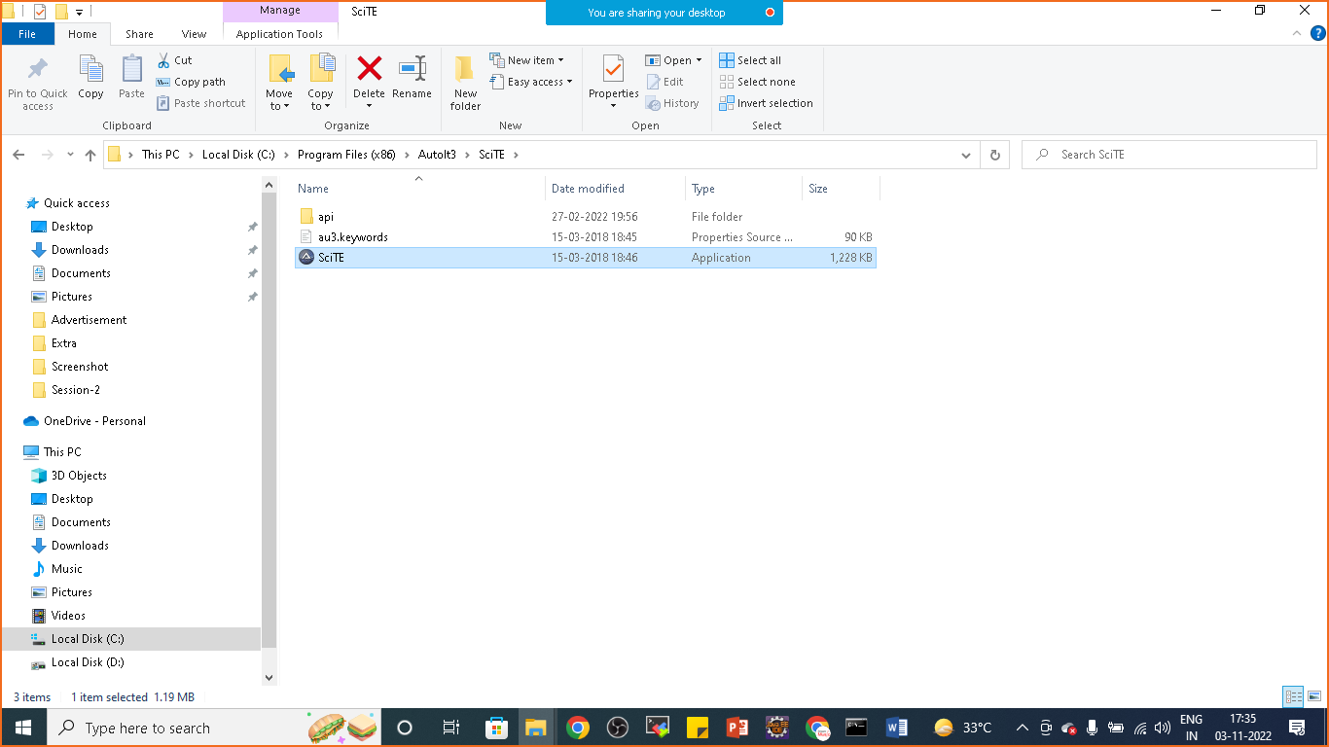

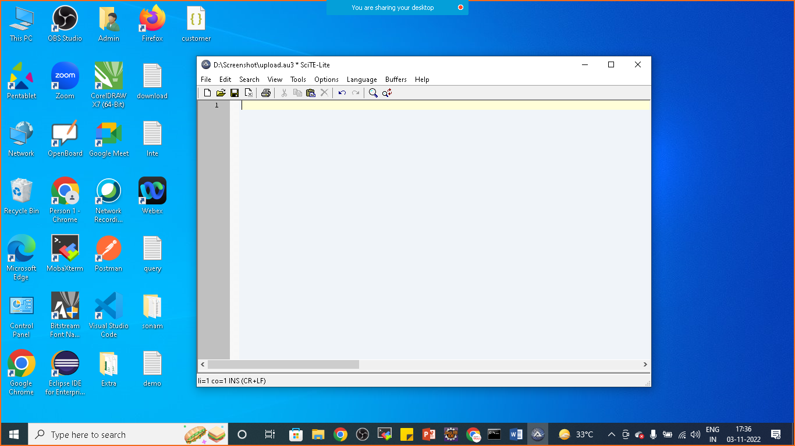

**Let’s write script**

**Code:**

**ControlFocus("Open","","Edit1")**

**ControlSetText("Open","","Edit1","D:\Screenshot\cv.pdf")**

**ControlClick("Open","","Button1")**

**Now save the file :upload.au3 extention in the same location where your pdf or document is located**

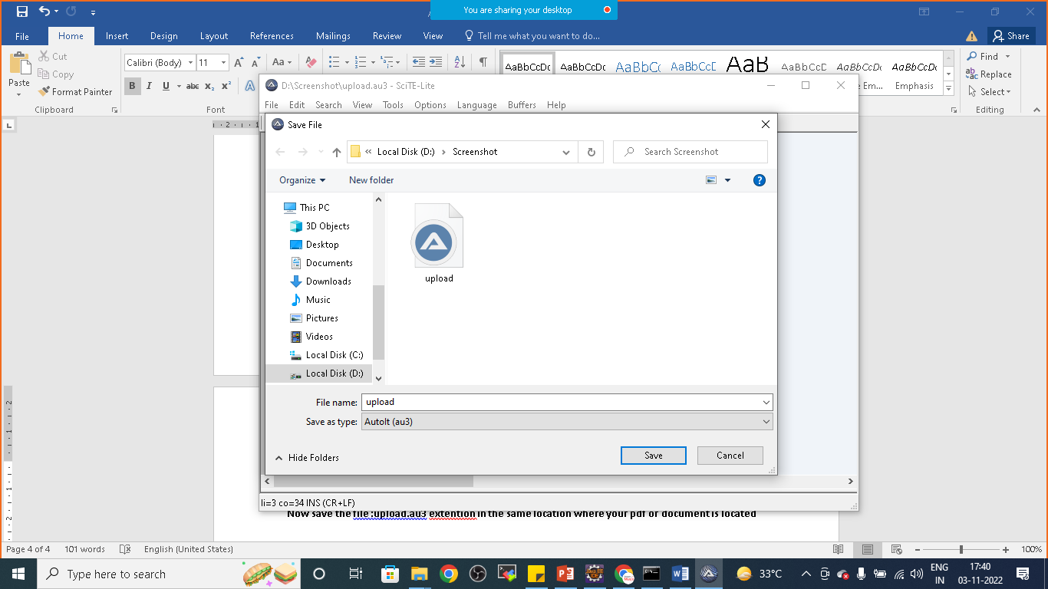

**Now go to the folder> right click on upload script and compile the script**

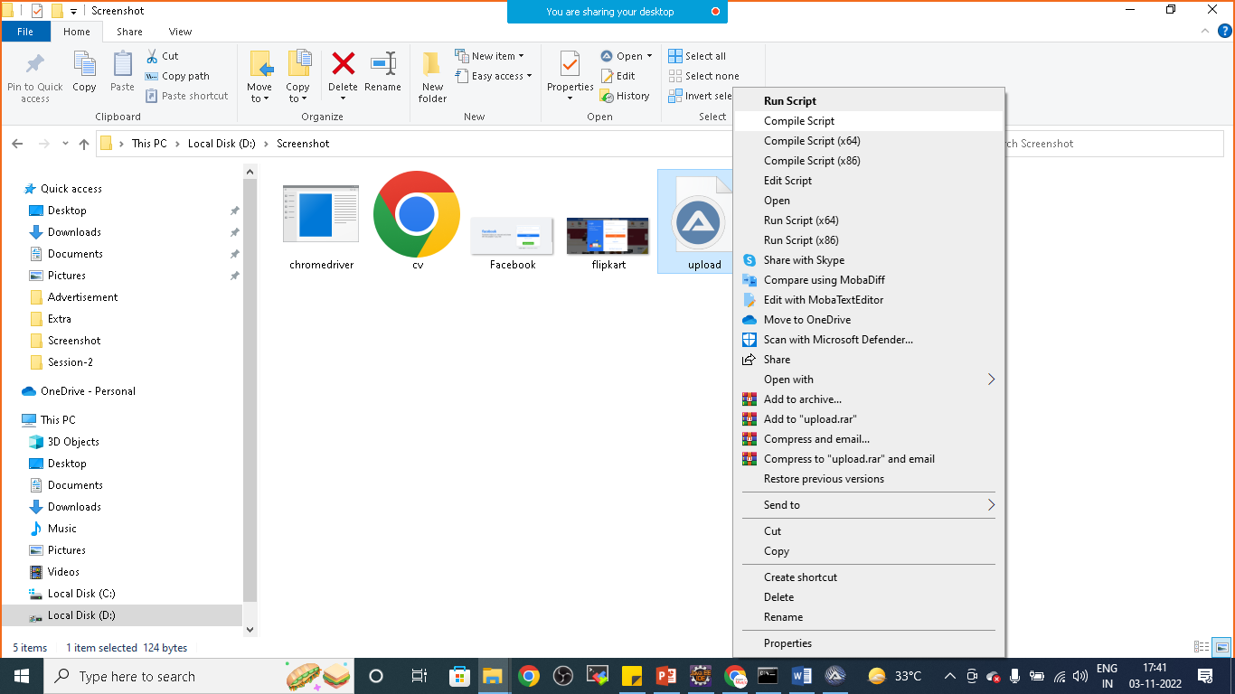

**Once compilation is done upload.exe file is generated**

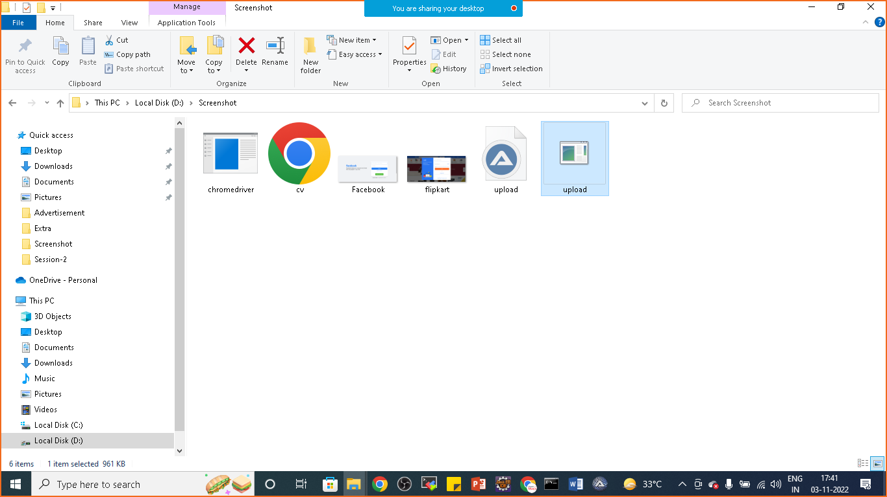

**Now we can write one simple java program to automate this windows gui**

**package** com.simplilearn.demo;

**import** java.io.IOException;

**import** org.openqa.selenium.By;

**import** org.openqa.selenium.JavascriptExecutor;

**import** org.openqa.selenium.WebDriver;

**import** org.openqa.selenium.WebElement;

**import** org.openqa.selenium.chrome.ChromeDriver;

**public** **class** AutoItExample {

**public** **static** **void** main(String[] args) **throws** IOException,InterruptedException {

System.*setProperty*("webdriver.chrome.driver", "D:\\Phase-5\\chromedriver_win32_Nov_new\\chromedriver.exe");

WebDriver driver= **new** ChromeDriver();

driver.get("https://www.shine.com/registration/");

driver.manage().window().maximize();

driver.findElement(By.*id*("id_name")).sendKeys("Nikunj Soni");

WebElement file=driver.findElement(By.*id*("id_file"));

JavascriptExecutor executor=(JavascriptExecutor)driver;

executor.executeScript("arguments[0].click()", file);

Thread.*sleep*(5000);

Runtime.*getRuntime*().exec("D:\\Screenshot\\upload.exe");

}

}

