**Pom.xml** file

<project xmlns="http://maven.apache.org/POM/4.0.0" xmlns:xsi="http://www.w3.org/2001/XMLSchema-instance" xsi:schemaLocation="http://maven.apache.org/POM/4.0.0 http://maven.apache.org/xsd/maven-4.0.0.xsd">

<modelVersion>4.0.0</modelVersion>

<groupId>com.simplileaern.testng</groupId>

<artifactId>TestNgExample</artifactId>

<version>0.0.1-SNAPSHOT</version>

<packaging>jar</packaging>

<name>TestNgExample</name>

<url>http://maven.apache.org</url>

<properties>

<project.build.sourceEncoding>UTF-8</project.build.sourceEncoding>

</properties>

<dependencies>

<dependency>

<groupId>junit</groupId>

<artifactId>junit</artifactId>

<version>3.8.1</version>

<scope>test</scope>

</dependency>

<dependency>

<groupId>org.testng</groupId>

<artifactId>testng</artifactId>

<version>7.5</version>

<scope>test</scope>

</dependency>

<dependency>

<groupId>org.seleniumhq.selenium</groupId>

<artifactId>selenium-java</artifactId>

<version>4.4.0</version>

</dependency>

<!--ReportNg 1.1.4-->

<dependency>

<groupId>org.uncommons</groupId>

<artifactId>reportng</artifactId>

<version>1.1.4</version>

<scope>test</scope>

</dependency>

<!--Velocity-dep 1.4-->

<dependency>

<groupId>velocity</groupId>

<artifactId>velocity-dep</artifactId>

<version>1.4</version>

</dependency>

<!--Guice 3.0-->

<dependency>

<groupId>com.google.inject</groupId>

<artifactId>guice</artifactId>

<version>3.0</version>

</dependency>

</dependencies>

</project>

Now goto>project>right click>properties>testng>

Check the checkbox   
: disable default listner

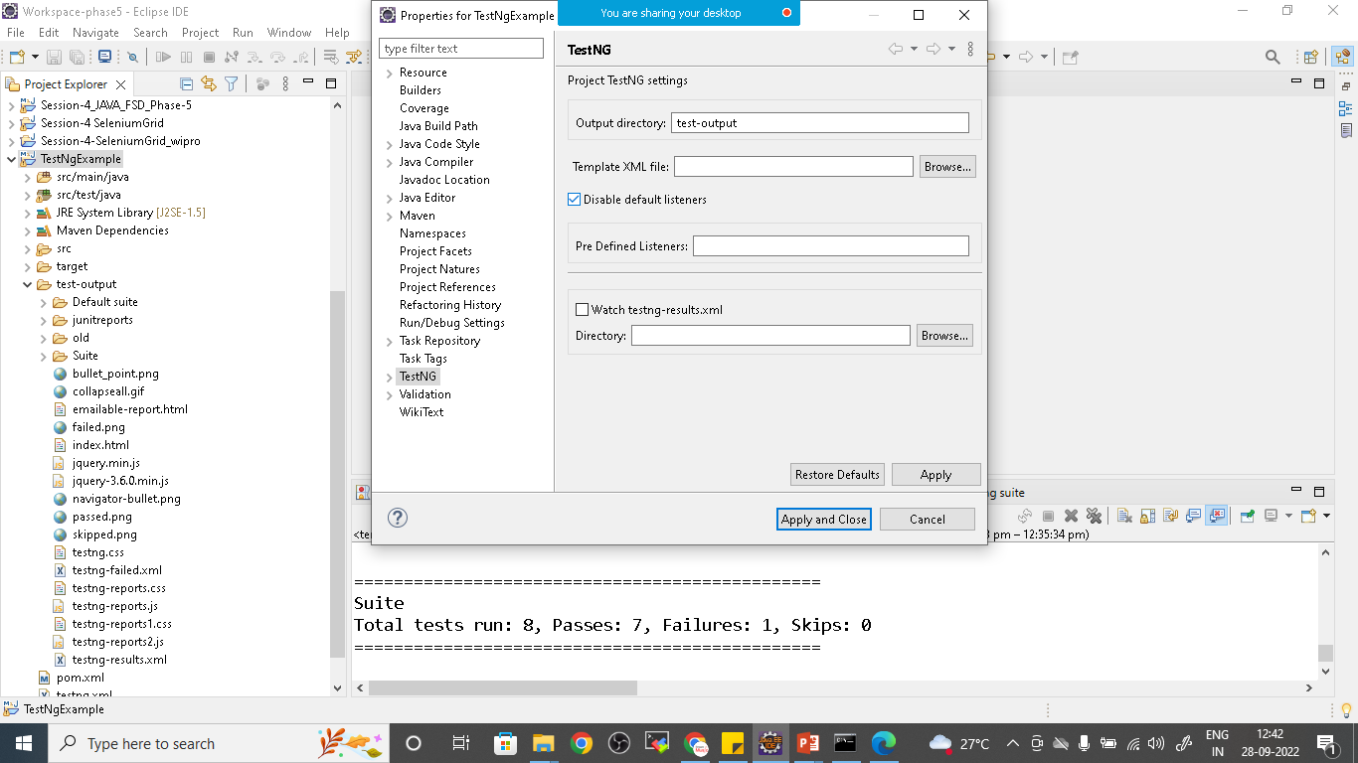

Click on apply and close

Maven update

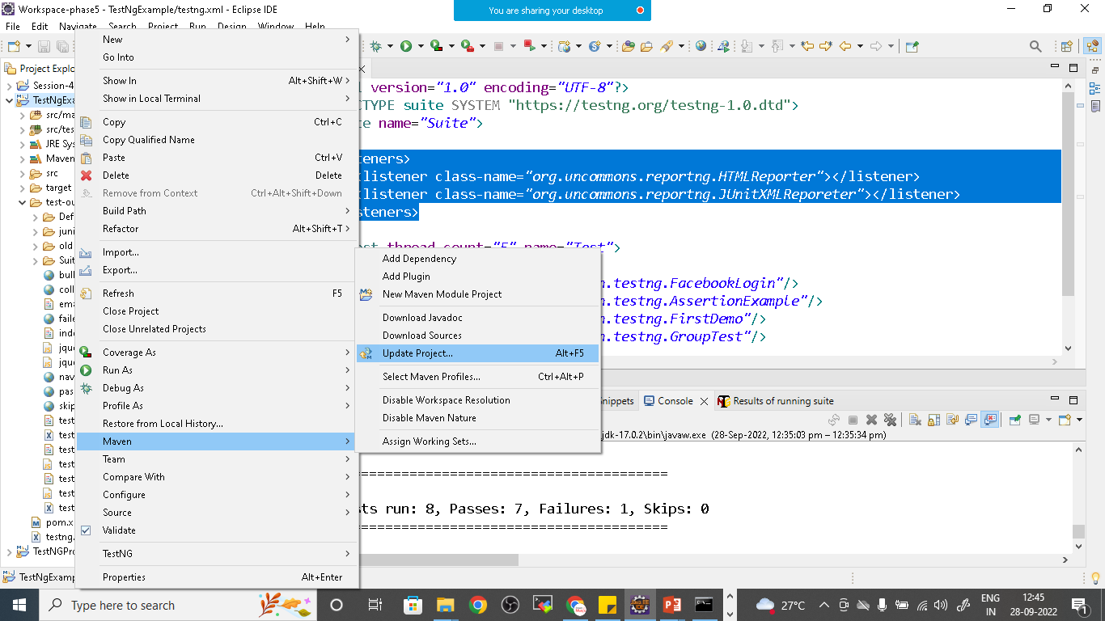

Add Listners to Testng.xml File

<?xml version=*"1.0"* encoding=*"UTF-8"*?>

<!DOCTYPE suite SYSTEM "https://testng.org/testng-1.0.dtd">

<suite name=*"Suite"*>

<listeners>

<listener class-name=*"org.uncommons.reportng.HTMLReporter"*></listener>

<listener class-name=*"org.uncommons.reportng.JUnitXMLReporter"*></listener>

</listeners>

<test thread-count=*"5"* name=*"Test"*>

<classes>

<class name=*"com.testngselenium.demo.NewTest"*/>

<class name=*"com.testngselenium.demo.GroupTest"*/>

<class name=*"com.testngselenium.demo.FirstTest"*/>

<class name=*"com.testngselenium.demo.AssertionTestDemo"*/>

</classes>

</test> <!-- Test -->

</suite> <!-- Suite -->

Right click on it and run as testNg suite

TestNg.Xml

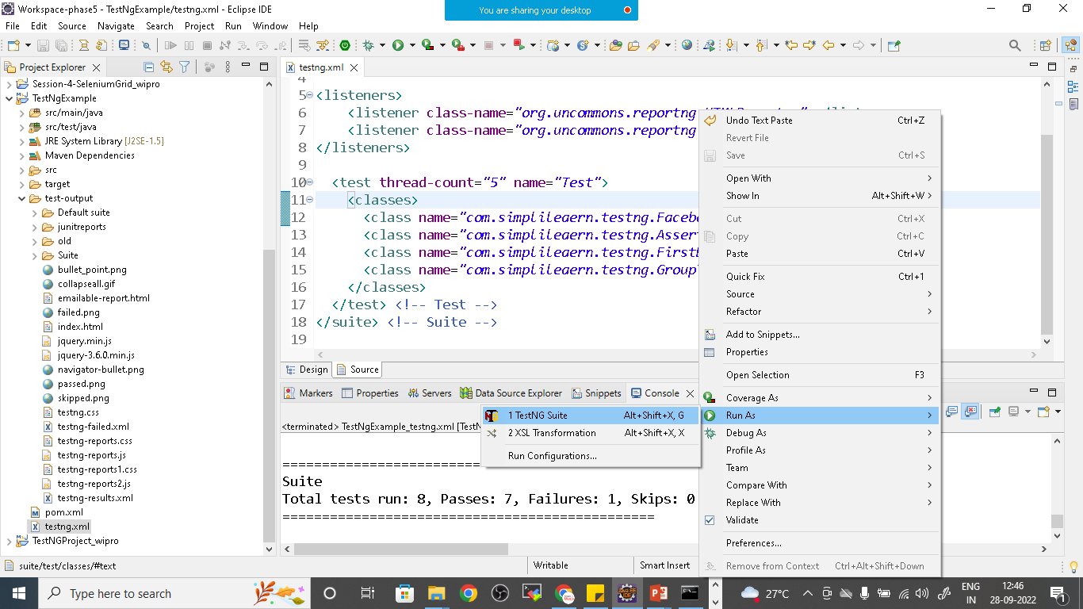

Once all testcases got executed refresh the project and open index.html file from testoutput>html>index.html

