Food Blog - CSS Live Lab 1

### Use Case:

Colors bring life to your website. Choosing appropriate, trendy and in demand colors for client’s website is very important. Depending on the business colors can be bold, jazzy, glittery, professional, smooth etc.

We need to design a website “Awesome Colors- AC” that provides a way for the user to choose from the latest collections of colors and make them aware about what is popular or new and also allow them to add in their collection.

The assignments in this lab are divided in 5 sections starting from easy to difficult level taking you through the process of creating a website for online book store.

NOTE:

Can change the color and styles or can choose your own images

### Lab Name: Assignment 1

### Content Mapping: Selectors - , Selectors – II, Selectors – III, Selectors – IV, Styling Links, Margin and Padding, Widths and Heights

### Learning Pre-requisites:

- Tags: header, span , div

- Should know to use font icons.

- CSS styles like padding, float, margin, padding, colors and fonts

### Env Needed:

VSCode, Google Chrome

### Asset Needed: Font Awesome icons <link rel="stylesheet" href="https://cdnjs.cloudflare.com/ajax/libs/font-awesome/4.7.0/css/font-awesome.min.css">

### Difficulty: Easy

### Duration: 10 Minutes

Input:

- Design the navigation bar as shown in the webpage below.

- Use HTML5 header for the menu bar

- Use font awesome icons for login and collection icons

- Need to add a border below the navigation bar

- Use letter spacing to add space in the letters of Login and Collection

Output:

Index.html

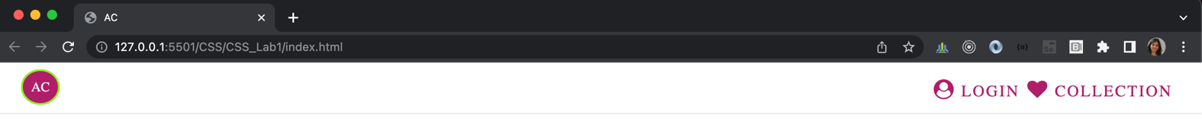

When hovered over the links the color changes

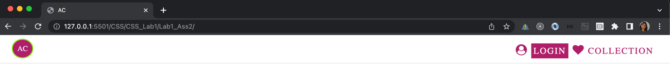

### Lab Name: Assignment 2

### Content Mapping: Selectors - , Selectors – II, Selectors – III, Selectors – IV, Styling Links, Margin and Padding, Widths and Heights, Cursors,

### Learning Pre-requisites:

- Tags: header, span , div

- Should know to use font icons.

- CSS styles like padding, float, margin, padding, colors and fonts, background image linear gradient for line below the menus on the left

### Env Needed:

VSCode, Google Chrome

### Asset Needed: Images

### Difficulty: Easy

### Duration: 10 Minutes

Input:

- Modify the previous webpage for adding styles and sections to the main page.

- Use appropriate line-height, letter-spacing of CSS to design the page

- Use float to divide the page into respective sections as shown below

Output –

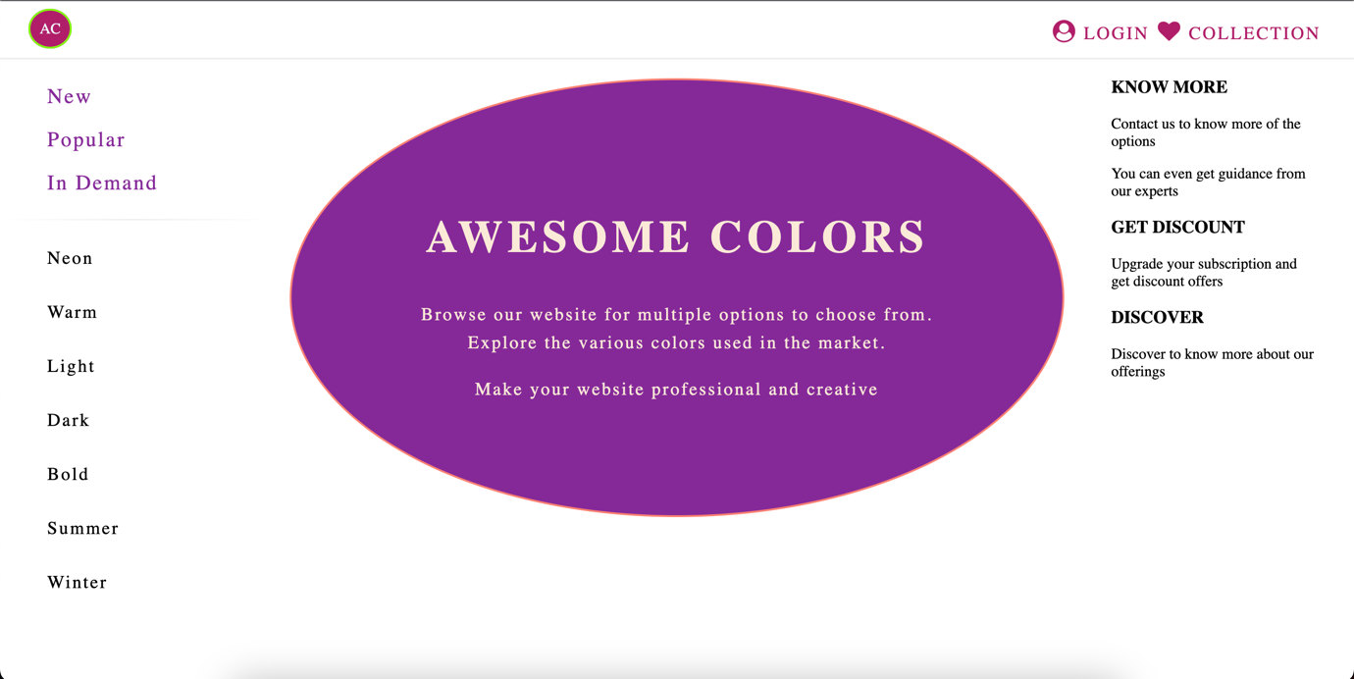

### Lab Name: Assignment 3

### Content Mapping: Selectors - , Selectors – II, Selectors – III, Selectors – IV, Styling Links, Margin and Padding, Widths and Heights, Cursors, Position

### Learning Pre-requisites:

- Tags: header, span , div

- Should know to use font icons.

- CSS styles like padding, float, margin, padding, colors and fonts, background image linear gradient for line below the menus on the left

- Should know to position elements

### Env Needed:

VSCode, Google Chrome

### Asset Needed: Images

### Difficulty: Medium

### Duration: 20 Minutes

Input:

- Modify the previous webpage for adding social media icons.

- These icons will be fixed on the page on the left hand side. Scrolling the page will not move the social media icons.

Output –

Index.html

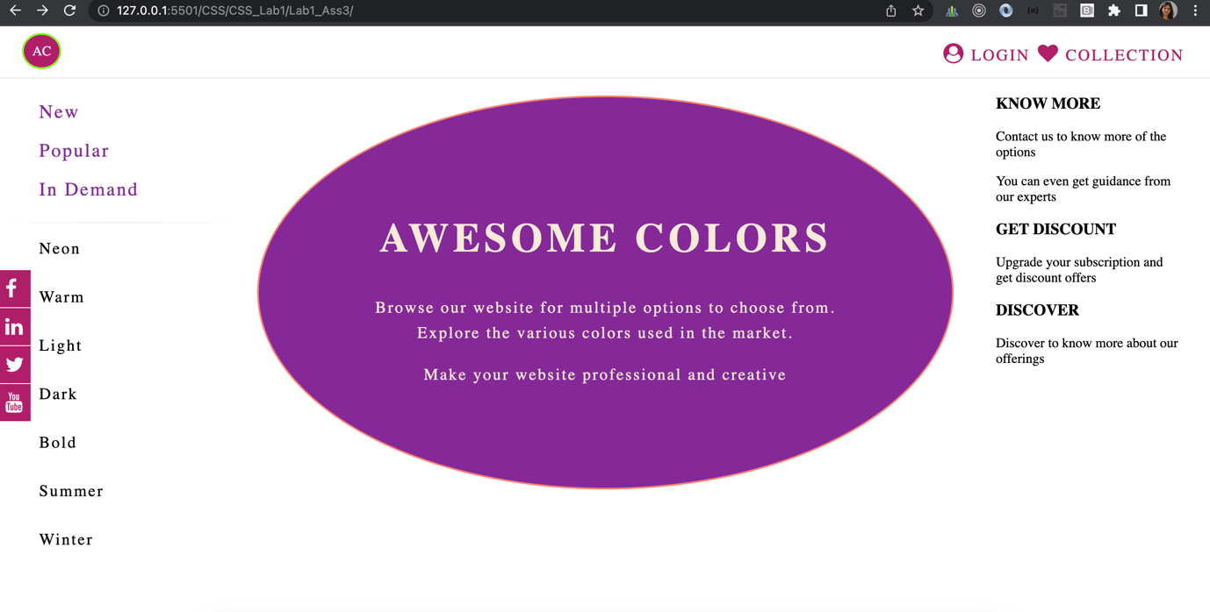

Hovering on the link should change background color and the text color

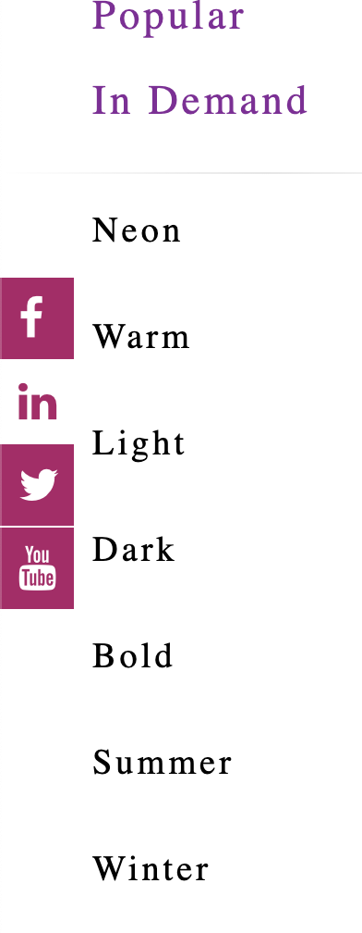

### Lab Name: Assignment 4

### Content Mapping: Selectors - , Selectors – II, Selectors – III, Selectors – IV, Styling Links, Margin and Padding, Widths and Heights, Cursors, Position, Display Types, Hiding an element

### Learning Pre-requisites:

- Tags: header, span , div

- Should know to use font icons.

- CSS styles like padding, float, margin, padding, colors and fonts, display and opacity

- Should know to position elements

### Env Needed:

VSCode, Google Chrome

### Asset Needed: Images

### Difficulty: Medium

### Duration: 20 Minutes

Input:

- Modify the previous index page and add blocks as shown below in the image

Output –

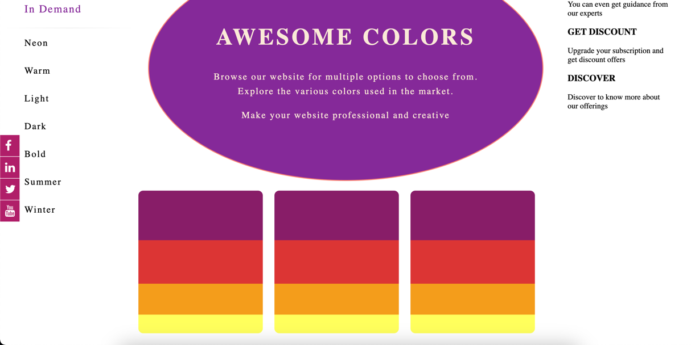

When hovered on any colored div , should display the color code for the same

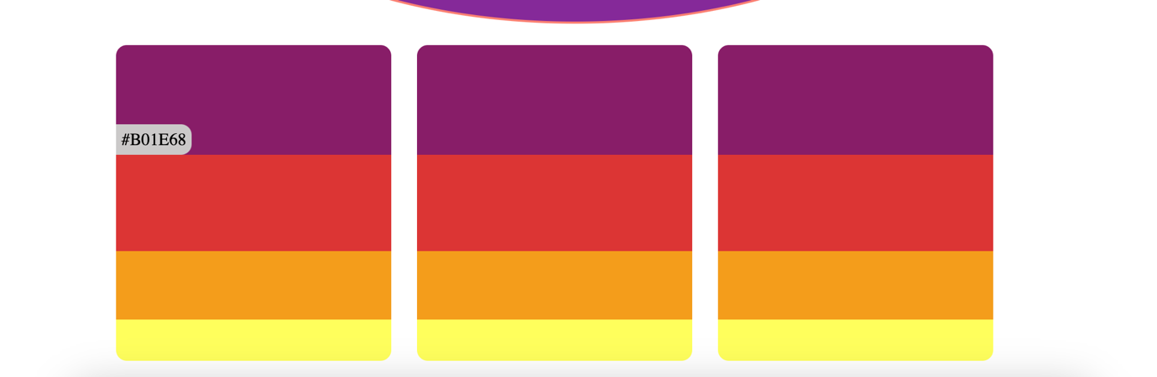

### Lab Name: Assignment 5

### Content Mapping: Selectors - , Selectors – II, Selectors – III, Selectors – IV, Styling Links, Margin and Padding, Widths and Heights, Cursors, Position, Display Types, Hiding an element, Z-Index

### Learning Pre-requisites:

- Tags: header, span , div

- Should know to use font icons.

- CSS styles like padding, float, margin, padding, colors and fonts, display and opacity, text-indent

- Should know to position elements and use z-index

### Env Needed:

VSCode , Google Chrome

### Asset Needed: Images

### Difficulty: Difficult

### Duration: 30 Minutes

Input:

- Add one more page collection.html. Add search bar in the header with search icon within the text box. Search bar should have following functionalities:

- When text box is focussed, the search icon should be removed

- User should be able to type text .

- The text though should not start from the border of text box. There should be some space between border and text

- When the textbox is focussed should add a border

- Add the content in collection.html as shown in the image below. The heart is fa-heart-o icon and z-index should be used to move it back of the heading text.

Output –

Collection.html search bar in header

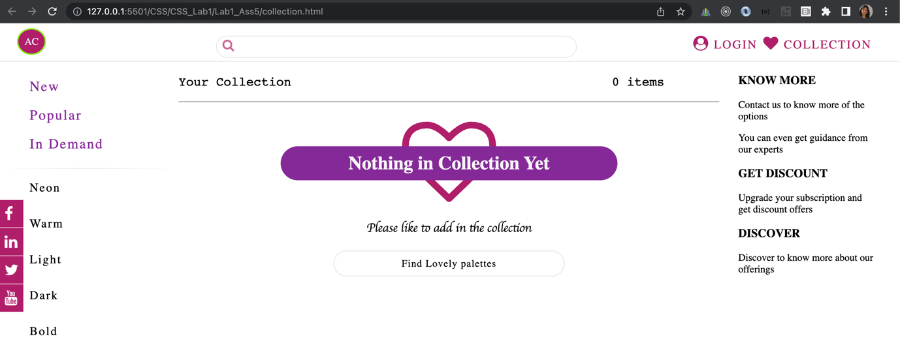

When search bar has focus, add border, icon should be removed and there should be indentation between border of textbox and text typed in

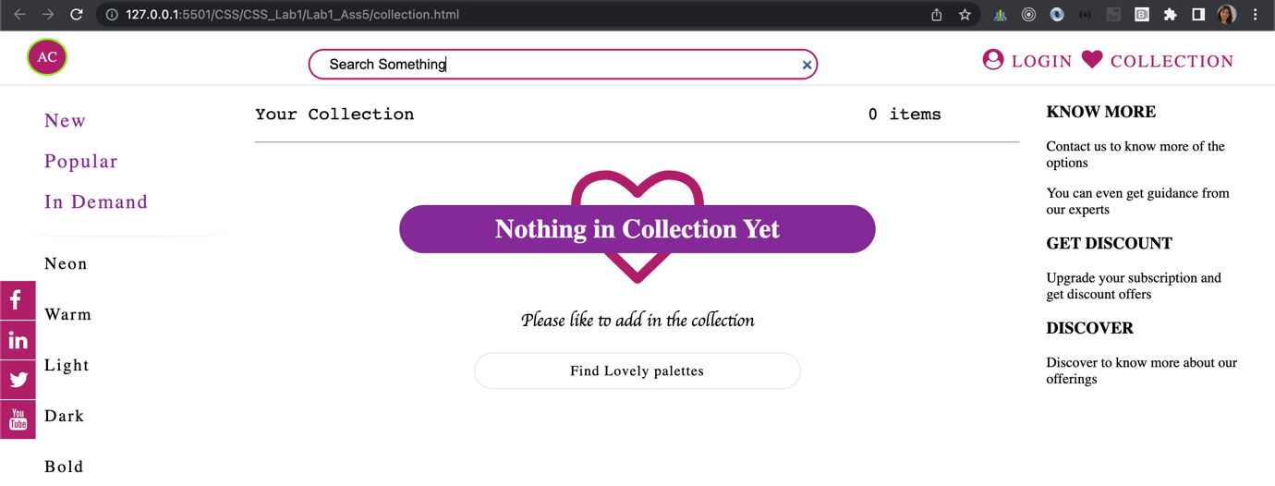

Collection.html center part of page and when hovered on “Find Lovely Palettes” background color should change

