Goto> app> rightclick on it and create new file

**ChangeColorDirective.ts**

import { Directive, ElementRef } from "@angular/core";

@Directive({

    selector:'[changeColor]'

})

export class ChangeColorDirective{

    constructor(er:ElementRef){

        er.nativeElement.style.color="green";

    }

}

Register created directive in **app.module.ts** in the list of Declaration

import { NgModule } from '@angular/core';

import { FormsModule, ReactiveFormsModule } from '@angular/forms';

import { BrowserModule } from '@angular/platform-browser';

import { AppRoutingModule } from './app-routing.module';

import { AppComponent } from './app.component';

import { RegisterComponent } from './register/register.component';

import { UserService } from './user.service';

import { DirectivesComponent } from './directives/directives.component';

import { ChangeColorDirective } from './ChangeColorDirective';

@NgModule({

  declarations: [

    AppComponent,

    RegisterComponent,

    DirectivesComponent,

    ChangeColorDirective

  ],

  imports: [

    BrowserModule,

    AppRoutingModule,

    ReactiveFormsModule,

    FormsModule

  ],

  providers: [UserService],//registering service

  bootstrap: [AppComponent]

})

export class AppModule { }

goto> **directive.component.html** or any component that you want to change the color

<h1>Change Color Directive Demo</h1>

<h2 changeColor>Hello World</h2>

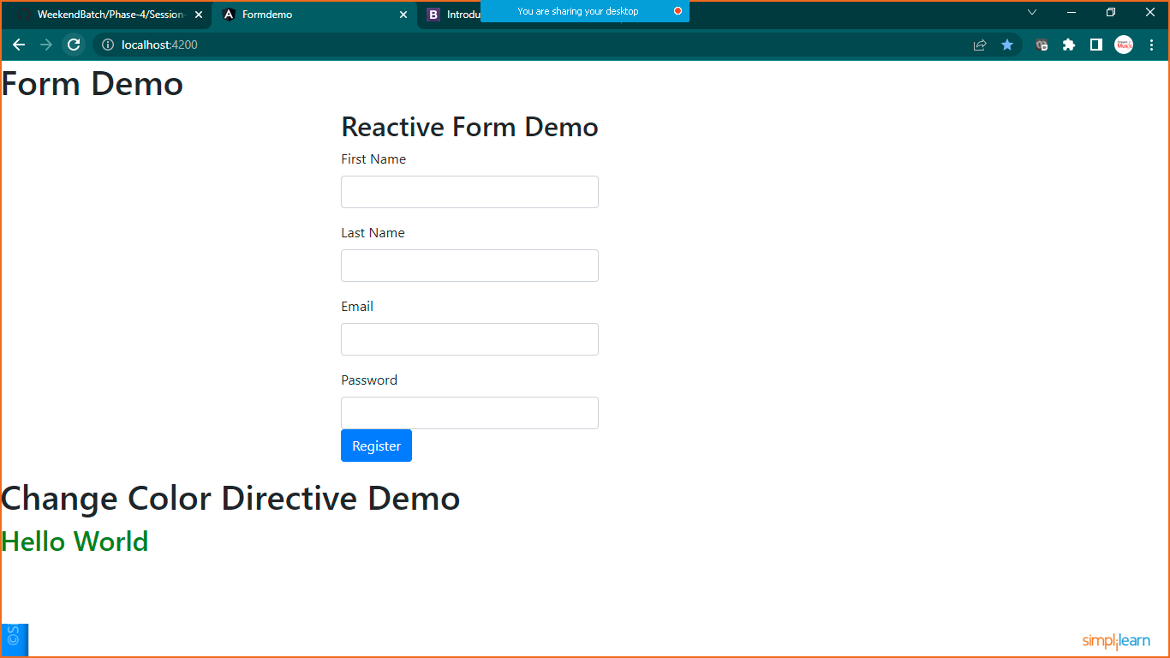

Another way using **Renderer and Element Reference**

**Create another file name**

**HighlightDirectives.ts**

import { Directive, ElementRef, Renderer2 } from "@angular/core";

@Directive({selector:'[highlight]'})

export class HighlightDirective{

    constructor(er:ElementRef,render:Renderer2){

        render.setStyle(er.nativeElement,'background-color','chocolate')

    }

}

**Register this in app.module.ts**

import { NgModule } from '@angular/core';

import { FormsModule, ReactiveFormsModule } from '@angular/forms';

import { BrowserModule } from '@angular/platform-browser';

import { AppRoutingModule } from './app-routing.module';

import { AppComponent } from './app.component';

import { RegisterComponent } from './register/register.component';

import { UserService } from './user.service';

import { DirectivesComponent } from './directives/directives.component';

import { ChangeColorDirective } from './ChangeColorDirective';

import { HighlightDirective } from './HighlightDirective';

@NgModule({

  declarations: [

    AppComponent,

    RegisterComponent,

    DirectivesComponent,

    ChangeColorDirective,

    HighlightDirective

  ],

  imports: [

    BrowserModule,

    AppRoutingModule,

    ReactiveFormsModule,

    FormsModule

  ],

  providers: [UserService],//registering service

  bootstrap: [AppComponent]

})

export class AppModule { }

**use it in any component**

**goto> directive.component.html**

<h1>Change Color Directive Demo</h1>

<h2 changeColor>Hello World</h2>

<h1>Highlight Directive Demo</h1>

<h2 highlight>Hello World</h2>