Let’s get started with service

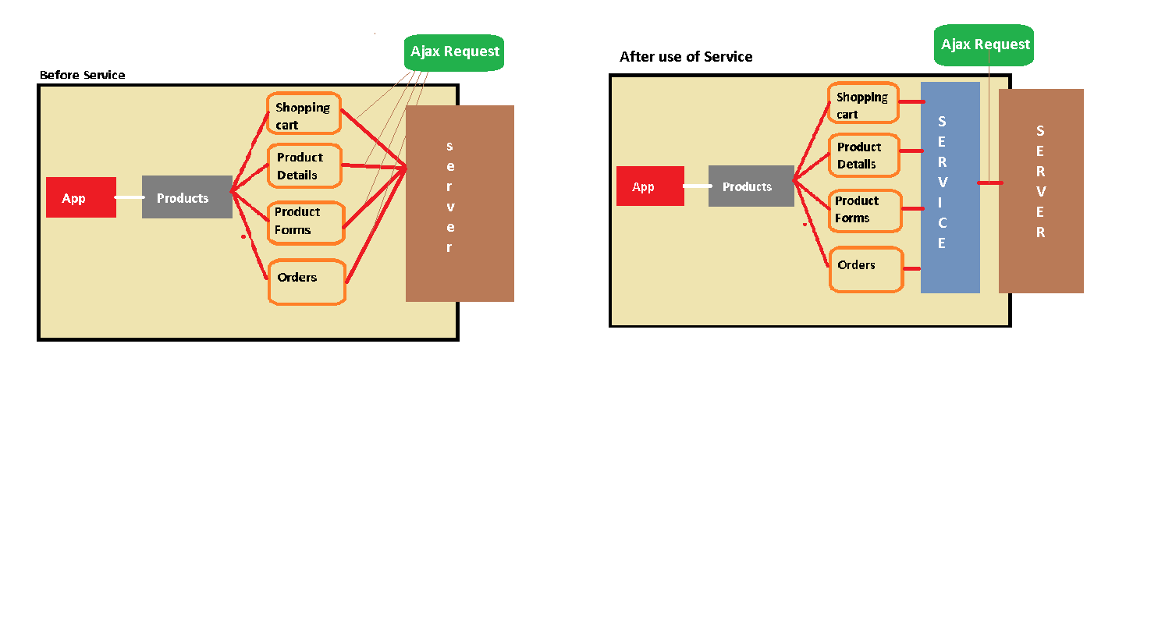

**To generate service**

* ng g s user

**it will provides us two file**

1. user.service.ts
2. user.service.spec.ts

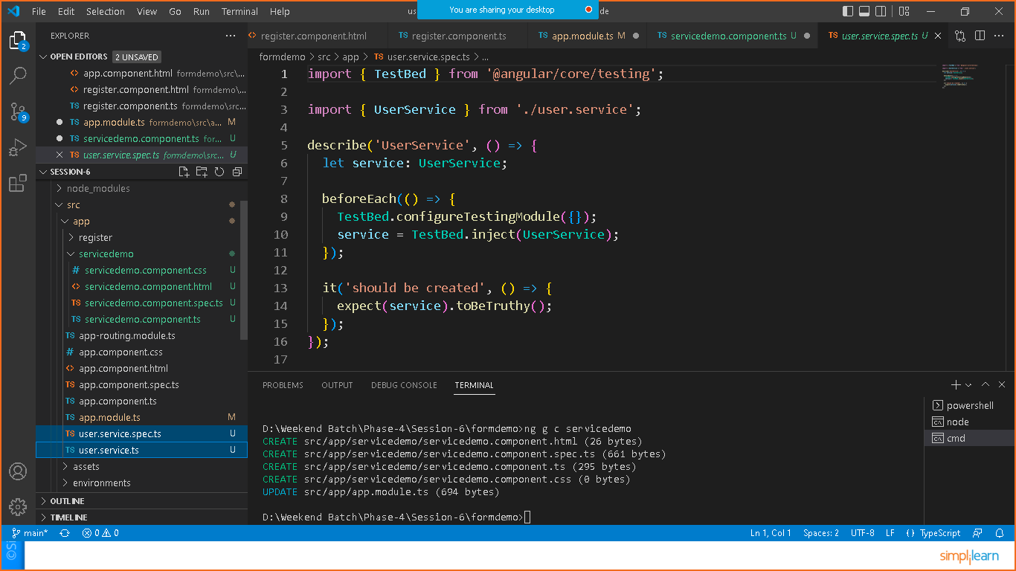

Now register the service in **app.module .ts**

import { NgModule } from '@angular/core';

import { FormsModule, ReactiveFormsModule } from '@angular/forms';

import { BrowserModule } from '@angular/platform-browser';

import { AppRoutingModule } from './app-routing.module';

import { AppComponent } from './app.component';

import { RegisterComponent } from './register/register.component';

import { UserService } from './user.service';

@NgModule({

  declarations: [

    AppComponent,

    RegisterComponent

  ],

  imports: [

    BrowserModule,

    AppRoutingModule,

    ReactiveFormsModule,

    FormsModule

  ],

  providers: [UserService],//registering service

  bootstrap: [AppComponent]

})

export class AppModule { }

**now we can inject the service in any component that you had already prepared at the beginning of the app or generate new component**

* ng g c servicedemo

now got to **servicedemo.component.ts** and add the below code

import { Component, OnInit } from '@angular/core';

import { UserService } from '../user.service';

@Component({

  selector: 'app-servicedemo',

  templateUrl: './servicedemo.component.html',

  styleUrls: ['./servicedemo.component.css']

})

export class ServicedemoComponent implements OnInit {

  //DI of service

  constructor(private service:UserService) { }

  ngOnInit(): void {

  }

}