Pipes in ANGULAR

There are two types of pipes are available with angular

1. INBUILT PIPES
2. CUSTOM PIPES
3. INBUILT PIPES

Prepare new app

* ng new pipapp
* ng g c pipe-demo

**goto> pipe-demo.component.ts** file and copy the selector tag and add to **App.component.html**

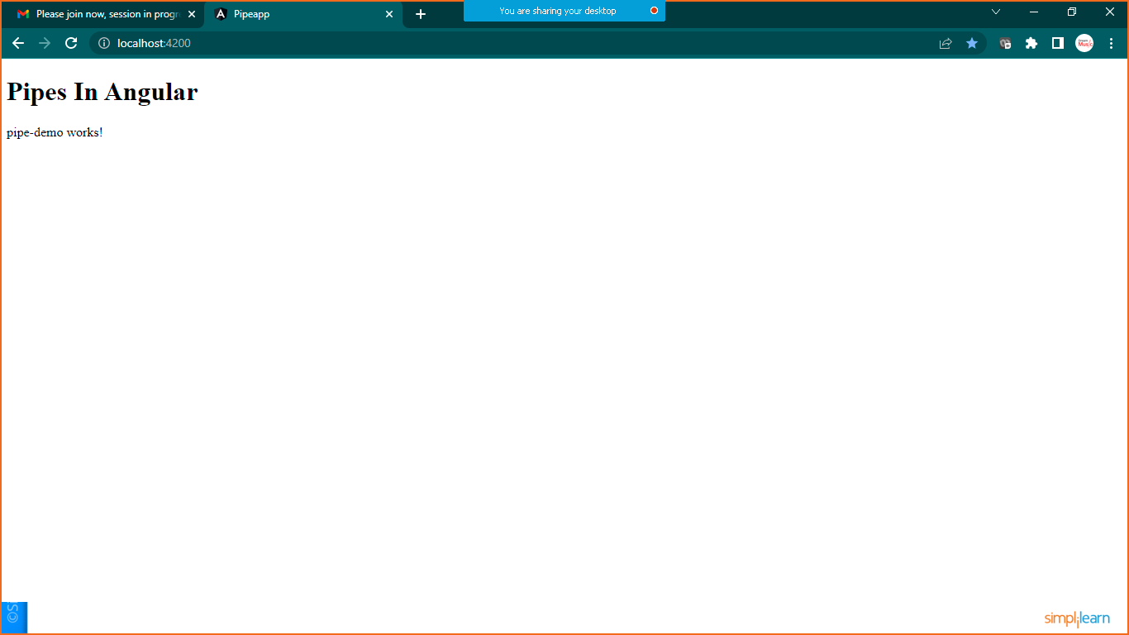

Now goto > **pipe-demo.component.ts** file and add below code

import { Component, OnInit } from '@angular/core';

@Component({

  selector: 'app-pipe-demo',

  templateUrl: './pipe-demo.component.html',

  styleUrls: ['./pipe-demo.component.css']

})

export class PipeDemoComponent implements OnInit {

  constructor() { }

  ngOnInit(): void {

  }

  name:string="My Name is Nikunj And i am a JAVA FSD Trainer";

  pi:number=3.1415927;

  a=0.12345;

  b=9876.5432;

  today=new Date();

  object={name:"nikunj",email:"nikunj@gamil.com",address:"mumbai"};

}

Goto>**pipe-demo.component.html** file

<h1>Inbuilt-Pipe Demo</h1>

<hr>

<h2>Inbuilt-Pipes</h2>

<hr>

<p><b>UPPERCASE DEMO: </b> {{name | uppercase}}</p>

<p><b>Lowercase Demo: </b>{{name | lowercase}}</p>

<hr>

<h2>Number Pipes</h2>

<hr>

<p><b>pi:</b> {{pi | number :'5.5-5'}}</p>

<p><b>pi:</b> {{pi | number :'.3-3'}}</p>

<p><b>pi:</b> {{pi | number :'.10-10'}}</p>

<hr>

<h2>Currency Pipe</h2>

<hr>

<p><b>USD</b> {{ a | currency : 'USD':true:'3.3-3'}}  </p>

<p><b>USD</b> {{ a | currency : 'USD':false:'3.3-3'}}  </p>

<p><b>EURO</b> {{ a | currency : 'EURO':false}}  </p>

<p><b>INR</b> {{ a | currency : 'INR':true:'5.4-4'}}  </p>

<hr>

<h2>Date pipes</h2>

<hr>

<p><b>Today is : </b> {{today}}</p>

<p><b>Today is : </b> {{today | date}}</p>

<p><b>Today is : </b> {{today | date :'dd/MM/yyyy'}}</p>

<hr>

<h2>JSON Pipe Demo</h2>

<hr>

<p><b>Without JSON Pipe</b> {{object}}</p>

<p><b>With JSON Pipe</b> {{object | json}}</p>

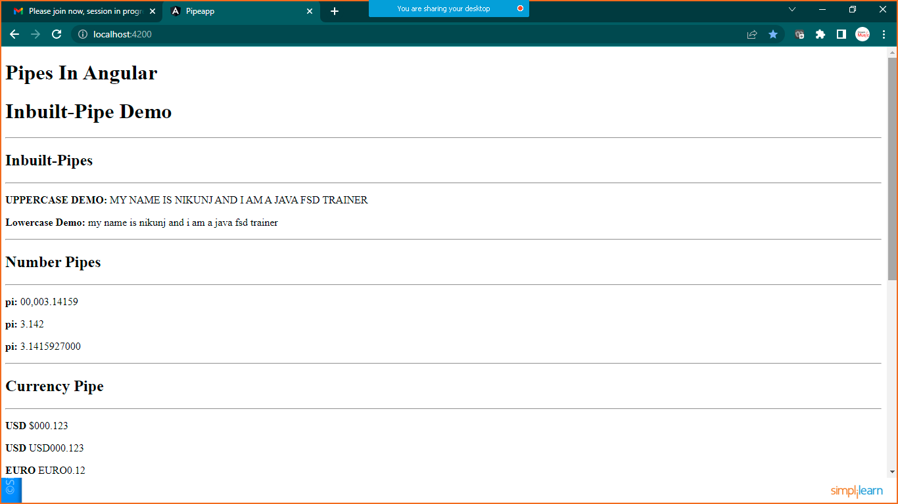

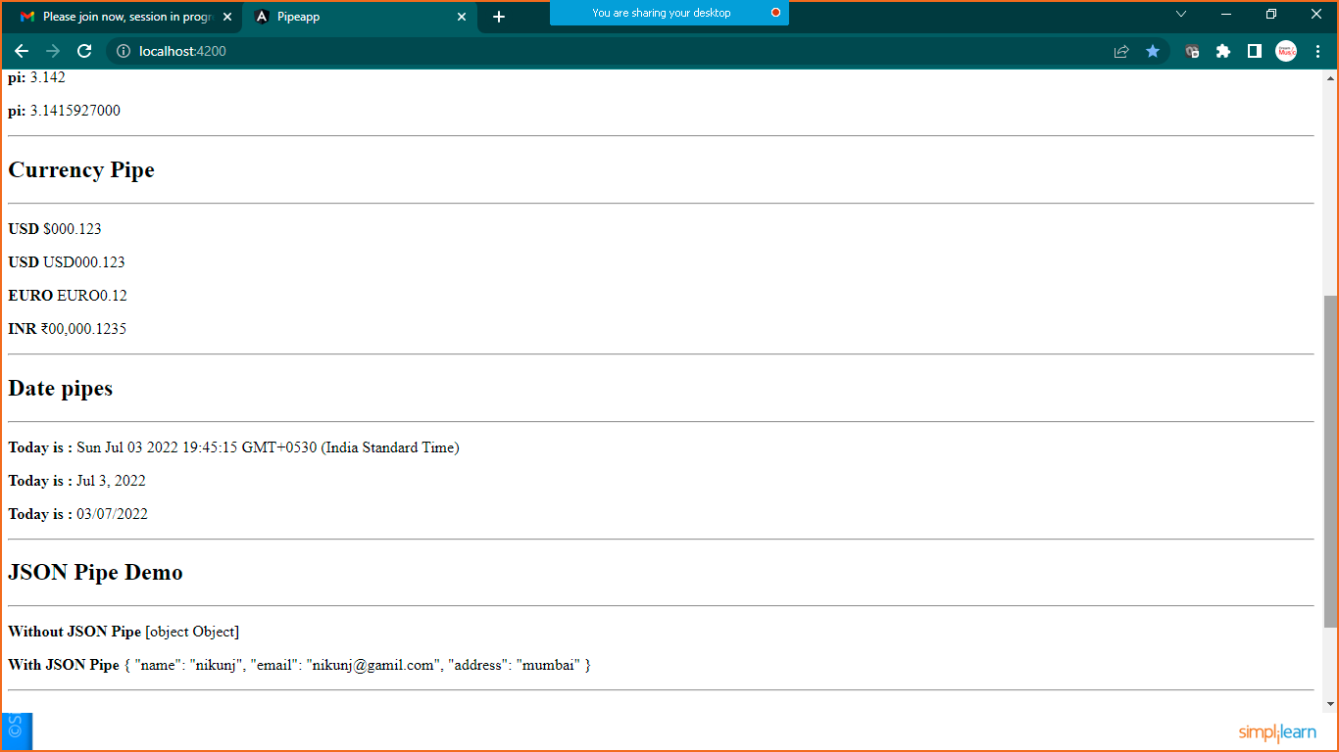

1. CUSTOM PIPES

Goto> **pipe-demo.component.ts** and add the below code

import { Component, OnInit } from '@angular/core';

@Component({

  selector: 'app-pipe-demo',

  templateUrl: './pipe-demo.component.html',

  styleUrls: ['./pipe-demo.component.css']

})

export class PipeDemoComponent implements OnInit {

  constructor() { }

  ngOnInit(): void {

  }

  name:string="My Name is Nikunj And i am a JAVA FSD Trainer";

  pi:number=3.1415927;

  a=0.12345;

  b=9876.5432;

  today=new Date();

  object={name:"nikunj",email:"nikunj@gamil.com",address:"mumbai"};

  //custome pipes

  cust:string ="Welcome to the Wolrd of CustomPipes"

}

Now we need to prepare one new file with name **CustomePipe.ts**

import { Pipe, PipeTransform } from "@angular/core";

@Pipe({name:'changeString'})

export class CustomPipe implements PipeTransform{

    transform(value: string,character:string) {

        return value.split(character).join("-")

    }

}

Now register this file into **app.module.ts** file

import { NgModule } from '@angular/core';

import { BrowserModule } from '@angular/platform-browser';

import { AppRoutingModule } from './app-routing.module';

import { AppComponent } from './app.component';

import { CustomPipe } from './custompipe';

import { PipeDemoComponent } from './pipe-demo/pipe-demo.component';

@NgModule({

  declarations: [

    AppComponent,

    PipeDemoComponent,

    CustomPipe

  ],

  imports: [

    BrowserModule,

    AppRoutingModule

  ],

  providers: [],

  bootstrap: [AppComponent]

})

export class AppModule { }

now we are ready to use Custom pipe in **pipe-demo.component.html** file

<hr>

<h1>Custom Pipe Demo</h1>

<p><b>Custom Pipe:</b> {{ cust | changeString:' ' }}</p>

<p><b>Inbuilt & Custom Pipe:</b> {{ cust | uppercase | changeString:' ' }}</p>

<hr>

Save it and check the output

