Step 1 : Create a New Folder in Documents [ Name of the document should be your full Roll No ]
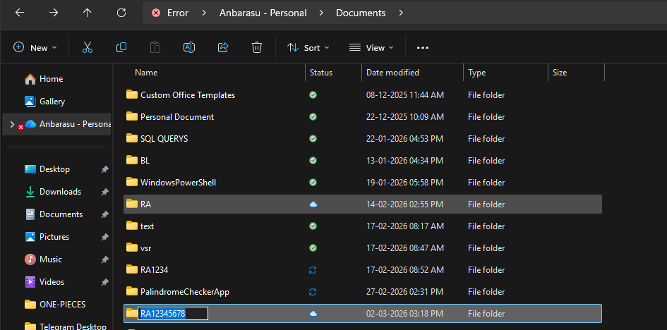

Step 2 : Create a Git Hub Repository with Name : TrainApp
Enable the Readme file [Mandatory]
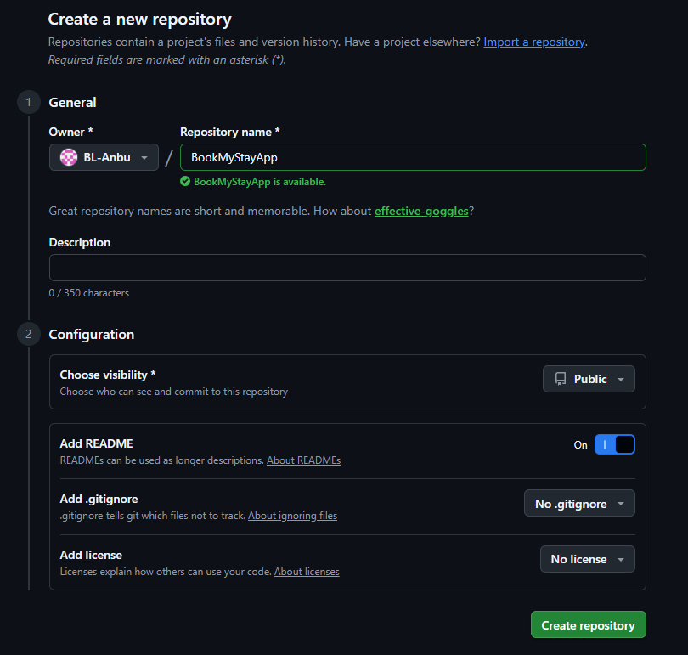
Step 3 : Click on CODE & Copy the github HTTPS Link
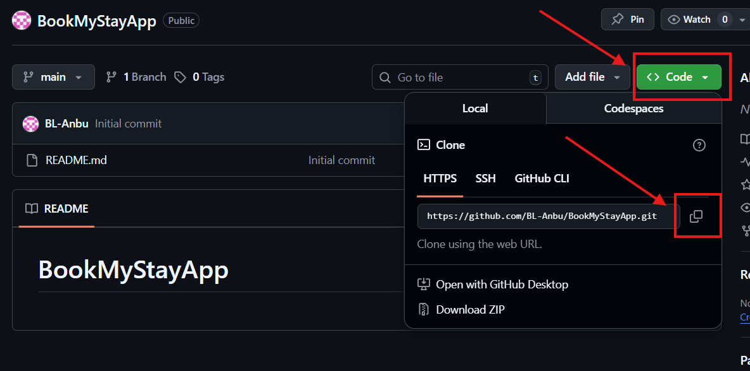

Step 4 : Open the Folder Location inside Right Click and Select Open in Terminal

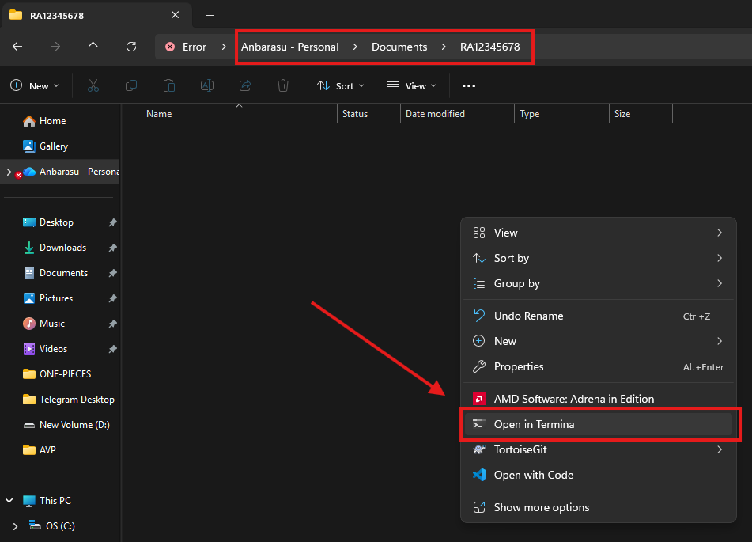

Step 5: Clone your Repository
Cmd: git clone REPOSITORY LINK YOU COPIED
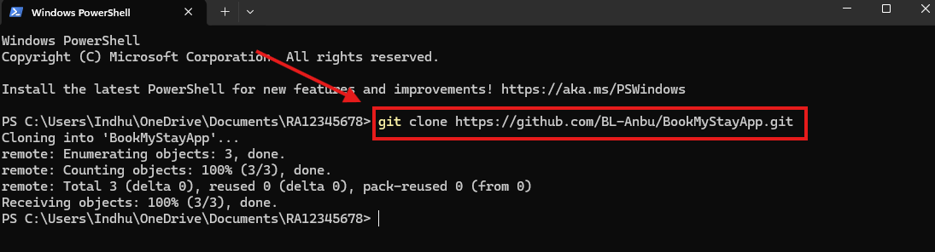

Step 6: If Existing Project Opened in IntellIj , Close that Project
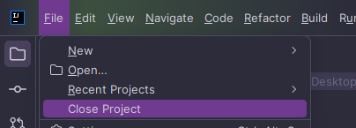

Step 7 : Click on Open Project
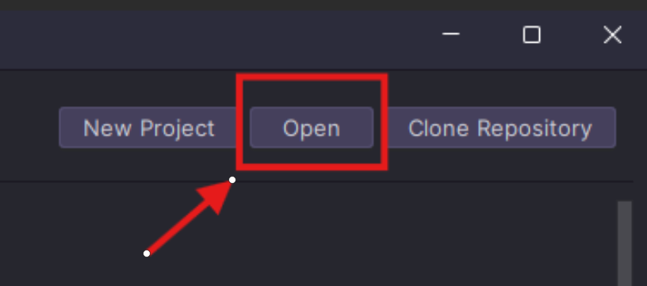

Step 8 : Open the Folder that Contains Name TrainApp & Click Select Folder
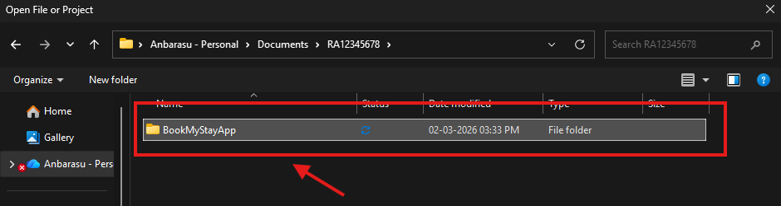
Step 9 : Create a New Module with the Name App, Uncheck the Add Sample Code and click Create.
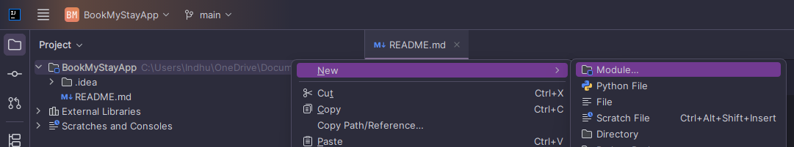
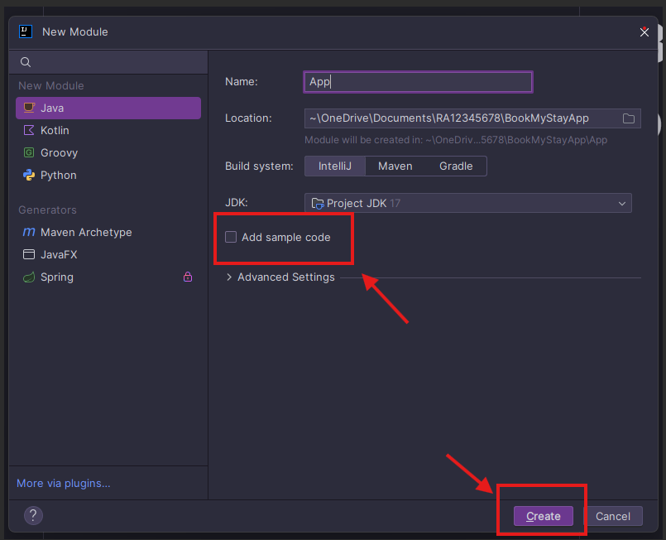
Step 10 : Create a New Java Class Inside the Src
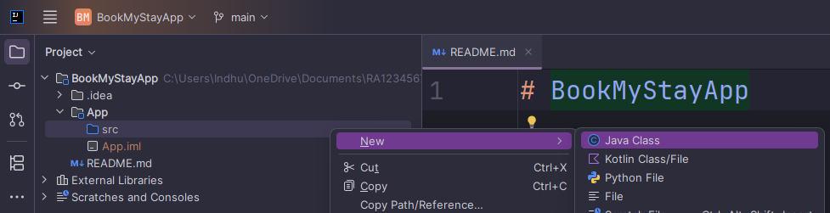
Name of the Java class Should be TrainApp
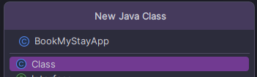
Click Cancel for this Box
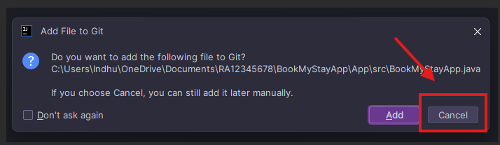

Step 11 : Create a new Branch dev
Cmd : git checkout -b dev
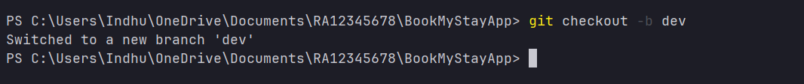

Step 12 : Do a Empty Push from dev branch
Cmd : git push origin dev
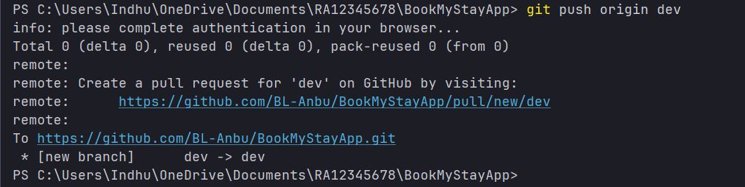

Step 13 : Create a new Branch feature/UC1-WelcomePage from dev branch
Cmd : git checkout -b feature/UC1-WelcomePage

Step 14 : Write your usecase logic inside BookMyStayApp.java class

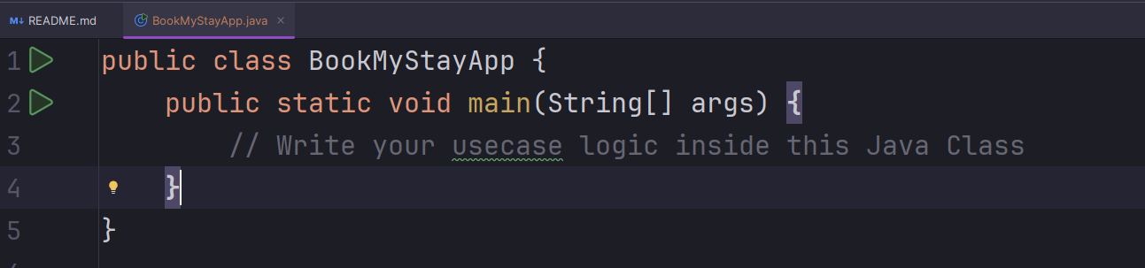

Step 15 : Add your code to git
Cmd : git add .

Step 16 : Commit your code to git.
Cmd : git commit -m "[your name] Added [branch name]"
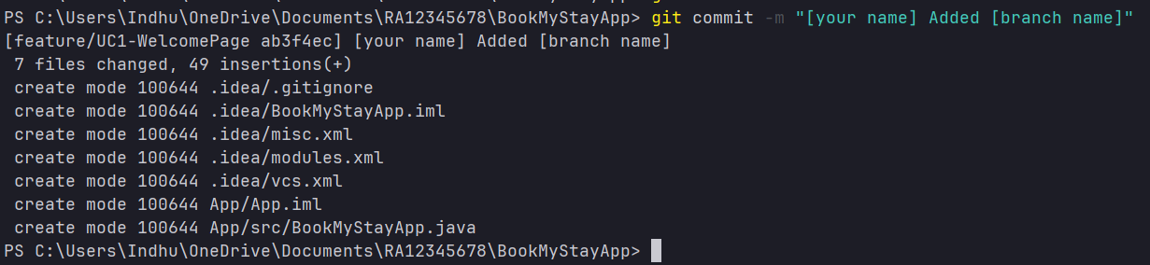

Step 17 : Push your code to github.
Cmd : git push origin feature/UC1-WelcomePage
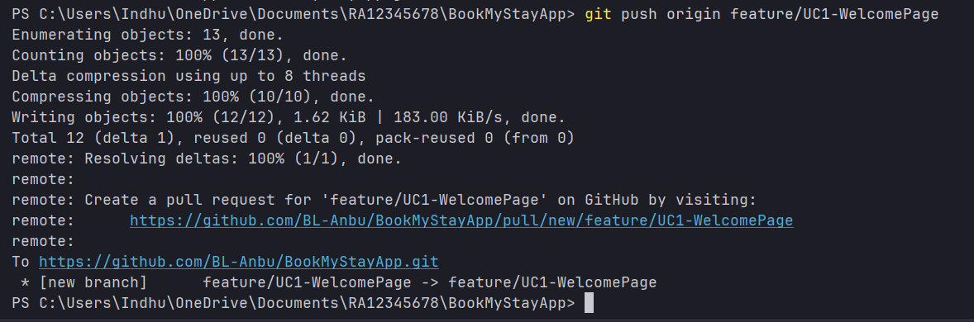

Step 18 : Go to your GitHub Repository In Browser and click Compare & Pull Request
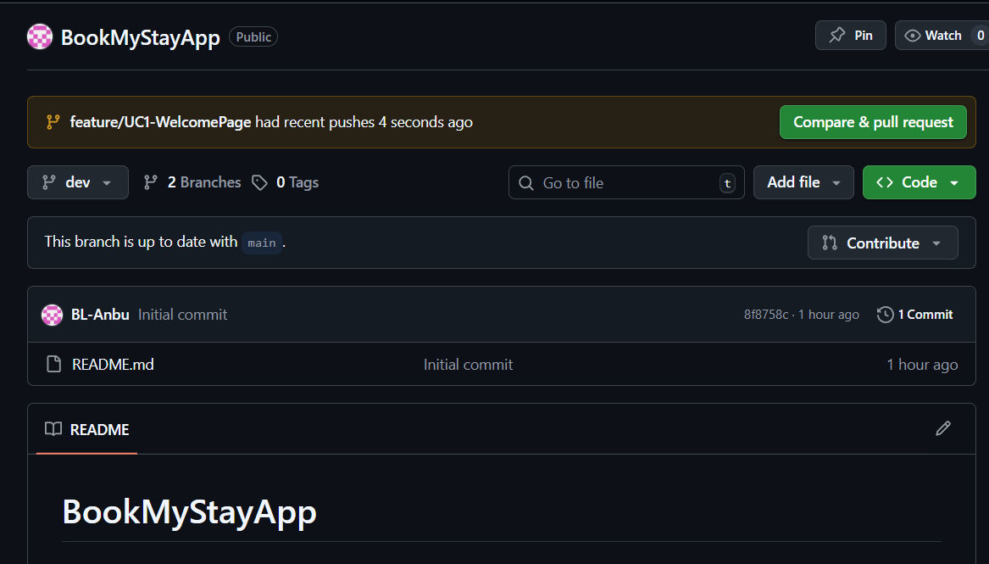

Step 19 : Change base branch from main to dev ( important )
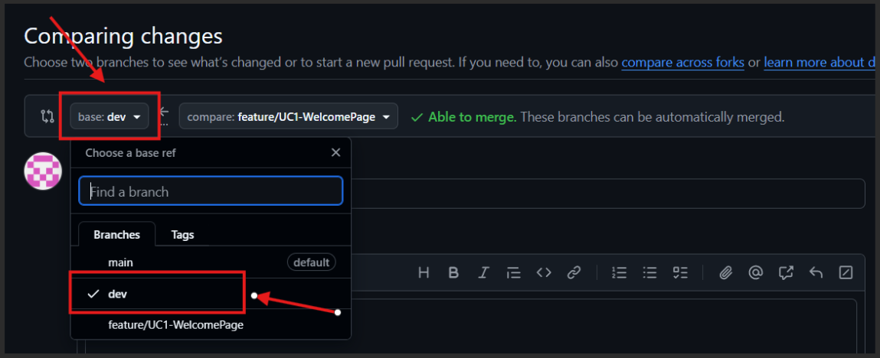
And click create pull request , Merge Pull Request , Confirm Merge.

Step 20 : Click on the Repository Name [ BookMyStayApp ]
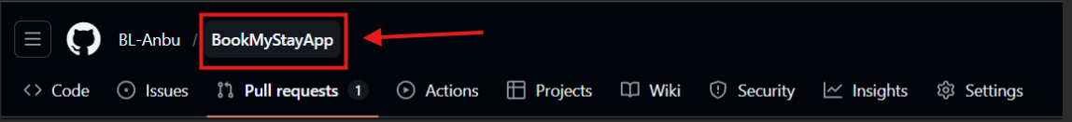

Step 21 : Don’t Merge Any Code from dev branch to main
If You see Pull request from dev branch don’t click compare & pull request.
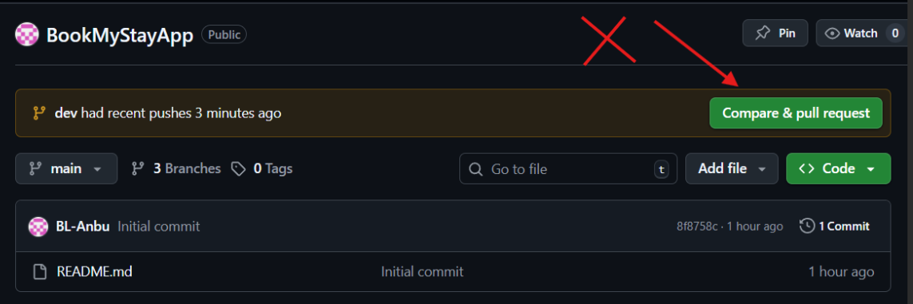

Step 22 : Switch to dev branch
Cmd : git checkout dev

Step 23 : Pull the latest code from git
Cmd : git pull origin dev
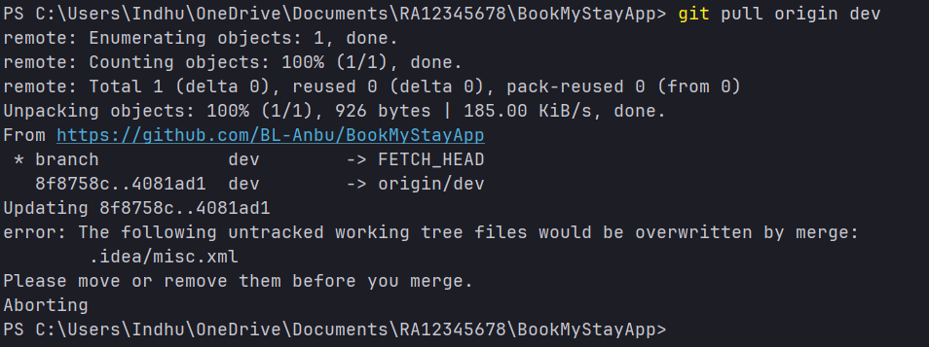

These are the complete step to finish UC1 follow these steps to complete all the usecases.

