TO,
{{client_name}},
{{client_number}}
{{client_address}}
Vendor Details:
{{vendor_name}}
{{vendor_phone}}

REF– {{ref_no}}
Subject: - PROPOSAL FOR {{kw}} kW NDCR. ROOF-TOP SOLAR PV PLANT
DATE – {{date}}
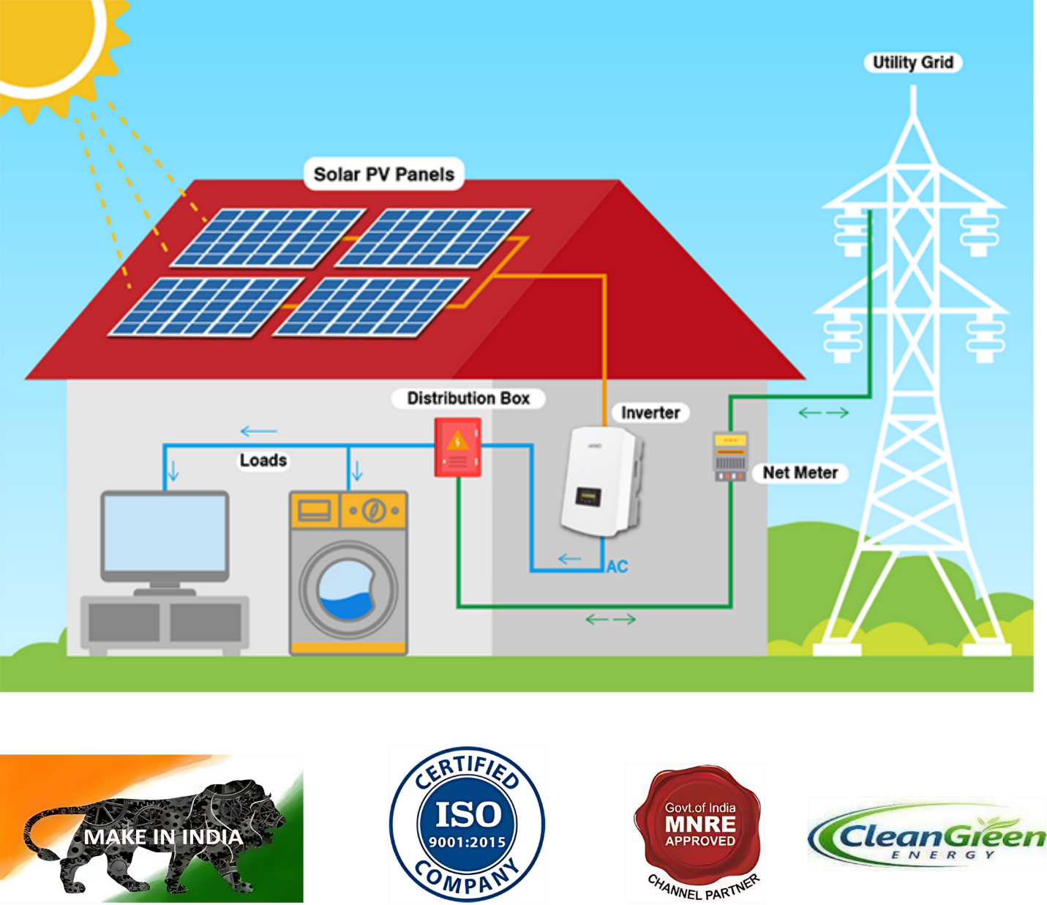
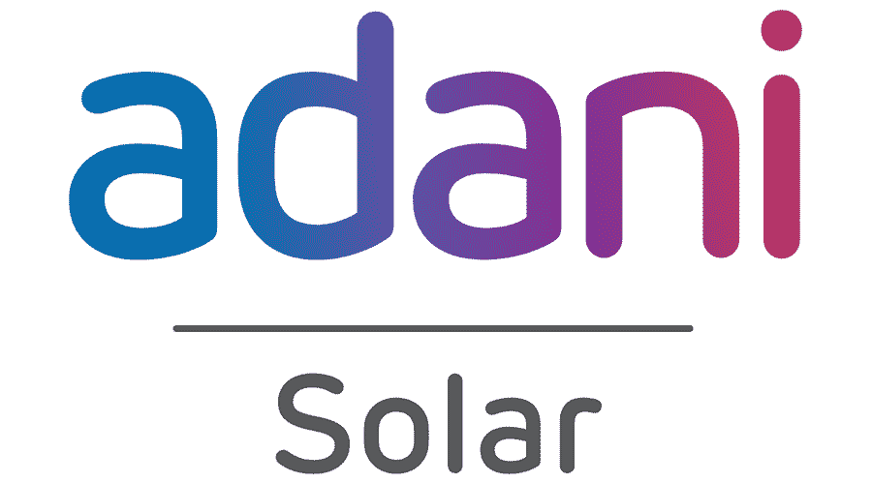



S. No. | Component | Specifications | Company | Warranty (In Years) | Qty.
1 | PV Modules | {{spec_1}} | {{company_1}} | 25 | {{qty_1}}
2 | Grid-Tie Inverter | Capacity of {{kw}} kW | {{company_2}} | 10 | {{qty_2}}
3 | Structure | {{spec_3}} | {{company_3}} | 10 | As Required
4 | Meter | {{spec_4}} | {{company_4}} | 1 | {{qty_4}}
5 | DC Wire | {{spec_5}} | {{company_5}} | 2 | As Required
6 | AC Wire | {{spec_6}} | {{company_6}} | 2 | As Required
7 | Earthing Wire | {{spec_7}} | {{company_7}} | N/A | As Required
8 | Earthing Material | {{spec_8}} | {{company_8}} | 5 | 1 Set
9 | Lighting Arrestor | {{spec_9}} | {{company_9}} | N/A | 1 No.
10 | Fitting Accessories | {{spec_10}} | {{company_10}} | N/A | As Required
11 | ACDB / DCDB / MCB Box / Busbar / Panel Box | {{spec_11}} | {{company_11}} | As Per Standard | 1 Set

Description of Materials: -

- Quotation will be valid for up to 7 days.
- Products once sold are not eligible for return or exchange.
- Cost of superstructure will be extra @ ₹2000 per kW (if required).
- Any difference in inverter cost will be charged extra as per the actual amount paid by the customer.
- Operation and maintenance are included for 5 years in the above cost.
- The area required for a 10-kW solar plant is 16 × 36 feet or 24 × 24 feet.
- The inverter will be installed from any available brand, subject to availability.
Payment Terms & Conditions: -
- 20% On Order.
- 60% Advance on Solar Panel Agencies.
- 15% Advance Inverter Install Agencies.
- 5% After Completion of Sites.
Bank Details:-
- Bank Name: HDFC Bank
- Account Name: GreenSun Energy Services
- Account No.: 50200103567038
- IFSC Code: HDFC0006364
- Payment Mode: Cheque/Demand Draft should be drawn in Favor of GreenSun Energy Services

Cost of the {{kw}} kW Solar Plant Total | ₹ {{base_cost}}/-
GST@8.9% | ₹ {{gst}}/-
Discount | ₹ {{Discount_amount}}/-
Total Amount payable Customer | ₹ {{final_amount}}/-
Final Price in words | {{final_amount_words}}
Subsidy Amount | ₹ 78,000/- (Central)  ₹ 17,000/- (State)

Proposal: -

Terms & Conditions
By accepting the service bill issued by GreenSun Energy & Services, the customer acknowledges and agrees to the following terms and conditions governing the provision of solar installation and related maintenance services:
 | CLAUSE | DESCRIPTION
1 | Manufacturer Warranty | Your solar panels, inverters, and all equipment come with the manufacturer's warranty only (e.g., Adani). If any product is defective or stops working, you must contact the manufacturer's service centre directly. GreenSun has no role in product warranties.
2 | 5-Year Service Period | GreenSun provides a free 5-year checkup covering only the wiring and installation work done by our team. This is not a product warranty. Any issues with the equipment itself are outside this coverage.
3 | On-Demand Maintenance | Maintenance visits are conducted only upon customer request. It is the customer's responsibility to contact GreenSun to schedule a visit.
4 | Exclusions from Service Coverage | We are not responsible for: cleaning or washing of panels, dust/bird damage, damage from power surges or grid issues, or any work done by a third party on your system after installation.
5 | Limitation of Liability | GreenSun's liability is strictly limited to installation-related issues only and does not cover equipment failure, energy loss, or any consequential damages.
6 | Acceptance of Terms | By accepting this bill, the customer confirms they have read and agreed to these terms. If anything is unclear, speak to a GreenSun specialist before signing.

Customer Signature: _______________________
Authorised Signatory: _______________________
Name: _________________________________
Date: _________________________________

