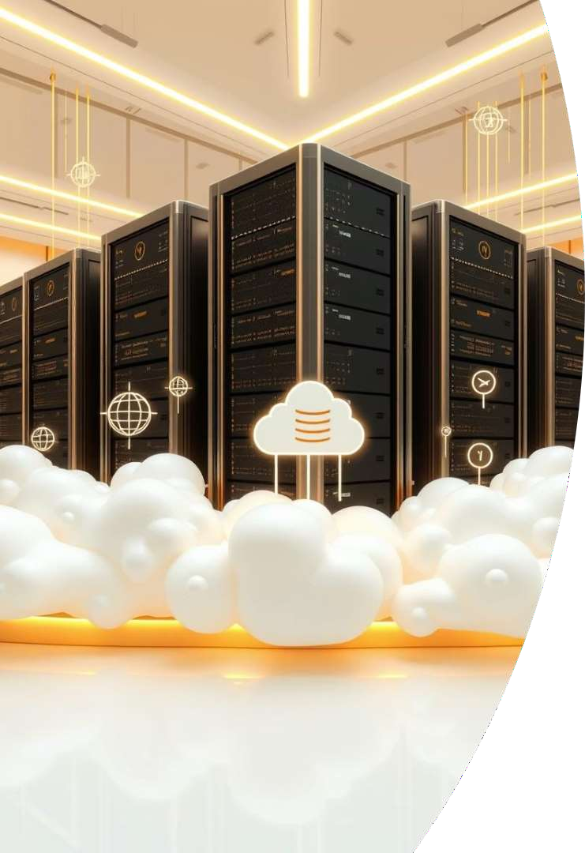

E xploring Data Features and Database Technologies
Data Features :Programming features refer to the fundamental tools and
constructs used in software development to process, manage, and organize data. These include data types, data structures, libraries, memory management, and error handling mechanisms that enable efficient and reliable data manipulation in programs.
Database Technologies :Data storage technologies are systems and methods used to save, organize, and retrieve digital data. They include file systems, databases (SQL and NoSQL), cloud storage, BLOBs, and data warehouses that support secure and scalable storage for various types of
information.

Program Libraries , BLOBs, Drives , and DPF S

Program Libraries
Reusable code units that enhance
modularity and maintainability. Libraries encapsulate functions and routines to speed up development and promote code sharing.

BLOBs and Drives
BLOBs (Binary Large Objects) handle unstructured data such as images and videos. Drives, especially virtual or cloud storage drives, provide scalable access to large datasets supporting BLOB manipulation.

Distributed Parallel File System (DPFS )
DPFS supports high-performance data storage across clusters, enabling fast access to large files across distributed environments, critical for big data and scientific computations.

SQL, NoSQL, and Non-relational Databases

SQL Databases
Structured query language (SQL) databases rely on fixed schemas and support ACID transactions, making them ideal for complex queries and relational data integrity.

NoSQL Databases
Designed for flexibility, scalability, and distributed data models. These include document, key-value, column- family, and graph databases, often sacrificing some consistency for speed and scale.


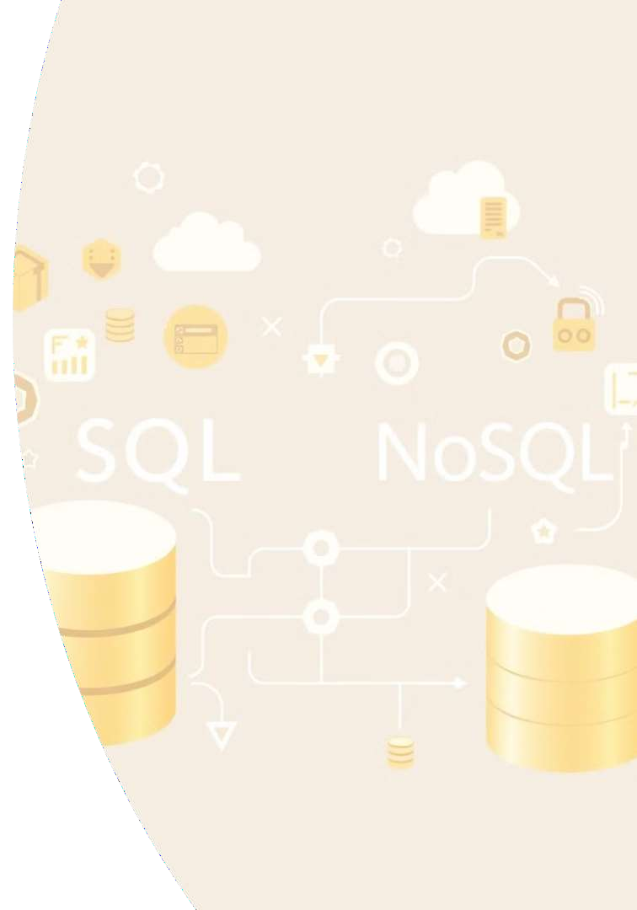

Non-relational Variants
Specialized non-relational stores offer unique data patterns like wide- column or time-series, suited for particular scenarios like IoT, analytics, and real-time data processing.

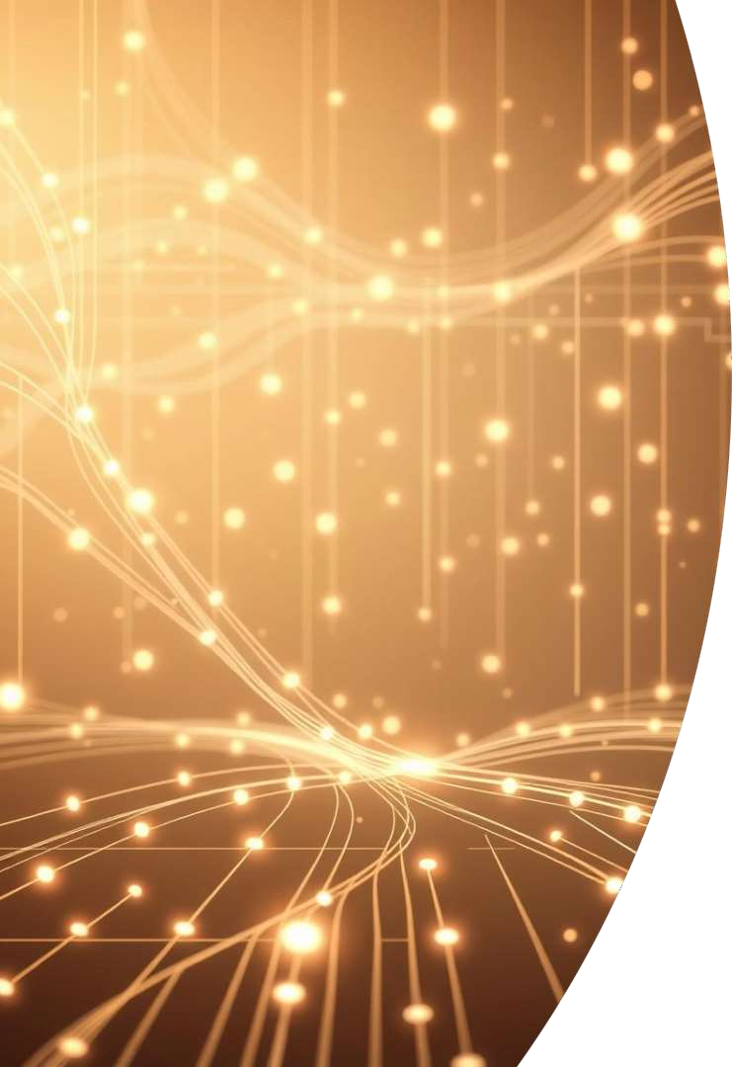
Specialized Queuing Services and Integration

Message Queuing
Enables asynchronous communication between distributed services, improving fault tolerance and scalability. Examples include RabbitMQ and AWS SQS.
Event Streaming
Real-time processing of data streams with systems like Kafka, allowing event-driven architecture and scalable data pipelines.
Integration with Databases
Queuing services often integrate tightly with databases to ensure consistent data flow and resilience, supporting transactional message handling and workflow automation.


Thank You
any Questions?

