Titel: Research Navigator: Semantic Paper Analyzer
1.ProblemStatement:
In the present digital era, evaluating an individual's intelligence quotient (IQ) through online platforms has become increasingly important for academic, professional, and personal development purposes. However, most existing IQ evaluation systems are limited to static question–answer formats and rely on manual assessment, lacking automation, analytical depth, and intelligent data interpretation. These systems often fail to provide real-time insights or visual representations of the user’s performance. Additionally, they do not effectively utilize modern technologies such as Natural Language Processing (NLP) for tokenizing and summarizing user input, nor do they integrate efficient backend data management and visualization mechanisms. This limitation highlights the need for an intelligent and automated IQ evaluation system that can analyze data, summarize responses, and visualize results in an interactive and user-friendly manner.
The proposed system addresses these issues by developing a web-based IQ Evaluation and Analysis System that utilizes Python for backend processing, MongoDB for database management, and HTML/CSS for interface design. The system further incorporates NLP techniques for tokenization and summarization of text data and employs Python data visualization libraries to represent analytical results clearly and effectively.
2.Objectives of the Project
- To develop a web-based IQ evaluation system using Python, HTML, and CSS with MongoDB as the database.
The primary objective of the project is to design and implement an intelligent web-based platform that enables users to take IQ tests online. Python serves as the backend programming language to handle data processing and logic implementation, while HTML and CSS are used to create an interactive and visually appealing user interface. MongoDB is utilized as the database for efficiently storing and managing user data, including test responses, scores, and analytical results. This integration ensures seamless communication between the frontend and backend components of the system.

- To apply NLP techniques such as tokenization and summarization for processing and analysing text data.
This objective focuses on incorporating Natural Language Processing (NLP) methods to enhance the intelligence and analytical capability of the system. Tokenization is used to break down input text into smaller, meaningful units (such as words or sentences), enabling efficient data analysis. Summarization techniques are employed to generate concise insights from the processed data, allowing users to better understand their test performance and cognitive patterns. These NLP operations help transform raw text input into structured and interpretable information.
- To visualize analytical results using Python data visualization libraries like Matplotlib or Seaborn.
Visual representation of IQ test results and analytical data is crucial for improving user understanding. This objective aims to use Python visualization libraries such as Matplotlib and Seaborn to create clear, informative charts and graphs that depict user performance trends and analytical outcomes. By visualizing results, users can easily interpret their strengths and weaknesses, making the system more interactive and data-driven.
- To provide a user-friendly and interactive platform for IQ testing, data analysis, and result interpretation.
The final objective is to ensure that the system is accessible, intuitive, and easy to use for all users. The platform will provide an interactive interface that allows users to take IQ tests, view their scores, and analyse their performance results without requiring technical knowledge. The combination of modern web design, NLP-based intelligence, and data visualization creates an engaging user experience while maintaining accuracy and efficiency in IQ assessment.
3.Project Module Description
The proposed Web-Based IQ Evaluation System is designed with multiple interconnected modules that together perform user interaction, data storage, evaluation, and visualization. Each module plays a key role in ensuring accurate IQ assessment and an interactive user experience.
2.1 User Interface Module
Description:
The User Interface (UI) Module acts as the primary interaction layer between the user and the system. It is designed using HTML and CSS, ensuring that the platform remains lightweight, visually appealing, and responsive across different devices such as desktops, tablets, and smartphones. The interface provides users with an intuitive experience, allowing them to easily register, log in, take IQ tests, and view their performance reports. The design emphasizes simplicity, readability, and user engagement, making it accessible to users of all age groups. The layout incorporates structured navigation bars, interactive buttons, and visually distinct sections to improve usability. Additionally, the UI communicates with the backend Python system through HTTP requests, ensuring smooth data flow between user actions and server-side operations.
Functions:
- Display IQ Test Questions and Options: Presents a series of dynamically generated IQ test questions, including multiple-choice or reasoning-based formats, fetched from the database.
- Provide Forms for Login and Registration: Allows new users to register with basic details and existing users to log in securely using form validation techniques.
- Show Results and Performance Summaries: Displays the outcome of each test, including total scores, summaries, and insights generated through NLP analysis.
- Enable Navigation Across Pages (Home, Test, Result): Provides seamless navigation between various sections of the system, ensuring smooth transitions and accessibility.
- Responsive Layout: Automatically adjusts content layout for various screen sizes and resolutions, maintaining usability on both desktop and mobile devices.
- Interactive Design Elements: Utilizes buttons, input fields, and progress indicators to guide users through the testing process efficiently.
2.2 Backend Processing Module
Description:
The Backend Processing Module forms the core of the system, responsible for handling all server-side operations, data processing, and business logic. It is implemented using Python with the Flask framework, which provides a lightweight and flexible environment for developing scalable web applications. This module serves as the bridge between the frontend interface and the MongoDB database, ensuring smooth communication and data exchange.
The backend receives input data from the user through the web interface, processes it according to defined algorithms, and returns the results in real time. It also integrates Natural Language Processing (NLP) techniques such as tokenization and summarization for text-based input analysis. The backend ensures data integrity, manages user sessions securely, and executes IQ evaluation logic to generate accurate performance results. Additionally, Flask’s routing mechanism enables organized API endpoints for login, registration, test submission, and result retrieval, improving maintainability and modularity.
Functions:
- Handle User Authentication and Session Management:
Manages secure user login and registration processes, including password verification and session tracking. Flask’s session management ensures that user data remains consistent throughout interactions.

- Process User Responses from the Frontend:
Receives answers and inputs submitted by users during IQ tests, validates the data, and prepares it for evaluation. The system checks for missing or invalid entries and processes responses efficiently.
- Manage Communication Between Frontend and Database:
Acts as the intermediary between the web interface and the MongoDB database. It handles all data transactions such as storing user profiles, retrieving questions, saving results, and fetching analytical summaries.
- Integrate NLP Processing:
Uses Python NLP libraries (such as NLTK or spaCy) to perform tokenization and summarization of text data, enhancing the analytical capability of the system and providing deeper insights into user responses.
- Error Handling and Security:
Implements validation checks, exception handling, and secure database communication to prevent unauthorized access and maintain system reliability.

2.3 Database Management Module
Description:
The Database Management Module is responsible for the structured storage, retrieval, and management of all application data. It is implemented using MongoDB, a NoSQL, document-oriented database that provides high flexibility, scalability, and efficiency for handling dynamic and unstructured data. Unlike traditional relational databases, MongoDB stores data in JSON-like documents, making it easier to manage complex and hierarchical data such as user profiles, IQ test questions, and performance analytics.
This module plays a vital role in ensuring data consistency and reliability throughout the system. It acts as the backbone of the application, supporting all backend operations such as user authentication, test management, and result analysis. MongoDB’s schema-less nature allows the system to evolve easily without extensive modifications to database structure. Additionally, it ensures fast data access through indexing and optimized queries, providing real-time response to user requests.
Functions:
- Store User Details, Test Questions, and Results:
Maintains user information including registration details, login credentials, and test participation history. It also stores IQ test questions, user responses, and computed results for further analysis.
- Retrieve Past Performance Records:
Allows users and the system to fetch historical data such as previous test scores and summaries. This enables performance comparison and long-term progress tracking.
- Support CRUD (Create, Read, Update, Delete) Operations:
Facilitates all essential database operations such as creating new records, retrieving stored data, updating existing entries, and deleting outdated or redundant information.
- Ensure Secure Data Storage and Retrieval:
Implements proper data validation and security mechanisms to protect sensitive user information. All database communications occur through secure connections, and access control mechanisms prevent unauthorized data manipulation.

2.4 Data Visualization Module
Description:
The Data Visualization Module is designed to transform complex analytical and numerical data into clear, meaningful, and visually interpretable graphical representations. This module utilizes popular Python data visualization libraries such as Matplotlib, Seaborn, and Plotly to create a variety of charts and graphs that effectively display user performance metrics.
The main purpose of this module is to enhance the interpretability of IQ test results by providing visual summaries of user performance, historical trends, and comparative statistics. Instead of displaying only raw scores or tabular results, the module converts backend-generated data into color full and interactive visual elements such as bar graphs, pie charts, and trend lines. These visualizations allow both users and administrators to easily observe improvement patterns, identify strengths and weaknesses, and make informed conclusions about cognitive performance.
The integration of visualization within the system not only improves user engagement but also adds analytical value, making the platform more dynamic and insightful. Visual outputs are dynamically updated based on user data fetched from the MongoDB database through the backend Python application.
Functions:
- Generate Bar Graphs ,PieCharts, and Trend Lines:
Creates multiple forms of visual representations, including bar charts for category-wise performance, pie charts for score distribution, and trend lines to depict progress over time.
- Display User Progress Over Multiple Attempts:
Tracks user scores across different test sessions and visually displays improvements or declines, helping users evaluate their learning and reasoning growth.
- Help Users and Administrators Analyze Performance Trends:
Provides detailed visual reports that allow both users and system administrators to assess performance patterns, detect anomalies, and identify key areas of improvement.
- Dynamic and Interactive Visuals:
Uses Plotly or Matplotlib interactivity features to allow zooming, hovering, and detailed inspection of data points for deeper insights.
- Integration with Backend Data:
Automatically fetches processed data from the Flask backend and MongoDB database, ensuring that all visualizations are accurate, up to date, and relevant to the current user’s performance data.

2.7 Result Module
Description:
The Result Module is responsible for generating, displaying, and managing the final outcomes of the IQ evaluation process. Once a user completes the IQ test, this module calculates the overall score, percentile, and performance interpretation using the backend scoring logic implemented in Python. The results are presented instantly through the web interface, providing users with immediate feedback on their performance.
This module plays a key role in enhancing user engagement by delivering personalized summaries and recommendations based on test outcomes. It may include analytical insights such as comparative performance graphs or textual summaries derived from NLP-based analysis. Furthermore, the module ensures that all results are securely stored in the MongoDB database for future reference and performance tracking.
In addition to individual feedback, this module enables the system to generate cumulative data reports that can be used by administrators or analysts to monitor user trends and overall system performance. The combination of instant score generation, intelligent analysis, and data persistence ensures a comprehensive and user-friendly evaluation experience.
Functions:
- Display IQ Results Instantly After Test Submission:
Presents the user’s IQ score, percentile, and category interpretation (e.g., average, above average, or exceptional) immediately after test completion.
- Store Results in MongoDB:
Saves the computed results, including user ID, test date, score, and analysis summary, in the database for secure storage and later retrieval.
- Provide Personalized Feedback or Performance Summary:
Generates feedback based on performance metrics and NLP-based text analysis, helping users understand their cognitive strengths and areas needing improvement.
- Enable Future Comparison:
Allows users to view and compare their past test results, helping them track progress over multiple attempts.

3.System Requirements
3.1. Hardware Requirements
Component | Minimum Specification | Recommended Specification
Processor | Intel Core i3 or equivalent | Intel Core i5/i7 or higher
RAM | 4 GB | 8 GB or higher
Storage | 250 GB HDD | 512 GB SSD
Display | 1366 × 768 resolution | Full HD (1920 × 1080)
Internet Connection | Required for data access and synchronization | Stable broadband connection
Peripherals | Keyboard, Mouse | Microphone (if voice input is used)
3.2 Software Requirements
Software | Description
Operating System | Windows 10 / 11, Linux, or macOS
Programming Language | Python 3.9 or above
Frontend | HTML5, CSS3
Backend Framework | Flask (Python web framework)
Database | MongoDB (for data storage and retrieval)
Visualization Libraries | Matplotlib / Seaborn / Plotly (for graphical analysis)
Additional Python Libraries | Pandas, NumPy, Flask-PyMongo
IDE / Code Editor | Visual Studio Code / PyCharm
Web Browser | Google Chrome / Mozilla Firefox
Version Control (optional) | Git and GitHub for source management

4.System Flow Diagram
The System Flow Diagram represents the overall workflow of the proposed Web-Based IQ Evaluation and Analysis System. It illustrates the sequential interaction between the user interface, backend processes, database, NLP components, and visualization modules.
The main objective of this flow is to demonstrate how user inputs move through various stages — from data collection to analysis and result generation — ensuring a smooth and automated IQ evaluation process. When a user interacts with the system through the web interface, their responses are processed by the backend (Python Flask), which performs tokenization, summarization, and IQ score calculation. The processed data is then stored in the MongoDB database, where it can later be retrieved for visualization and performance analysis using Python libraries such as Matplotlib or Seaborn.
This flow ensures that each component of the system communicates efficiently, providing a reliable, data-driven, and user-friendly environment for IQ testing and analysis.
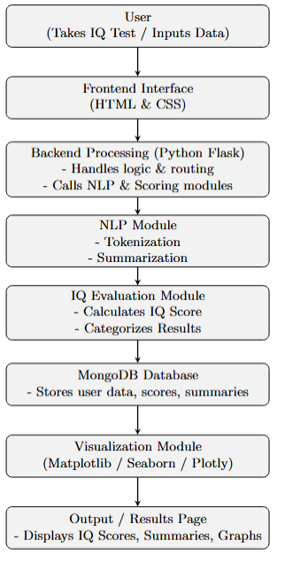
FIGURE 4.1: System flow Diagram
- UserInteraction:
The process begins when the user accesses the web application through a browser. The user registers or logs in, takes the IQ test, or provides text input for analysis.
- Frontend Interface (HTML & CSS):
The frontend acts as the presentation layer, collecting user responses and displaying information. It provides easy navigation and ensures smooth interaction. All data entered by the user is sent to the backend server using HTTP requests.
- Backend Processing (Python Flask):
The backend serves as the control unit of the system. It receives data from the frontend, validates it, and routes it to appropriate modules such as IQ scoring or NLP processing. Flask handles all logical operations and connects the user interface with the database.
- NLP Module (Tokenization & Summarization):
This component performs natural language processing on text data. Tokenization splits the input text into smaller meaningful units, while summarization extracts the essential information. This ensures that data is refined before visualization or storage.
- IQ Evaluation Module:
The system then evaluates the user’s performance based on their test responses. It calculates the IQ score, determines accuracy, and classifies the user into categories such as Average, Above Average, or Gifted.
- Database (MongoDB):
The processed results, user details, and summarized text data are stored in MongoDB. The database supports quick retrieval of information for result display and performance tracking.
- Data Visualization Module:
This module generates analytical reports using Python visualization libraries such as Matplotlib, Seaborn, or Plotly. Graphs and charts display user performance trends, score distribution, and summary insights.
- Output / Result Display:
Finally, the processed IQ score, textual summary, and visual graphs are displayed to the user through the web interface. The results can also be saved for future reference and comparison.
5.Data Flow Diagram
5.1 Context Diagram (DFD Level 0) — shows external entities and the whole system as a single process.
5.2 DFD Level 1 — breaks the system into main processes (Auth, NLP, Scoring, DB, Visualization) and shows labeled data flows and data stores (MongoDB).
5.1 Context Diagram (Level 0)

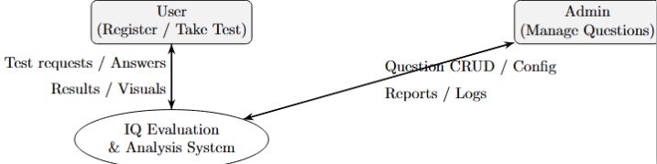
The Level 0 DFD, also known as the Context Diagram, provides a high-level overview of the entire IQ Evaluation and Analysis System.
It represents the system as a single process and shows how it interacts with external entities such as Users and Admins.
Explanation:
- User:
The user interacts with the system by registering, logging in, taking the IQ test, or submitting text for analysis. The system processes these inputs and returns the IQ score, summarized data, and visual reports back to the user interface.
- Admin:
The admin manages the question database, updates test sets, and monitors analytical reports. They send configuration or question management requests to the system and receive reports or logs as output.
- IQ Evaluation and Analysis System (Main Process):
This central process handles all internal operations—data collection, NLP processing, IQ score computation, database interaction, and data visualization—before sending results back to the user and admin.
Overall, the Level 0 DFD gives a simplified view of how external entities communicate with the system and how information flows into and out of it.
5.2 Overall DFD(Level 1 )

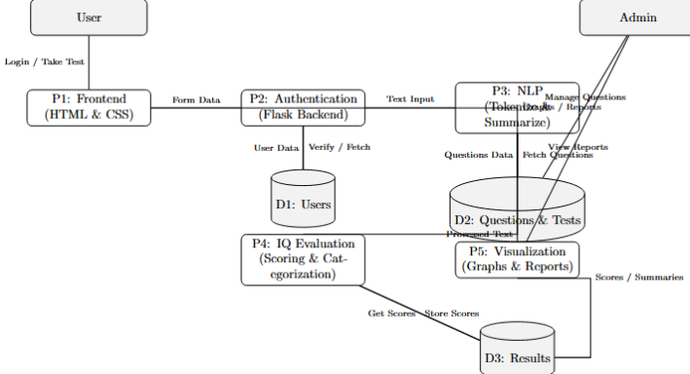
The Level 1 DFD breaks down the main system process into multiple smaller, interconnected components that describe how data moves internally between modules.
It illustrates the logical flow between the frontend interface, backend processes, NLP module, database, and visualization unit.
Explanation of Major Processes:
- P1 – Frontend (HTML & CSS):
This module collects input data such as user credentials, text entries, or quiz answers. It acts as the presentation layer that sends and receives data through the backend (Flask API).
- P2 – Authentication & Routing (Flask Backend):
The backend validates user details using the Users datastore (D1) and routes each request to the correct module—either the NLP processor or IQ evaluation component.
- P3 – NLP Module (Tokenization & Summarization):
This process handles natural language processing tasks on user input. It tokenizes text into smaller segments and generates summaries, storing them in the Results datastore (D3) for further analysis.
It also retrieves questions from the Questions datastore (D2).
- P4 – IQ Evaluation (Scoring & Categorization):
The IQ evaluation module calculates the user’s IQ score based on test answers, determines performance levels (Average, Above Average, Genius, etc.), and stores results in the Results datastore (D3).
- P5 – Visualization (Graphs & Reports):
Using Python libraries such as Matplotlib or Seaborn, this module retrieves summarized data and results from the database to generate visual charts and performance graphs for users and admins.
Datastores:
- D1 – Users: Contains user credentials and profile data.
- D2 – Questions & Tests: Stores all test questions, options, and correct answers managed by the admin.
- D3 – Results: Keeps IQ scores, analysis summaries, and performance history.
External Entities:
- User: Inputs test answers or text and views graphical results.
- Admin: Updates test questions and views analytical reports.

