Title
PAPER IQ- SMART DOCUMENT PROCESSING SYSTEM

Abstract
This project implements a Document Processing System that allows users to ingest, preprocess, analyze, and summarize documents through a graphical user interface
(GUI). It features a secure login system with user registration and stores credentials in a file. The system supports multiple document formats including .txt, .docx, and
.pdf. After logging in, users can execute four modules:
- Document Ingestion – Reads all supported documents from a folder.
- Text Preprocessing – Cleans text by removing unwanted characters and spaces.
- Insight Extraction– Extracts top keywords and sentence statistics.
- Text Summarization – Generates a concise summary using LSA (Latent Semantic Analysis).
The system is user-friendly, lightweight, and efficient, making it ideal for academic, professional, and research purposes.

Introduction
In today’s world, handling and analyzing large volumes of text data is essential for extracting meaningful insights. Traditional manual methods are inefficient and time- consuming. This project provides a fully automated system with a GUI that simplifies document processing and text analysis for non-technical users.
The project integrates:
- Python for backend processing.
- Tkinter for GUI.
- NLTK for text tokenization and preprocessing.
- Sumy for text summarization.

The inclusion of a secure login system ensures that only authorized users can access the dashboard and its functionalities. This project is particularly useful in *academic research, business reports, and content analysis.

System Objectives
The primary objectives of this project are:
- To create a secure login system with registration functionality.
- To allow users to ingest multiple document formats automatically.
- To perform preprocessing to clean and normalize text.
- To provide insight extraction to analyze content statistics and keywords.
- To generate automatic summaries of documents for faster understanding.
- To provide a GUI-based system for user-friendly interaction.

System Specification
  - Software Requirements
    - Python 3.10+
    - Tkinter (for GUI)
    - NLTK(for tokenization and stopwords)
    - PyPDF2(for PDF extraction)
    - python-docx (for DOCX files)
    - Sumy (for LSA summarization)

  - Hardware Requirements
    - Minimum 4 GB RAM
    - Processor: Intel i3 or equivalent
    - Storage: 500 MB free space

System Design
  - Architecture

The system follows a modular design:

User Login & Registration
|
Document Ingestion -> Reads .txt/.docx/.pdf
|
Text Preprocessing -> Cleans text (removes unwanted characters)
|

Insight Extraction -> Tokenizes text, removes stopwords, finds keywords
|
Text Summarization -> Uses LSA to summarize the document
  - GUI Design
Login Window: Username, Password, Login, Reset, Register
Dashboard Window: Four buttons for modules and a scrollable output box Output Display: Real-time messages, statistics, keywords, and summary

Implementation Details
  - Login System
    - Users can login with existing credentials.
    - Users can register new accounts, which are stored in users.txt.
    - Credentials are validated before accessing the dashboard.
  - Document Ingestion
    - Reads all files from a folder named documents.
    - Supports PDF, DOCX, and TXT formats.
    - Displays the first 1000 characters as a preview.
  - Text Preprocessing
    - Removes extra spaces, newline characters, and special symbols.
    - Keeps only letters, numbers, and punctuation.
    - Preprocessed text is used for further analysis.
  - Insight Extraction
    - Tokenizes the text into words and sentences.
    - Removes English stopwords.
    - Counts word frequency and extracts top 10 keywords.
    - Displays total sentences and words.
  - Text Summarization
    - Uses LSA (Latent Semantic Analysis) from Sumy.
    - Generates a concise summary of the document (configurable sentence count)

Testing
The system has been tested with:

- .txt files with plain text
- .docx files with paragraphs and formatting
- .pdf files containing multiple pages TEST Result
MODULE | TEST CASE | RESULT
login | Correct credentials | Success
login | Incorrect credentials | Error message
Document Ingestion | Mixed file types | All text read correctly
preprocessing | Special characters | Removed successfully
Insight Extraction | Large Document | Keywords and stats  displayed
Summarization | Long Test | Summary generated

Screenshots
- Login Page: Username, Password, Login, Reset, Register buttons.

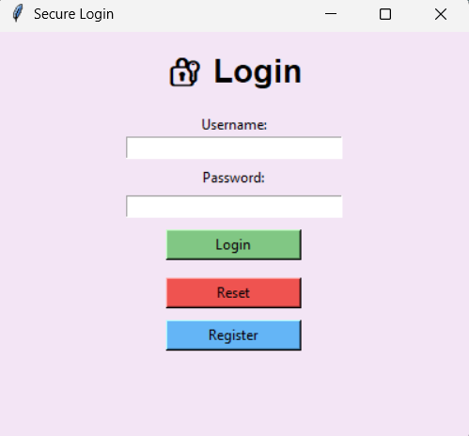

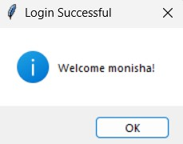
- Dashboard: Buttons for Ingest, Preprocess, Insights, Summarize.
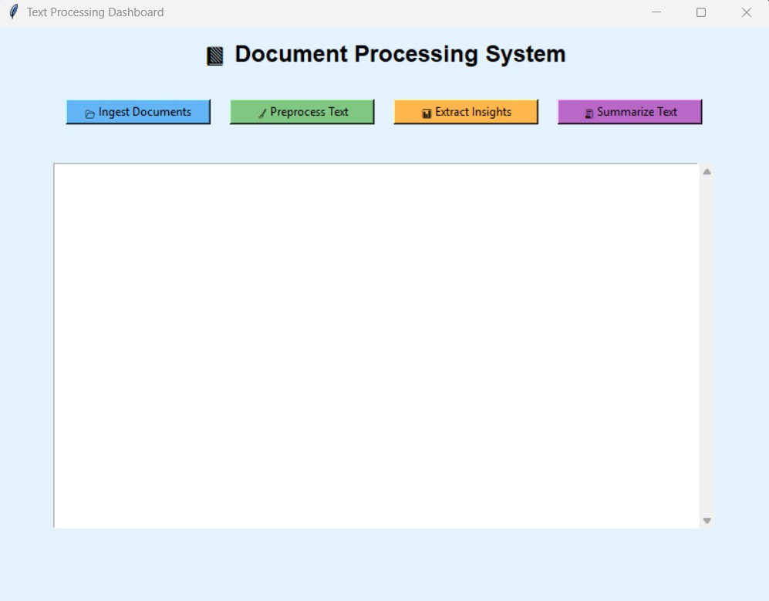

- Output: Scrollable box displaying results in real-time.
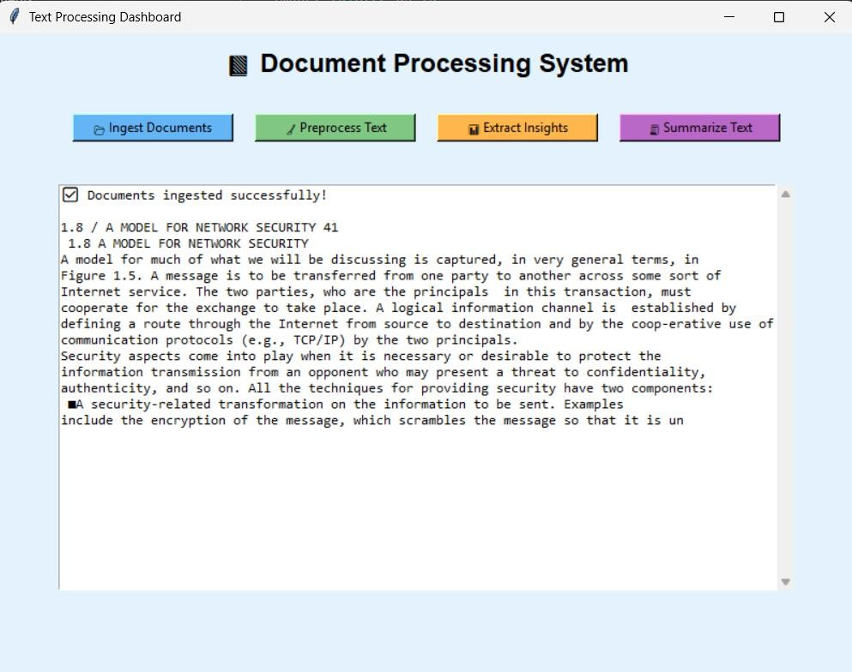

Advantages
- Easy-to-use GUI
- Supports multiple file formats
- Modular design for scalability
- Secure login system
- Automated insights and summarization

Future Enhancements
- Add multi-language support for text processing.
- Add PDF generation of insights and summaries.
- Integrate AI-based keyword extraction.
- Include cloud storage for uploaded documents.
- Enhance GUI with better themes and icons.

Conclusion
This project provides a complete text processing system with secure login and multiple modules in a GUI. It simplifies the task of document ingestion, preprocessing, analysis, and summarization. The system is modular, user-friendly, and can be extended for advanced NLP tasks in the future.

References
- NLTK Documentation: [https://www.nltk.org/](https://www.nltk.org/)
- Sumy Documentation:
[https://pypi.org/project/sumy/](https://pypi.org/project/sumy/)
- PyPDF2 Documentation:
[https://pythonhosted.org/PyPDF2/](https://pythonhosted.org/PyPDF2/)
- python-docx Documentation: [https://python-
docx.readthedocs.io/](https://python-docx.readthedocs.io/)
- Tkinter Documentation:
[https://docs.python.org/3/library/tkinter.html](https://docs.python.org/3/library/tk inter.html)

