**Macros**

Macros is used to do the same task again and again having different dataset but in the same cell location of other sheets.

Way to record macros:

🡪click on bottom left button which is to record macros

🡪Click any tab right click and select customize ribbon

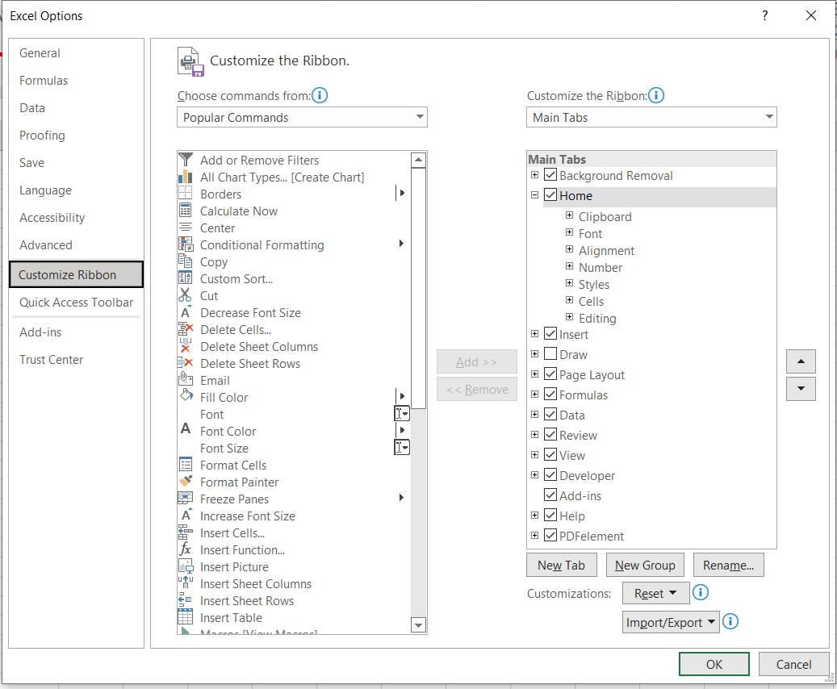 Tick the developer and select ok.

And select developer tab and click record macros

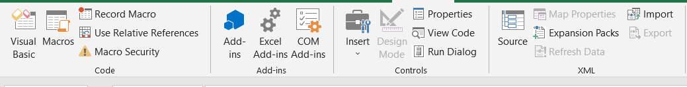

After recording macros

To apply record in other sheets too

🡪select view

🡪select macros in right side of the tab and click view macros

* Click ok and you will get your desired work done in a second.

Macros is time saving important factors for the user to do same task again and again.

**Not to do while recoding macros:--**

🡪Do not select table manually by mouse because each sheet might have different data set which make the corrupted data

Eg the sheet used to record is of 4 rows and u selected manually.

Now applying macros on other sheet which contain 10 rows but the task will perform only for 4 row thus this make the data corrupted.

**Solution**

**To select entire column ctrl+shift+down arrow**

**To select entire row ctrl+shift+right arrow**