DENORMALIZATION

🡪Normalize the existing db to improve progress.

🡪Main aim for denormaliztion is to reduce data redundancy, this means data redundancy is same field of data is present in two tables which increases the space of the db.

This generally occur at the time of data backup/recovery.

Advantage

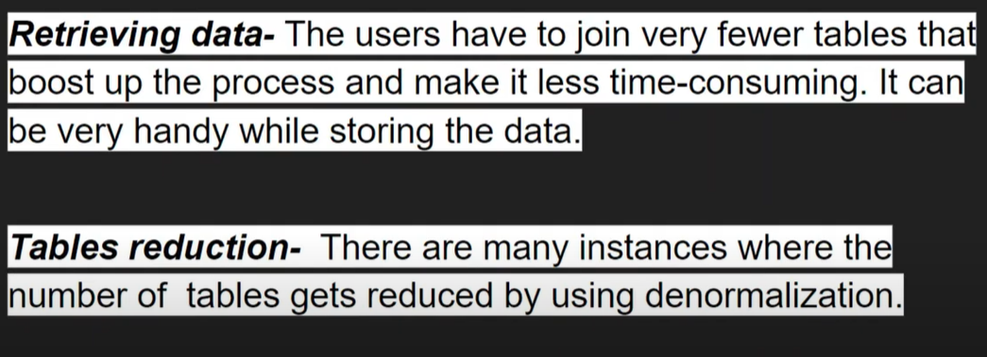

Cons

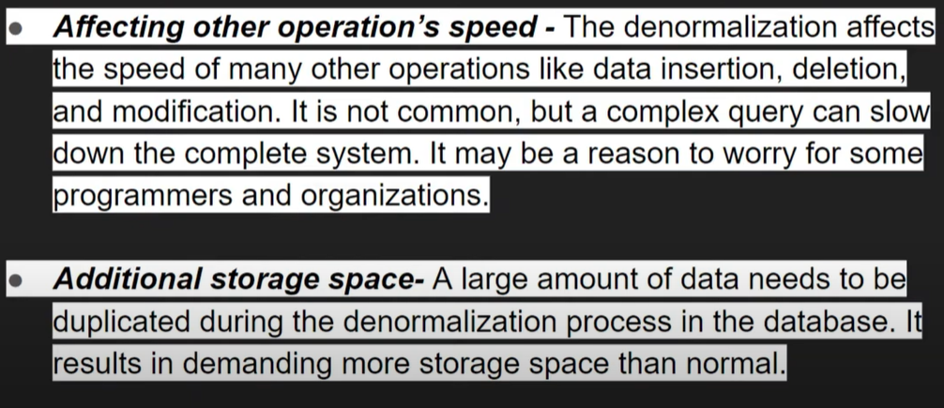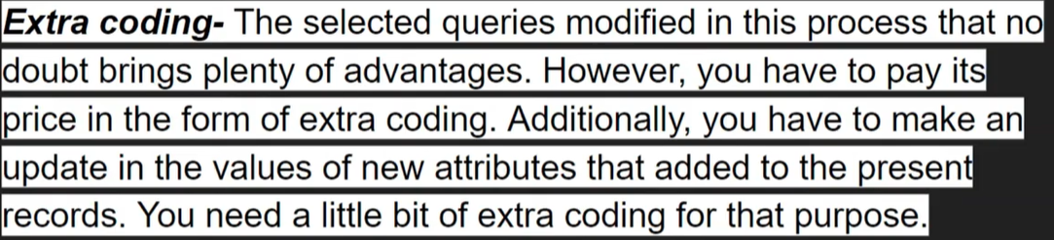

Main question which to choose Data normalization/denormalization

Normalization is good for those db where orders are inserted In a couple of minutes.

Denomalization is good for olap ie datawarehousing ,data lake solution,analytics like trend analysis and visual reports etc.

