Normalization

🡪Normalization is the process of organizing the data in the database.

🡪Normalization is used to minimize the redundancy from a relation or set of relations. It is also used to eliminate undesirable characteristics like Insertion, Update, and Deletion Anomalies.

🡪Normalization divides the larger table into smaller and links them using relationships.

🡪The normal form is used to reduce redundancy from the database table.

Why normalisation?

🡪To remove data anomalies ie insert update delete anomalies.

Types of normal form

1 NF 2 NF 3 NF BCNF

1 NF

🡪To remove repeating groups ie remove multiple value of an attribute

🡪Create separate table for each set of data

🡪Identify set of data with primary key

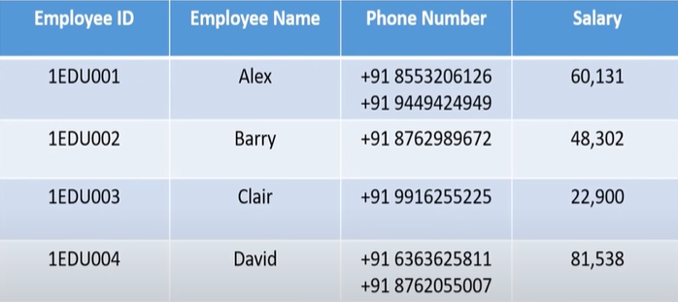

1NF is violated as there consists multiple phone number.

So 1st NF is achieved by

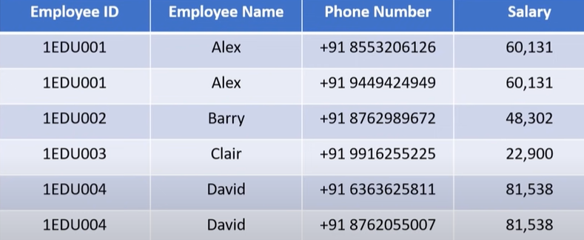

2 NF

Needed:- 1st NF

No partial function dependency.

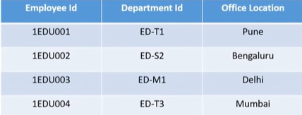

So Here 1NF is achieved already ,but office location is depeneded on department_id but partial key is employee_id and department_id is depeneded on employee_id so thus department_id is partial key thus we need to segregate the columns in two tables

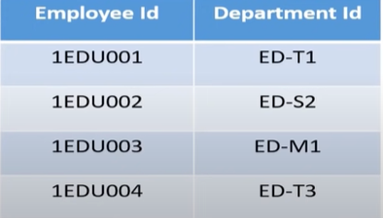 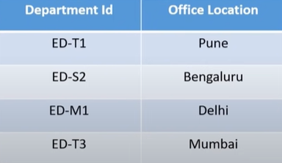

3 NF

Needed :- 2NF

No transitive dependacy of non prime attributes

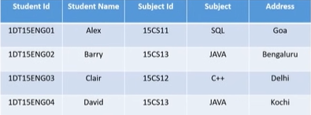

Here 1NF is achieved AS NO VIOLATION of multiple values of each attributes in a row.2NF is achieved also due to no partial key dependency.

3NF is achieved is violated as subject is depeneded on subject_id which is dependent on student_name as follow by student_id which is prime attribute ie primary key.

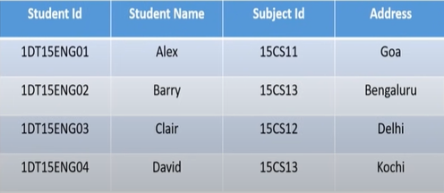 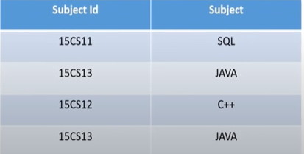

BCNF

Needed :- 3NF

Every functional A🡪B where A is super key of that table.

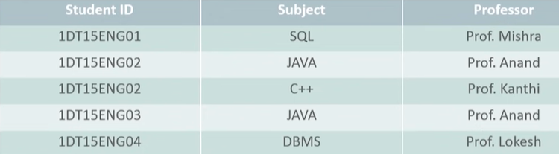

All 3 nf except bcnf are not violated.

Since Here subject and student_id r primary key and professor is dependend on subject which non-prime so

A new column of professor_id will be added in 2 table

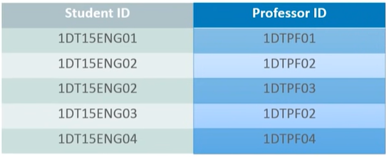

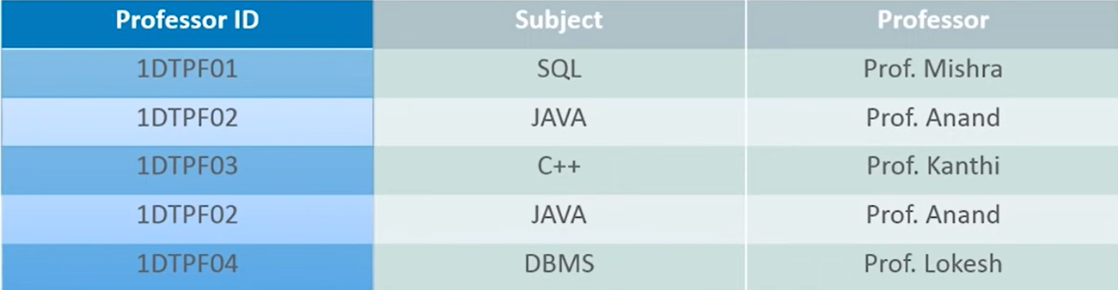

Professor_id is super key.

Pros of Normalization

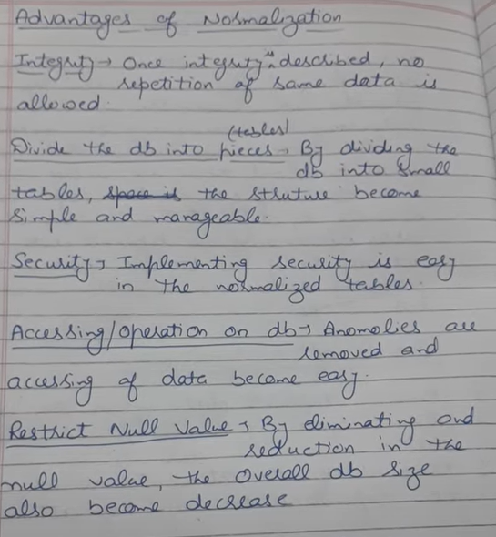

Cons of Normalization

