**🡪Sorting algo**

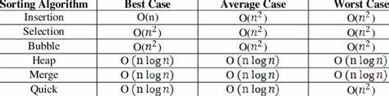

**🡪xor:**

**Same number xor is 0.**

**O xor any number is any number.**

**🡪Relatively prime nos:-**

**gcd(a,b)=1**

**🡪Solve problem technique**

**Brute force**

**Optimised sol (to overcome tle)**