**Sql cheat cheat**

**RANKING FUNCTION**

**🡪Rank ()**

**It is used to rank the attributes values according to its attributes.**

**🡪over() can be used in rank().**

**Over contain order by attribute_name ASC/DESC**

**🡪Rownumber()**

**It provides the specific row number of each row**

**🡪Partition by**

**Rank() over(partition by attribute order by attribute)**

**Difference between partition by and group by**

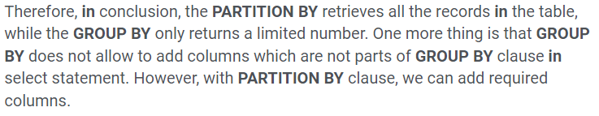

**Eg:->**

**Select name,marks,rank() over(partition by school_position order by marks desc) as [‘Rank’] from xyz**

|  |  |  |
| --- | --- | --- |
| **name** | **marks** | **Rank** |
| **Maitri** | **97** | **2** |
| **Ketal** | **89** | **1** |

**🡪Dense rank()**

**Denserank() over(order by …)**

**Differnce between rank and denserank**



**Let try an example**

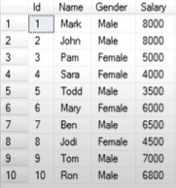

**Select *,rank() over(order by Salary desc) as [‘Rank’], denserank() over(**

**Order by Salary desc) as [‘DenseRank’] from employee;**

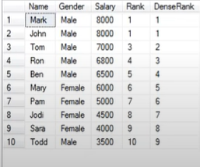

**Window functions vs Aggregate functions : :->**

**The main difference between window functions and aggregate functions is that aggregate functions group multiple rows into a single result row; all the individual rows in the group are collapsed and their individual data is not shown. On the other hand, window functions produce a result for each individual row. This result is usually shown as a new column value in every row within the window.**

**Aggregate function collapses when data are same and produce only one result ,**

**While window function do not collapses and return all the values in multiple rows.**

**Eg🡪**

**SQL queries that return the department name and the max salary of each department.**

**Using aggregate function,**

**Select department_name,max(salary) from xyz group by department**

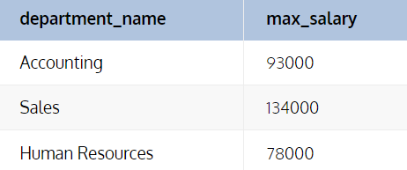

**Using Window functions,**

**Select department_name,max(salary),over(partition**

**ANALYTIC FUNCTION**

**🡪Lead()**

**🡪Lag()**

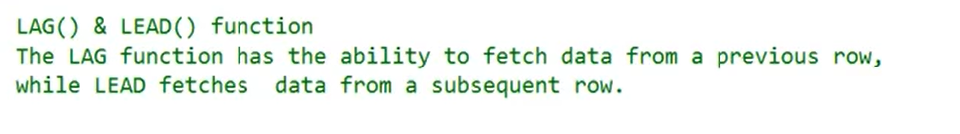

**Example🡪**

**Select emp_id,prod_id,dept,sales_year,sales,**

**Lag(sales) over(order by sales asc) as Previous_year,**

**Lead(sales) over(order by sales asc) as Next_year from xyz;**

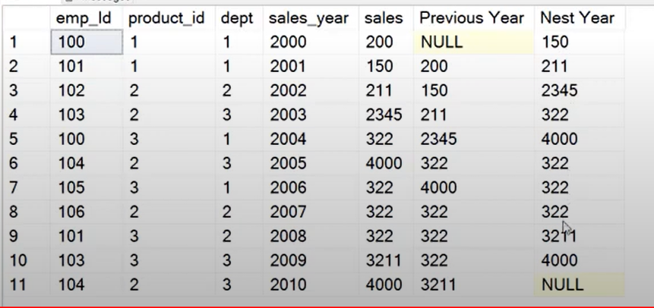

**🡪First_value()**

**Returns first value of the column in all the rows.**

**🡪Last_value()**

**Returns last_value of the column in all the rows.**

**\*\*\*\*\*\*\*\*\*\*\*\*\*\*\*\*\*\*\*\*\*\*\*\*\*\*\*\*\*\*\*\*\*\*\*\*\*\*\*\*\*\*\*\*\*\*\*\*\*\*\*\*\*\*\***

**Eg🡪**

**Select *,first_value() over (order by sales asc) as first value from xyz;**

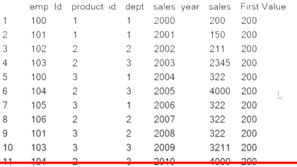

**🡪Nth_value()**

**Returns the nth value of the attribute which is being partitioned.**

**Eg🡪**

**Write a sql query to display the second most highest salary of each department along with department name.**

**Select department_name,nth_value(salary,2) over(partition by department_name order by salary desc ) as SecondHighestSalary from xyz;**

**🡪Range function**

**DISTRIBUTION FUNCTION**

**🡪percent_cont()**

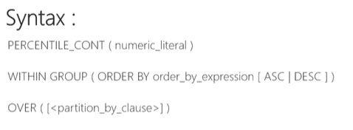

**🡪percent_rank()**

**percent_rank() within group (order by attribute ) over(partition by attribute)**

**🡪percent_disc()**

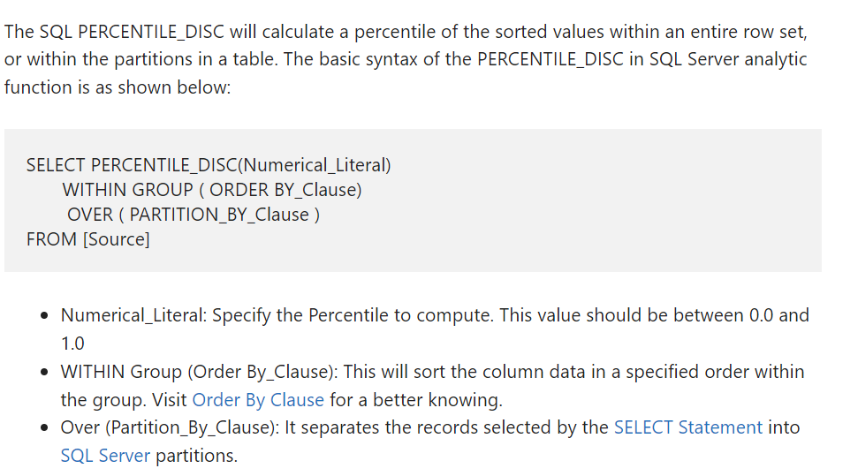

**🡪cume_dist()**

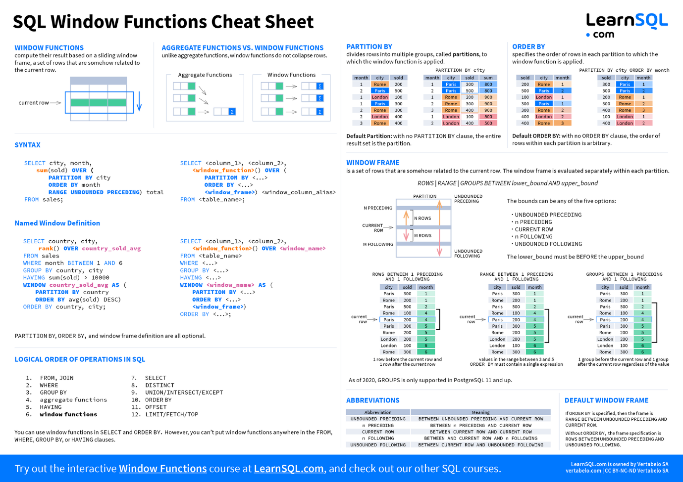

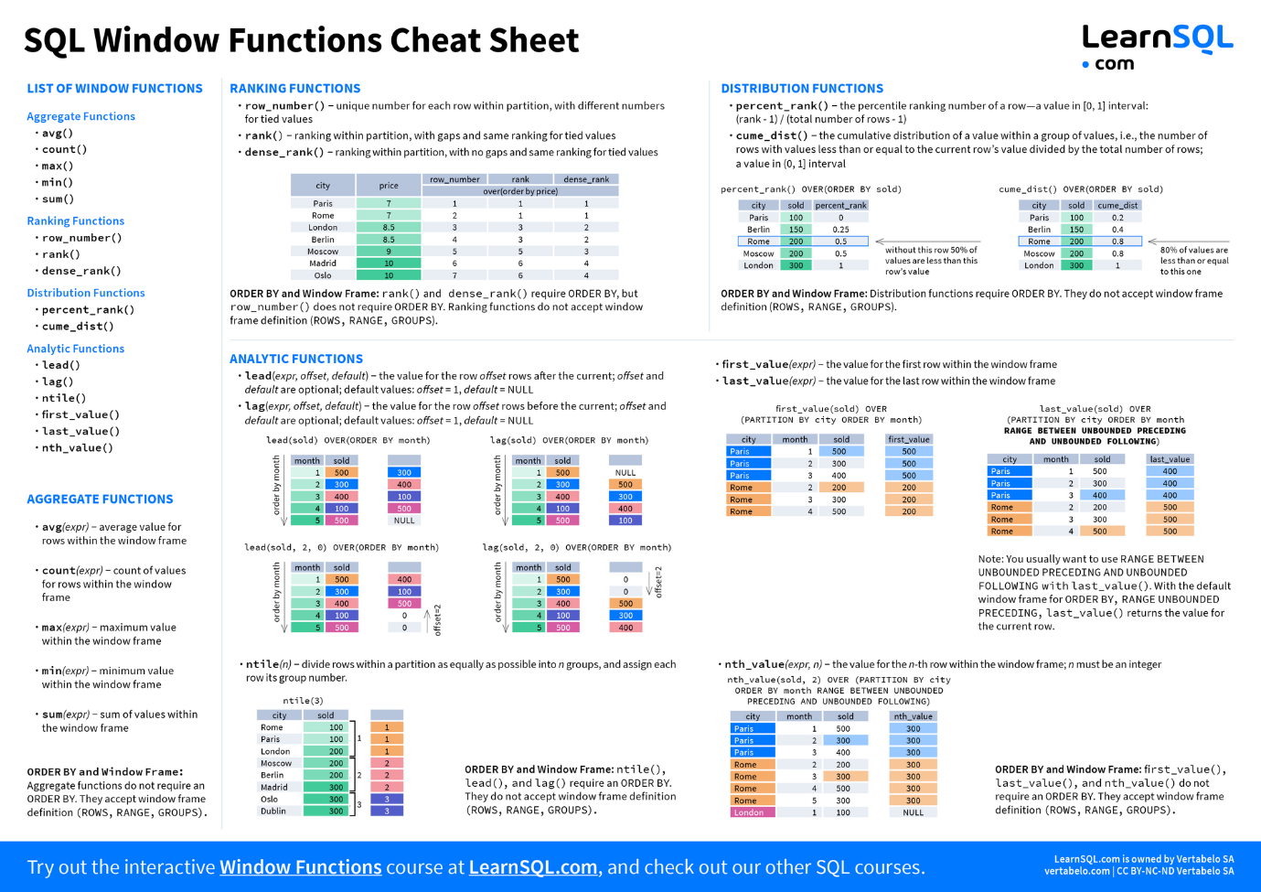

**Source code CheatSheet Link: https://learnsql.com/blog/sql-window-functions-cheat-sheet/**