PySpark With & Without Sql

PYSPARK ARCHITECTURE

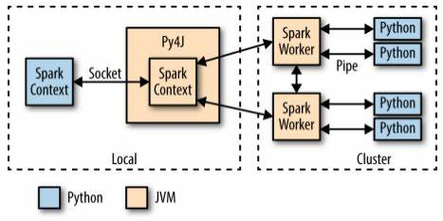

SQL ENGINE

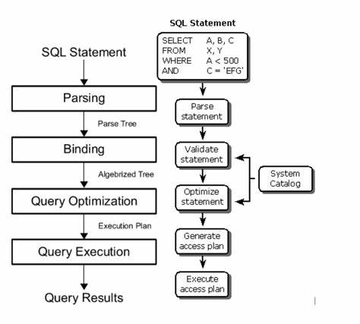

|  |  |
| --- | --- |
| spark.Sql | Without spark.sql |
| ASsuming table is formed using df.createOrReplaceTempView[“table”] | ASsuming import pyspark.sql.functions AS f |

Selection

* SQL spark.sql(SELECT col_1 FROM table”)
* Pyspark df.select(f.col(“col_1”))

Alias

* SQL spark.sql(SELECT col_1 AS “new” FROM table”)
* Pyspark df.select(f.col(“col_1”).alias(“new”)

Describe

* SQL spark.sql(“DESCRIBE table”)
* Pyspark df.printSchema( )

Select Distinct

* SQL spark.sql(“SELECT distinct col_1 FROM table”)
* Pyspark df.select(f.col(“col_1”)).distinct( )

Limit n

* SQL spark.sql(“SELECT col_1 FROM table limit n”)
* Pyspark df.select(f.col(“col_1”)).limit( n )

Ascending Sort

* SQL spark.sql(“SELECT col_1 FROM table order by col_1”)
* Pyspark df.orderBy(“col_1”).

Descending Sort

* SQL spark.sql(“SELECT col_1 FROM table order by col_1 desc”)
* Pyspark df.orderBy(“col_1”,AScending=false)

Filter

* SQL spark.sql(“SELECT col_1 FROM table WHERE col_1>5”)
* Pyspark df.filter(f.col(“col_1”)>f.lit( 5 ))

New Column with constant

* SQL spark.sql(“SELECT col_1,1 AS “new” FROM table”)
* Pyspark df.withColumn(“new, f.lit(1))

Group By with Aggregation

* SQL

spark.sql(“SELECT col_1,sum(col_1),count(col_1) FROM table group by col_1”)

* Pyspark

df.groupBy(“col_1).agg(f.sum(col_1),f.count(col_1))

Union

* SQL

spark.sql(“SELECT col_1 FROM left_table UNION SELECT col_1 FROM right_table”)

* Pyspark

left_df.select(f.col(“col_1”)).union(right_df.select(f.col(“col_1))).distinct( ).

Union All

* SQL

spark.sql(“SELECT col_1 FROM left_table UNION ALL SELECT col_1 FROM right_table”)

* Pyspark

left_df.select(f.col(“col_1”)).union(right_df.select(f.col(“col_1)))

Inner Join

* SQL

spark.sql(“SELECT * FROM left_table l join right_table r ON l.col_1=r.col_2”)

* Pyspark

left_df.join(right_df,left_df.left1==right_df.right1”).show( )

Outer Join

* SQL

spark.sql(“SELECT * FROM left_table FULL OUTER JOIN right_table ON left_table.left1=right_table.right1”)

* Pyspark

left_df.join(right_df,left_df.left1==right_df.right1,how=”outer”).show( )

Left Join

* SQL

spark.sql(“SELECT * FROM left_table LEFT JOIN right_table ON left_table.left1=right_table.right1”)

* Pyspark

left_df.join(right_df,left_df.left1==right_df.right1,how=”left”).show( )

Cross Join

* SQL

spark.sql(“SELECT * FROM left_table CROSS JOIN right_table ON left_table.left1=right_table.right1”)

* Pyspark

left_df.crossJoin(right_df).show( )

Case When

* SQL

spark.sql(“SELECT *, CASE WHEN col_1 >5 THEN “Yes” ELSE “No” end FROM table”)

* Pyspark

df.withColumn(“col_4”,f.when(df.col_1>5 ,”Yes”).otherwise(“No”))\.

show( )

Power

* SQL

spark.sql(“SELECT POWER(f.col(“col_1”),5) AS newMeASure

FROM table”)

* Pyspark

Df.selectExpr(f.col(“col1”),Power(f.col(“col1”,5))).show( )

Round & Bround

* SQL

spark.sql(“SELECT ROUND( 2.5 ), BROUND( 2.5 ) “)

* Pyspark

df.select(f.round(lit(“2.5”),f.bround( lit( 2.5 ) ).show( )

Regular Expression

* SQL

spark.sql(“SELECT regexp_replace( Description,'BLACK|WHITE|RED|GREEN|BLUE', 'COLOR') AS color_clean, Description FROM table”)

* Pyspark

regex_string = "BLACK|WHITE|RED|GREEN|BLUE"

df.select( regexp_replace(col("Description"), regex_string, "COLOR").aliAS("color_clean"),f.col("Description")).show(2)

Drop Null

* SQL

spark.sql(“SELECT * FROM table WHERE col_1 is null”)

* Pyspark

df.na.drop("all", subset=["col_1", "col_2"])

Fill Null

* SQL

spark.sql(“SELECT coalesce(col_1,value,null ) AS new FROM table”)

* Pyspark

df.na.fill("all", subset=["col_1", "col_2"])

Replace

* SQL

spark.sql(“SELECT REPLACE(col_1,’value’,’new value’) FROM table”)

* Pyspark

df.na.replace([""], ["UNKNOWN"], "col_1")

Split

* SQL

spark.sql(“SELECT col_1, col_2, exploded FROM (SELECT *, split(col_1, " ") AS splitted FROM table) LATERAL VIEW explode(splitted) AS exploded”)

* Pyspark

df.select(split(col("DescriptiON"), " ")).show(2)

Explode

* SQL

spark.sql(“SELECT split( col_1, ’,’ ) FROM table”)

* Pyspark

df.withColumn("splitted", split(col("col_1"), " "))\.

withColumn("exploded", explode(col("splitted")))\ .

select("col_1", "col_2", "exploded").show(2)

Map

* SQL

spark.sql(“SELECT map(col_1, col_2) AS complex_map FROM table WHERE col_1 IS NOT NULL”)

* Pyspark

df.select(create_map(col("col_1"),col("col_2")).aliAS("complex_map")) .show(2)

Group Concat

* SQL

spark.sql(“SELECT col_1,GROUP_CONCAT ( col_2,’,’ ) FROM table GROUPBY col_1”)

* Pyspark

df.agg(f.collect_set("col_1"), f.collect_list("Country")).show( )

Date Format

* SQL

spark.sql(“SELECT col_1,to_char (date_1,’mm-dd-yyy’ ) AS new FROM table”)

* Pyspark

df.select(f.col("col_1"),date_format(f.col("col_1"),

“MM-dd-yyyy”).aliAS(“new”).show(2)

Row Number

* SQL

spark.sql(“SELECT *,row_number( ) over(partition by col_1 order by col_2)AS row_number FROM table”)

* Pyspark

windowSpec=f.Window.partitionBy(“col_1).orderBy(“col_2”)

df.withColumn(“row_number,row_number(),windowSpec)\.

show( truncate=False )

Rank

* SQL

spark.sql(“SELECT *,rank( ) over(partition by col_1 order by col_2)AS rank FROM table”)

* Pyspark

windowSpec=f.Window.partitionBy(“col_1).orderBy(“col_2”)

df.withColumn(“ rank ”,rank( ).over( windowSpec )).show( )

Dense Rank

* SQL

spark.sql(“SELECT *,dense_rank( ) over(partition by col_1 order by col_2)AS dense_rank FROM table”)

* Pyspark

windowSpec=f.Window.partitionBy(“col_1).orderBy(“col_2”)

df.withColumn(“dense_rank,dense_rank(),windowSpec)\.

show( truncate=False )

Lag

* SQL

spark.sql(“SELECT *,lag(col_2) over(partition by col_1 order by col_2)AS previous FROM table”)

* Pyspark

windowSpec=f.Window.partitionBy(“col_1).orderBy(“col_2”)

df.withColumn("previous",lag("col_2",2).over(windowSpec)).show( )

Lead

* SQL

spark.sql(“SELECT *,lead (col_2 ) over(partition by col_1 order by col_2)AS next FROM table”)

* Pyspark

windowSpec=f.Window.partitionBy(“col_1).orderBy(“col_2”)

df.withColumn("next",lead("salary",2).over(windowSpec)) .show( )

Percentile Rank

* SQL

spark.sql(“SELECT *,percent_rank() over(partition by col_1 order by col_2) AS percent_rank FROM table”)

* Pyspark

windowSpec=f.Window.partitionBy(“col_1).orderBy(“col_2”)

df.withColumn(“percent_rank”,percent_rank (),windowSpec)\.

show( truncate=False )

Window Aggregate

* SQL

spark.sql(“

With cte AS ( SELECT *,row_number( ) over(partition by col_1)AS row_number FROM table )

SELECT *,AVG( col_2) over(partition by col_1),SUM(col_2 ) over(partition by col_1), MAX (col_2 ) over(partition by col_1), MIN ( col_2) over(partition by col_1) FROM cte WHERE r=1 ) ”)

* Pyspark

windowSpecAgg = Window.partitionBy("department")

df.withColumn("row",row_number().over(windowSpec)) \

.withColumn("avg", avg(col("salary")).over(windowSpecAgg)) \

.withColumn("sum", sum(col("salary")).over(windowSpecAgg)) \

.withColumn("min", min(col("salary")).over(windowSpecAgg)) \

.withColumn("max", max(col("salary")).over(windowSpecAgg)) \

.WHERE(col("row")==1).select("department","avg","sum","min","max") \

.show( )

E -- N -- D