**Hotel Management System**

Submitted in partial fulfilment of the requirements of the degree

**BACHELOR OF ENGINEERING** IN **I.T. ENGINEERING**

By

**Anurag Hale 03**

**Shubham Khose 40**

**Nikunj Mistry 64**

Supervisor

**Dr.Madhuri Rao**



**Department of Information Technology**

**Engineering Thadomal Shahani College**

**Bandra(w), Mumbai - 400 050**

**University of Mumbai**

**( AY 2021-22)**

# CERTIFICATE

This is to certify that the Mini Project entitled **“ HOTEL MANAGEMENT SYSTEM ”** is a bona fide work of **Anurag Hale(03),Shubham Khose(40),Nikunj Mistry(64)**submitted to the University of Mumbai in partial fulfilment of the requirement for the award of the degree of **“Bachelor of Engineering”** in **“Department of Information Technology” .**

**(Dr. Madhuri Rao)**

Supervisor

**(Prof._________________ ) (Prof._________________ )**

Head of Department Principal

# Mini Project Approval

This Mini Project entitled “HOTEL MANAGEMENT SYSTEM**”** by **Anurag Hale(3), Shubham Khose(40), Nikunj Mistry(64)** is approved for the degree of **Bachelor of Engineering** in **Department of Information Technology.**

**Examiners**

**1………………………………………**

(Internal Examiner Name & Sign)

**2…………………………………………**

(External Examiner name & Sign)

Date: 18/12/2021

Place:

# Contents

1. **Introduction** 
   1. Introduction
   2. Problem Statement & Objectives
2. **Literature Survey** 
   1. Survey of Existing System
   2. Limitation Existing system or research gap
3. **Proposed System (eg New Approach of Data Summarization )** 
   1. Architecture/ Framework
   2. Algorithm and Process Design

**3.3** Design

* 1. Conclusion and Future work.

**CHAPTER 1**

This chapter gives an overview about objective, problem statement, background and motivation of choosing this topic.

## 1.1 INTRODUCTION

Hotel management is an array of roles and responsibilities all held together under one umbrella. Being able to adapt, meet challenges and place yourself on a scale of personal growth is vital herein

Hotel management as the name suggested seems to be simple as looking into hospitality and care but on a broad basis It requires a lot of strategies and planning not only for proper functioning but also for better performance and improved incentives

An effective way of managing hotels and hotel industry are created to get the business flourishing.

## 1.2 Problem statement and objective

A hotel system manages various information about rooms, reservation, customers, building etc.

This customer can make a reservation through hotel website. He requires details as in, availability of rooms, dates, customer details-If everything seems fine he receives a confirmation number from the website.

The desk clerk checks in the time and billing record is created at that time. Customer billing is recorded is updated every night at

12.Customer can pay by cash when they check out

If the customer needs a pick up/down service, online availability can also be made. One has an access to the details of the driver the nature of vehicle, his current location. And the type of car used by driver.

The app bears many more function.

* Room status
* Allocated Room Modification
* Check In/Check Out details
* Customer details
* Total customer present in hotel
* Services like rides, also included
* Billing
* Hotel staff and their details
* Miscellaneous services.

There are new Strategies technologies emerging every day that one needs to track on. How effective one manages their property, pays to have your finger on the pulse. Its thereby essential to have the most effective system incorporating multiple areas with all its ardently meticulously and its caliber.

## CHAPTER 2 - Literature Survey

### 2.1 Survey Of Existing System

In the existing system, most of the activities takes place manually, manually carrying out this activity in very tedious time consuming. As we have tried to develop computerized application so as to handle all the activity that takes place in Hotel. As all the activities that happen in the Hotel such as information of new customers, check status, information on drivers ,rooms and other employees etc. can be handled on this system simultaneously.

The existing system of Hotel Management was manual. So all the daily routines is carried out manually and the records are maintained in the record books or the registers.

Since it is a manual system a lot of time is spent in communicating the information across different branches. There is a need for an integrated automated system, which has some centralized control over the entire process. Conventional System makes use of huge amounts of paper for recording transactions. The existing system is a manually maintained system. All the Hotel records are to be maintained for the details of each customers, Fee details, Room Allocation , Attendance etc. All these details are entered and retrieved manually.

Due to manual system the efficiency of manager decreases to handle all the hotel activities . And managing various hotel rooms , condition of the rooms , availability of rooms , employees , etc. makes working an inconvenience for the manager and other employees too .

#### 2.2 Limitation of Existing System

1. The word manual itself makes the existing system outdated in today’s high tech world.
2. Processing of application manually takes a lot of time .
3. A lot of time is also wasted in summing up records of employees , customers , budgets etc.
4. The staff is also deviated from its main stream work , by paying more time to manual processing information . As a result need of employing more staff is being felt , which involves a lot of expenditure.
5. The system is not deprived of common manual mistakes .
6. The system is also prone to insecurities .
7. All the data the receptionist used to give the customer was based on paper works, there was no clear idea of the status of rooms like they are available or not or cleaned or not cleaned as they did not update automatically.

There is no particular defense for admin and the information of the customers .

1. Existing system also decreases efficiency of the hotel .

**CHAPTER-3**

## 3.1 Framework :-

**Cover Page :-** It includes topic of our mini project and a next button which proceeds to the login page.

**Login Page :-** It includes a Create button which takes you to the new user registration page. Else it contains a login button which matches your username and password you entered in their respective field. The Cancel button can be used to exit the program.

**Dashboard :-** This is the main page of our project which contains Admin and reception dropdown menu.

**Admin :-** The admin section contains Add driver, Add Employee and Add Room options.

**Reception :-** This section contains all the necessary tools for the Receptionist of the Hotel.

**3.2 Algorithm and process design**

Steps to run the project :

* Run the main page of the hotel management system in eclipse.
* After cover page appears, click on next.
* Create a new account or login with an existing account.
* Use the admin section to add new rooms, drivers or employees.
* The Reception section can be used to keep track of all the necessary systems in the Hotel like the customer details, rooms available and all the necessary information.

**3.3 Design**

## A) Cover Page

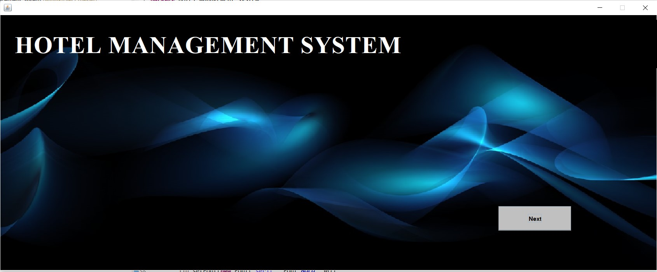

1. **Login Page**

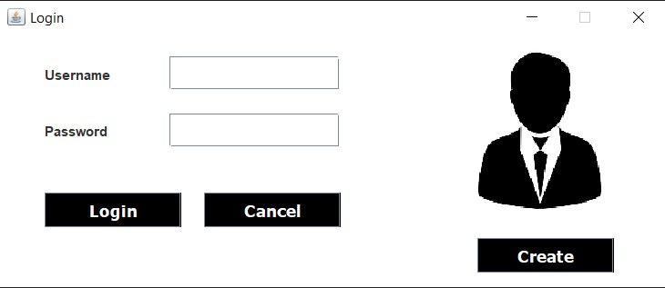

1. **New User Registration Page**

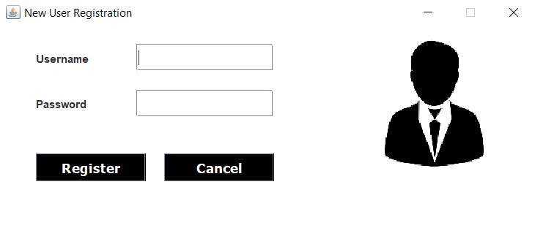

1. **Dashboard**

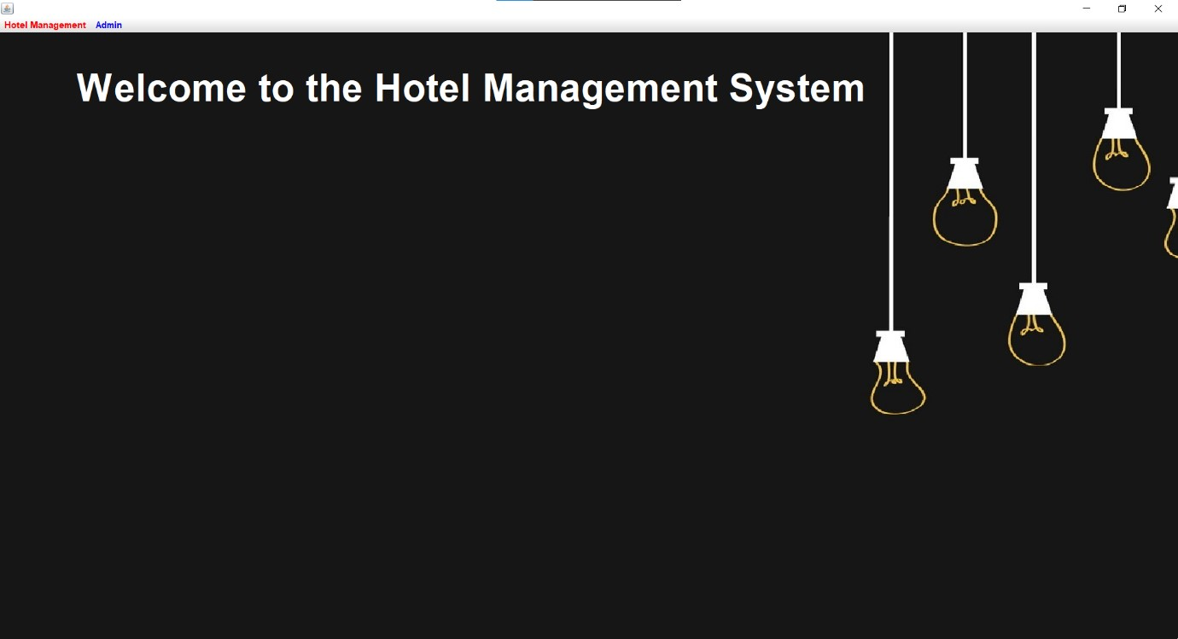

1. **Add Employee Details**

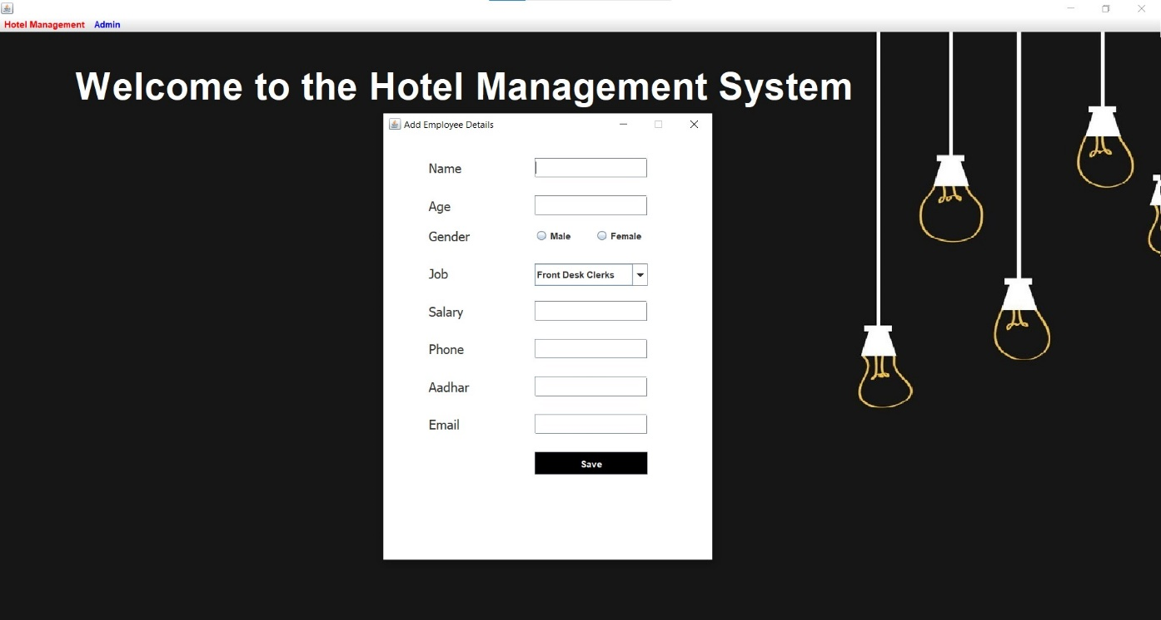

1. **Update Room Status**

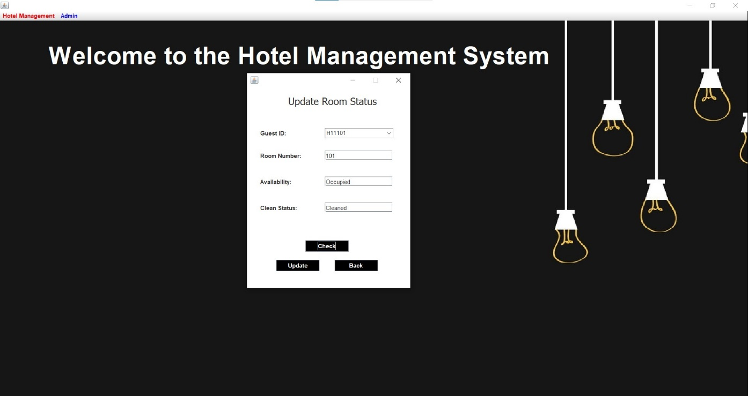

1. **Check – in details**

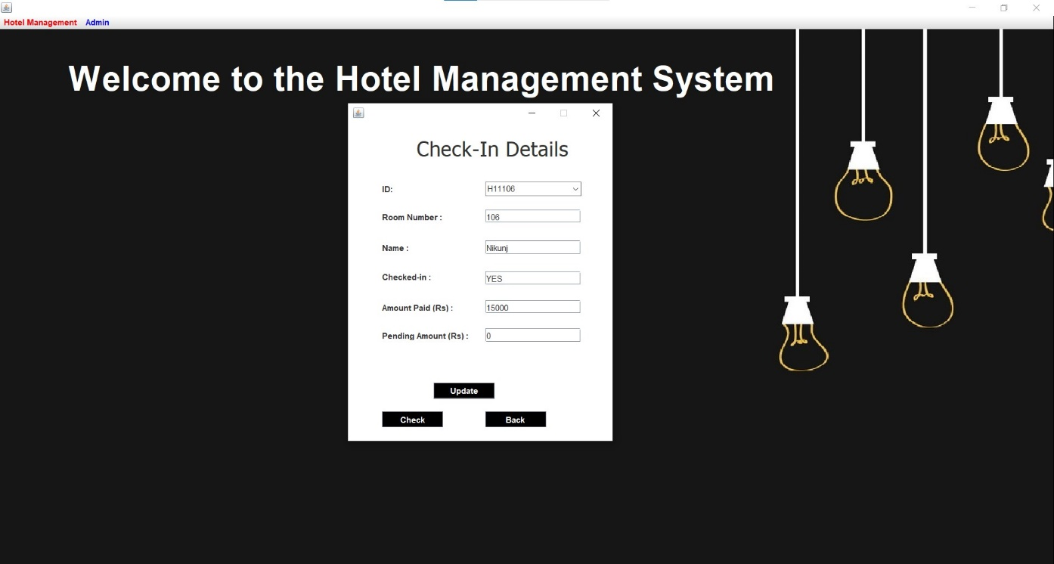

1. **Check – out details**

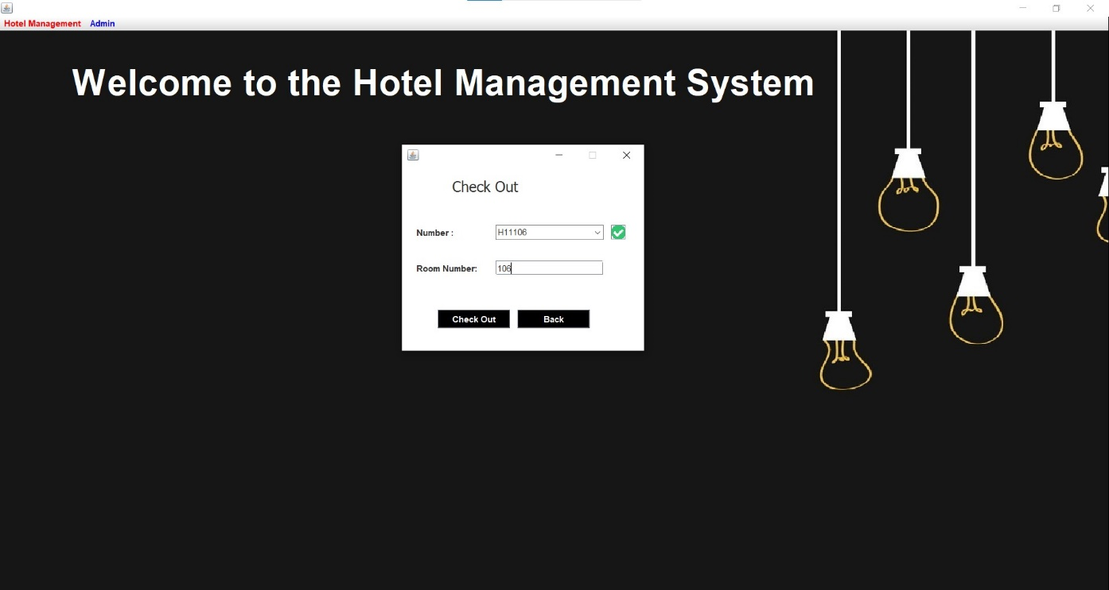

## Manager Details

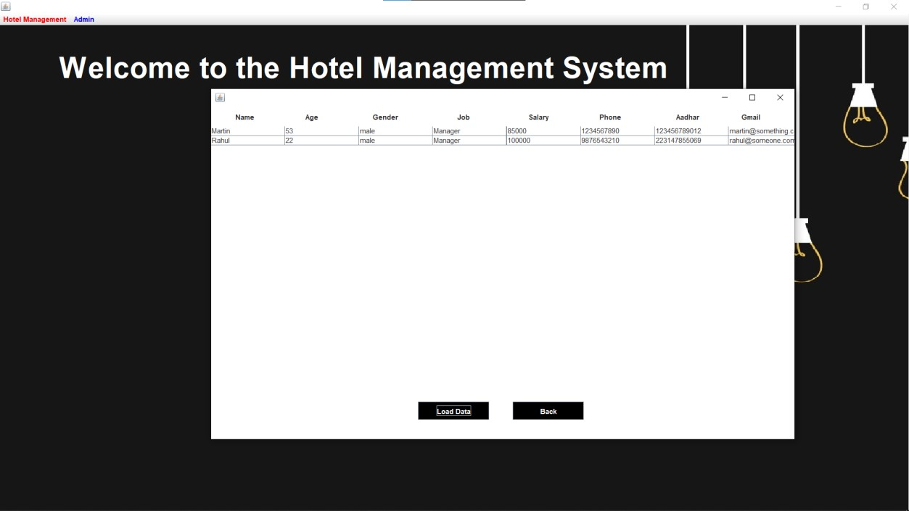

1. **Customer Details**

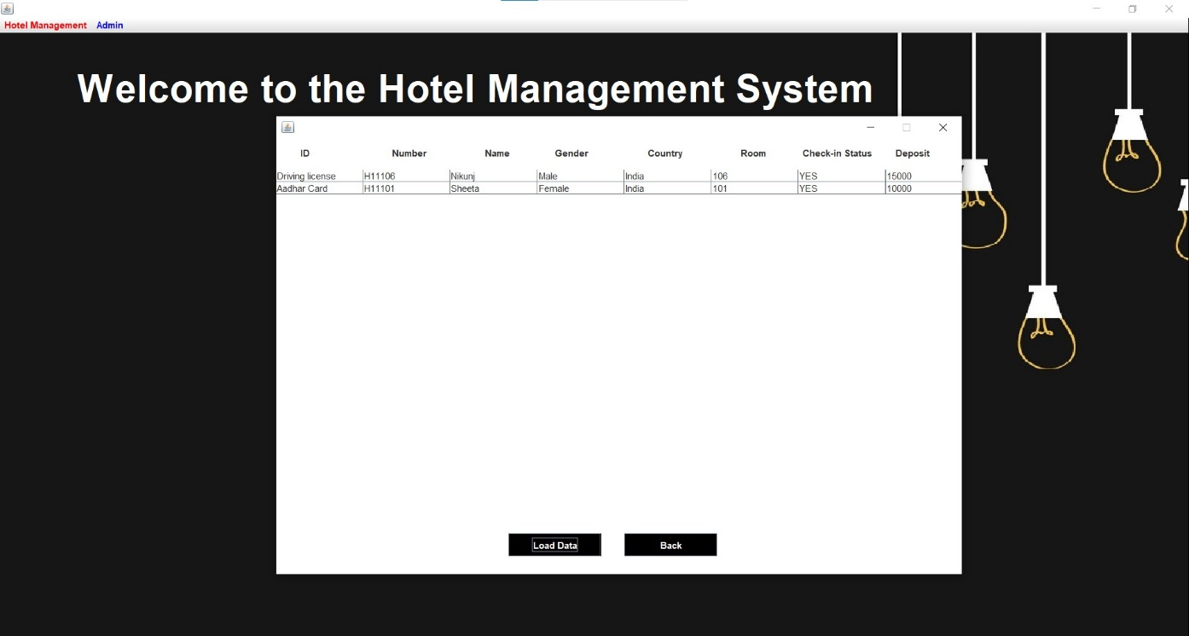

1. **Employee Details**

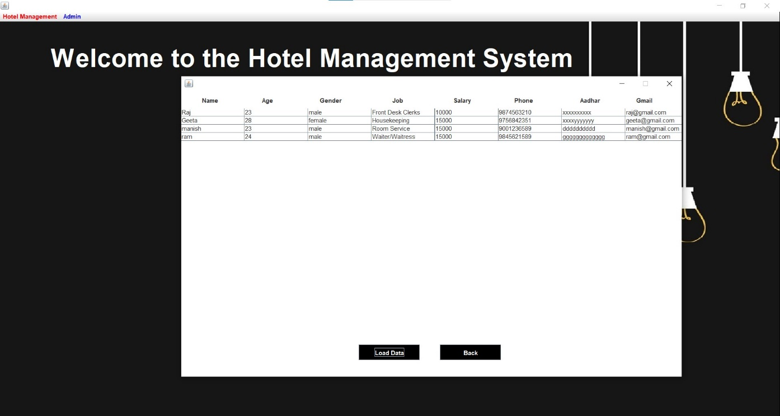

1. **Department Details**

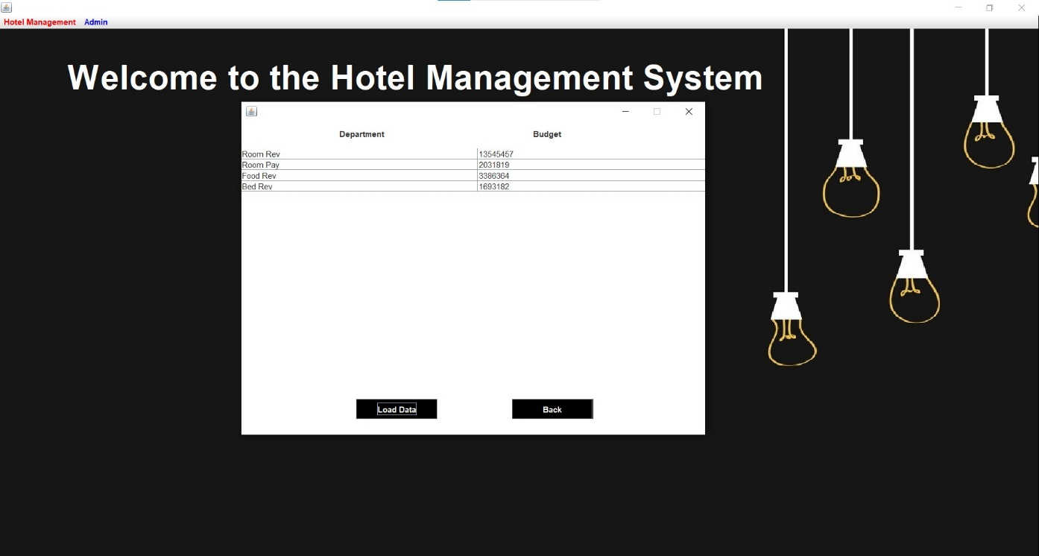

1. **Room Status**

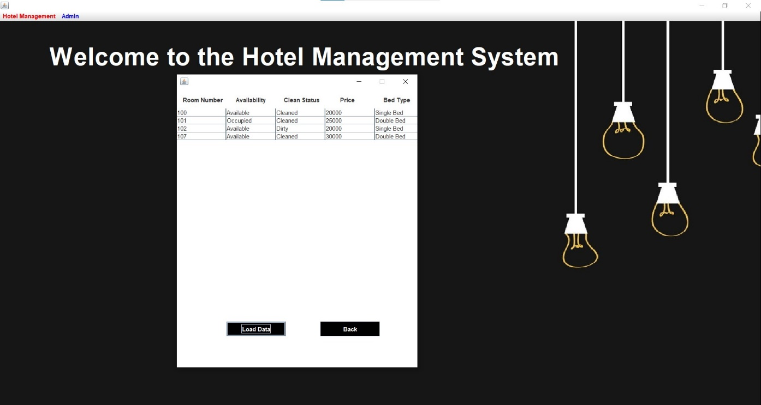

1. **New Customer Details**

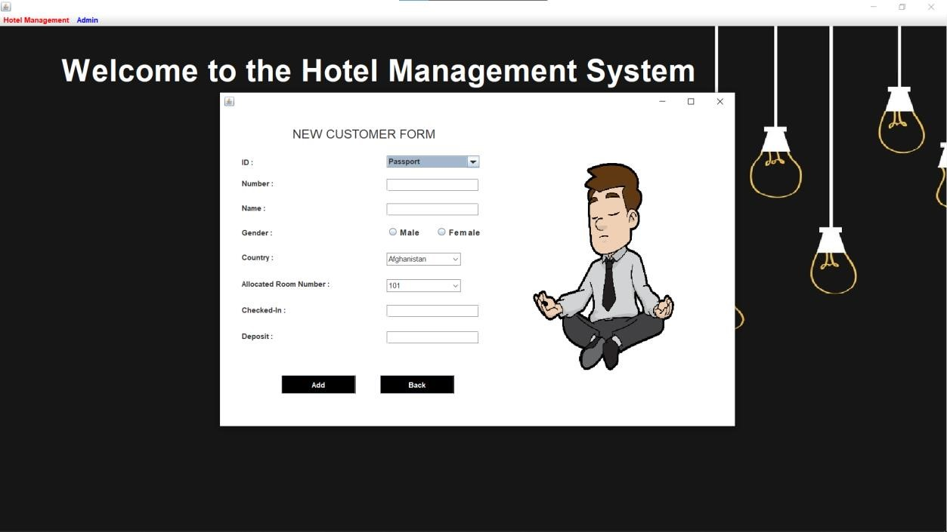

1. **Reception Page**

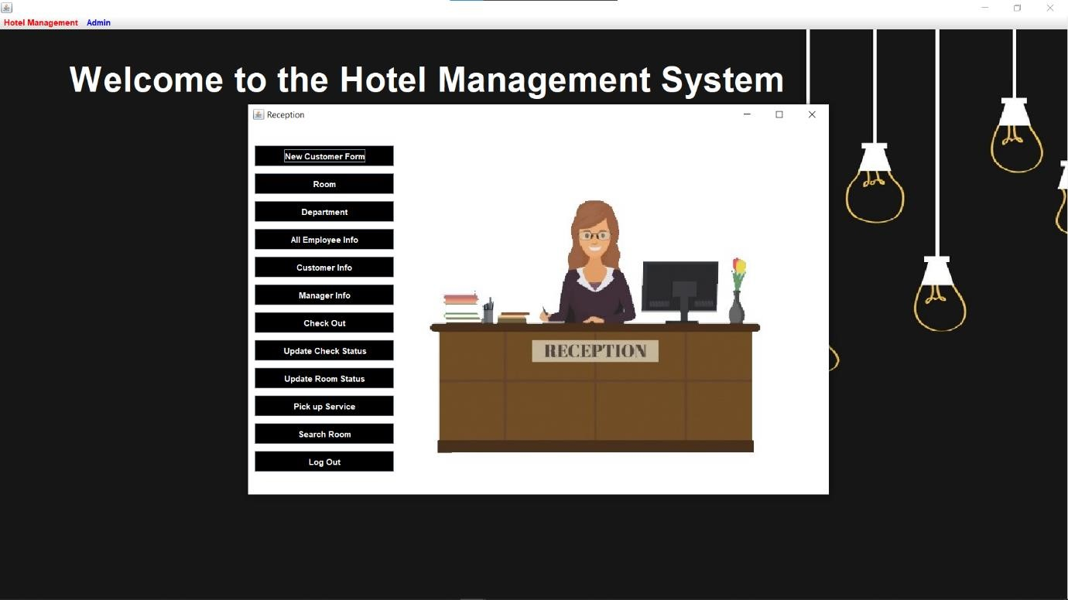

1. **Driver Details**

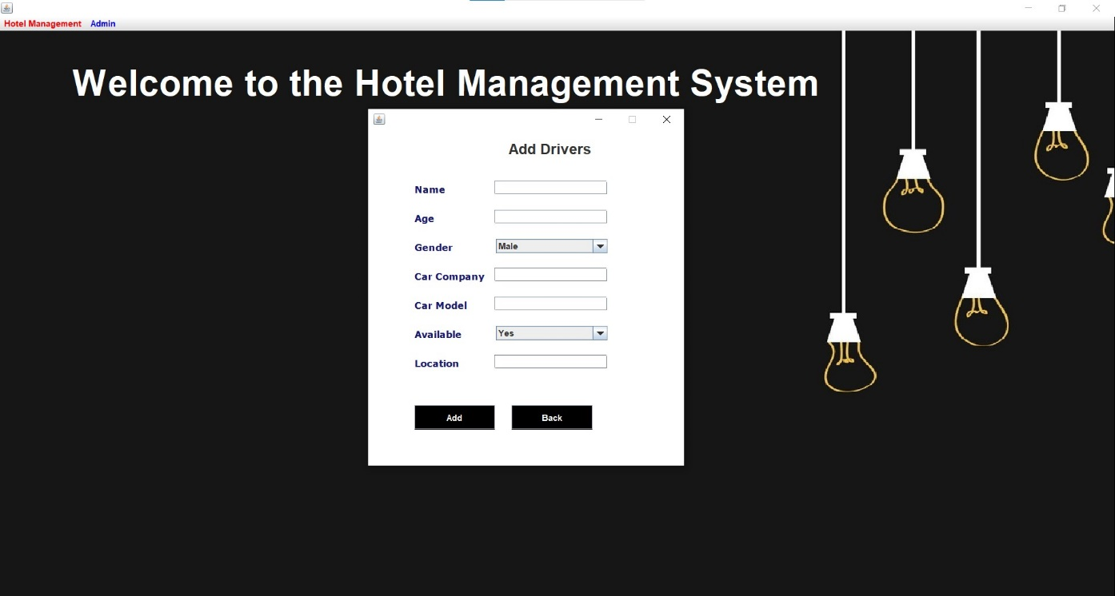

1. **Add Room Details**

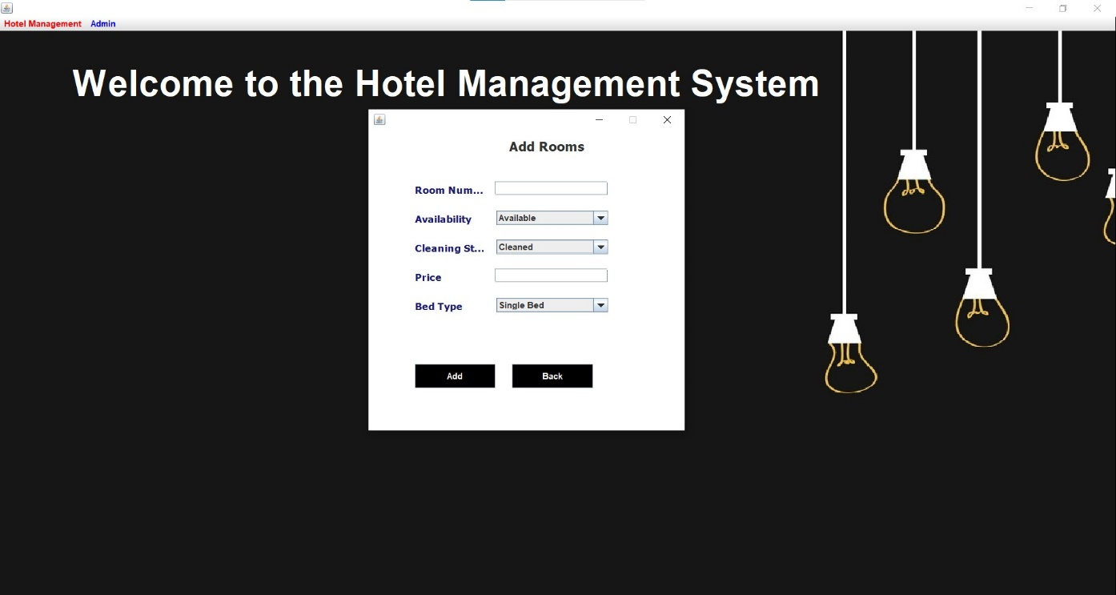

### Search For Rooms

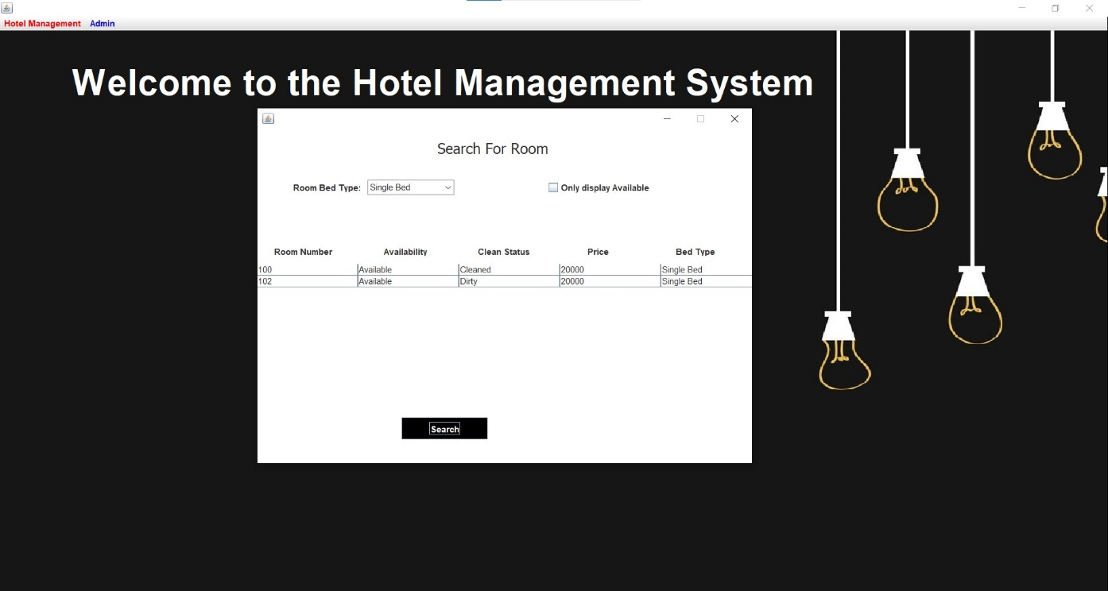

## S) Pick – up service

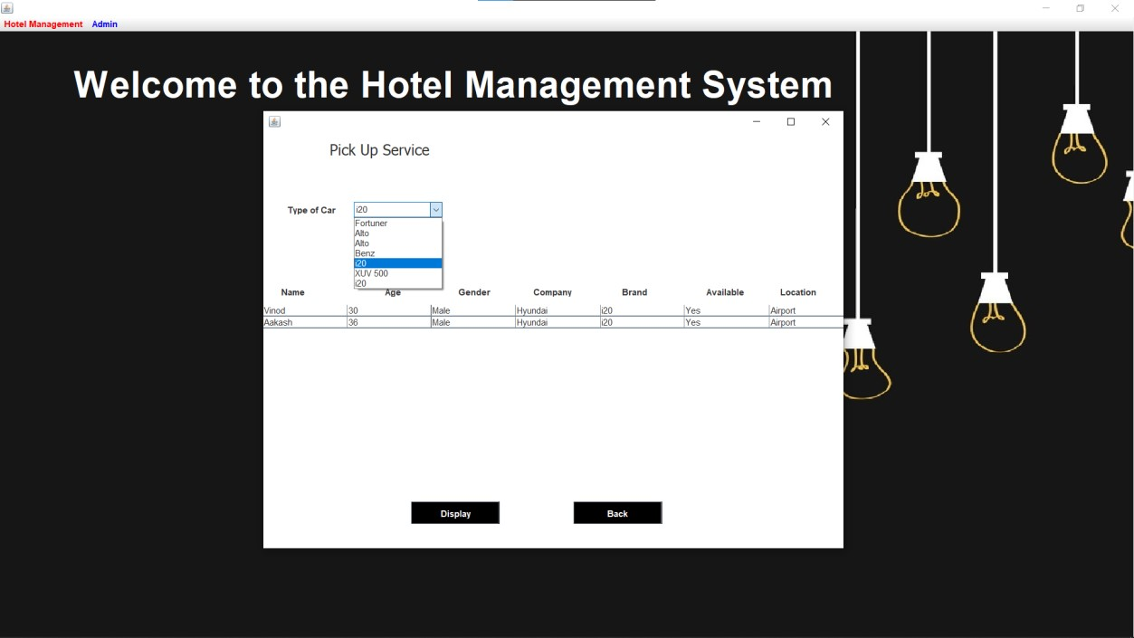

**3.4 Future Scope**

1. Storing the history of all the customers entering the hotel.
2. Generating random key number for a room booked by a customer.