**Bill Management System**

Submitted in partial fulfilment of the requirements of the degree

**BACHELOR OF ENGINEERING** IN **I.T. ENGINEERING**

By

**Anurag Hale 03**

**Shubham Khose 40**

**Nikunj Mistry 64**

Supervisor

**Dr.Madhuri Rao**



**Department of Information Technology**

**Engineering Thadomal Shahani College**

**Bandra(w), Mumbai - 400 050**

**University of Mumbai**

**( AY 2021-22)**

# CERTIFICATE

This is to certify that the Mini Project entitled **“ HOTEL MANAGEMENT SYSTEM ”** is a bona fide work of **Anurag Hale(03),Shubham Khose(40),Nikunj Mistry(64)**submitted to the University of Mumbai in partial fulfilment of the requirement for the award of the degree of **“Bachelor of Engineering”** in **“Department of Information Technology” .**

**(Dr. Madhuri Rao)**

Supervisor

**(Prof._________________ ) (Prof._________________ )**

Head of Department Principal

# Mini Project Approval

This Mini Project entitled “Bill MANAGEMENT SYSTEM**”** by **Anurag Hale(3), Shubham Khose(40), Nikunj Mistry(64)** is approved for the degree of **Bachelor of Engineering** in **Department of Information Technology.**

**Examiners**

**1………………………………………**

(Internal Examiner Name & Sign)

**2…………………………………………**

(External Examiner name & Sign)

Date:

Place:

# Contents

1. **Introduction** 
   1. Introduction
   2. Problem Statement & Objectives
2. **Literature Survey** 
   1. Survey of Existing System
   2. Limitation Existing system or research gap
3. **Proposed System (eg New Approach of Data Summarization )** 
   1. Architecture/ Framework
   2. Algorithm and Process Design

**3.3** Design

* 1. Conclusion and Future work.

**CHAPTER 1**

This chapter gives an overview about objective, problem statement, background and motivation of choosing this topic.

## 1.1 INTRODUCTION

A bill is a record of statement, and transaction of the money. Bill is used to keep

record of business when a person buys some goods or any valuable things.

To track of the all the products sold to the customer and how much products

was there in their reserve. They need to write down all the records in a record

book manually. The bill is not just for keeping the record of transaction, the

bill is used for so many other purposes. They use the data from the bills to

control the extra expenditure and spend on what is needed and also use it

to improve their businesses.

The administrator only is allowed to record and bill the all the purchased

goods, employee details and modify the prices with the aid of a database

functions.

## 1.2 Problem statement and objective

To build an Desktop application program to reduce the manual work and papers. The application will have a convinient features to manage their shopping bills. will have records of customer

The app bears many more function.

* Qrcode generator
* Qrcode Scanner
* Whatsaap Automation with Verification
* Automation of existing customer names

There are new Strategies technologies emerging every day that one needs to track on. How effective one manages their property, pays to have your finger on the pulse. Its thereby essential to have the most effective system incorporating multiple areas with all its ardently meticulously and its caliber.

## CHAPTER 2 - Literature Survey

### 2.1 Survey Of Existing System

* In the existing system, most of the activities takes place manually, manually carrying out this activity in very tedious time consuming. As we have tried to develop computerized application so as to handle all the activity that are related to bills.
* The existing system of Bill Management was manual. So all the daily routines is carried out manually and the bills are either being kept safely for years or are torn up within sometimes.
* Since it is a manual system a lot of time is spent in communicating the information across different branches. There is a need for an integrated automated system, which has some centralized control over the entire process. Conventional System makes use of huge amounts of paper for recording transactions.

#### 2.2 Limitation of Existing System

About 70% of the paper bill are being discarded and lot of papers are being wasted.

**CHAPTER-3**

## 3.1 Framework :-

**Cover Page :-** It includes topic of our mini project and a next button which proceeds to the login page.

**Login Page :-** It includes a Create button which takes you to the new user registration page. The Exit button can be used to exit the program.

**Qrscanner:** It scans the qr code of the employee’s username.

**Billmaker GUI:** It includes making new bills , searching existing bills, automation of existing customer, and whatsapp button to automate whatsapp messages.

**3.2 Algorithm and process design**

Steps to run the project :

* Run the application
* If the user is a new employee than click on register to create qr code else login button.
* Qr scanner will scan the qr code
* After successful password prompt bill gui pops up.

**3.3 Design**

## A) Cover Page

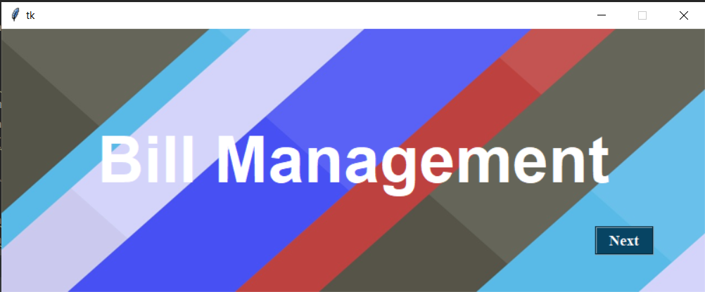

1. **Login Page**

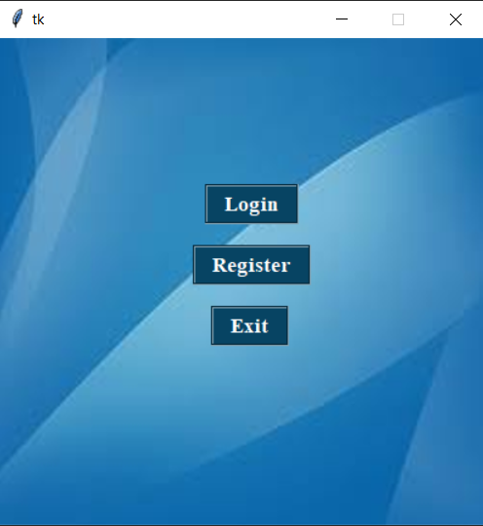

1. **Registration Page**

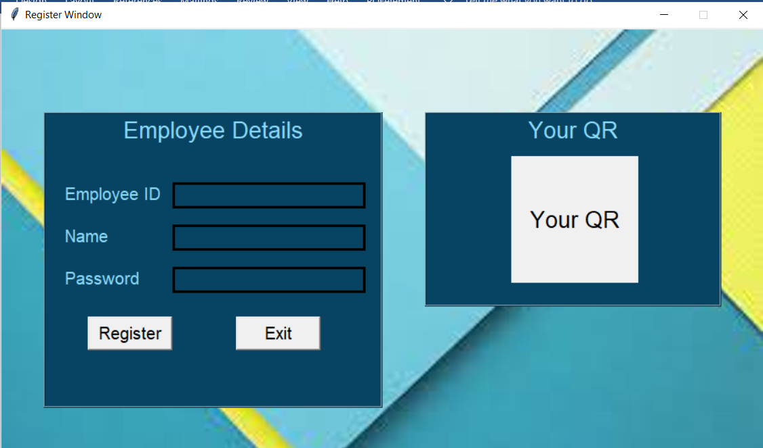

1. **Qrscanner**

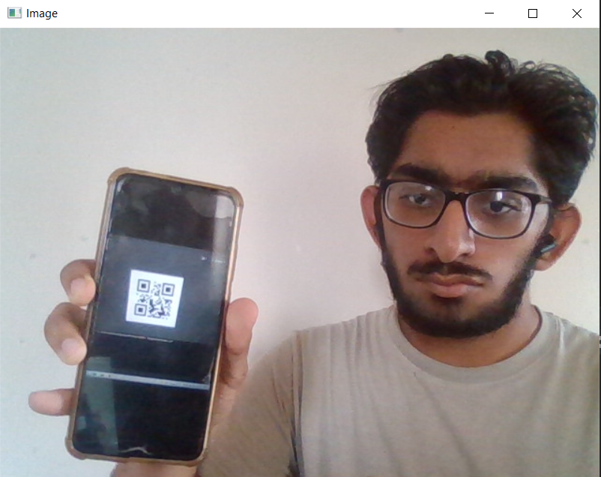

1. **Password of qrcode**

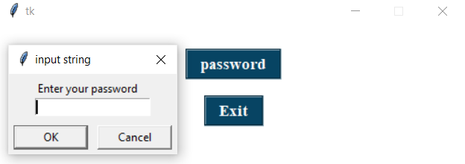

1. **Bill GUI**

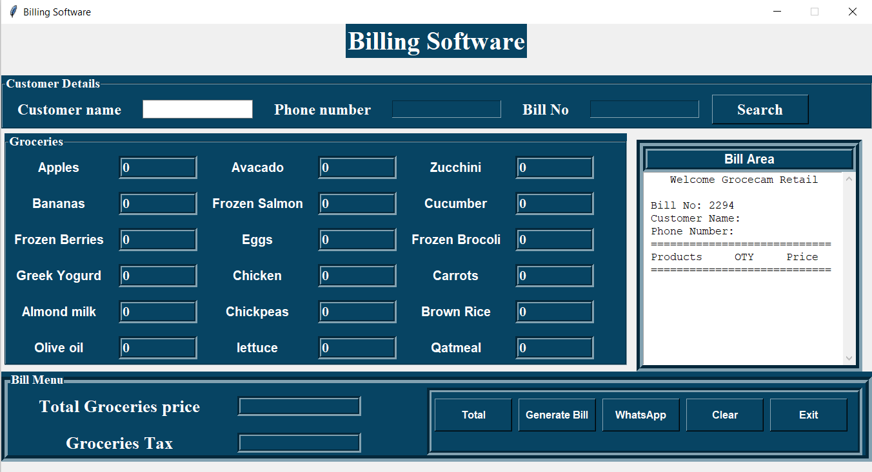

**3.4 Future Scope**

1. Improve the model so that it can run in low internet speed also.
2. Screenshot of qr scanner after succefully login.