**Session-3 Lab**

**Assignment 1:**

● Write a Java program named Car

● The Car class should have the following attributes: make (String), model (String) , year (short) , and price(int) .

● The car class should have a constructor that takes all the attributes.

● Add a main method to instantiate car objects.

● The program should allow the user to create and display objects of each Car Class.

Solution:

package session3.lab;  
  
import java.util.Scanner;  
  
public class Car {  
 String make;  
 String model;  
 short year;  
 int price;  
 public static void main(String[] args){  
 Scanner scanner = new Scanner(System.*in*);  
  
 System.*out*.println("Enter a car make/Name:");  
 String make = scanner.nextLine();  
  
 System.*out*.println("Enter a car model:");  
 String model = scanner.nextLine();  
  
 System.*out*.println("Enter a car year:");  
 short year = scanner.nextShort();  
  
 System.*out*.println("Enter a car Price:");  
 int price = scanner.nextInt();  
  
 Car mycar = new Car(make,model,year,price);  
  
 mycar.displayCar();  
  
 scanner.close();  
  
 }  
 // for taking all attributes here is Constructor  
 public Car(String make, String model, short year, int price){  
 this.make = make;  
 this.model = model;  
 this.year= year;  
 this.price = price;  
 }  
  
 // To Display details of CAr  
  
 public void displayCar(){  
 System.*out*.println("Car details: ");  
 System.*out*.println("make: "+ make);  
 System.*out*.println("model:"+ model);  
 System.*out*.println("Year: "+ year);  
 System.*out*.println("Price: "+ price);  
 }  
  
  
}

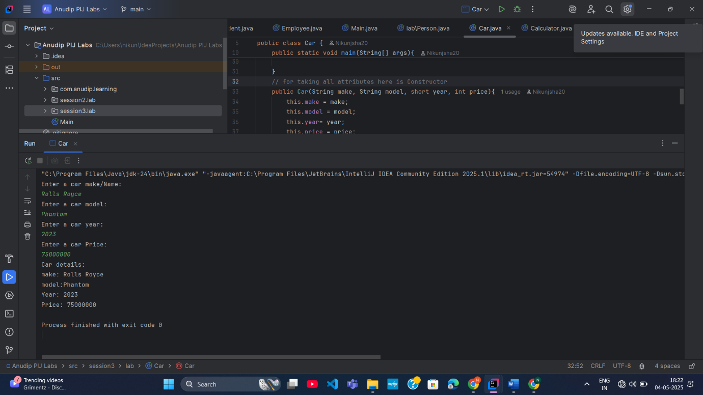

**Assignment 2:**

● Write a Java program that demonstrates method overloading by creating a class called Calculator.

● Add three methods called add().

● The first add() method should take two int variables as arguments and return their sum as int.

● The second add() method should take three int variables as arguments and return their sum as int.

● The third add() method should take two doubles as arguments and return their sum as double.

● The program should allow the user to display the results of each method.

Solution:

package session3.lab;  
import java.util.Scanner;  
  
public class Calculator {  
 public static void main(String [] args){  
 int ans1 = *add*(29,40);  
 System.*out*.println("Sum of Two integer number: "+ ans1);  
  
 int ans2 = *add*(10,20,30);  
 System.*out*.println("Sum of Three integer number: "+ ans2);  
  
 double ans3 = *add*(230.34, 345.67);  
 System.*out*.println("Sum of Two double/float number: "+ ans3);  
 }  
 public static int add(int num1, int num2){  
 return num1+num2;  
 }  
 public static int add(int num1, int num2, int num3){  
 return num1+num2+num3;  
 }  
  
 public static double add(double num1, double num2){  
 return num1+num2;  
 }  
}

