x coordinate [mm]

Number of hits

**Hit distribution for align v2**

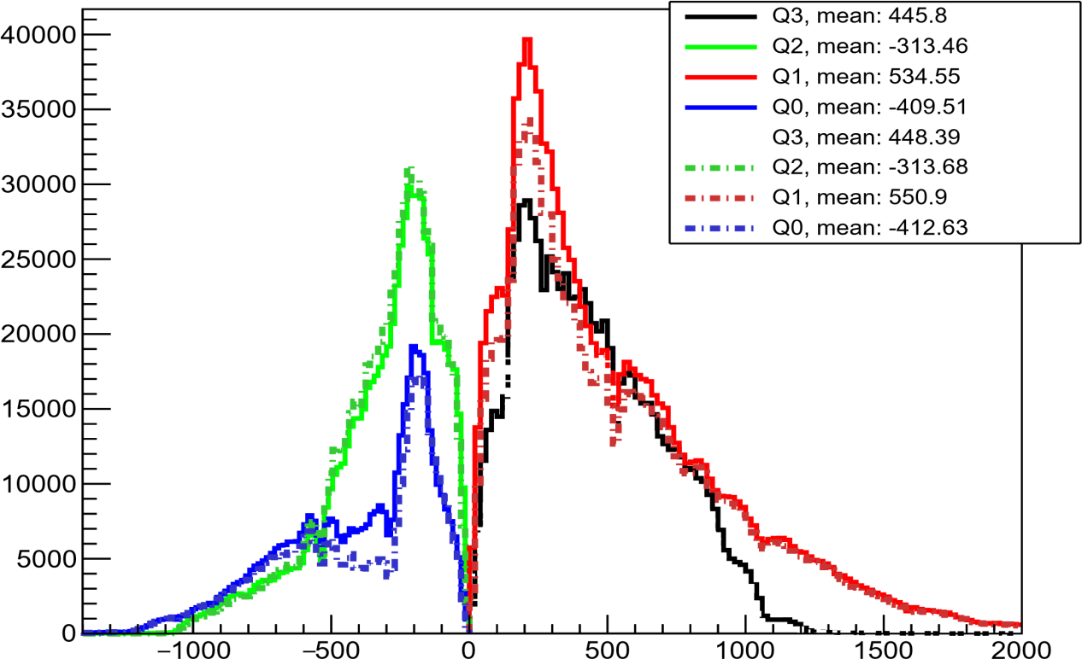

g