Hit distribution for align V2

Number of hits

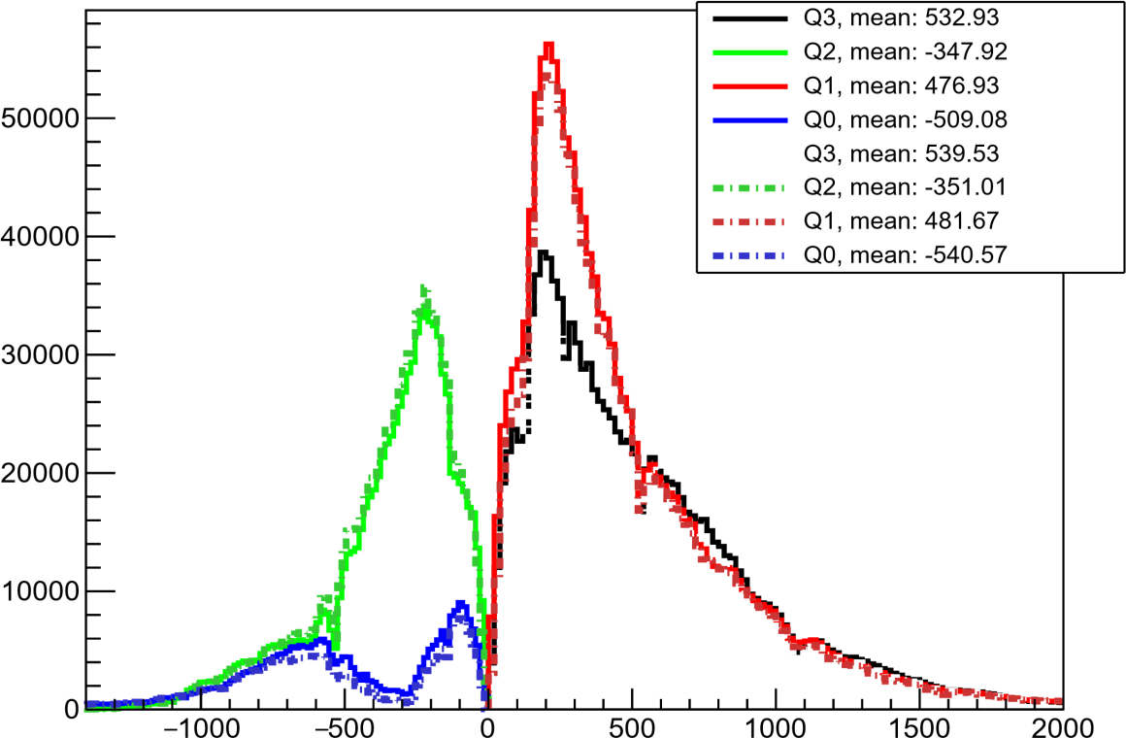

x coordinate [mm]