node_X, run256145_V2, alignment, (9hits solid|11hits dashed)

#hits

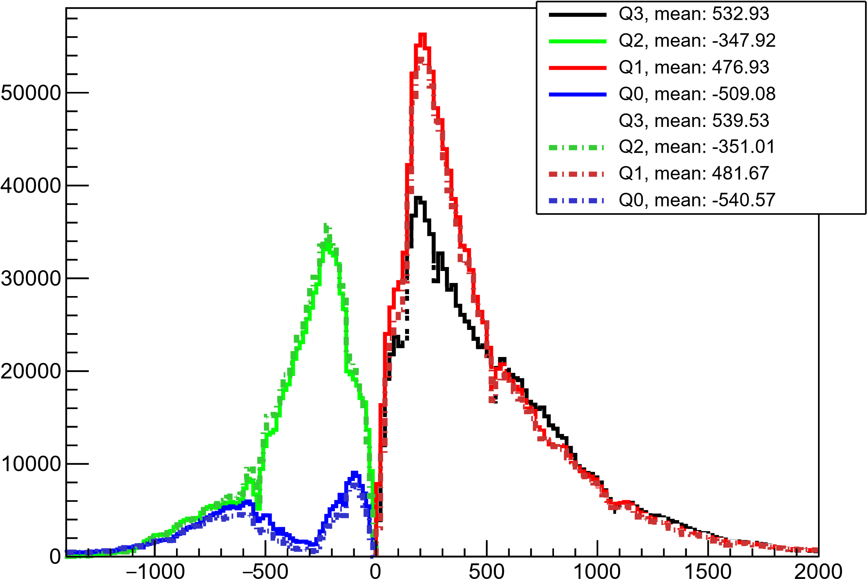

x in v1 [mm]