**Part A of the Project**

--For avg acceptane rate of super_host vs other_host For City Athens

SELECT Host_is_superhost,SUM(host_listings_count) [Total listings],AVG(avgAR) AVgAcceptanceRate FROM(

SELECT Host_is_superhost, host_listings_count, AVG(host_acceptance_rate) as avgAR from Greece_Athens.dbo.host_athens_df

GROUP BY Host_is_superhost,host_listings_count)A

WHERE Host_is_superhost IS NOT NULL

GROUP by Host_is_superhost;

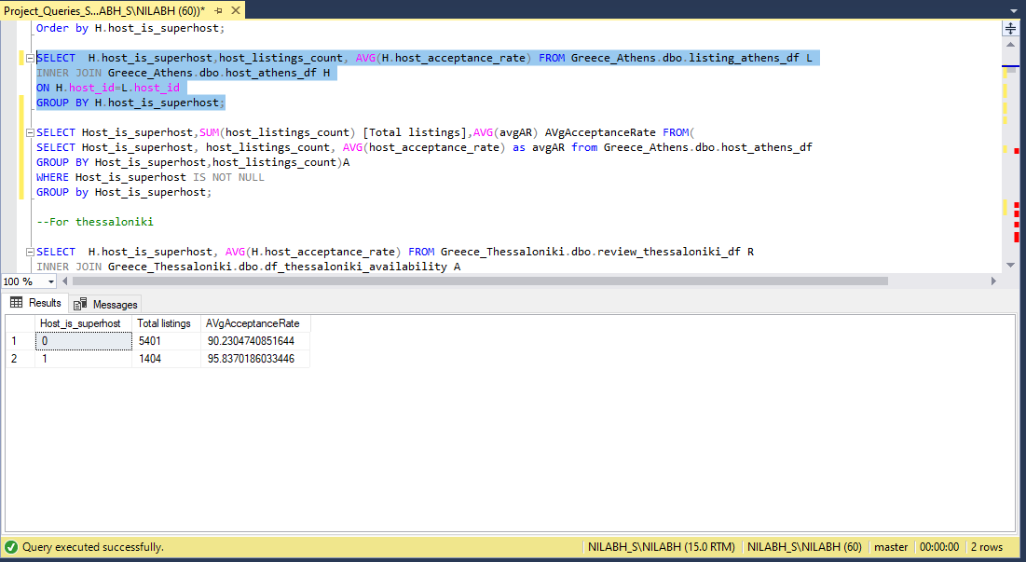

--For avg acceptane rate of super_host vs other_host For City Thessaloniki

SELECT Host_is_superhost,SUM(host_listings_count) [Total listings],

AVG(avgAR) AVgAcceptanceRate FROM(

SELECT Host_is_superhost, host_listings_count, AVG(host_acceptance_rate) as avgAR

from Greece_Thessaloniki.dbo.host_thessaloniki_df

GROUP BY Host_is_superhost,host_listings_count)A

WHERE Host_is_superhost IS NOT NULL

GROUP by Host_is_superhost;

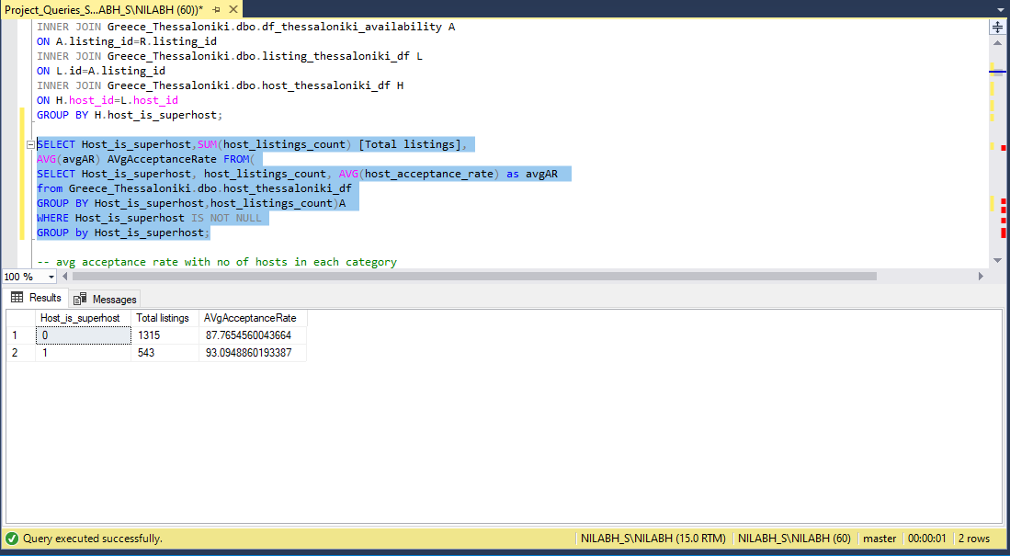

--No of hosts that Provide instant bookable in each category

--For Athens

SELECT H.host_is_superhost, H.host_response_time,AVG(H.host_acceptance_rate) AVG_Acceptance_Rate, COUNT(H.host_is_superhost) Host_count,

SUM(CAST(L.instant_bookable AS INT)) Host_Provide_instant_booking

FROM Greece_Athens.dbo.host_athens_df H

INNER JOIN Greece_Athens.dbo.listing_athens_df L

ON H.host_id=L.host_id

WHERE H.host_is_superhost IS NOT NULL

GROUP BY H.host_is_superhost, H.host_response_time

ORDER BY H.host_is_superhost;

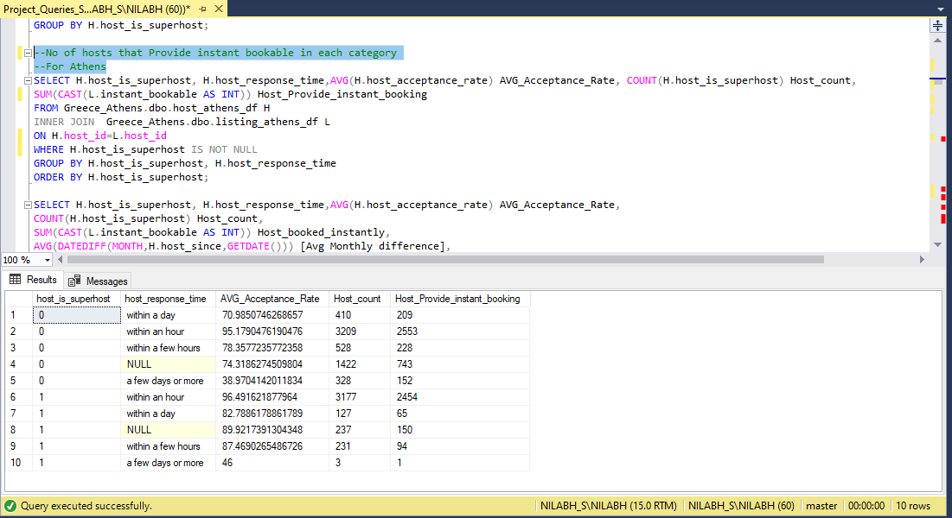

--No of hosts that Provide instant bookable in each category with age of host in months since joined

SELECT H.host_is_superhost, H.host_response_time,AVG(H.host_acceptance_rate) AVG_Acceptance_Rate,

COUNT(H.host_is_superhost) Host_count,

SUM(CAST(L.instant_bookable AS INT)) Host_booked_instantly,

AVG(DATEDIFF(MONTH,H.host_since,GETDATE())) [Avg Monthly difference],

AVG(DATEDIFF(YEAR,H.host_since,GETDATE())) [Avg Yearly difference]

FROM Greece_Athens.dbo.host_athens_df H

INNER JOIN Greece_Athens.dbo.listing_athens_df L

ON H.host_id=L.host_id

WHERE H.host_is_superhost IS NOT NULL

GROUP BY H.host_is_superhost, H.host_response_time

ORDER BY H.host_is_superhost;

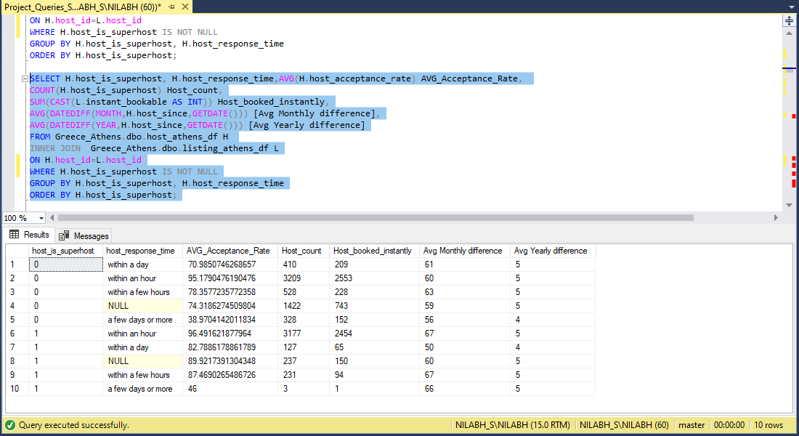

--No of hosts that Provide instant bookable in each category

--For Thessaloniki

SELECT H.host_is_superhost, H.host_response_time,AVG(H.host_acceptance_rate) AVG_Acceptance_Rate,

COUNT(H.host_is_superhost) Host_count,

SUM(CAST(L.instant_bookable AS INT)) Host_booked_instantly

FROM Greece_Thessaloniki.dbo.host_thessaloniki_df H

INNER JOIN Greece_Thessaloniki.dbo.listing_thessaloniki_df L

ON H.host_id=L.host_id

GROUP BY H.host_is_superhost, H.host_response_time

ORDER BY H.host_is_superhost;

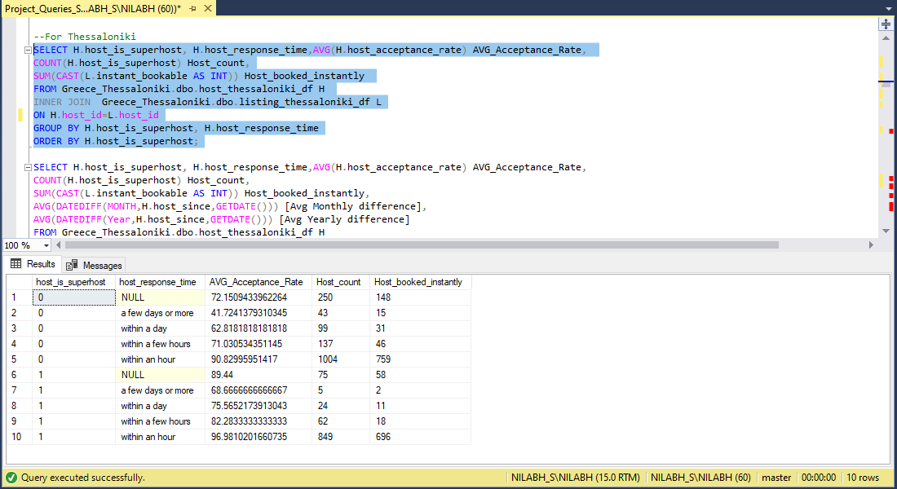

--No of hosts that Provide instant bookable in each category with age of host in months since joined

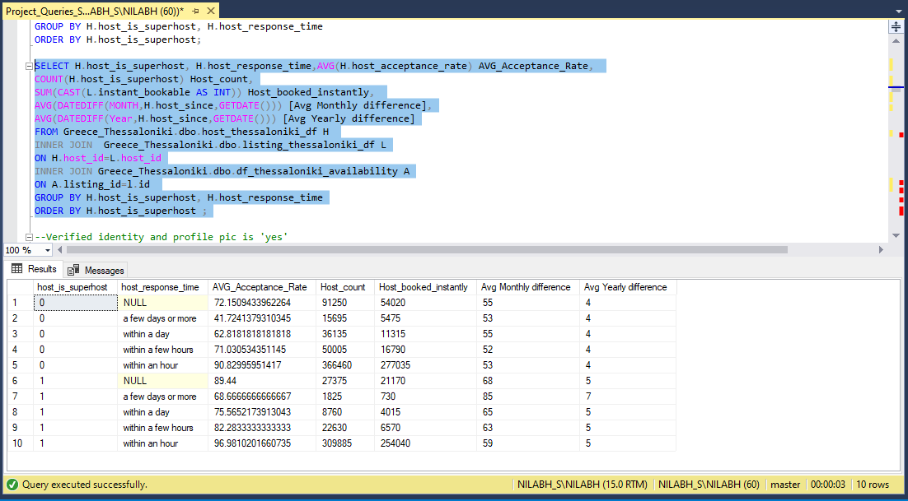

--Verified identity and profile pic is 'yes'

--For Athens

SELECT H.host_is_superhost, COUNT(host_is_superhost) #OfHosts,

SUM(host_listings_count) Host_holds_listing,

sum(CAST(H.host_identity_verified AS INT)) [Verified Identity],

sum(CAST(H.host_has_profile_pic AS INT)) [Profile Pic is YES]

FROM Greece_Athens.dbo.host_athens_df H

WHERE H.host_is_superhost IS NOT NULL

GROUP BY H.host_is_superhost

order by H.host_is_superhost;

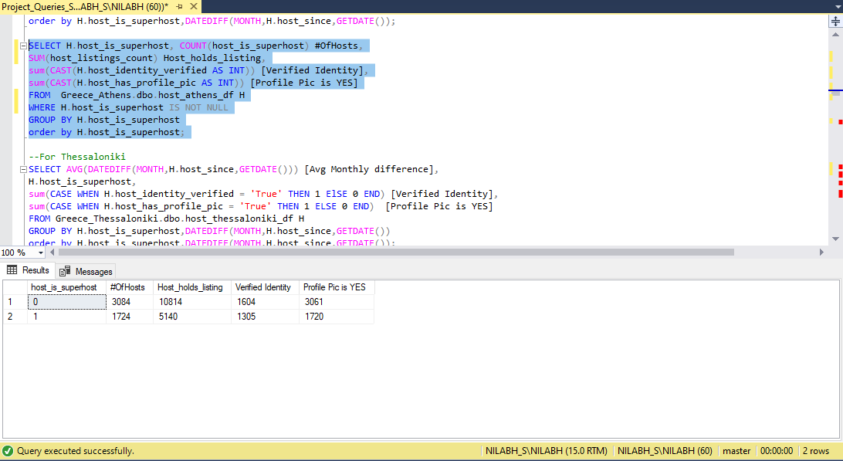

--Verified identity and profile pic is 'yes'

--For Thessaloniki

SELECT H.host_is_superhost, COUNT(host_is_superhost) #OfHosts,

SUM(host_listings_count) Host_holds_listing,

sum(CASE WHEN H.host_identity_verified = 'True' THEN 1 ElSE 0 END) [Verified Identity],

sum(CASE WHEN H.host_has_profile_pic = 'True' THEN 1 ELSE 0 END) [Profile Pic is YES]

FROM Greece_Thessaloniki.dbo.host_thessaloniki_df H

GROUP BY H.host_is_superhost

order by H.host_is_superhost;

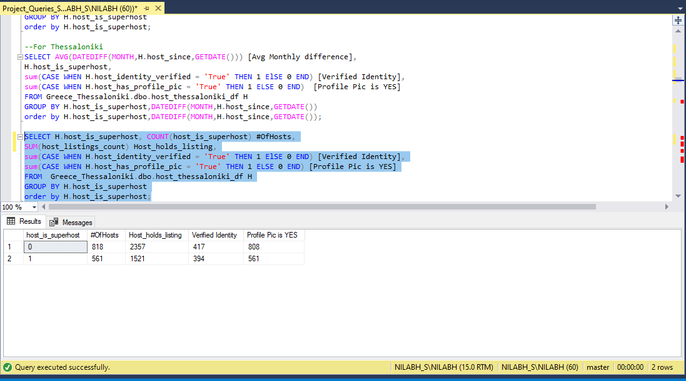

--AVG ratings for hosts according to year of joining the company

--For Athens

SELECT H.host_is_superhost,COUNT(H.host_is_superhost) #ofHosts,

DATEPART(YEAR,H.host_since) [Host joining year],COUNT(L.host_id) [listing belongs to host] ,

ROUND(AVG(L.review_scores_accuracy),2) R_Accuracy,ROUND(AVG(L.review_scores_checkin),2) R_Checkin,

ROUND(AVG(L.review_scores_cleanliness),2) R_Cleanliness,ROUND(AVG(L.review_scores_communication),2) R_Communication,

ROUND(AVG(L.review_scores_location),2) R_location,

ROUND(AVG(L.review_scores_rating),2) R_Rating,

ROUND(AVG(L.review_scores_value),2) R_Value,

ROUND(AVG(H.host_response_rate),2) Host_Response_Rate

FROM Greece_Athens.dbo.listing_athens_df L

INNER JOIN Greece_Athens.dbo.host_athens_df H

ON H.host_id=L.host_id

GROUP BY H.host_is_superhost,DATEPART(YEAR,H.host_since)

ORDER BY H.host_is_superhost,DATEPART(YEAR,H.host_since);

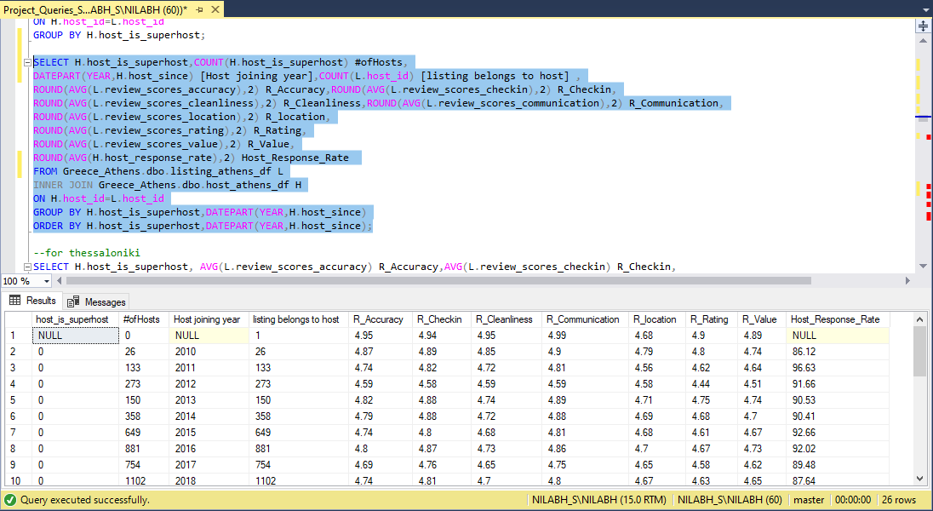

--AVG ratings for hosts according to year of joining the company

--For Thessaloniki

SELECT H.host_is_superhost,DATEPART(YEAR,H.host_since) [Host joining year],

COUNT(L.host_id) [listing belongs to host] ,

ROUND(AVG(L.review_scores_accuracy),2) R_Accuracy,

ROUND(AVG(L.review_scores_checkin),2) R_Checkin,

ROUND(AVG(L.review_scores_cleanliness),2) R_Cleanliness,

ROUND(AVG(L.review_scores_communication),2) R_Communication,

ROUND(AVG(L.review_scores_location),2) R_location,

ROUND(AVG(L.review_scores_rating),2) R_Rating,

ROUND(AVG(L.review_scores_value),2) R_Value,

ROUND(AVG(H.host_response_rate),2) Host_Response_Rate

FROM Greece_Thessaloniki.dbo.review_thessaloniki_df R

INNER JOIN Greece_Thessaloniki.dbo.listing_thessaloniki_df L

ON L.id=R.listing_id

INNER JOIN Greece_Thessaloniki.dbo.host_thessaloniki_df H

ON H.host_id=L.host_id

GROUP BY H.host_is_superhost,DATEPART(YEAR,H.host_since)

ORDER BY H.host_is_superhost,DATEPART(YEAR,H.host_since);

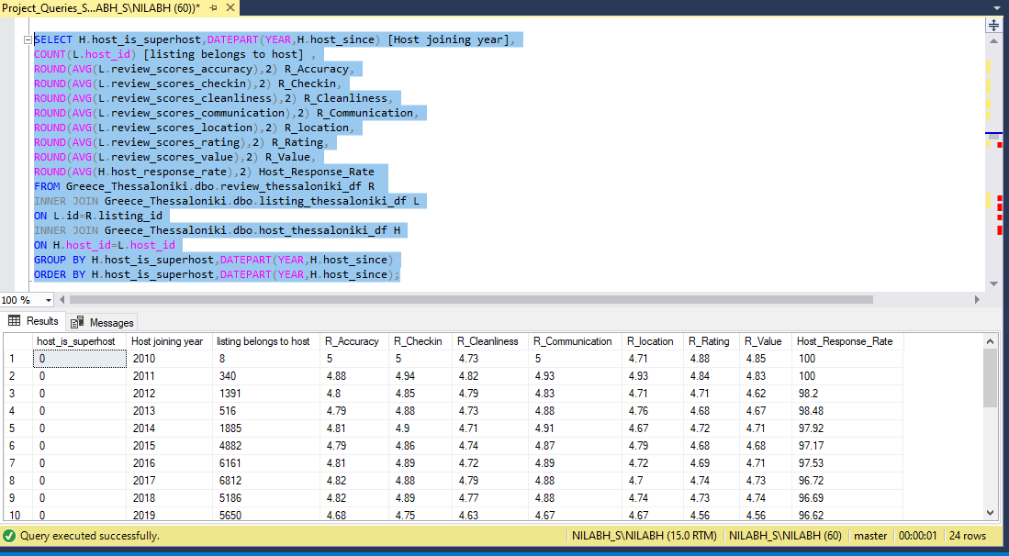

--AVG ratings for hosts with host since joined

--For athens

SELECT DATEDIFF(YEAR,H.host_since,GETDATE()) [Age of Host WRT Company],H.host_is_superhost,

ROUND(AVG(L.review_scores_accuracy),2) R_Accuracy,

ROUND(AVG(L.review_scores_checkin),2) R_Checkin,

ROUND(AVG(L.review_scores_cleanliness),2) R_Cleanliness,

ROUND(AVG(L.review_scores_communication),2) R_Communication,

ROUND(AVG(L.review_scores_location),2) R_location,

ROUND(AVG(L.review_scores_rating),2) R_Rating,

ROUND(AVG(L.review_scores_value),2) R_Value,

ROUND(AVG(H.host_response_rate),2) Avg_response_rate

FROM Greece_Athens.dbo.df_athens_availability A

INNER JOIN Greece_Athens.dbo.listing_athens_df L

ON L.id=A.listing_id

INNER JOIN Greece_Athens.dbo.host_athens_df H

ON H.host_id=L.host_id

GROUP BY H.host_is_superhost,DATEDIFF(YEAR,H.host_since,GETDATE())

ORDER BY DATEDIFF(YEAR,H.host_since,GETDATE()),H.host_is_superhost;

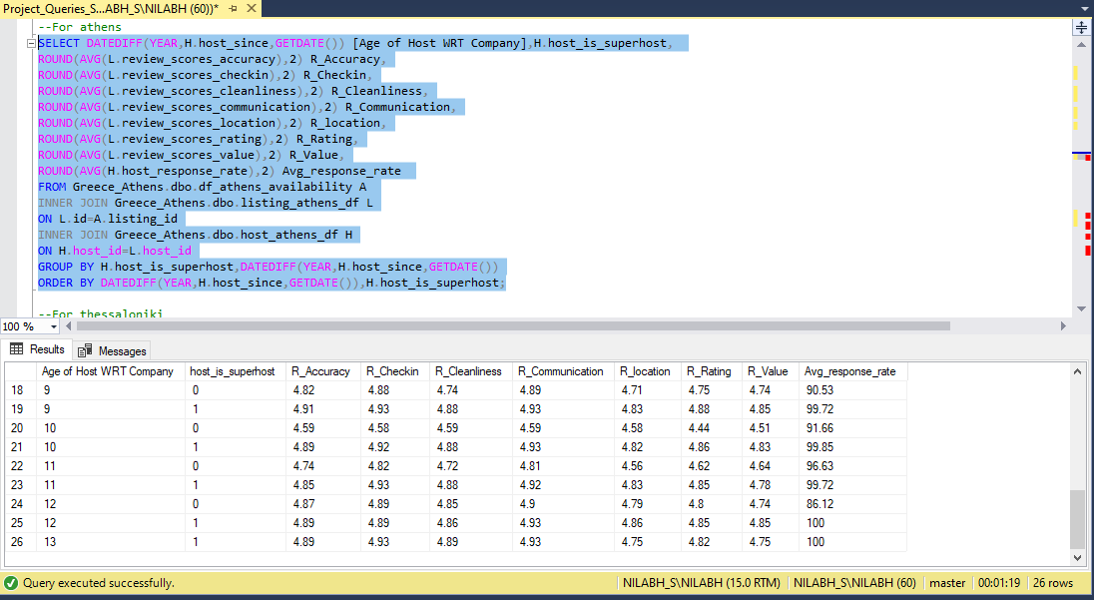

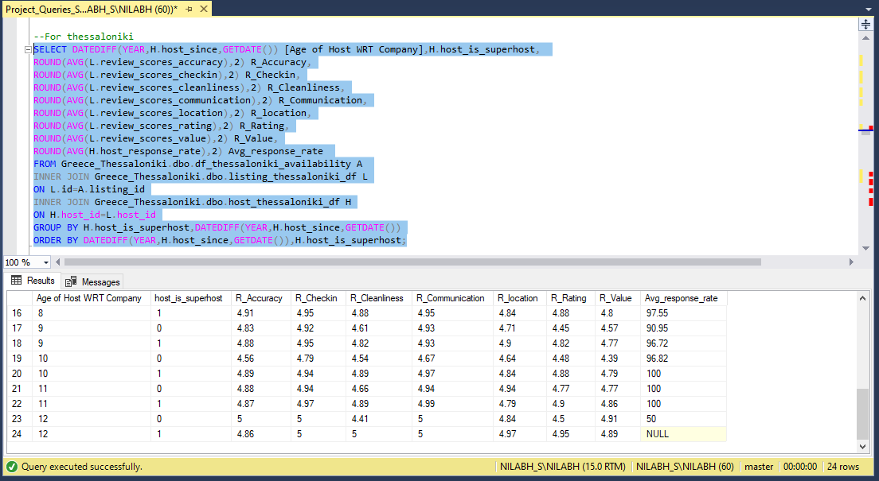

--AVG no of booking per month for all cases  
--For Athens

SELECT [year],host_is_superhost,SUM([NoofBokking]) NoOfBooking FROM(

SELECT DATENAME(YEAR,H.host_since) [year],H.host_is_superhost,

COUNT(R.reviewer_id) [NoofBokking]

FROM Greece_Athens.dbo.review_athens_df R

INNER JOIN Greece_Athens.dbo.listing_athens_df L

ON L.id=R.listing_id

INNER JOIN Greece_Athens.dbo.host_athens_df H

ON H.host_id=L.host_id

GROUP BY H.host_is_superhost,DATENAME(YEAR,H.host_since))A GROUP BY [year],host_is_superhost,[NoofBokking] ORDER BY [Year]

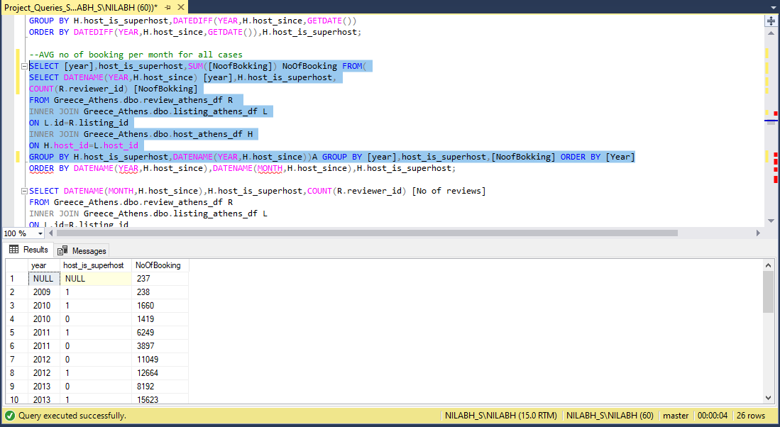

--For Thessaloniki (Month wise and year)

SELECT DATENAME(MONTH,H.host_since),DATENAME(YEAR,H.host_since),

H.host_is_superhost,

COUNT(R.reviewer_id) [No of reviews]

FROM Greece_Thessaloniki.dbo.review_thessaloniki_df R

INNER JOIN Greece_Thessaloniki.dbo.listing_thessaloniki_df L

ON L.id=R.listing_id

INNER JOIN Greece_Thessaloniki.dbo.host_thessaloniki_df H

ON H.host_id=L.host_id

GROUP BY H.host_is_superhost,DATENAME(MONTH,H.host_since),DATENAME(YEAR,H.host_since)

ORDER BY DATENAME(YEAR,H.host_since),DATENAME(MONTH,H.host_since),H.host_is_superhost;

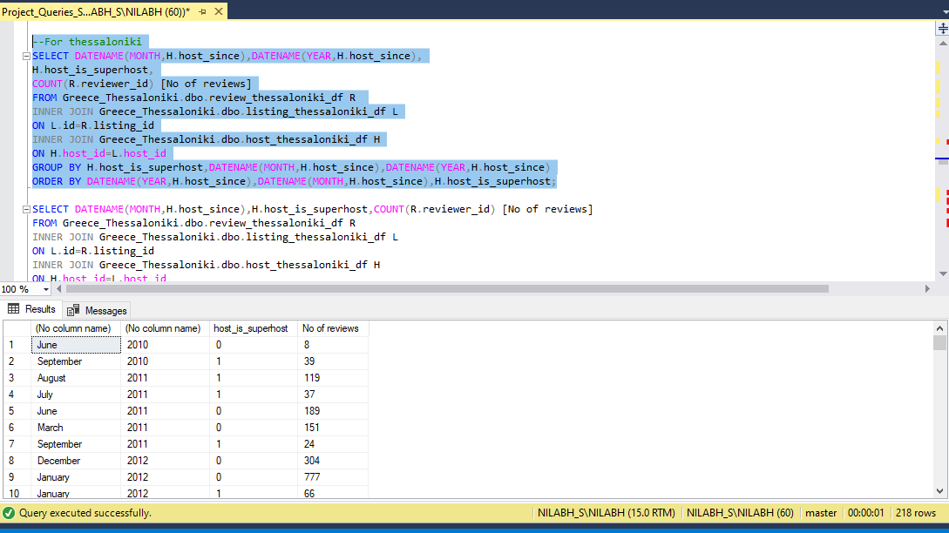

--c. Analyze how does the comments of reviewers vary for listings of Super Hosts vs Other Hosts

--(Extract words from the comments provided by the reviewers)  
--For Athens

SELECT H.host_is_superhost,COUNT(CASE WHEN CHARINDEX('great', R.comments,1)>0 THEN 1 ELSE NULL END) Count_great,

COUNT(CASE WHEN CHARINDEX('Amazing', R.comments,1)>0 THEN 1 ELSE NULL END) Count_Amazing,

COUNT(CASE WHEN CHARINDEX('Friendly', R.comments,1)>0 THEN 1 ELSE NULL END) Count_Friendly,

COUNT(CASE WHEN CHARINDEX('recommend', R.comments,1)>0 THEN 1 ELSE NULL END) Count_recommend,

COUNT(CASE WHEN CHARINDEX(H.host_neighbourhood, R.comments,1)>0 THEN 1 ELSE NULL END) Count_host_neighbourhood,

COUNT(CASE WHEN CHARINDEX('helpful', R.comments,1)>0 THEN 1 ELSE NULL END) Count_helpful,

COUNT(CASE WHEN CHARINDEX(H.host_name, R.comments,1)>0 THEN 1 ELSE NULL END) Count_host_name,

COUNT(CASE WHEN CHARINDEX('very nice', R.comments,1)>0 THEN 1 ELSE NULL END) Count_very_nice,

COUNT(CASE WHEN CHARINDEX('home', R.comments,1)>0 THEN 1 ELSE NULL END) Count_home,

COUNT(CASE WHEN CHARINDEX('decorated', R.comments,1)>0 THEN 1 ELSE NULL END) Count_decorated,

COUNT(CASE WHEN CHARINDEX('refurbished', R.comments,1)>0 THEN 1 ELSE NULL END) Count_refurbished,

COUNT(CASE WHEN CHARINDEX('Wonderful', R.comments,1)>0 THEN 1 ELSE NULL END) Count_Wonderful,

COUNT(CASE WHEN CHARINDEX('comfortable', R.comments,1)>0 THEN 1 ELSE NULL END) Count_comfortable

FROM Greece_Athens.dbo.review_athens_df R

INNER JOIN Greece_Athens.dbo.listing_athens_df L

ON L.id=R.listing_id

INNER JOIN Greece_Athens.dbo.host_athens_df H

ON H.host_id=L.host_id

GROUP BY H.host_is_superhost

ORDER BY H.host_is_superhost

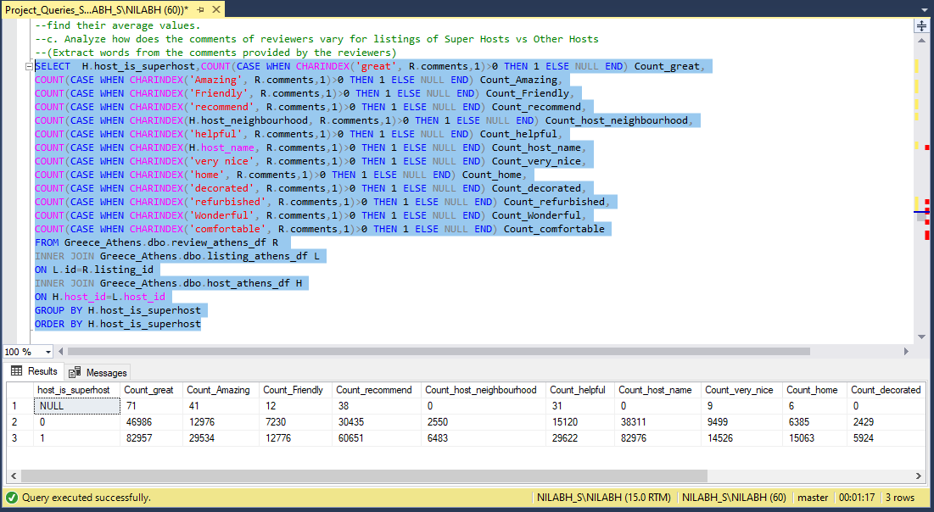

-- For Thessaloniki

SELECT H.host_is_superhost,

COUNT(CASE WHEN CHARINDEX('great', R.comments,1)>0 THEN 1 ELSE NULL END) Count_great,

COUNT(CASE WHEN CHARINDEX('Amazing', R.comments,1)>0 THEN 1 ELSE NULL END) Count_Amazing,

COUNT(CASE WHEN CHARINDEX('Friendly', R.comments,1)>0 THEN 1 ELSE NULL END) Count_Friendly,

COUNT(CASE WHEN CHARINDEX('recommend', R.comments,1)>0 THEN 1 ELSE NULL END) Count_recommend,

COUNT(CASE WHEN CHARINDEX(H.host_neighbourhood, R.comments,1)>0 THEN 1 ELSE NULL END) Count_host_neighbourhood,

COUNT(CASE WHEN CHARINDEX('helpful', R.comments,1)>0 THEN 1 ELSE NULL END) Count_helpful,

COUNT(CASE WHEN CHARINDEX(H.host_name, R.comments,1)>0 THEN 1 ELSE NULL END) Count_host_name,

COUNT(CASE WHEN CHARINDEX('very nice', R.comments,1)>0 THEN 1 ELSE NULL END) Count_very_nice,

COUNT(CASE WHEN CHARINDEX('home', R.comments,1)>0 THEN 1 ELSE NULL END) Count_home,

COUNT(CASE WHEN CHARINDEX('decorated', R.comments,1)>0 THEN 1 ELSE NULL END) Count_decorated,

COUNT(CASE WHEN CHARINDEX('refurbished', R.comments,1)>0 THEN 1 ELSE NULL END) Count_refurbished,

COUNT(CASE WHEN CHARINDEX('Wonderful', R.comments,1)>0 THEN 1 ELSE NULL END) Count_Wonderful,

COUNT(CASE WHEN CHARINDEX('comfortable', R.comments,1)>0 THEN 1 ELSE NULL END) Count_comfortable

FROM Greece_Thessaloniki.dbo.review_thessaloniki_df R

INNER JOIN Greece_Thessaloniki.dbo.listing_thessaloniki_df L

ON L.id=R.listing_id

INNER JOIN Greece_Thessaloniki.dbo.host_thessaloniki_df H

ON H.host_id=L.host_id

GROUP BY H.host_is_superhost

ORDER BY H.host_is_superhost

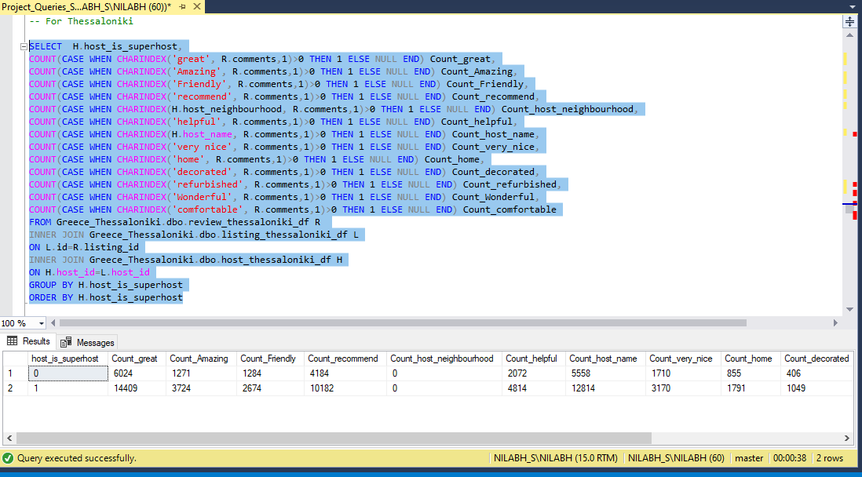

--e. Analyze the average price and availability of the listings for

--the upcoming year between Super Hosts and Other Hosts

--FOR Athens

SELECT [YEAR],id,available,AVG(AvgAdjustPrice) OVER (Partition by id,available Order by avgAdjustprice) FROM (

SELECT H.host_is_superhost,A.available,L.id,

DATEPART(YEAR,CAST(A.[date] AS date)) [Year], AVG(L.price) AvgAdjustPrice

from Greece_Athens.dbo.df_athens_availability A

INNER JOIN Greece_Athens.dbo.listing_athens_df L

ON L.id=A.listing_id

INNER JOIN Greece_Athens.dbo.host_athens_df H

ON H.host_id=L.host_id

WHERE H.host_is_superhost IS NOT NULL

group by H.host_is_superhost, L.id,DATEPART(YEAR,CAST(A.[date] AS date)),A.available)A

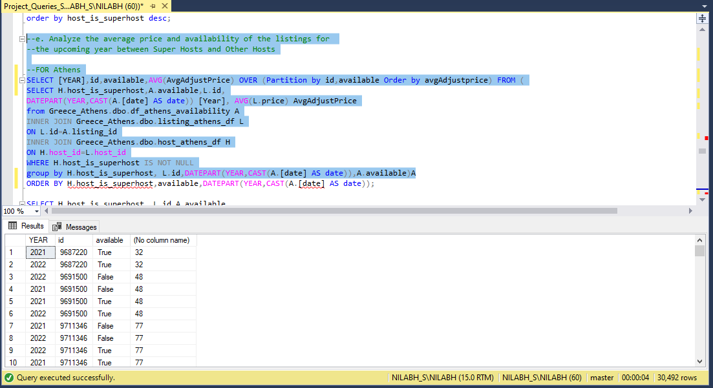

SELECT H.host_is_superhost,A.available,

DATEPART(YEAR,CAST(A.[date] AS date)) [Year], AVG(L.price) AvgAdjustPrice

from Greece_Athens.dbo.df_athens_availability A

INNER JOIN Greece_Athens.dbo.listing_athens_df L

ON L.id=A.listing_id

INNER JOIN Greece_Athens.dbo.host_athens_df H

ON H.host_id=L.host_id

WHERE H.host_is_superhost IS NOT NULL

group by H.host_is_superhost,DATEPART(YEAR,CAST(A.[date] AS date)),A.available

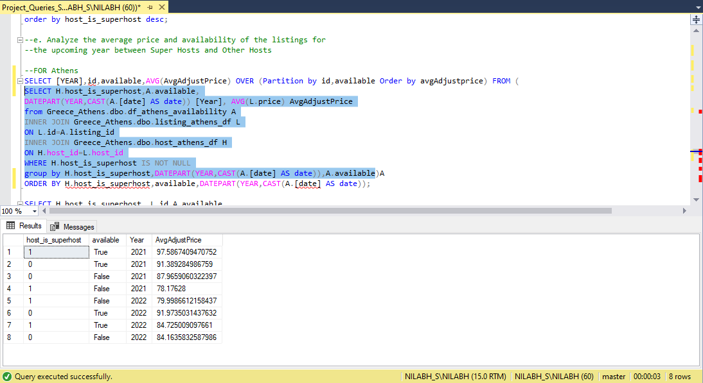

--For Thessaloniki

SELECT host_is_superhost,[YEAR],id,available,AVG(AvgAdjustPrice) OVER (Partition by id,available Order by avgAdjustprice) FROM (

SELECT H.host_is_superhost, L.id,A.available,

DATEPART(YEAR,CAST(A.[date] AS date)) [Year], AVG(L.price) AvgAdjustPrice

from Greece_Thessaloniki.dbo.df_thessaloniki_availability A

INNER JOIN Greece_Thessaloniki.dbo.listing_thessaloniki_df L

ON L.id=A.listing_id

INNER JOIN Greece_Thessaloniki.dbo.host_thessaloniki_df H

ON H.host_id=L.host_id

--WHERE H.host_is_superhost IS NOT NULL AND A.available='True'

group by H.host_is_superhost,L.id, DATEPART(YEAR,CAST(A.[date] AS date)),A.available)A

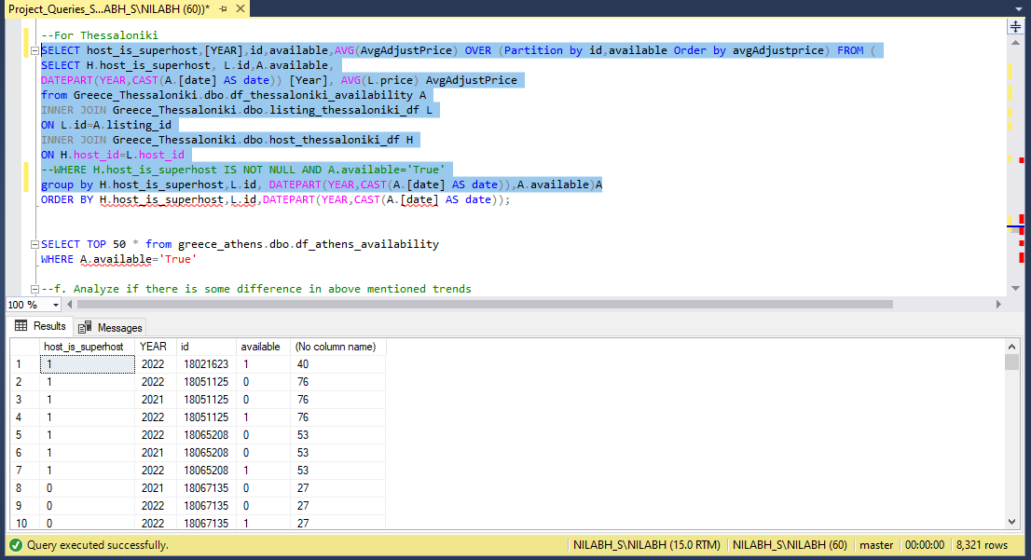

SELECT H.host_is_superhost, A.available,

DATEPART(YEAR,CAST(A.[date] AS date)) [Year], AVG(L.price) AvgAdjustPrice

from Greece_Thessaloniki.dbo.df_thessaloniki_availability A

INNER JOIN Greece_Thessaloniki.dbo.listing_thessaloniki_df L

ON L.id=A.listing_id

INNER JOIN Greece_Thessaloniki.dbo.host_thessaloniki_df H

ON H.host_id=L.host_id

--WHERE H.host_is_superhost IS NOT NULL AND A.available='True'

group by H.host_is_superhost, DATEPART(YEAR,CAST(A.[date] AS date)),A.available

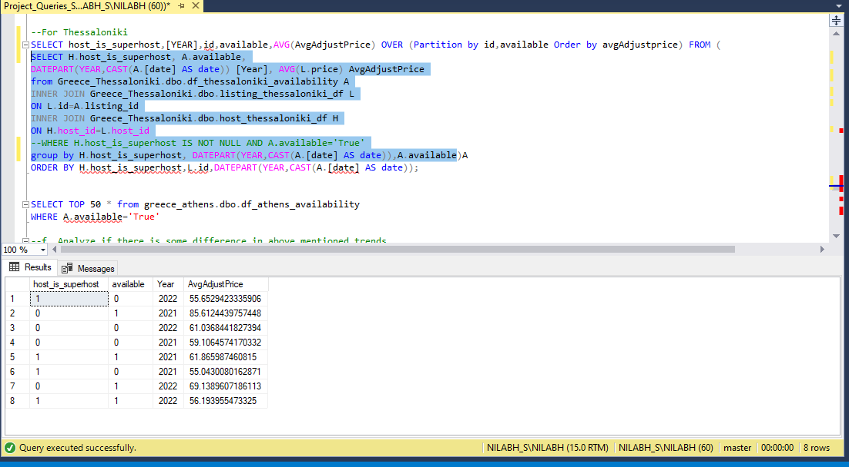

--f. Analyze if there is some difference in above mentioned trends

--between Local Hosts or Hosts residing in other locations

SELECT top 500 *,

SUM(CASE WHEN (neighbourhood_cleansed= 'ΑΓΙΟΣ ΝΙΚΟΛΑΟΣ' AND host_neighbourhood = 'Agios Nikolaos') THEN 1 ELSE 0 END),

CASE WHEN (neighbourhood_cleansed= 'ΑΚΑΔΗΜΙΑ ΠΛΑΤΩΝΟΣ' AND host_neighbourhood = 'Akadimia Platonos') THEN 1 END,

CASE WHEN (neighbourhood_cleansed= 'ΑΜΠΕΛΟΚΗΠΟΙ' AND host_neighbourhood = 'Ampelokipoi') THEN 1 END,

CASE WHEN (neighbourhood_cleansed= 'ΑΜΠΕΛΟΚΗΠΟΙ' AND host_neighbourhood = 'Ambelokipi') THEN 1 END,

CASE WHEN (neighbourhood_cleansed= 'ΙΛΙΣΙΑ' AND host_neighbourhood = 'Ilisia') THEN 1 END,

CASE WHEN (neighbourhood_cleansed= 'ΚΟΛΩΝΑΚΙ' AND host_neighbourhood = 'Kolonaki') THEN 1 END,

CASE WHEN (neighbourhood_cleansed= 'ΝΕΟΣ ΚΟΣΜΟΣ' AND host_neighbourhood = 'Neos Kosmos') THEN 1 END,

CASE WHEN (neighbourhood_cleansed= 'ΠΕΔΙΟ ΑΡΕΩΣ' AND host_neighbourhood = 'Pedion Areos') THEN 1 END,

CASE WHEN (neighbourhood_cleansed= 'ΠΑΤΗΣΙΑ' AND host_neighbourhood = 'Patisia') THEN 1 END,

CASE WHEN (neighbourhood_cleansed= 'ΠΕΤΡΑΛΩΝΑ' AND host_neighbourhood = 'Petralona') THEN 1 END,

CASE WHEN (neighbourhood_cleansed= 'ΣΕΠΟΛΙΑ' AND host_neighbourhood = 'Sepolia') THEN 1 END

FROM(

SELECT H.host_is_superhost, L.id,A.available,L.neighbourhood_cleansed,H.host_neighbourhood,

DATEPART(YEAR,CAST(A.[date] AS date)) [Year], AVG(L.price) AvgAdjustPrice

from Greece_Athens.dbo.df_athens_availability A

INNER JOIN Greece_Athens.dbo.listing_athens_df L

ON L.id=A.listing_id

INNER JOIN Greece_Athens.dbo.host_athens_df H

ON H.host_id=L.host_id

--WHERE (L.neighbourhood_cleansed= 'ΑΓΙΟΣ ΝΙΚΟΛΑΟΣ' AND H.host_neighbourhood = 'Agios Nikolaos')

group by H.host_is_superhost,L.id, DATEPART(YEAR,CAST(A.[date] AS date)),A.available,L.neighbourhood_cleansed,H.host_neighbourhood)A

GROUP BY host_is_superhost,id,available,neighbourhood_cleansed,host_neighbourhood,[Year],AvgAdjustPrice

