

* We can group Governor’s profile, CM’s profile and Deputy CM’s profile into one tab with a dropdown called “Profile”
* We can can the gallery tab to look like this

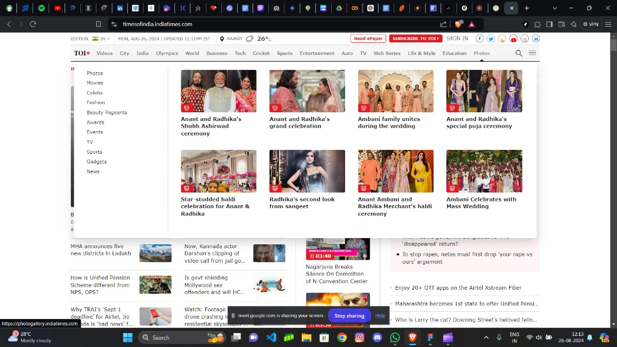

* We can change the design of the navigation bars to something like this



* Rather than having a separate calendar we can have a calendar dropdown here

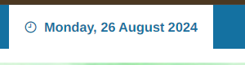

* This website has good responsiveness in mobile but the desktop version has many extra empty spaces and does look good. For reference we can take the example of the [Times of India](https://timesofindia.indiatimes.com/) Website.
* We can improve the content placement positions
* We can put the map on the right side rather placing it below the icons

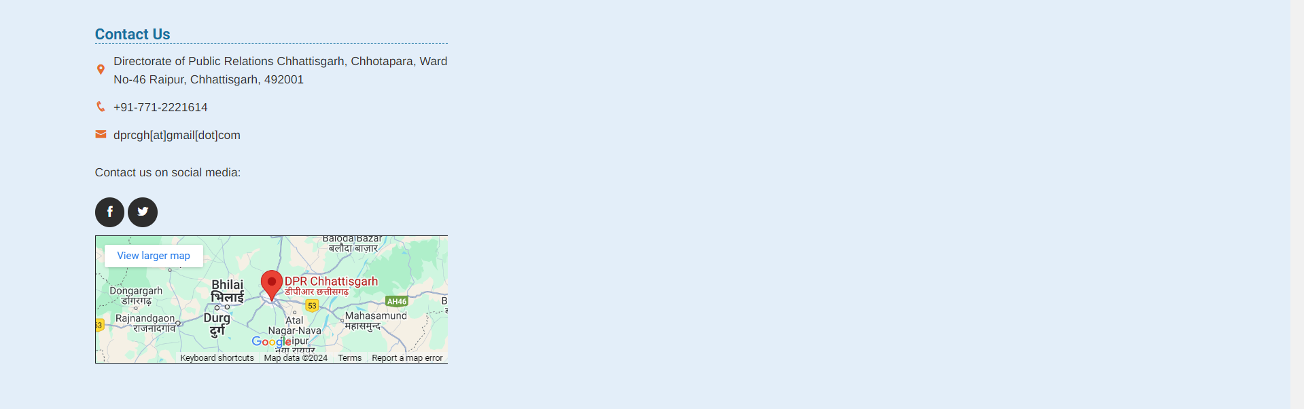

* We need to improve the loading time of the website by lazing loading images

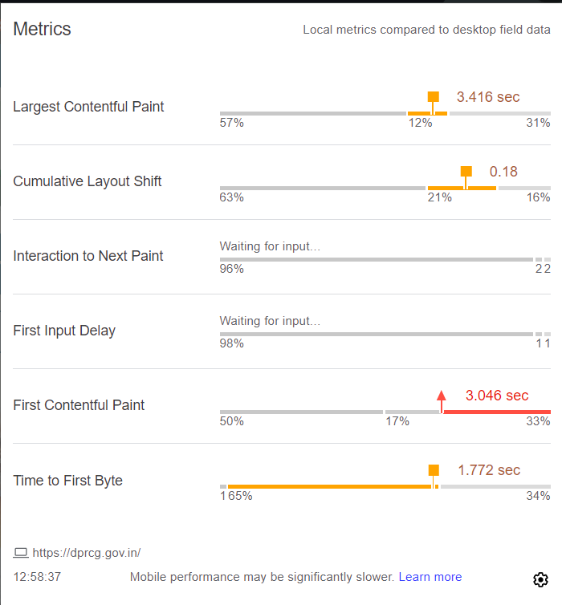

* We need to improve image clarity

