Terminal 1 - (core docker compose up) [PC1-(Gnb+Core)]
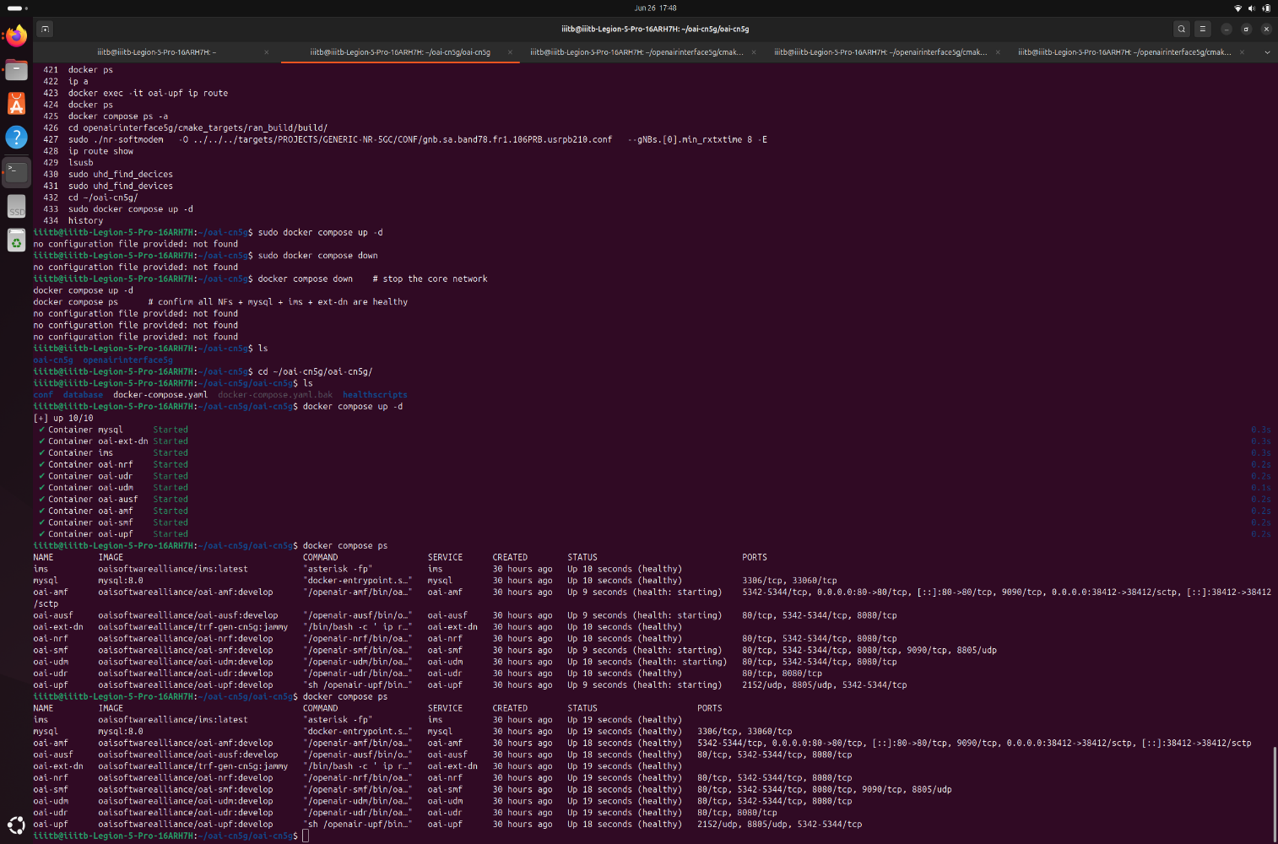
Terminal 2 - (gnb startup log) [PC1-(Gnb+Core)]
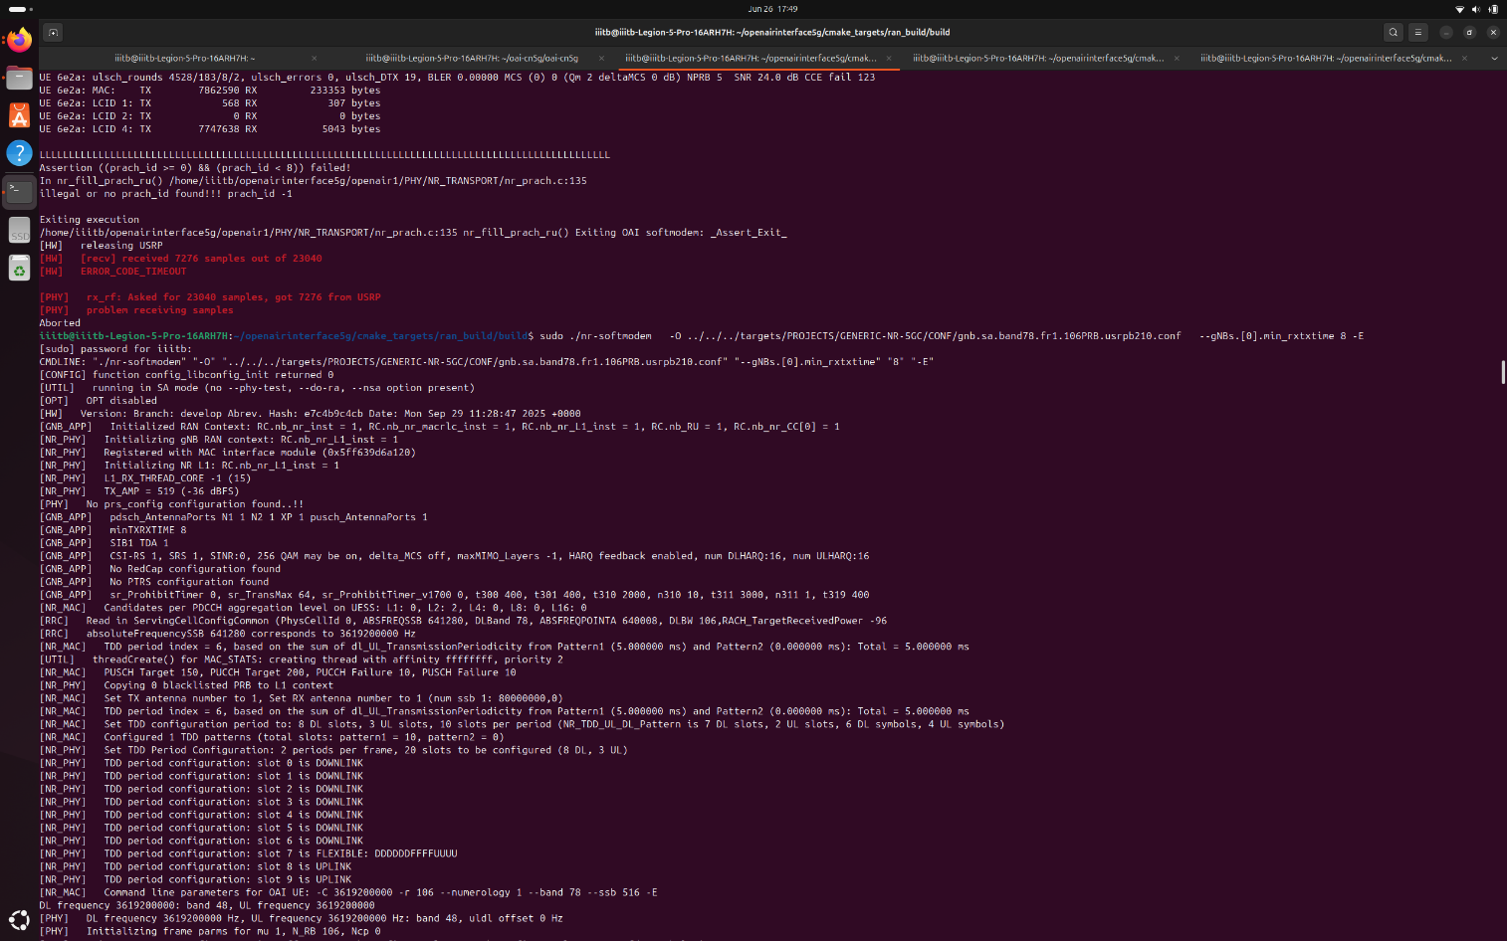

UE1-(eMBB startup logs) [PC2]
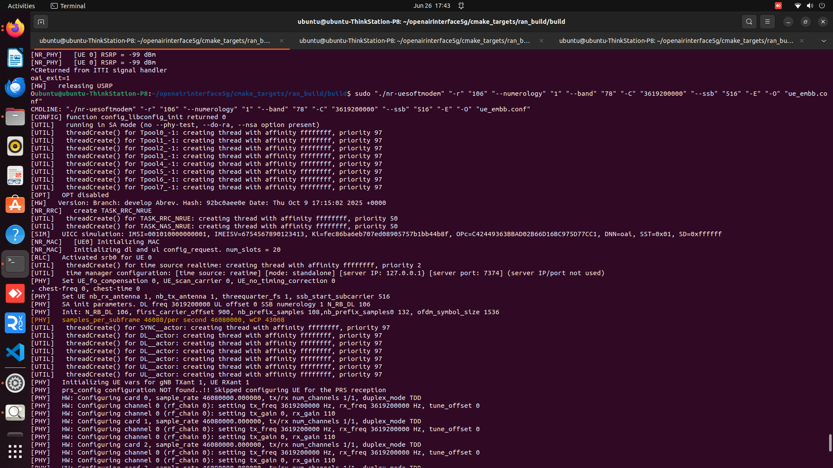
UE2-(URLLC startup logs) [PC3]
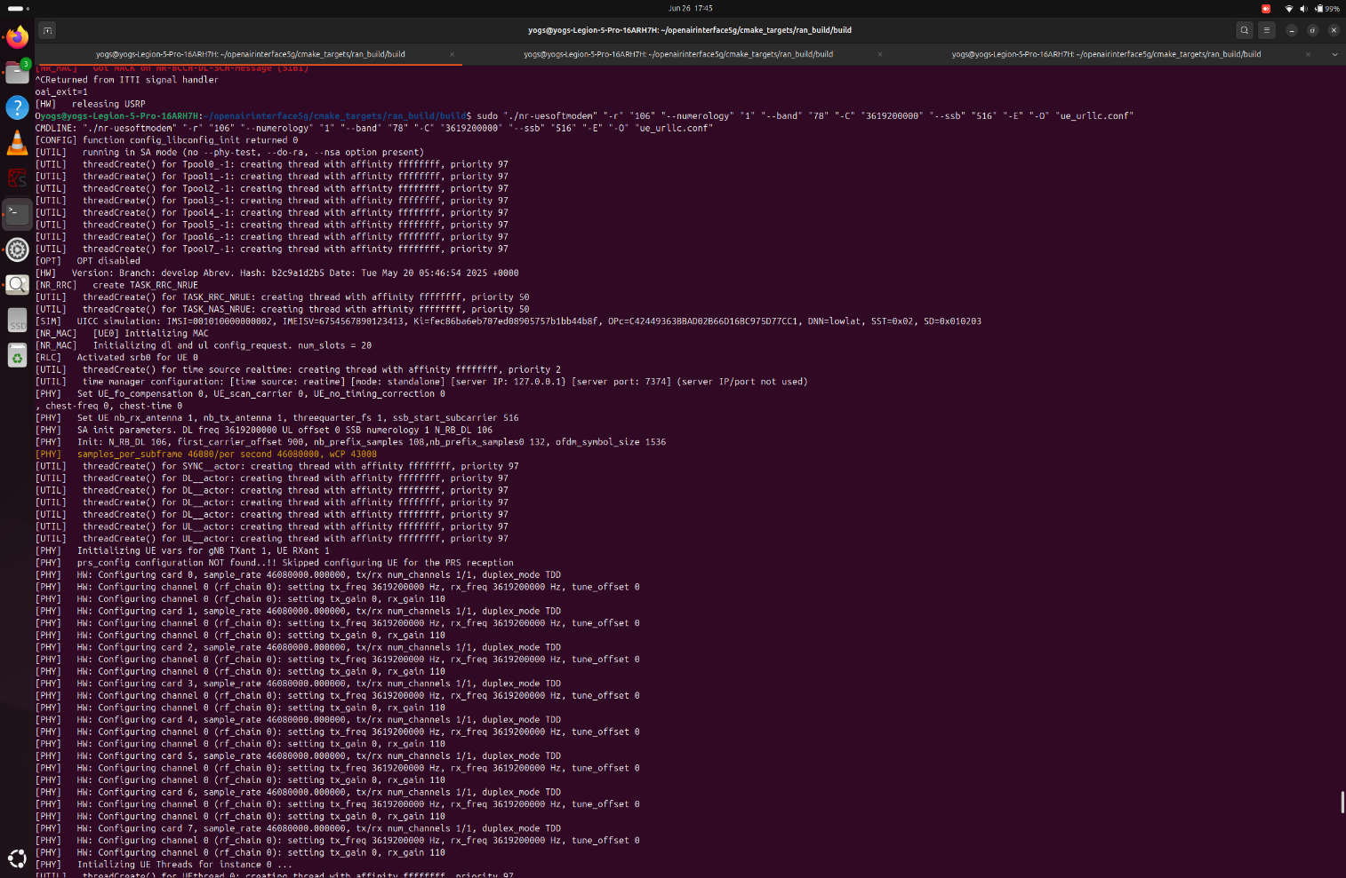

UE1-(eMBB tunnel ping) [PC2]
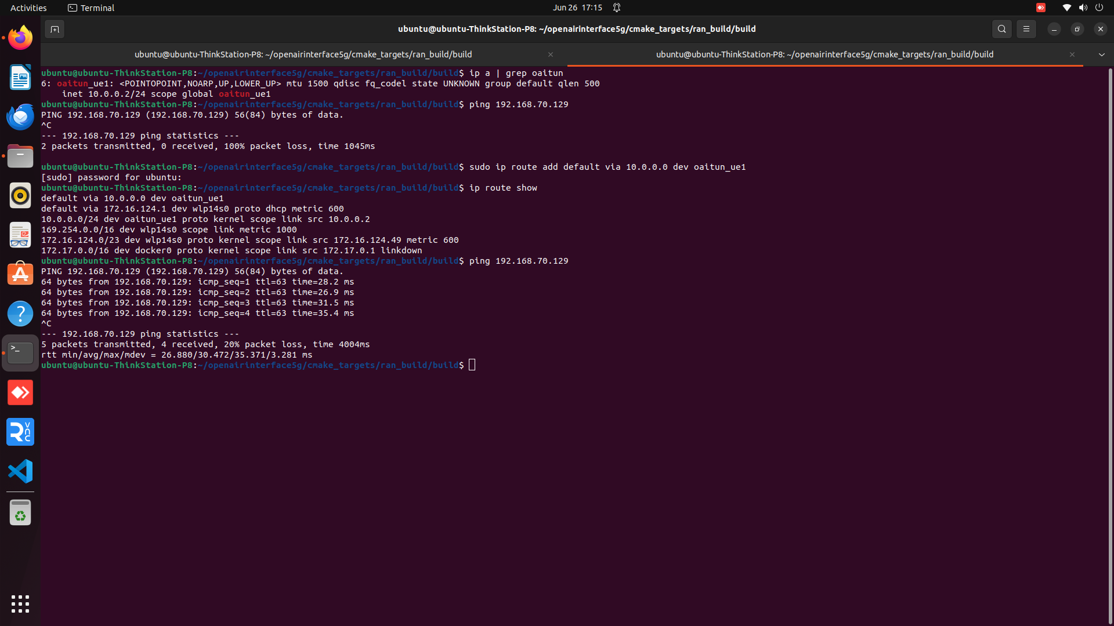
UE2-(URLLC tunnel ping) [PC3]
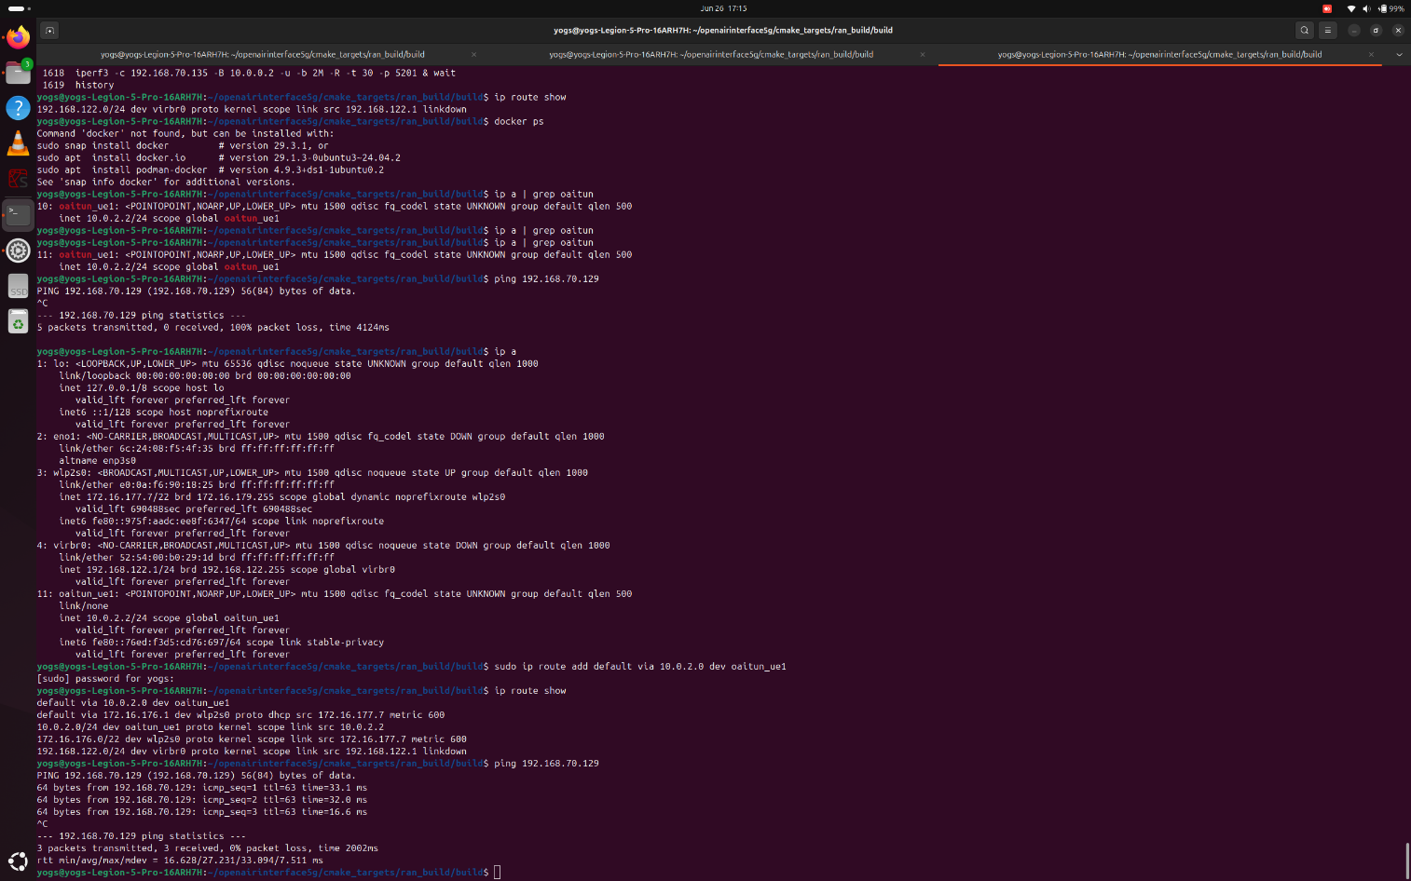

Terminal 3 - (Core is pinging with URLLC) [PC1-(Gnb+Core)]
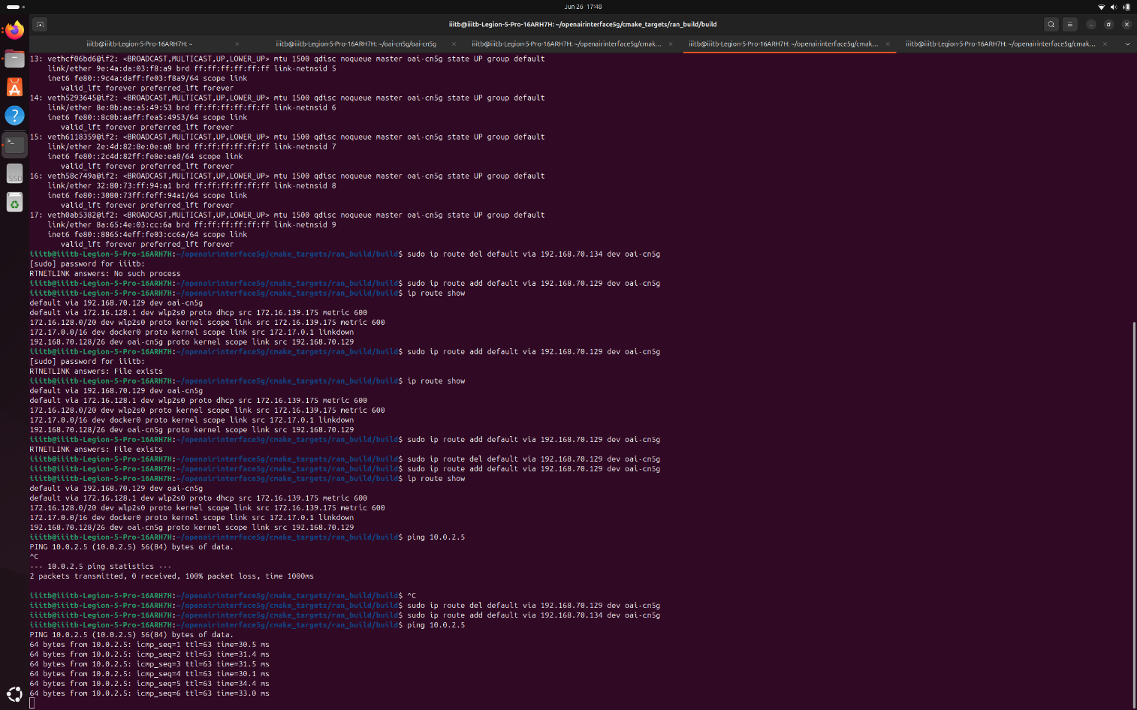

Terminal 3 - (Core is pinging with eMBB) [PC1-(Gnb+Core)]
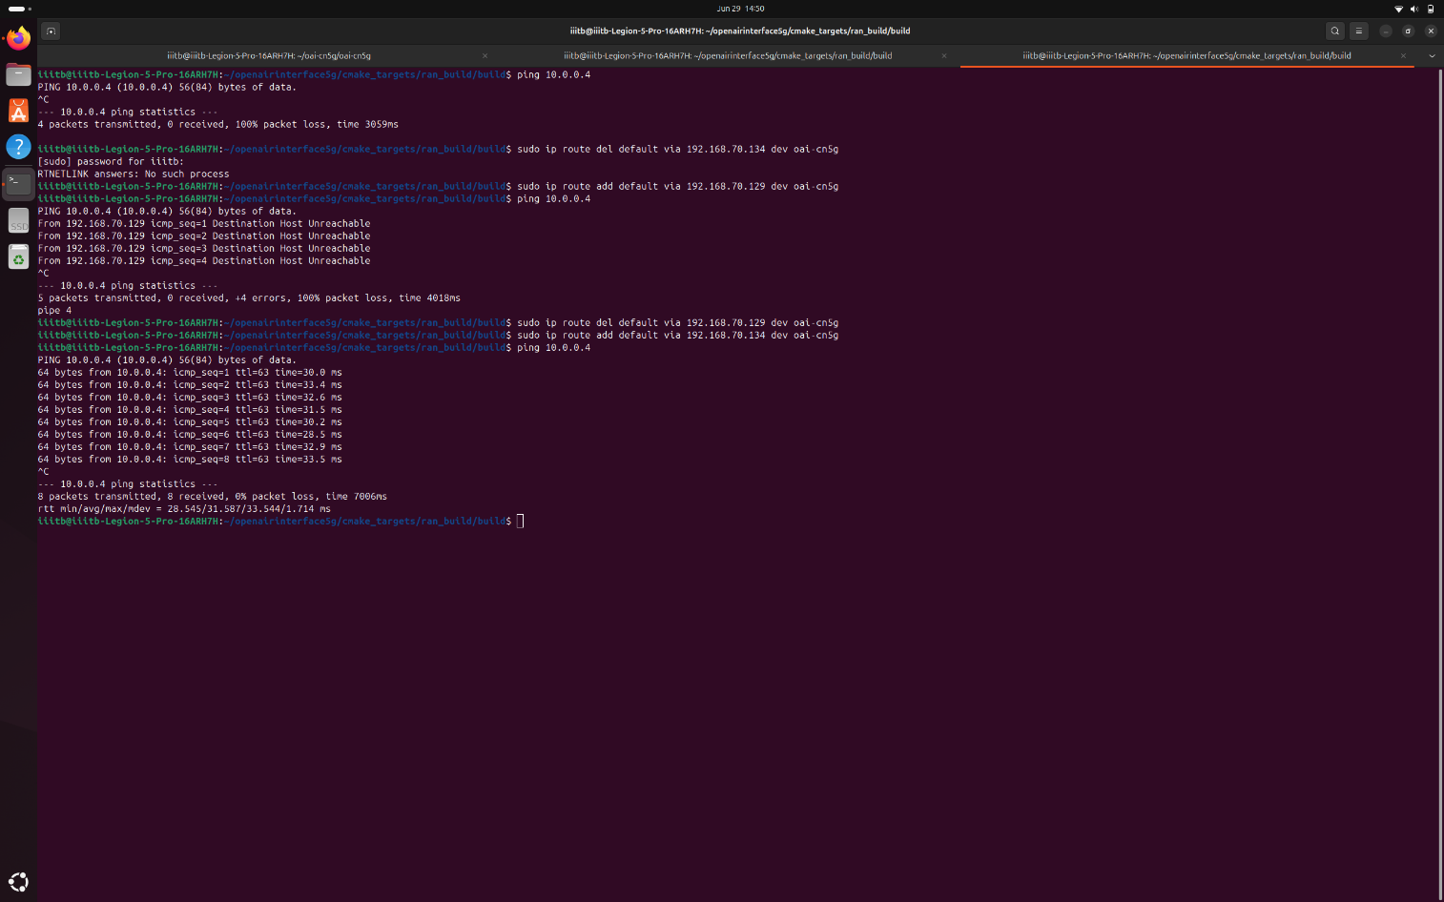

Terminal 4 – (start one server per slice/port) [PC1-(Gnb+Core)]
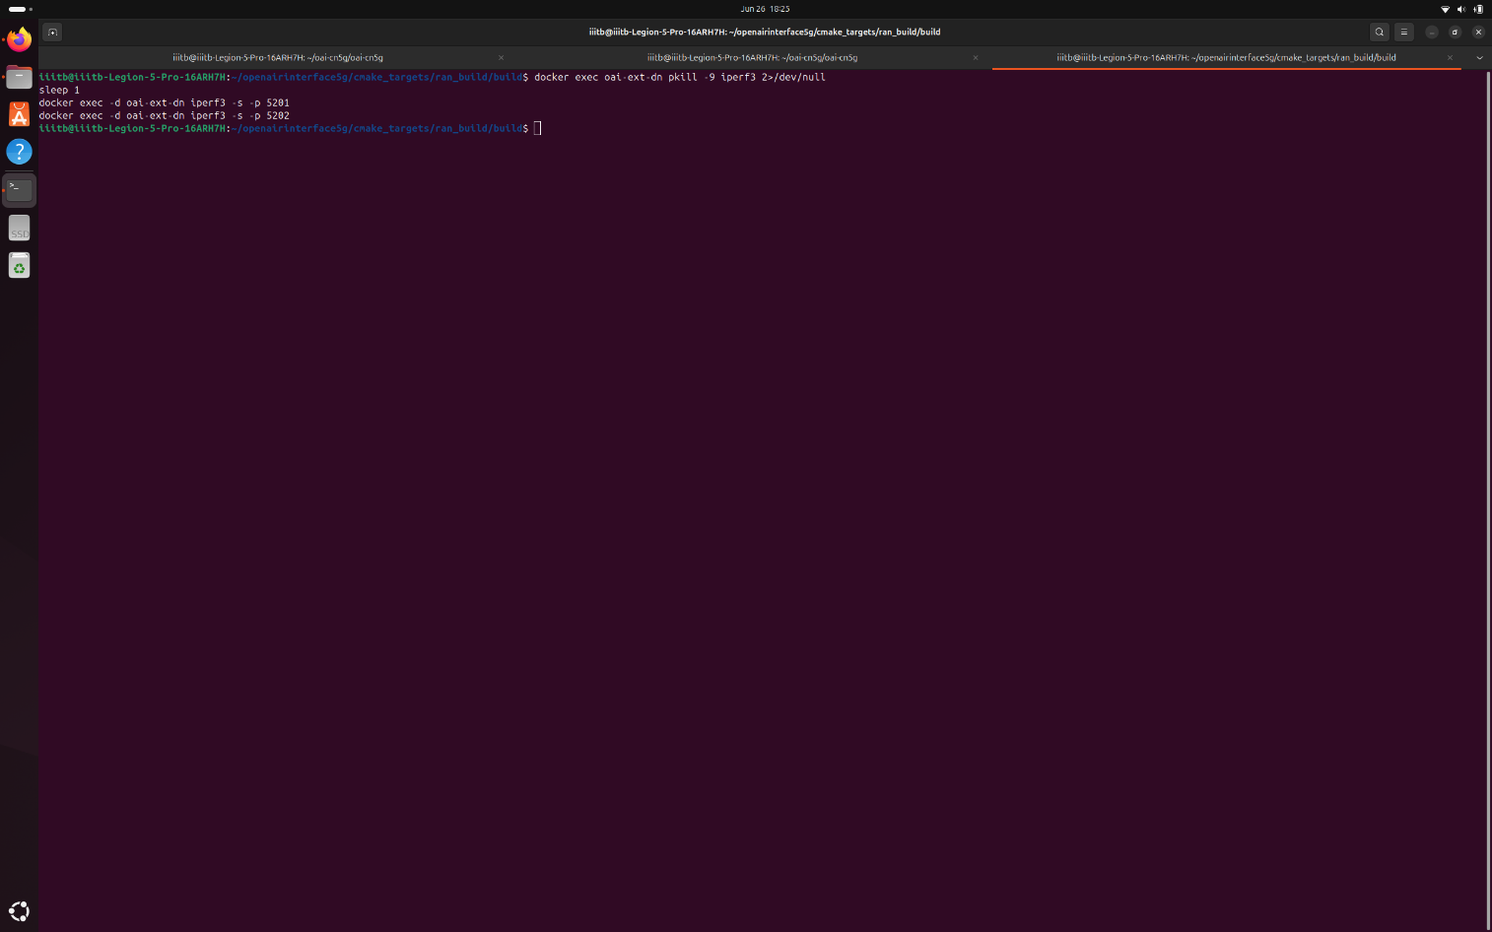

Terminal 2 – (iperf from eMBB/UE1 client) [PC2]
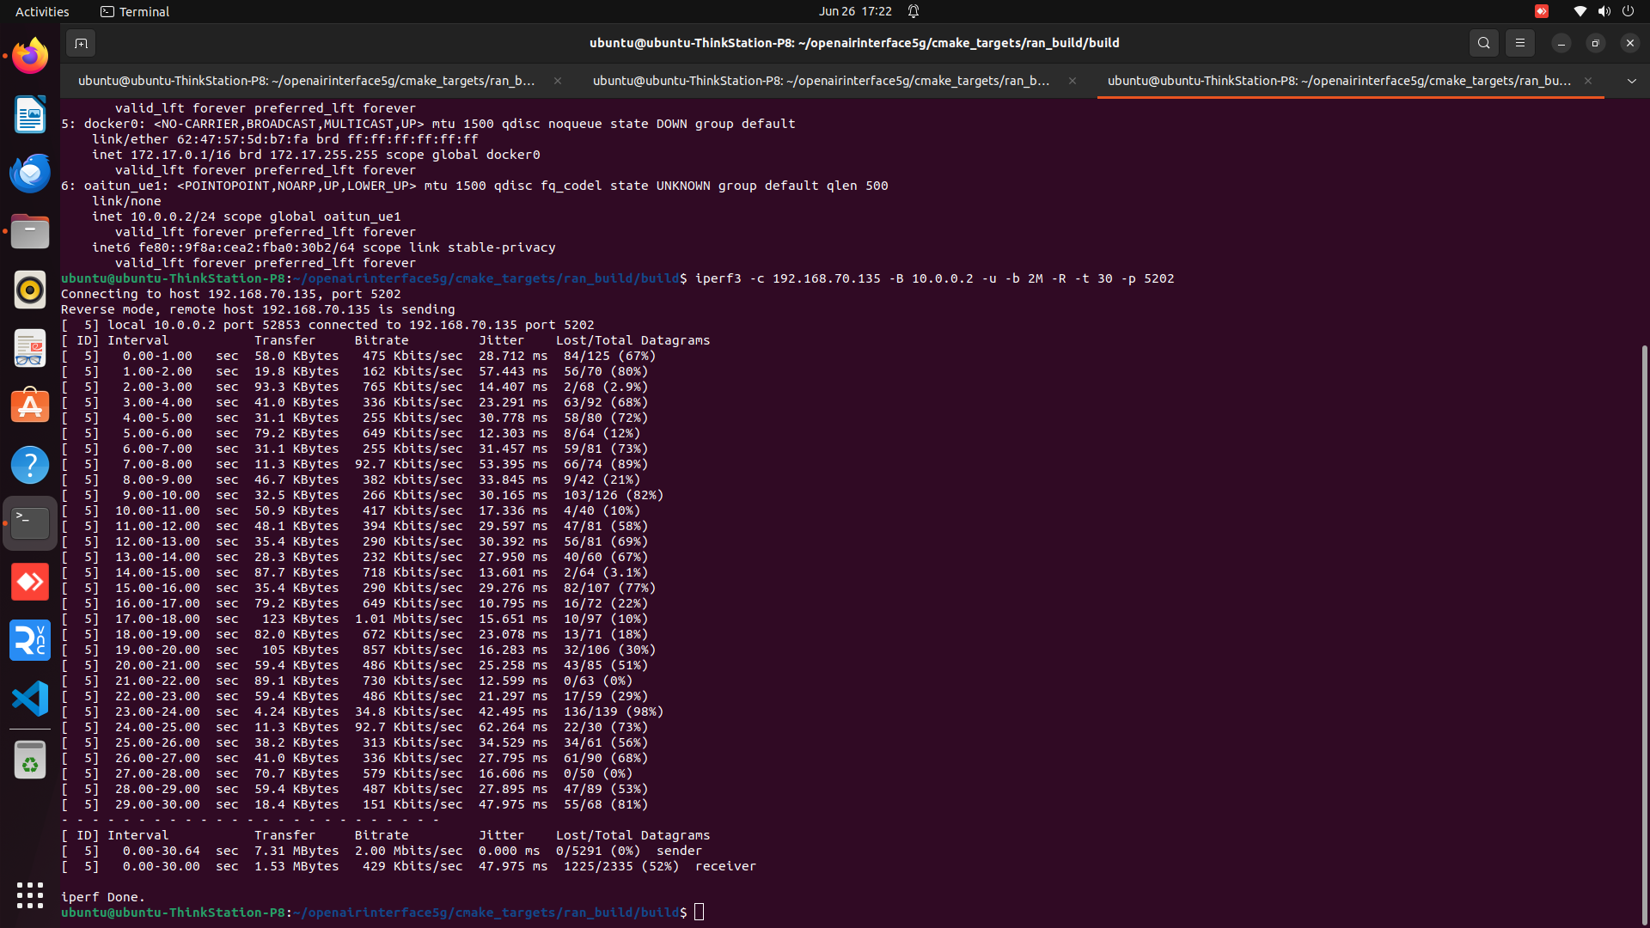

Terminal 2 - (iperf from URLLC/UE2 client) [PC3]
