Name: neelam Makwana

Last 4 digits ID:

Computer IP address:

CSE 6331, Cloud Computing

Quiz April 22, Spring 2020 (c) DL, UTA, 2020

C&P means cut and paste only those relevant lines from your program(s) into this quiz.

1. I understand that I am on my honor during this quiz, I will not collaborate, use

non-allowed sources, and I will not discuss or share this quiz with anyone for the next

4 hours.

You MAY: use Google to search, use previous source code,

YOU MAY NOT use:

Email, Facebook, Hangouts, IM, chats, Skype or ANY other human connection.

This is a timed test. Late tests will have points deducted for being late.

Very late tests will not be graded.

The second part of the test, you should electronically submit, you will need to copy and paste

only those lines of code to implement that part of the test, usually a few (two to eight) lines of code.

Place it immediately after the question.

Submit this Quiz (renamed) with code cut and pasted, ONLY text. DO NOT submit zips, binaries, libraries,

or anything other than text.

When any parts(questions) are complete complete, submit this test, you may make multiple submissions.

2. Get files from this same folder.

3. Name your program/submission with your name and last digits of your ID.

4. Using the cloud services provider, all functionality possible should be implemented on that provider.

(Of course, displaying web pages through a browser and the user interface is "local")

5. Show a web page and interface (which resides on the cloud provider) with your name and

student ID in large font at the top of every web page dispayed (for this quiz)

The cloud service provider is AWS (Amazon Web Services).

Show and submit code:

5. Please read part 5. above, again.

Note: Due to (rather obvious) conditions, anything you have running "locally", we can not see.

If you do wish to submit anything that ONLY runs locally, please append your code after the question

below, (same as for clod implementation code).

If appropriate, you are welcome to submit "screen shots", if they are in a "MS Word", (or compatible) format,

or PDF. We can not read other formats.

<h1>1001453836</h1>  
<h1>Neelam Makwana</h1>  
<br>  
<br>

6. On the cloud provider, please show a web page that has a very simple interface:

1. A counter (that displays 0 then 1 then 2, etc) at a rate between 1 and 5 increments per second

(that is, your counter should count no slower than once per second, no faster than 5 times per second,

there are many ways to implement this, we just want to see it "count", it doesn't need to be time precise)

Please display this count in the bottom half of the screen in large font.

2. The time of day (in hours, minutes and seconds) in a large font at the top of the screen

(as well as your name and student ID)

3. A "reset" button (on that web page) where we can reset the count to zero ("0")

(put anywhere on the page).

@application.route('/')

def index():

start = datetime.datetime.now()

b = start.second

if (b % 2) == 0:

return render_template('index_m.html', dt=str(start))

else:

return render_template('index1_m.html', dt=str(start))

return render_template("index_m.html", dt=str(start))

<body align="center">

<header>

<center><b>

Neelam Makwana<br/>

1001453836

<br/><br/>

counter

</b></center>

</header>

<p>2</p>

<!--<img src="https://xyz.s3.us-east-2.amazonaws.com/a.jpg" height="100" width="100"/>-->

<br/>

<br/>

{{dt}}

</body>

<body align="center">

<header>

<center><b>

Neelam Makwana<br/>

1001453836

<br/><br/>

counter

</b></center>

</header>

<p>1</p>

<!--<img src="https://xyz.s3.us-east-2.amazonaws.com/b.jpg" height="100" width="100"/>-->

<br/>

<br/>

{{dt}}

</body>

<title>Home</title>  
 <p style="text-align:center">1001453836</p>  
 <p style="text-align:center">Neelam Makwana</p>  
 </head>  
 <body style="text-align:center" onload="startTime()">  
 <div id="txt" style="font-size:20px;"></div>  
  
  
  
 <div class="container">  
  
  
 <form action="/Q1" method="post">  
  
<br>  
 </form>  
  
 COUNT :  
 <span id="seconds"></span>  
  
 <input type="submit" value="RESET" >  
 </div>  
 </body>

7. Modify part 6 (above) to only increment the count when that page is "requested" by an external (user-like)

request. Those requests will come from your (local) computer from a "load-testing" application

which is "testing" your cloud application.

Please enter the name of your load-testing application here:jmeter

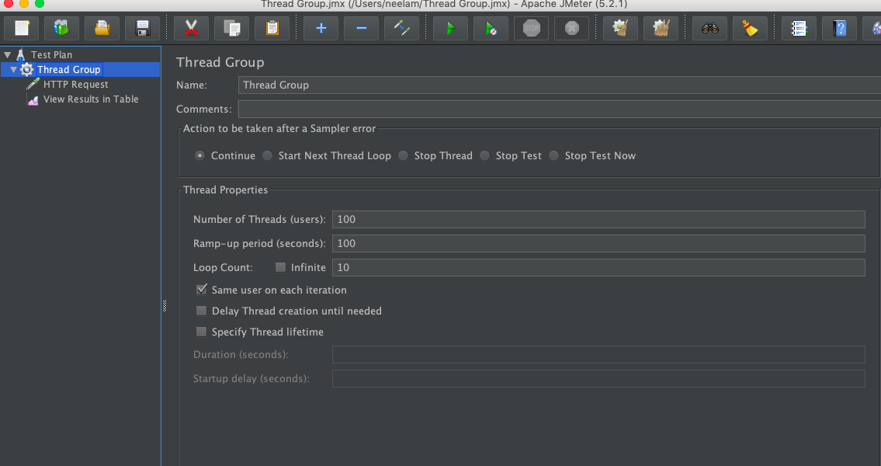

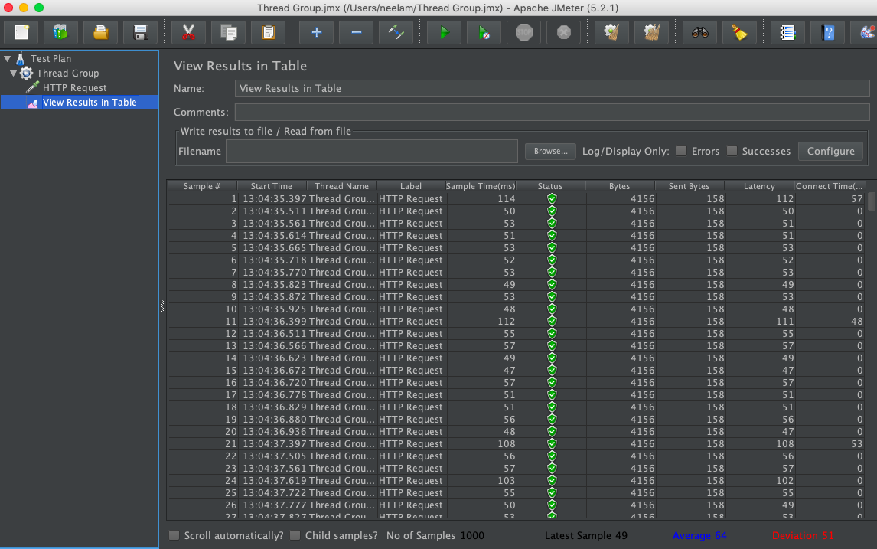

We will ask you to set some parameters (such as 2 requests per second, or change to more requests or fewer),

and we will watch your web page respond.

8. Bonus:

Show that you can scale the number of instances on the cloud provider to a maximum of 3, based on "load"

of your application. (This will require both screen shots of your cloud provider settings/implementation

and showing us.)

9. When you are finished with any part, please submit a link (a link to your AWS app)

to Teams, and we will try to demo it, then when you are FINISHED

(or at the end of the class) please submit code to Teams, and terminate your app.

Good Luck!