AWS CLOUD COST CALCULATOR
The AWS Cloud Cost Calculator is a web-based application that allows users to estimate the monthly cost of using various AWS cloud services. The project helps users understand the pricing structure of AWS and make informed decisions while choosing cloud resources. It is especially useful for students, developers and organizations looking to manage cloud budgets effectively. The AWS Cloud Cost Calculator enables users to select different AWS services (such as EC2, S3, Lambda and DynamoDB) and enter their estimated usage (for example, hours, GB, or requests). Based on predefined pricing values, the calculator computes and displays the estimated monthly cost for each selected service.The web application is built using HTML, CSS, and JavaScript, and is hosted on Amazon S3 as a static website. Optional integration with AWS Lambda and API Gateway can be added to fetch live pricing data or perform advanced calculations dynamically.
Services used in the project:
- S3 – Hosts the static web application (HTML, CSS, JS).
- IAM – Controls access permissions to the S3 bucket.
- API Gateway – Acts as an interface for dynamic data requests.
- Lambda – Executes backend logic or real-time pricing calculations.
- Dynamo DB (Optional) – Stores historical cost data.
- Cloud watch (Optional) – Monitoring the website.

Architectural Diagram:
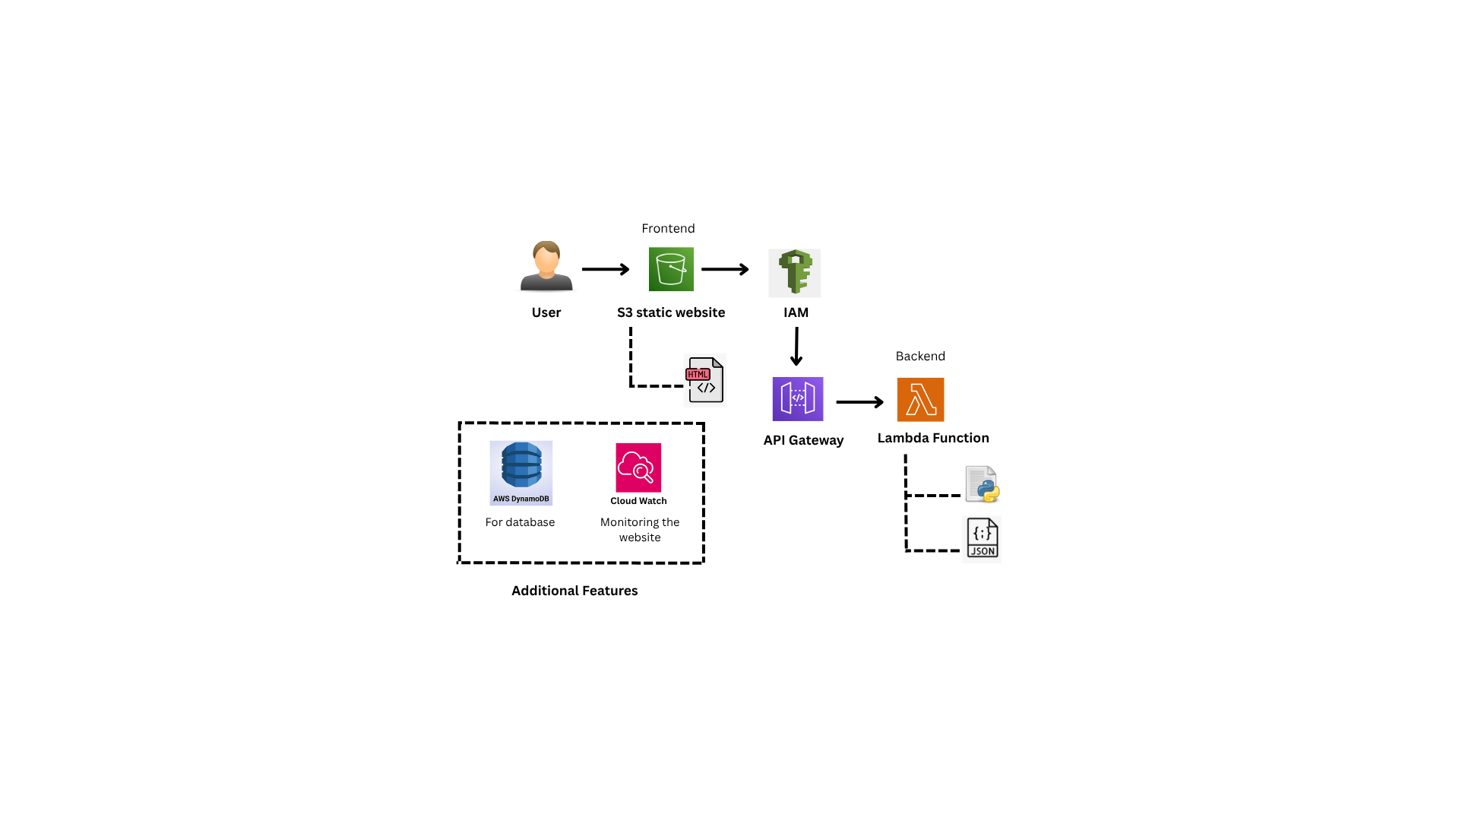

Step 1: Create AWS Lambda Function
Created a Lambda named CloudCostCalculator. Add the python code to calculate EC2,S3 and data transfer costs, then deploy the function.
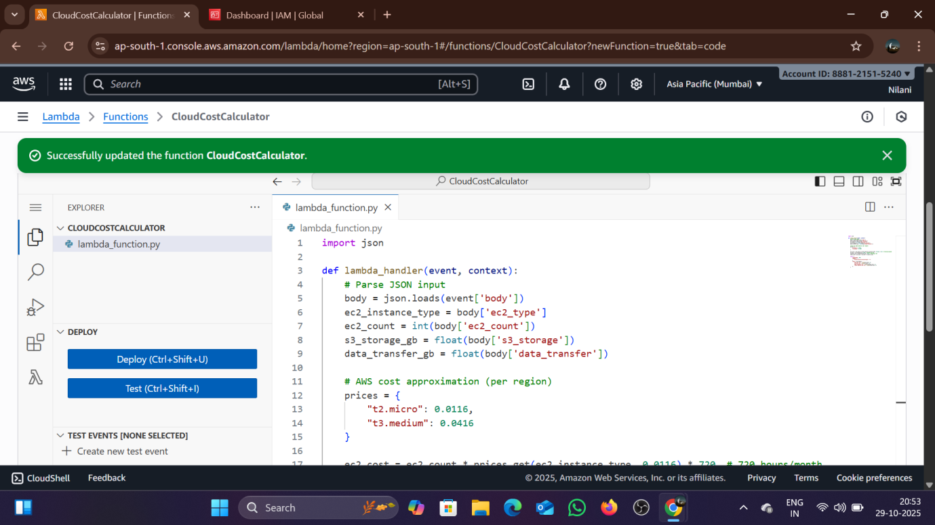

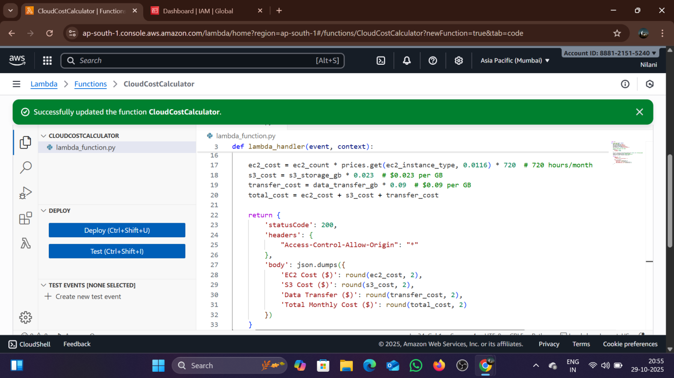

Step 2: Create API Gateway
Create an HTTP API to integrate it with the Lambda to set route /cost (POST) method to deploy to the stage PROD and copy the Invoke URL for frontend use.
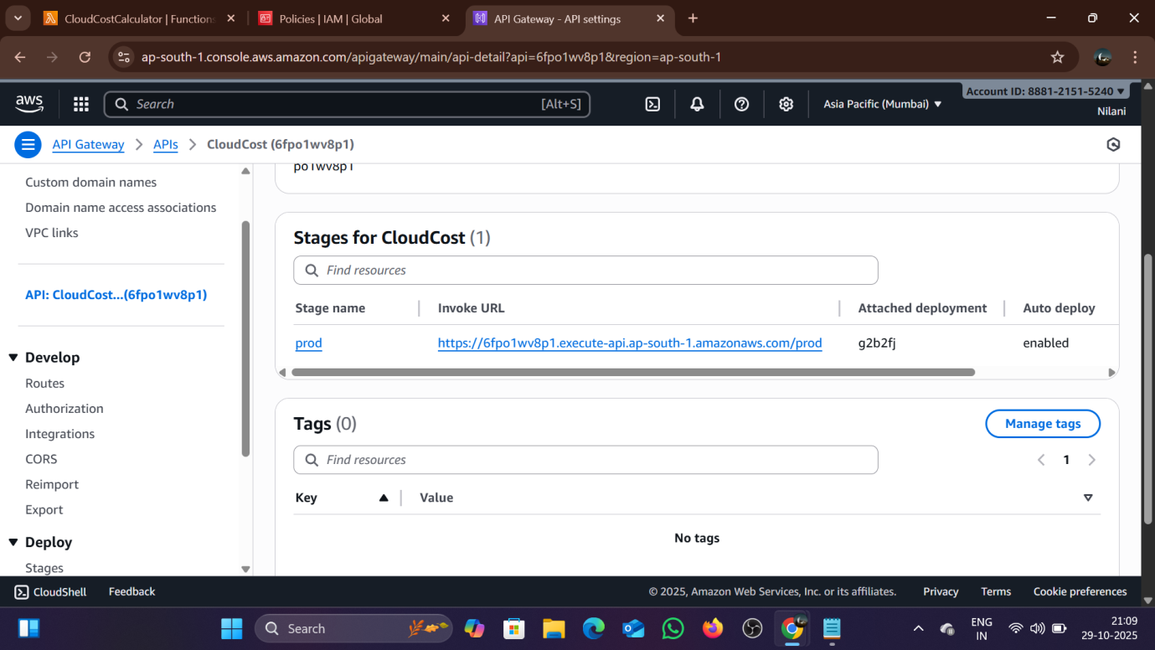

Step 3: Create S3 Bucket
Create a new bucket called cloud-cost-calculator-nila and uncheck the block all public access then upload the index.html file in it.
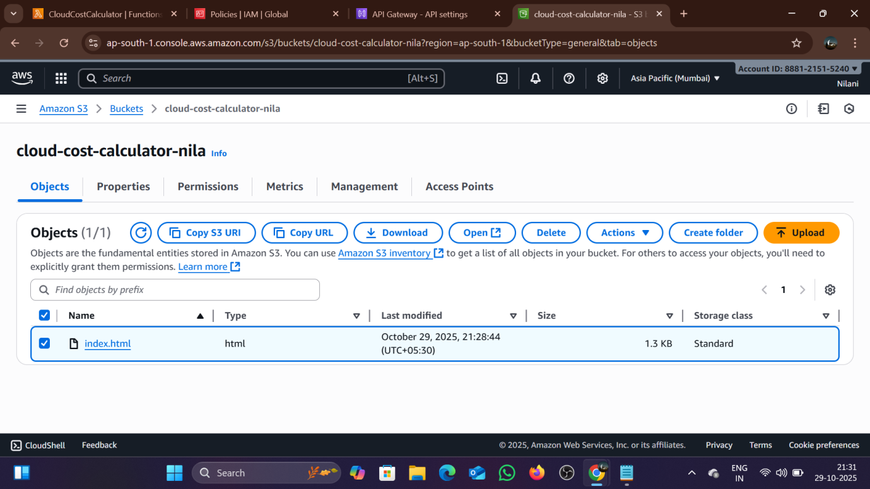

Step 4 : Enable Static Website Hosting
In bucket properties Static website hosting , enable hosting, set index document as index.html and save changes.
Step 5: IAM roles and policy
IAM roles and policies are attached default, While creating the lambda function. It allow secure access between AWS Services which are listed.
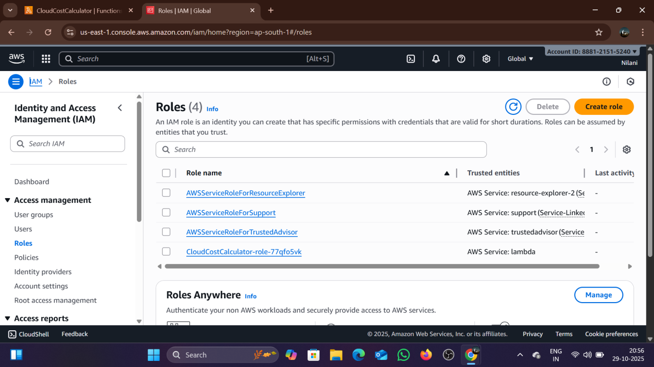

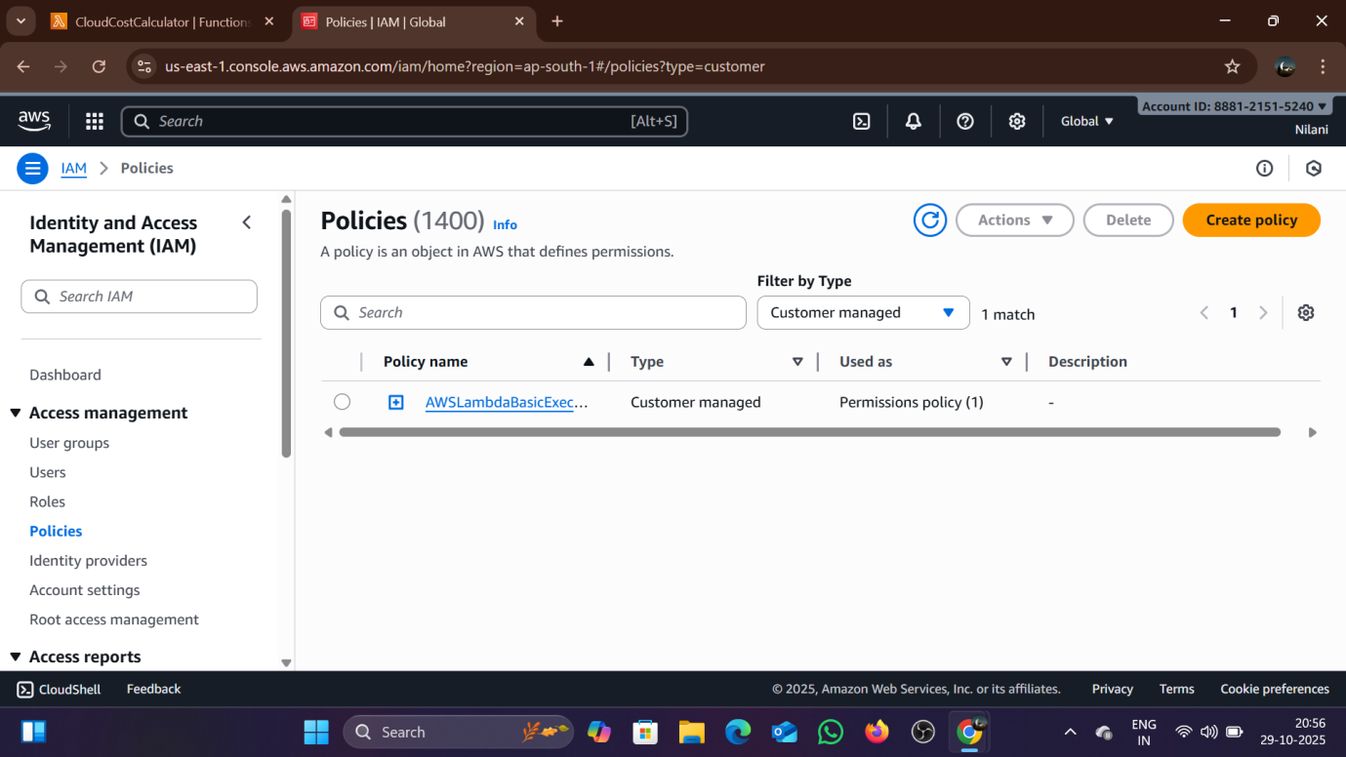

Step 6: Set Permissions
When a website shows an access denied we have to set the permissions in the permissions tab. Add a bucket policy allowing public read access to all objects using the JSON.

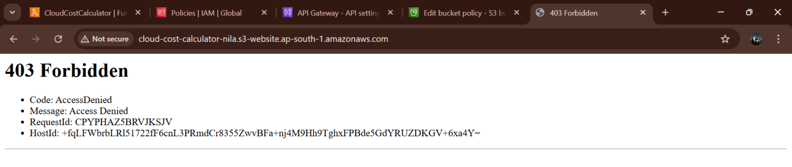

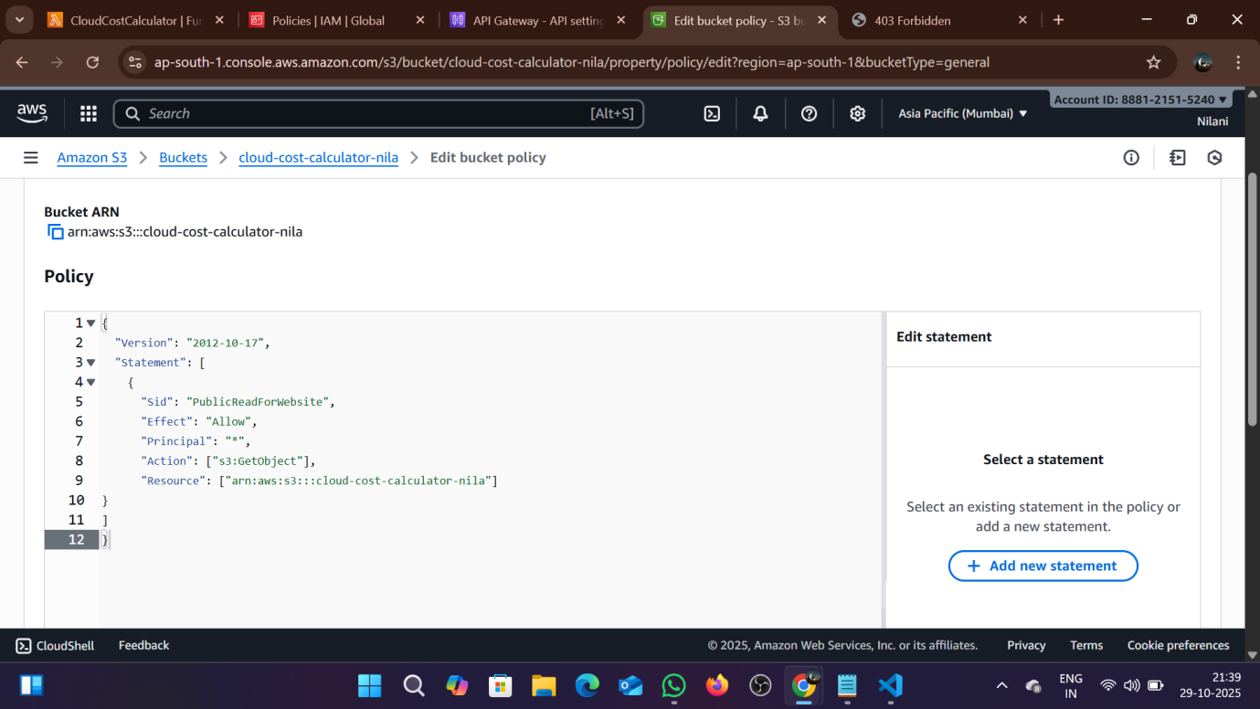

Step 7 : Test the application
Open the S3 website endpoint URL “http://cloud-cost-calculator-nila.s3-website.ap-south-1.amazonaws.com “in the browser. Enter the values and Click Calculate Monthly Cost , so you can view cost results instantly.
