BLUE-GREEN DEPLOYMENT USING JENKINS + AWS EC2 + NGINX
The Blue-Green Deployment strategy is to achieve zero-downtime deployment using Jenkins, Nginx and AWS EC2 instances. The main objective of the project is to perform a manual Blue-Green Deployment using Jenkins as a Continuous Integration tool, Nginx as a load balancer and AWS EC2 instances as the deployment environment. The deployment should allow switching between two environments (Blue and Green) without affecting end users. The three EC2 instances are used. The Blue server hosts the current version of the web application, the Green server hosts the new version, and the Nginx Load Balancer routes traffic to one of these servers. Jenkins is installed on a separate server to perform manual deployments. When a new version is ready, Jenkins is used to manually deploy it on the Green server. After successful verification, Nginx configuration is updated to point to the Green server instead of Blue, thereby completing the switch without downtime.
Tools used in the project:
- AWS EC2 – For creating virtual servers (Blue, Green, and Load Balancer).
- Jenkins – For managing the deployment process manually through build jobs.
- Nginx – Used as a load balancer to route traffic between Blue and Green servers.
- Git and GitHub – To store the application source code.
- Ubuntu 22.04 – The operating system used for all servers.
- SSH – For secure communication between Jenkins and EC2 servers.

Architectural Diagram:
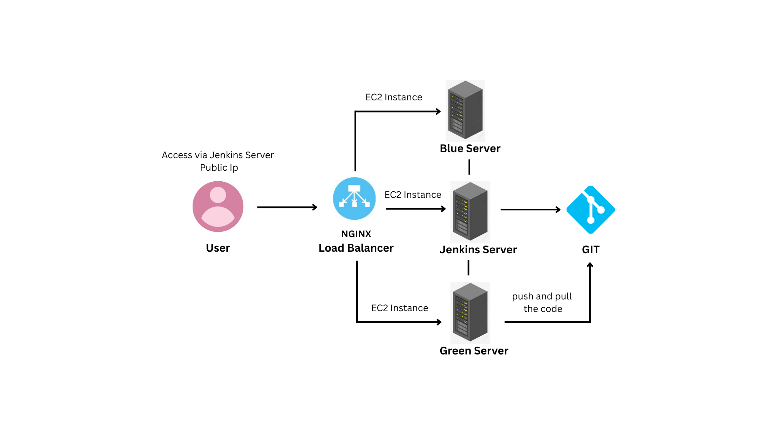

Step 1: Launching EC2 Instances
Three EC2 instances were launched on AWS using the Ubuntu 22.04 operating system. They were named Blue Server, Green Server and Jenkins Server is for Nginx Load Balancer. Proper security groups were configured to allow inbound connections on ports 22 (SSH), 80 (HTTP), and 8080 (for Jenkins access).
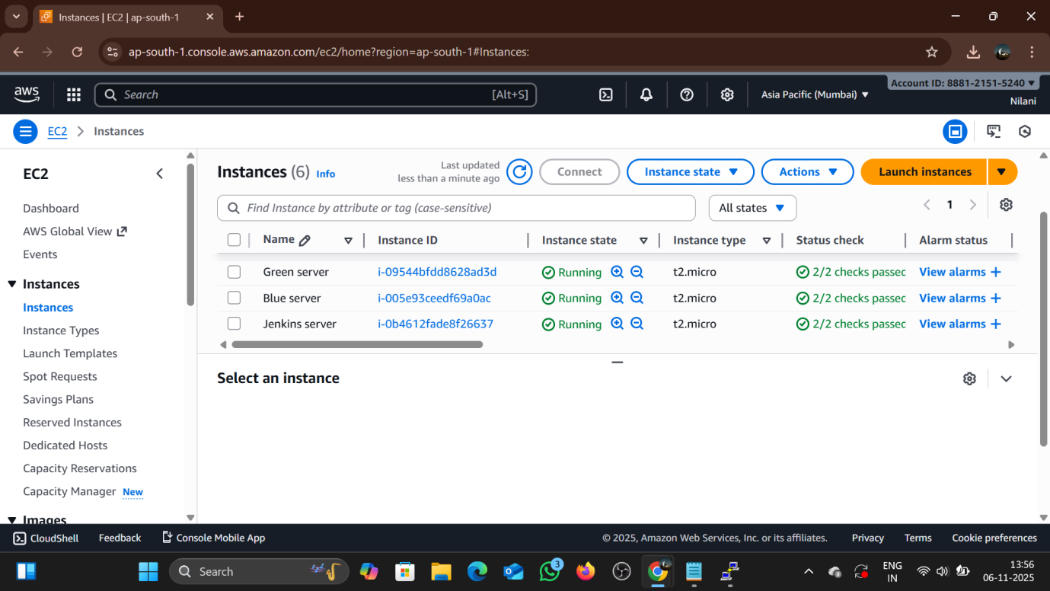
Step 2: Installing Required Packages
On all servers, system packages were updated. Git and Nginx were installed using the following commands:
sudo apt update -y
sudo apt install git nginx -y
On the Jenkins server, Java and Jenkins were installed using official Jenkins repository commands. Once installed, Jenkins was started and configured through the browser using the public IP and port 8080.
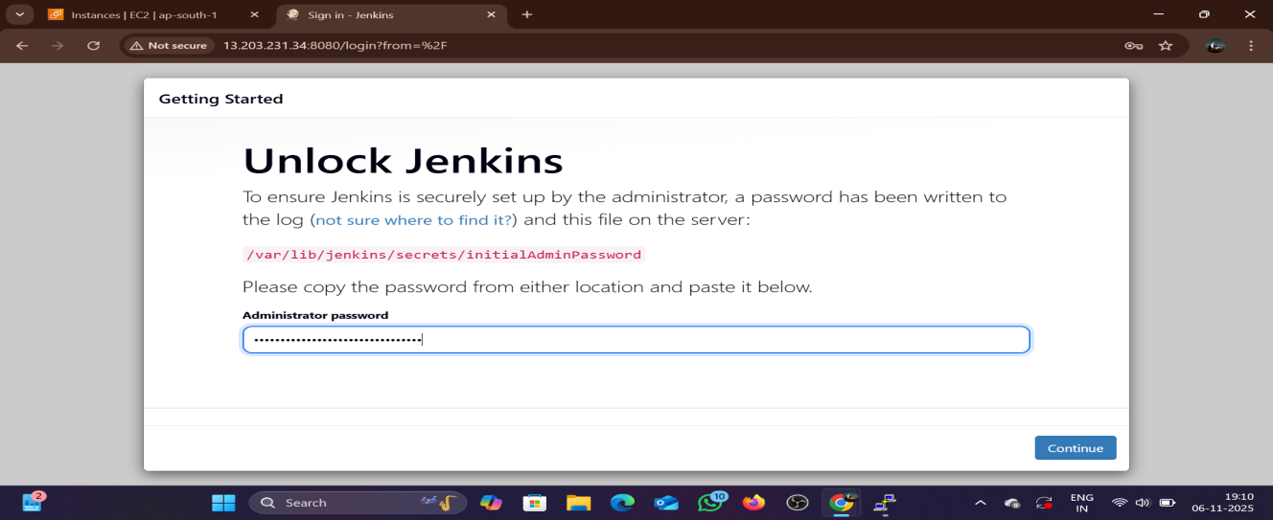
Step 3: Configuring Jenkins
After accessing Jenkins at http://<jenkins-public-ip>:8080, the initial setup wizard was completed and the “Suggested Plugins” were installed. An admin user was created and plugins such as SSH Agent Plugin and Git Plugin were added. These plugins enable Jenkins to connect to remote servers and pull code from GitHub.
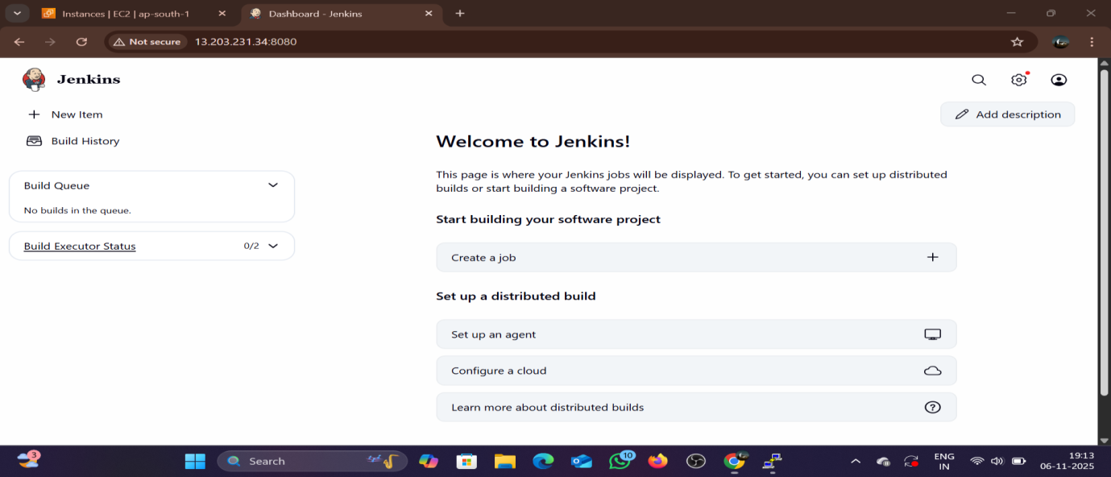

Step 4: Setting Up SSH Authentication
To allow Jenkins to connect securely with both Blue and Green servers, SSH keys were generated using :
sudo su - jenkins
ssh-keygen -t rsa -b 4096 -C "jenkins@bluegreen"
The public key was copied to the authorized_keys file on both Blue and Green servers. This allowed Jenkins to log in to both servers without using a password.

Step 5: Configuring Blue and Green Servers
A simple HTML file was created under /var/www/html to represent version 1 and version 2 of the application as Blue and Green Versions.
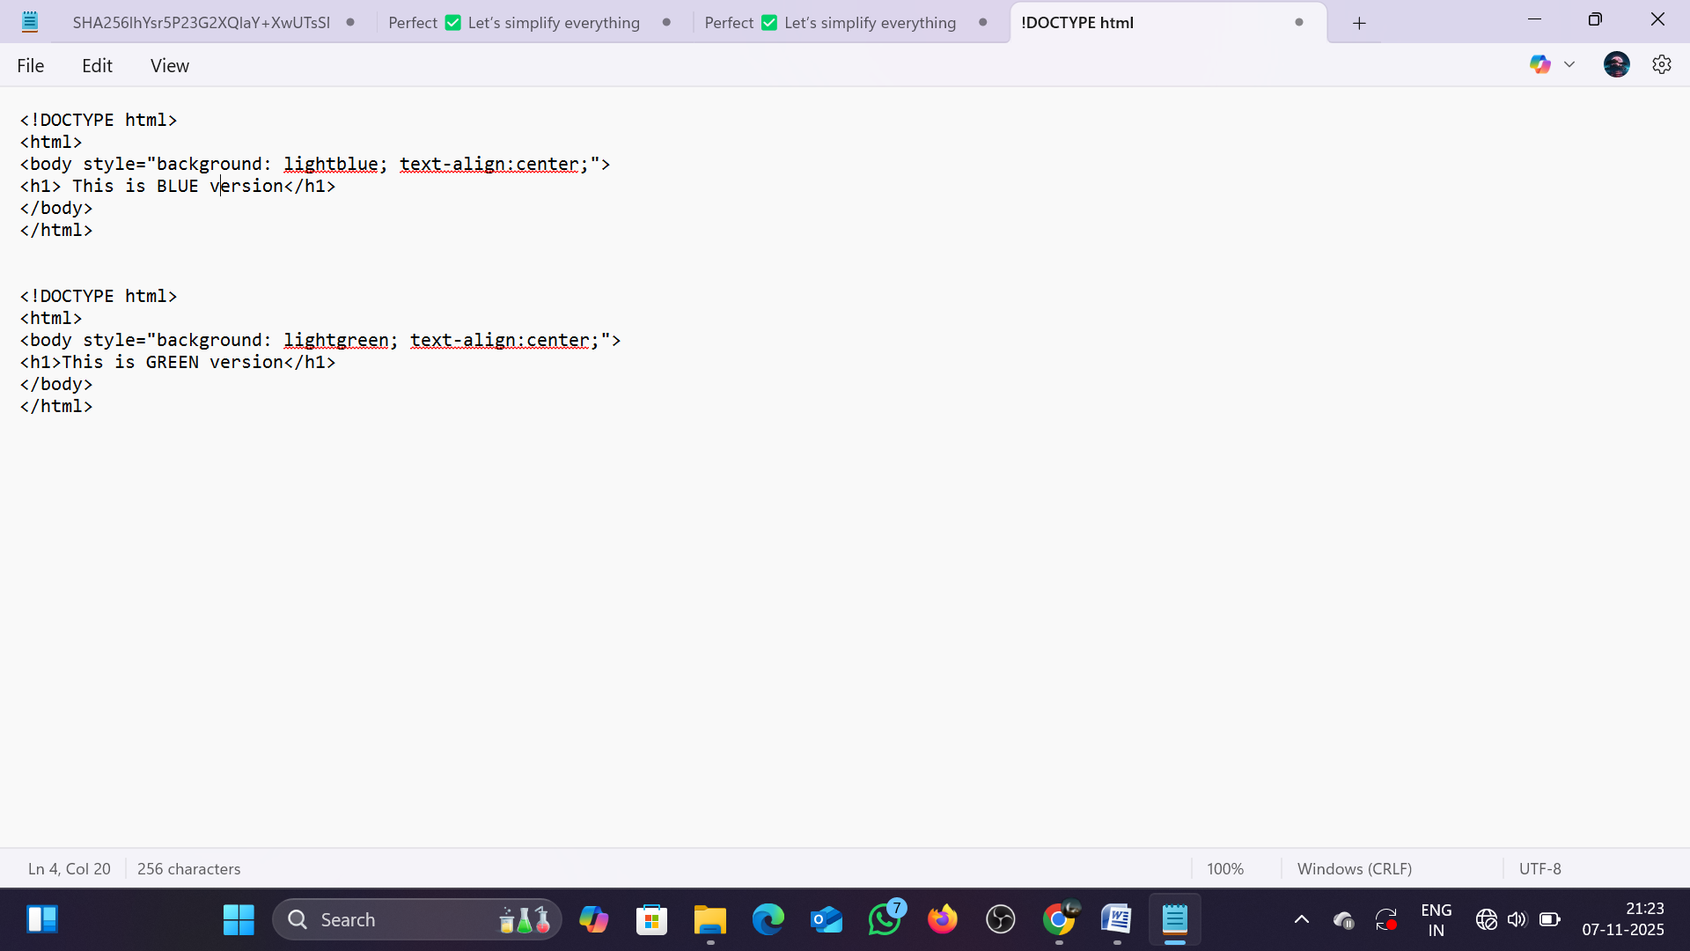

Step 6: Configuring Nginx Load Balancer
On the Jenkins instance, the default configuration file /etc/nginx/sites-available/default was edited to define the Blue server as the default upstream backend is coded. After saving the file, Nginx was reloaded using:
sudo nginx -t
sudo systemctl restart nginx
At this stage, visiting the Jenkins public IP showed the Blue version of the website.
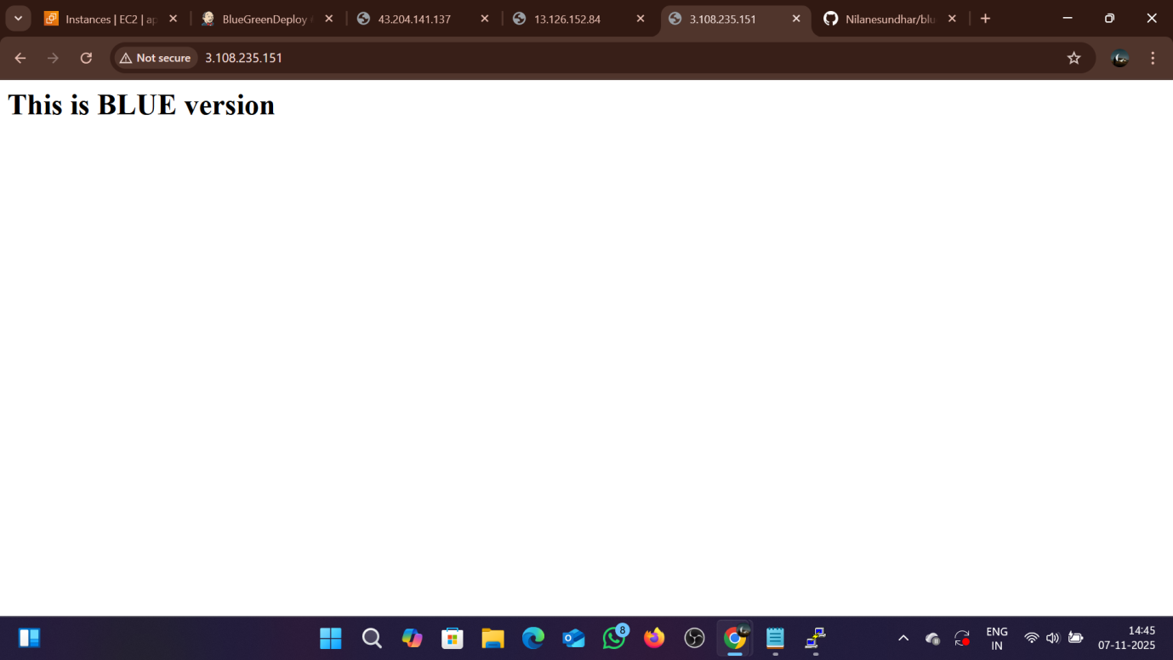

Step 7: Creating a Jenkins Job for Manual Deployment
In Jenkins, a Freestyle Project named BlueGreenDeploy was created. Under Source Code Management, the GitHub repository URL containing the sample web application was provided again under Build Environment, the SSH credentials were selected and an Execute Shell build step was added with commands to deploy files to the Green server. When the job was executed, Jenkins manually transferred the updated files to the Green server.

Step 8: Manual Traffic Switch Using Nginx
After verifying that the Green server was running correctly, the load balancer configuration was updated manually by commenting out the Blue IP and enabling the Green IP:
upstream backend {
# server <BLUE_PRIVATE_IP>:80;
server <GREEN_PRIVATE_IP>:80;
}
Then, Nginx was reloaded and the application displays Green Version.
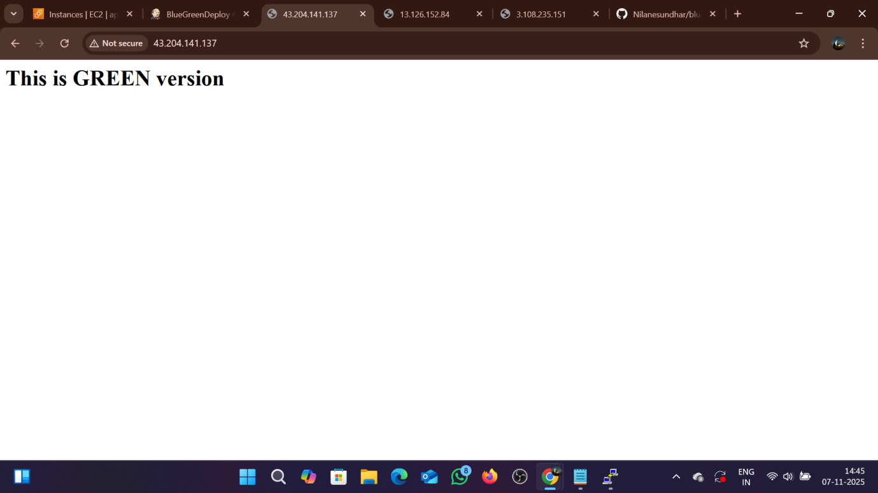

Step 9: Rollback Process
If any issue occurred with the Green version, the rollback process was simple. The Nginx configuration was edited again to point back to the Blue server, and Nginx was reloaded. This instantly restored the previous working version without downtime.

Step 10: Conclusion
After completing the setup, the Blue-Green Deployment process worked successfully. The Nginx load balancer seamlessly routed traffic between Blue and Green servers based on configuration changes. The Jenkins job manually deployed new versions to the Green server and switching traffic required only a few seconds with zero downtime observed during deployment.

