# **RADAR USING ARDUINO**

**Abstract**

Radar is a long-range object detection system that uses radio waves to establish certain parameters of an object like its range, speed and position. Radar technology is used in aircrafts, missiles, marine, weather predictions and automobiles. This Arduino Radar Project is based on Sonar technology which uses an ultrasonic sensor to determine the presence of any object in a particular range. It is implemented with the help of Processing Application. The information collected from the Ultrasonic Sensor with the help of Arduino is passed to the Processing Application where a simple Graphics application is implemented to mimic a Radar Screen. This can be implemented as a surveillance system.

**Module Description**

The Radar project using Arduino is more of a visual project than just a circuit implementation. The project consists of mainly two modules. Fetching data is done by the Arduino IDE and implementation of radar system is done by the Processing Application Software.

The Arduino IDE gets the distance of the object from the data read by the sensor. The ultrasonic sensor has four pins out of which two act as ground and +5 supply. The other two are trigger and echo pins. The distance is read by the sensor in the echo pin, using radio waves emitted by it, which strike the object and are reflected back to the sensor. Then the distance is calculated from the duration the radio waves take to hit and reflect back. Also, the angle of the object with respect to the sensor is calculated. The sensor can read an object up to a distance of 200cm.

The output of the sensor is displayed in the serial monitor of the Arduino IDE. This output, that is the angle and distance of the object, is then sent to Processing through COM Port (Serial Communication). Based on the data received, a sketch in Processing creates a graphics application that is similar to radar screens in aircrafts. This is used to mimic a radar system.

**Pin Diagram of Arduino Uno**

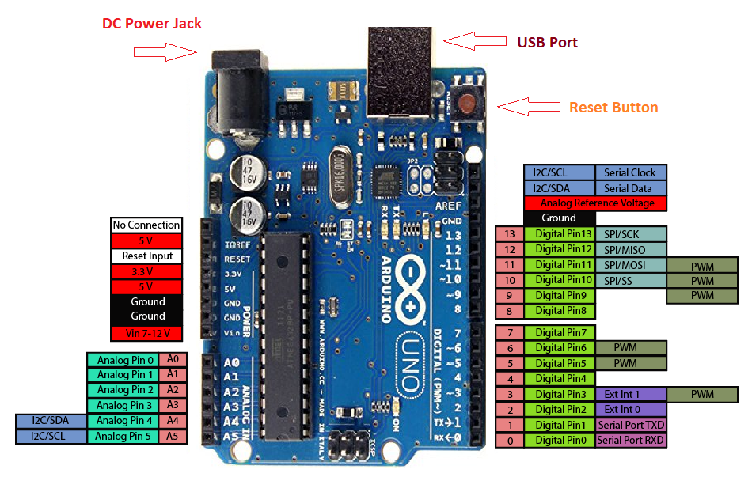

**Pin Diagram of Ultrasonic Sensor HS-SR04**

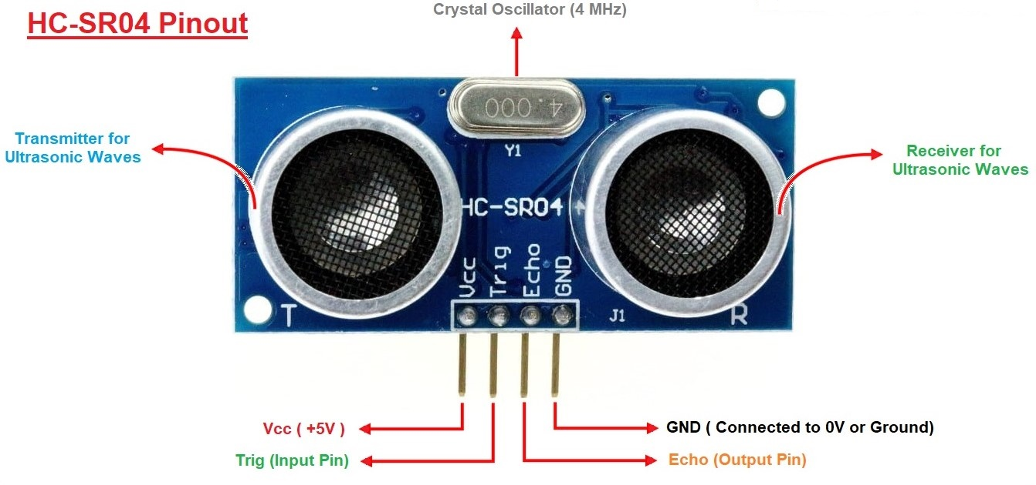

**Pin Diagram of Piezo buzzer and Servo motor**

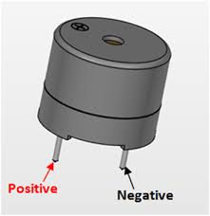 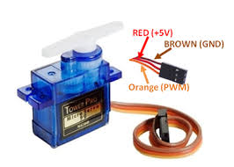

**Circuit Diagram**

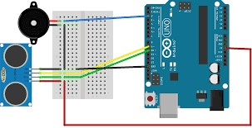

**Flow Diagram**

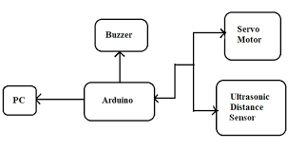

**Components Required**

**HARDWARE**

* Arduino UNO
* HC-SRo4 Ultrasonic Sensor
* Tower Pro SG90 Servo Motor
* Piezo Buzzer
* Jumper Cables
* USB Cable for Arduino

**SOFTWARE**

* Arduino IDE
* Processing Application

**Input**

The echo pin in the ultrasonic sensor is set as the input pin. The data in the echo pin is the duration the radio wave takes to hit the object and reflect back to the sensor and the angle of the object. From this duration, the distance is calculated and both the angle and distance are sent to Processing as input.

**Expected Output**

Distance and angle are the output of the sensor in Arduino IDE. In the Processing software, a graphical representation of the data from the Ultrasonic Sensor is represented in a Radar type display. If the Ultrasonic Sensor detects any object within its range, the same will be displayed graphically on the screen in the form of red lines.

**Application**

This Radar System have various applications for security purposes and it is mainly used for mapping.

o APPLCATION IN AIR FORCE: It is used in airplanes or aircraft machines which have implemented radar system in it to detect the objects that comes in a way. It is also used to calculate height readings.

o APPLICATION IN MARINE: This radar system also used in ships or marine. It is implemented on big ships to calculate the distance of other boats or ships, with the help of this sea accidents can also be reduced by not colliding. It can also be implemented on ports to see the distance of other ships and to monitor or control the ship movements.

o APPLICATON IN METEROLOGY: Meteorologists also uses radar systems to track or monitor the wind. It has been become an important equipment for climate testing. For example to detect tornados, storms.

**Team members**

Khavyaa S (204020)

Nilani P (204029)