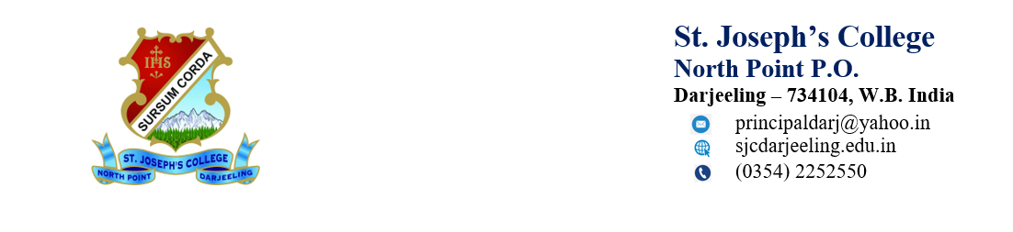
Date:6/9/2024
The details of all suspended officials and staff

Name of the suspended  employee | Name of the suspended Office/Institution with address | Suspended from | Reason for  suspension | Any  other
Nil | St Joseph’s College, PO North Point, Darjeeling. W B 734104 | Nil | Nil | Nil

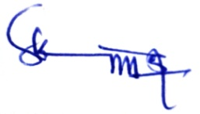
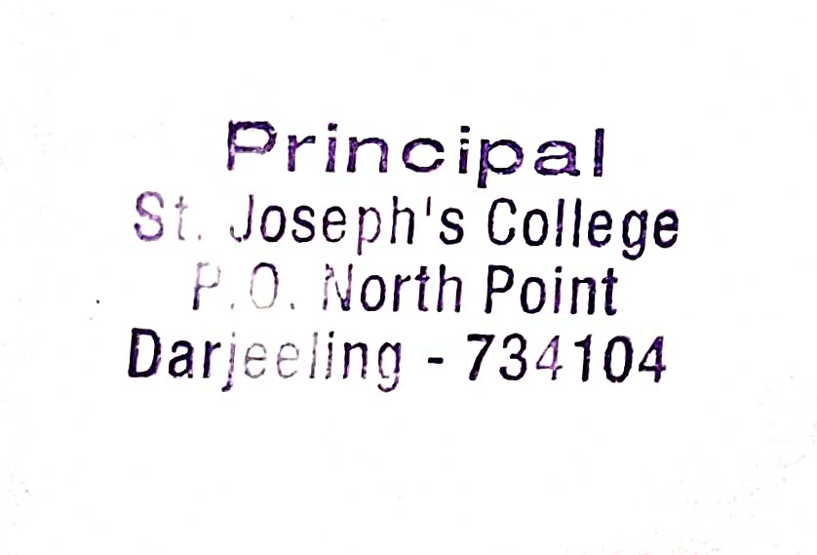
Principal

