

American International University-Bangladesh (AIUB)

**Advance Operating System Project**

**Topic: RFID Based Attendance System.**

**Submitted By:**

|  |  |
| --- | --- |
| 17-35583-3 | Nilanjan Biswas |
| 17-35327-2 | Shahnaj Zahan Mou |
| 17-35068-2 | Mahia Islam |

**Submitted To**

**ARIFUR RAHMAN**

**Department of Computer Science**

**Faculty of Science & IT**

**American International University Bangladesh**

**April, 2020**

**Project Idea:**

Topic : RFID Scanner based class attendance system.

An RFID based Attendance System is a very interesting project which can be used in different places say in Schools to register the attendance of students and teachers, Private organizations to monitor their attendance.

In our project we used RFID technology to make a note of every student entering into the classroom and also keep a log of entry time in the classroom. In this proposed system, every student is allotted with an RFID tag. The process of attendance can be done by placing the card near the RFID reader then storing data into a database and from the Database information retrieved on a Graphical User Interface.

**Component List:**

The components required for making IoT Based RFID Attendance System project are given below:

1. ESP 32.
2. RC 522 RFID scanner.
3. Breadboard.
4. Jumper wire Female to male.

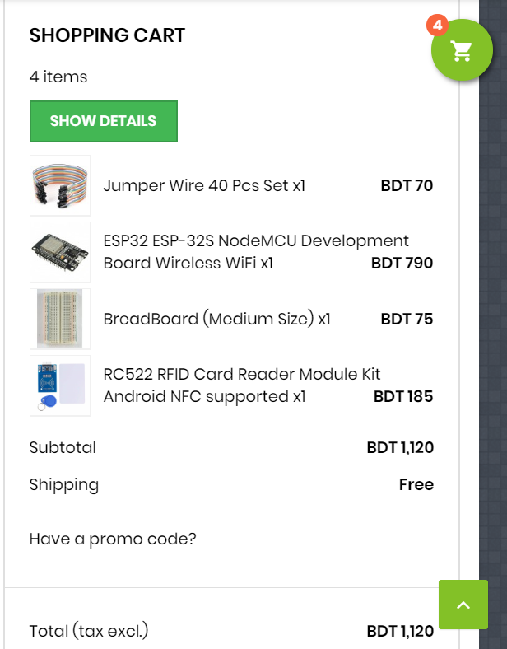

**Project Implementation Description**

Connect ESP32 with MFRC522:

First, we configured our components. We used **ESP32 and MFRC522 RFID**. So, the connection diagram is exactly the same as shown in the figure.

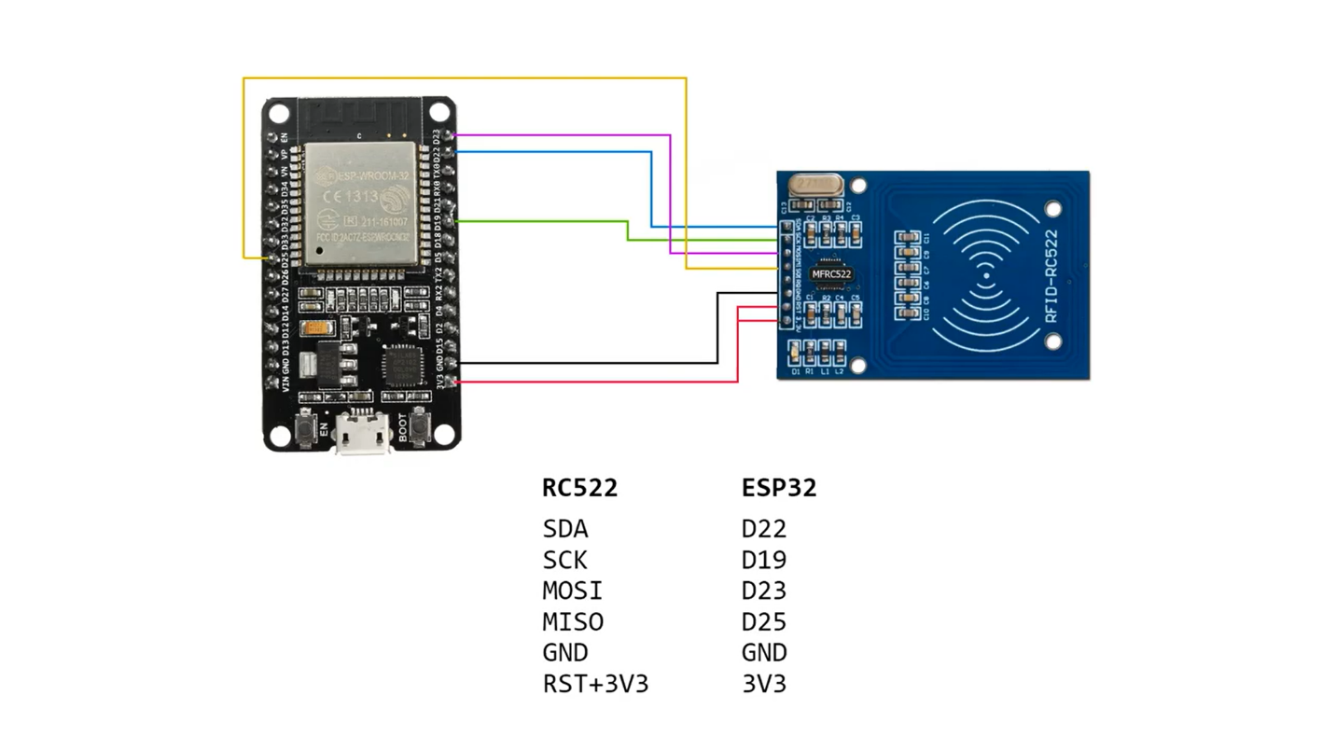

IDE Setup and Libraries installation

### 

### Preparing Arduino IDE:

First download and install the Arduino IDE. Once installed, open the Arduino IDE and go to *Files -> Preferences* to open the preferences window and locate the *“Additional Boards Manager URLs:”* as shown below:

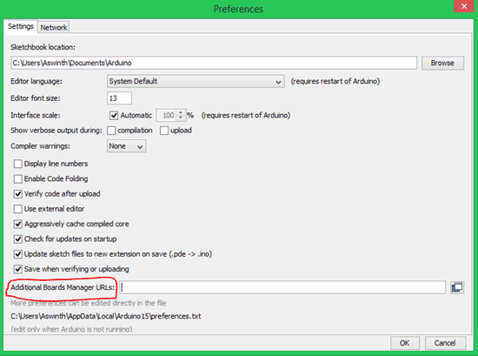

paste the below URL into the text box

https://dl.espressif.com/dl/package_esp32_dev_index.json

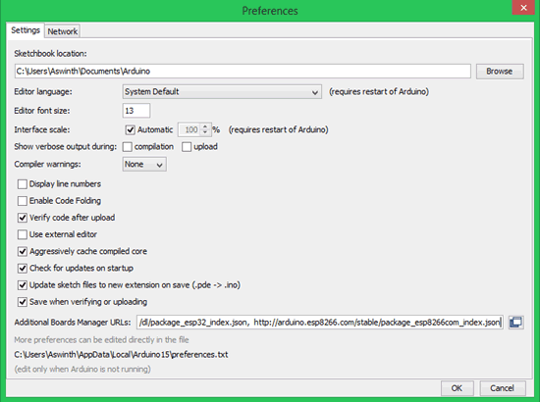

Now go to *Tools -> Boards -> Board Managers* to open the Board manager window and search for ESP32. If the URL was pasted correctly your window should find the below screen with *Install* button, just click on the Install button and your board should get installed.

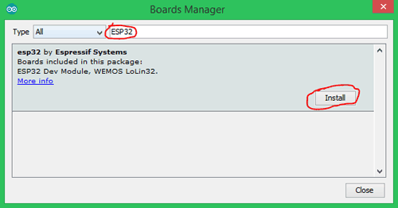

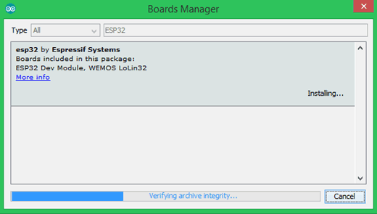

Done with the IDE setup.

### 

### Programming ESP32 with Arduino IDE:

For programming with esp32 with Arduino IDE we needed to follow some steps:

**STEP 1:** Connect ESP32 board to computer through the micro-USB cable. After getting power supply the red LED goes high on the module to ensure power supply.

**STEP 2:** Start the Arduino IDE and navigate to *Tools -> Boards and select ESP32Dev* board as shown below

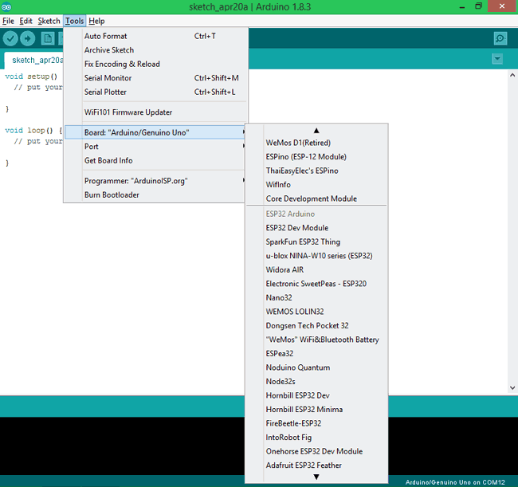

**STEP 3:** Open device manager and check to which com port your ESP32 is connected to. Mine is connected to COM 3 as shown below

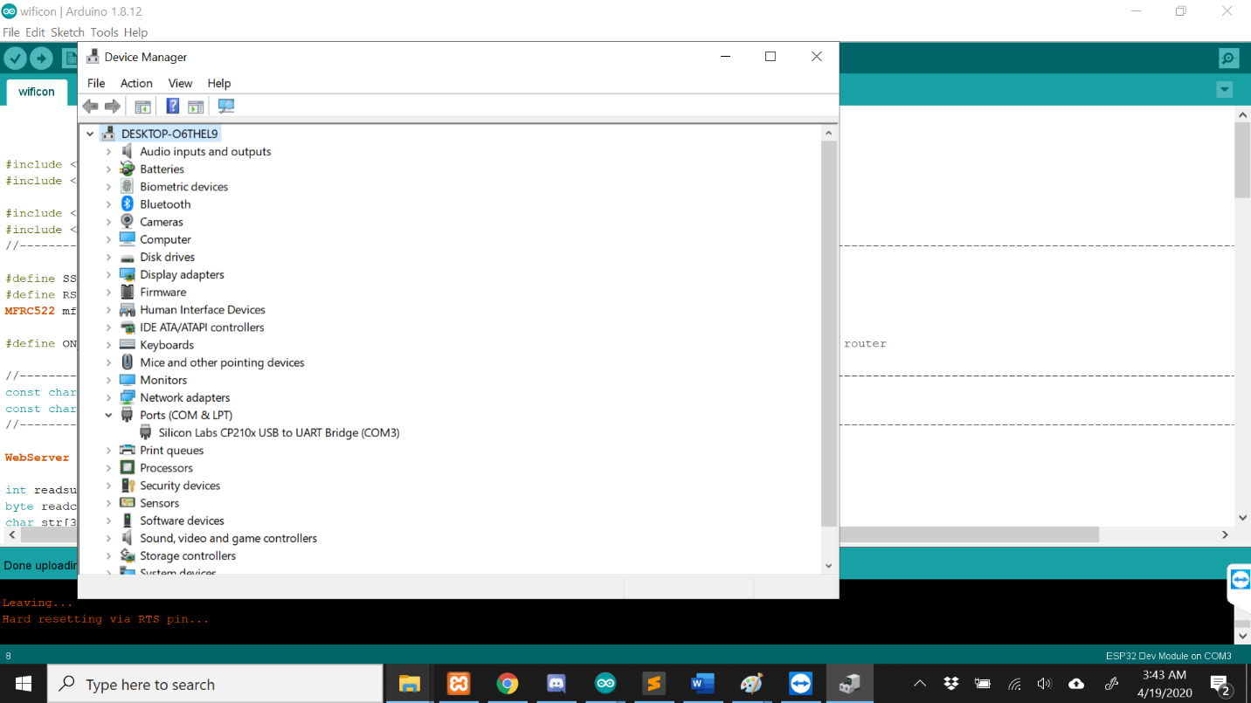

**STEP 4:** Go back to Arduino IDE and under *Tools -> Port select* the Port to which your ESP is connected to. Once selected you should see something like this on the bottom right corner of the IDE.

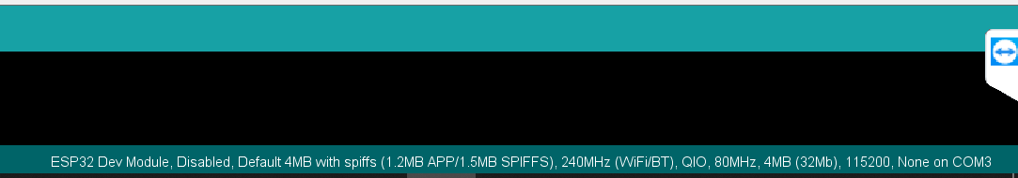

**Download Libraries**

Installed following library in Arduino IDE:

1.**MFRC522**

2.**ESPAsyncWebServer-master**

3.**HttpClient**

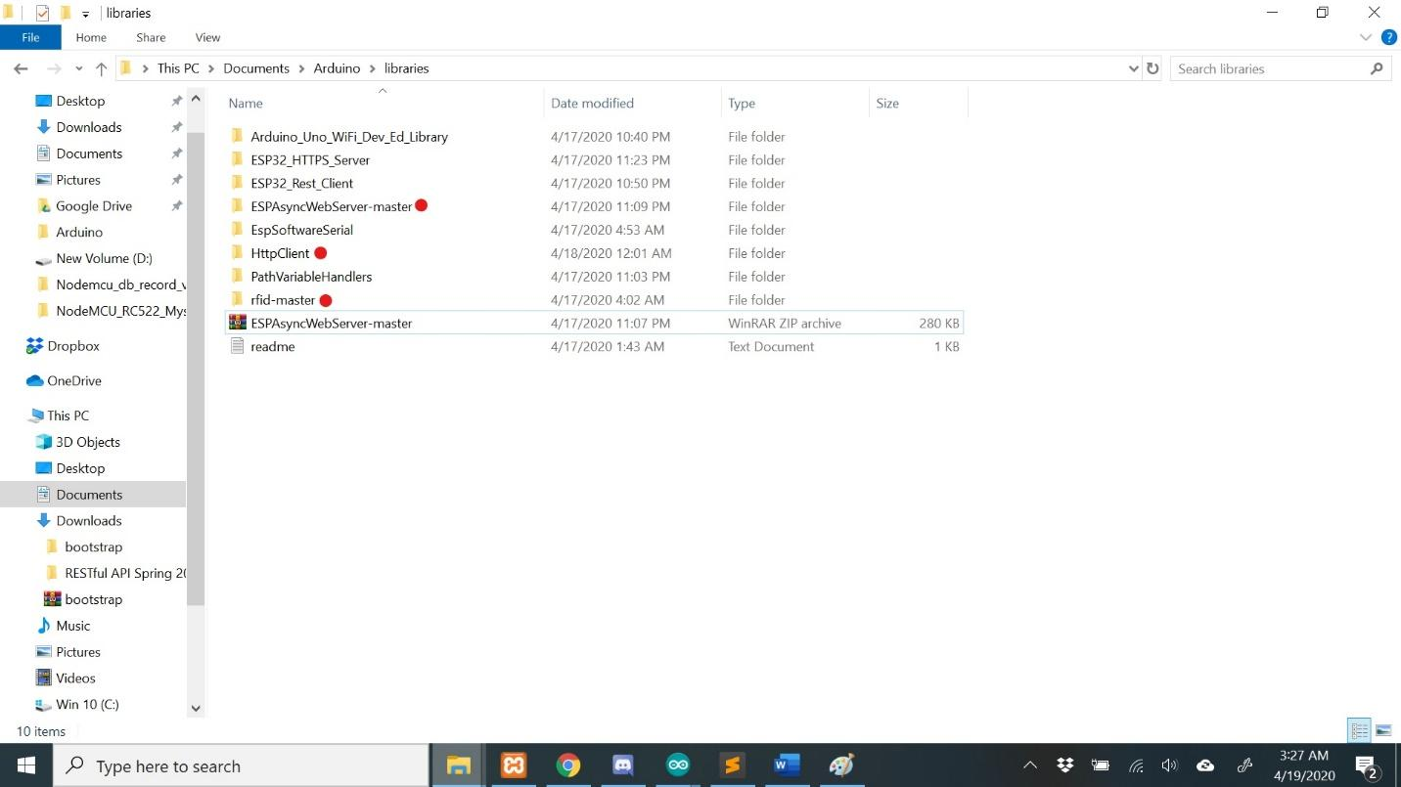

After Installing Libraries, we wrote code on IDE. And on Serial monitor we can see read data:

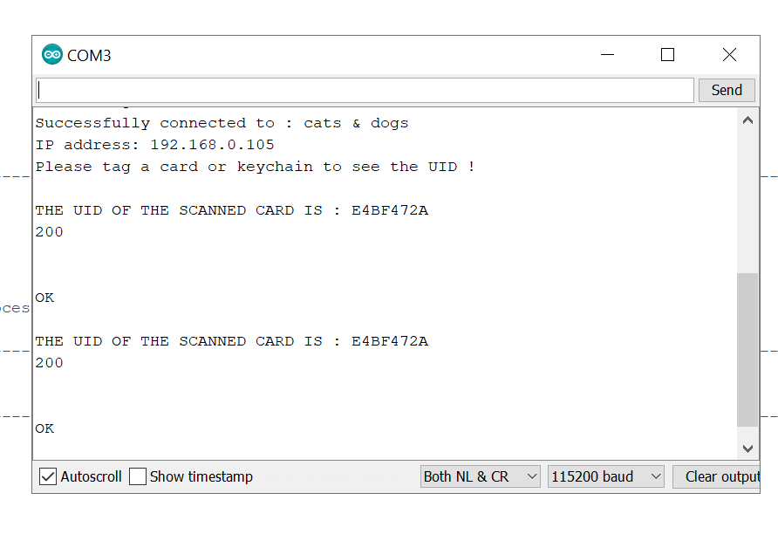

References

1.<https://github.com/espressif/arduino-esp32>

2.<https://www.youtube.com/watch?v=4jfb_PL-FEA>

3.<https://randomnerdtutorials.com/esp32-troubleshooting-guide/>

4.<https://circuits4you.com/2019/01/05/connecting-esp32-to-wifi-network/>

5.<https://www.instructables.com/id/MFRC522-RFID-Reader-Interfaced-With-NodeMCU/>