|  |  |
| --- | --- |
|  |  |

Summer Internship Report

IBM E-Commerce Project

StockHawk

**Date:**

**Priyanjit Dey**

**Nilanjan Daw**

**Priyangbada Ganguly**

**B.Tech 3rd Year**

**Computer Science and Engineering**

**Institute of Engineering and Management**

**Executive Summary**

Our two-month Industrial Internship Program work term was with the IBM Global Business Services, Kolkata. We were involved in the area of e-Commerce during our work term, all of which will be outlined in this report. This report will cover some background information on the project we were involved in, as well as details on how the project was developed.  
  
One of the important achievements of this project was the development of a new application named as StockHawk which provides many features and supports the concept of “stock market”. The major benefits of this project is:

* It greatly simplifies the task of an investor by showing present market price of all the companies.
* It provides some additional functionality, which would be helpful for any investor.

An application was finally developed using the above API to demonstrate its usefulness. It was a prototype solution to a real life problem for most of the active investors and buyers in the world of ecommerce.

We acquired many new technical skills throughout our work term. We acquired new knowledge by using IBM Bluemix. We also brushed up our skills in PHP while making the Stock Hawk application. Most importantly, the work experience was very good which included good fellowship, cooperative teamwork and accepting responsibilities.

This report concludes with our overall impressions of our work experience as well as our opinion of the Industrial Internship Program in general.

Table of contents

1 Acknowledgements 3

2 Introduction and Overview 4

2.1 IBM and e-Trading – Background Information 4

2.2 Introduction 4

2.3 Need for E-trading 4

2.4 Issues in implementing e-governance 5

2.5 Project Overview 6

3.3 Technical Details and Applicable Issues 8

3.3.1 Understanding the stock hawk 8

3.3.2 Architecture of Stock hawk 8

3.3.3 User 8

3.3.4 Transaction 10

3.3.5 Stock Master 10

3.3.6 Corporate actions 10

3.3.9 Summary 17

5 Learning From the Internship Program 25

6 Applying My University Skills 26

7 Appendices 27

# Acknowledgements

During our summer internship , we are very thankful to our guide Mr.Abhishek Basu Mallik for his invaluable guidance and advice during our Summer Internship.

We are grateful to our professors of IEM for supporting us. We are also thankful to our team members for their constant effort to make this project.

# Introduction and Overview

## IBM and e-Trading – Background Information

Ecommerce software from IBM helps you provide your customers and partners with a personalized, seamless shopping experience, whether they interact with your brand via the web, mobile devices, social media, call centers or in-store touch points. This means consistent ecommerce catalogs, pricing, promotions and discounts across every channel, regardless of how they come into contact with your brand.

## Introduction

Electronic commerce, commonly written as e-commerce or eCommerce, is the trading or facilitation of trading in products or services using computer networks, such as the Internet or online social networks.

E-commerce businesses may employ some or all of the following:

* Online shopping web sites for retail sales direct to consumers
* Providing or participating in online marketplaces, which process third-party business-to-consumer or consumer-to-consumer sales
* Business-to-business buying and selling
* Gathering and using demographic data through web contacts and social media
* Business-to-business electronic data interchange
* Marketing to prospective and established customers by e-mail or fax (for example, with newsletters)
* Engaging in e-retail for launching new products and services
* Online financial exchanges for currency exchanges or trading purposes

One of the most important feature of E-commerce is E-trading (first electronic stock market).

Trading in the financial markets can broadly be split into two groups:

* Business-to-business (B2B) trading, often conducted on exchanges, where large investment banks and brokers trade directly with one another, transacting large amounts of securities, and
* Business-to-consumer (B2C) trading, where retail (e.g. individuals buying and selling relatively small amounts of stocks and shares) and institutional clients (e.g. hedge funds, fund managers or insurance companies, trading far larger amounts of securities) buy and sell from brokers or "dealers", who act as middle-men between the clients and the B2B markets.

For stock trading, the process of connecting counterparties through electronic trading is supported by the Financial Information exchange (FIX) Protocol. Used by the vast majority of exchanges and traders, the FIX Protocol is the industry standard for pre-trade messaging and trade execution.

For this reason, to reach out to a huge number of customers E-trading gradually became popular in today’s world.

## Need for E-trading

The increase of electronic trading has had some important implications:

* **Reduced cost of transactions** – By automating as much of the process as possible (often referred to as "straight-through processing" or STP), costs are brought down. The goal is to reduce the incremental cost of trades as close to zero as possible, so that increased trading volumes don't lead to significantly increased costs. This has translated to lower costs for investors.
* **Greater liquidity** – electronic systems make it easier to allow different companies to trade with one another, no matter where they are located. This leads to greater liquidity (i.e. there are more buyers and sellers) which increases the efficiency of the markets.
* **Greater competition** – While electronic trading hasn't necessarily lowered the cost of entry to the financial services industry, it has removed barriers within the industry and had a globalization-style competition effect. For example, a trader can trade futures on Eurex, Globex or LIFFE at the click of a button – he or she doesn't need to go through a broker or pass orders to a trader on the exchange floor.
* **Increased transparency** – Electronic trading has meant that the markets are less opaque. It's easier to find out the price of securities when that information is flowing around the world electronically.
* **Tighter spreads** – The "spread" on an instrument is the difference between the best buying and selling prices being quoted; it represents the profit being made by the market makers. The increased liquidity, competition and transparency means that spreads have tightened, especially for commoditized, exchange-traded instruments.

For retail investors, financial services on the web offer great benefits. The primary benefit is the reduced cost of transactions for all concerned as well as the ease and the convenience. Web-driven financial transactions bypass traditional hurdles such as logistics.

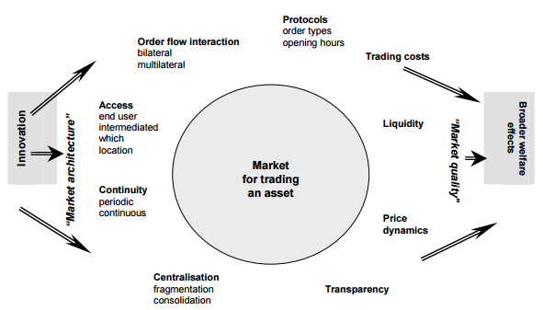**A framework for illustrating the effects of electronic trading**

## The pervasiveness of networks and challenges for e-trading

Network issues permeate analysis of trading. They vary from the network externalities of markets attracting liquidity to practical consideration of physical network access arrangements. The greater use of electronic systems and linkages for trading highlights these effects. Although network technologies may broaden access and in principle enable “more perfect” markets, the immediate reality may prove less benign. For example, the presence of electronic networks can embed existing privileges, with network access and design choices giving strategic advantages to certain classes of participants (see Section 5). And the effects recognized in network economics (see Box B) are a powerful influence in this area. They can lead to sustained suboptimal equilibrium in market arrangements and a tendency to consolidation. While the latter may bring about significant scale efficiencies in market processes, if (near) monopoly power emerges there can be undesirable outcomes such as lack of choice and monopoly pricing. The prospect of such outcomes creates difficult policy questions. First, identifying a suboptimal situation is not easy given the different, possibly conflicting, objectives of affected parties. Then, even where problems are recognized, they may represent a temporary phase of an immature market, which competitive forces and innovation could well resolve. Intervention may be judged inadvisable unless there is demonstrably a sustained problem plus a response which could clearly improve on the market outcome. Analysis of such situations carries clear dangers of misinterpretation. The multiple, potentially competing, public policy objectives make it likely that not all can be simultaneously achieved. There are dilemmas between intervention or “wait and see”. The former could risk stifling competition and limiting innovation in fast changing environments, while the latter might risk missing opportunities to prevent problems becoming widespread. Responses to market fragmentation illustrate the difficulties, seen especially in equity markets when alternative trading venues become available. Concerns are associated with whether the liquidity of the “main” market is reduced - which could mean less market depth to absorb large trades and shocks, reduced price efficiency, higher search costs and price comparison being made more difficult. However, the flip side is that the additional execution routes may reflect greater variety of services, competition to cut costs and innovation in trading systems. This raises significant questions about the efficacy of policy intervention. It is illustrative of the dilemmas that views can differ starkly even over whether there is a problem to be addressed. If the situation is believed detrimental to public policy interests, there are judgments to be made over whether market forces will resolve difficulties (say, through consolidation following competitive attrition of illiquid venues and/or technological innovations offering linkages). Or whether, and in what manner, to intervene actively.

## Project Overview

In this application there will be admins or portfolio managers and users. Portfolio managers can also act as an investor but vice versa is not allowed over there.

Each investor will have 1 portfolio and each portfolio can have multiple stocks not only that it will also have an additional entry for cash so that e-trading can take place.

The portfolio manager (PM) will enter the transaction details. Each transaction is associated with an investor and reflected in the investor’s portfolio. For each transaction, corresponding cash position gets updated. i.e. if a stock is bought, cash will be reduced from the portfolio. If a stock is sold the cash will be added to the portfolio.

# Project : Stock Hawk

## Project Background and Scope

Stock Hawk is a massive project in which data management plays a vital role. Since the number of applications running on the system will be large in number, data storage, retrieval and management will be an important issue. An IBM product called Bluemix offers one possible solution.

Since the information generated by most of the eTrading companies may not possess a structured format and thus there is an obvious need of some tool, which can mange this unstructured information in a efficient manner. Bluemix, an IBM trademark, offers a scalable solution for the same as it can manage all unstructured information in an efficient fashion.

## Technical Details and Applicable Issues

### Understanding Stock Hawk

#### What is StockHawk?

Simply put, Stock Hawk is a database management application, providing many sophisticated features and easily adaptable to a network solution for stock trading.

StockHawk leverages the power of IBM Bluemix to provide a real-time semi-automated Stock Trading system. The system allows enlisting of publicly traded companies and allows users to trade in such companies.

The UI is inspired by Google’s material design so that it feels light and easy to use. . It offers automated real time stock updates, so that traders can take informed decisions. Also due to its cloud based nature the system is resilient to faults and thus can be depended upon.

Other than this, StockHawk allows an in-house messaging service for secure communication between fellow traders, Portfolio Managers and Admins.

The system also boasts of a fully-fledged issue tracking system for fast resolution of bugs in the system.

### Overview of the Architecture of Stock Hawk

#### User

The project architecture allows for 3 levels of user arbitration.

* At the highest level is the Admin. This account allows for maximum flexibilityand is given maximum amount of access rights however only to such an extent that it doesnot endanger the integrity of the system,
* At the second level is the Portfolio Manager. Though lacking system modification access, this account are empowered to transfer and transact stock options for their allocated users,
* At the lowest level are the Users. These accounts have the least access rights and can only transact business under the direct supervison of Manager accounts.

#### Transaction

All transactions made in the system is performed under direct supervision of Portfolio Managers.

* Each transaction is duly logged with date of transaction, number of shares purchased or sold, nameof stock company and other necessary details.
* Each purchase automatically triggers an updation of the stock prices using complex mathematical models which are notified across all relevant accounts in realtime.
* Every stock transaction also affects the credits availabale to the user according to the type of transaction.

#### Stock Master

Accounts with Admin or Portfolio Manager designations have the power to enlist new Company stocks and update stock pricing as and when required.

#### Corporate actions

Corporate actions are allowed to users with a minimum of level 2 access. The following corporate Actions are permited by the present system.

* Stock Spillting: Company stocks can be split into integer multiples which leads to automatic normalisation of company stock prices and account credits or relevent users.
* Dividend Updation: Every time dividents are paid by companies all stock portfolios are automatically updated without any human interaction.

### Flow Diagrams

**Main Module**



**Transaction Module**



### Features of Stock Hawk – Brief Summary

* Let’s you store perform transactions by buying and selling shares as well as it helps to controls the cash balance in respective accounts.
* Stores data on distributed servers and provides single point access.
* Provides many sophisticated features like
  + Checking present market value of a company.
  + Can discuss with admin whether to buy or sell a product.
  + Uses complex mathematical models to update stock values according to market factors.
  + Automatic updating of cash balance.
  + Can deposit more cash to the account or withdraw if needed.

### Capture.PNGUI Design Details

**LOG IN PAGE FOR USERS**

* 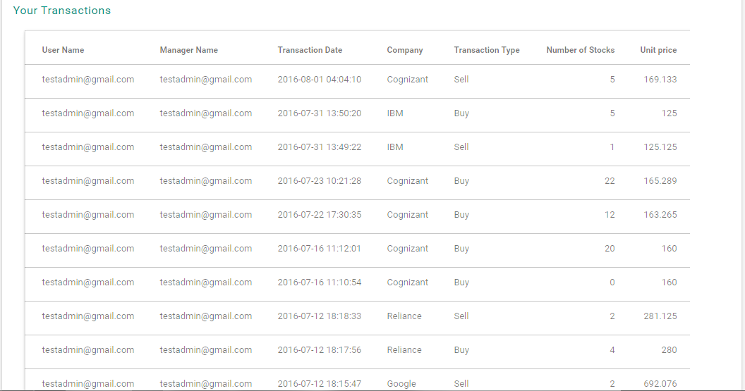Once user logged into the home page, list of transaction that the user has done is visible.

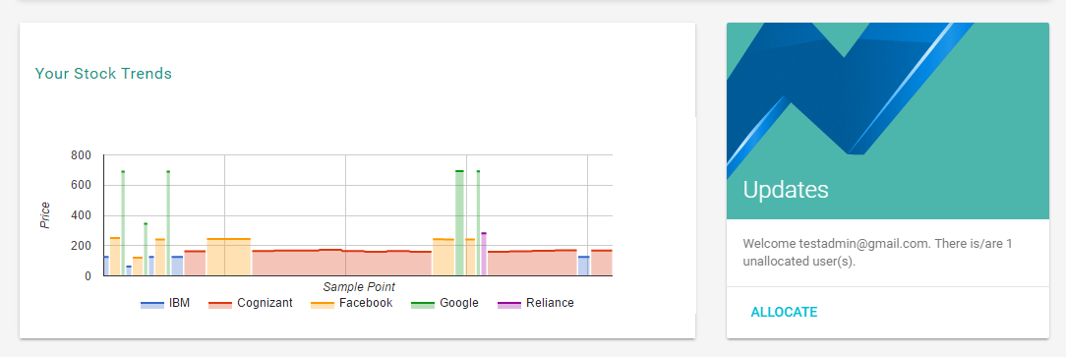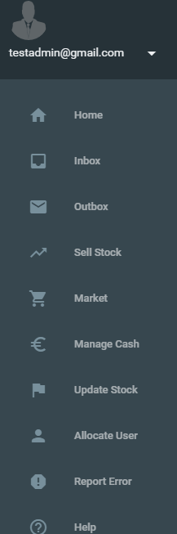**HOME PAGE ALSO CONSIST OF GRAPHICAL REPRESENTATION OF MARKET PRICE OF DIFFERENT COMPANIES**

DIFFERENT FUNCTIONS OF STOCK HAWK

### Summary

Stock Hawk is a good solution for managing unstructred data arising from various applications running in etrading. It has a distributed architecture and provides many features conducive to an ecommerce implementation.

In the above project, a new API was developed to provide simplicity and extensibility catering to some eTrading requirements.

# Learning From the Internship Program

The Internship program was quite beneficial for us. It helped us in improving our various technical skills and enhanced our knowledge in new areas.

* We gained new knowledge in the area of Databases and Distributed Databases, the various issues involved and mechanisms in these systems etc.
* E-Trading is an emerging field and we got some insight into a how a new field looks like when in the initial stage and what are the various things which need to be done initially like requirement analysis, survey of existing solutions etc.
* We were working on a research topic for the first time and we got introduced to this important area of research and methods employed in conducting research.
* We brushed up our knowledge of PHP, as it was required to develop application of Stock Hawk.

**Work Experience**

Our internship was quite satisfactory in terms of work environment. The team we worked with was very friendly and helped us a lot in all of our problems. New experiences include

* Teamwork

In these projects 4-5 people worked together thus providing enough opportunity for proper teamwork and coordination.

* Responsibility and keeping commitments

The importance of honoring commitments and time of others was an important thing, which we learnt as a summer Intern. Especially, while working as a team it is very important to keep these points in mind.

# Applying Our University Skills

Our education at IEM was very helpful in our Internship. The programming skills which we developed in IEM were very helpful in developing the Stock Hawk.

# Appendices

## Bibliography

* <http://www.investopedia.com/university/stocks/>
* <https://en.wikipedia.org/wiki/Stock_market>
* <http://finance.yahoo.com/>
* <https://www.google.com/finance>
* <https://getmdl.io/index.html>
* <https://developers.google.com/chart/>
* <http://php.net/>
* <http://www.ibm.com/cloud-computing/bluemix/>
* <http://w2.cleardb.net/>
* <http://www.w3schools.com/>
* <https://www.mysql.com/>
* <https://github.com/>