**Longest Common Subsequence**:

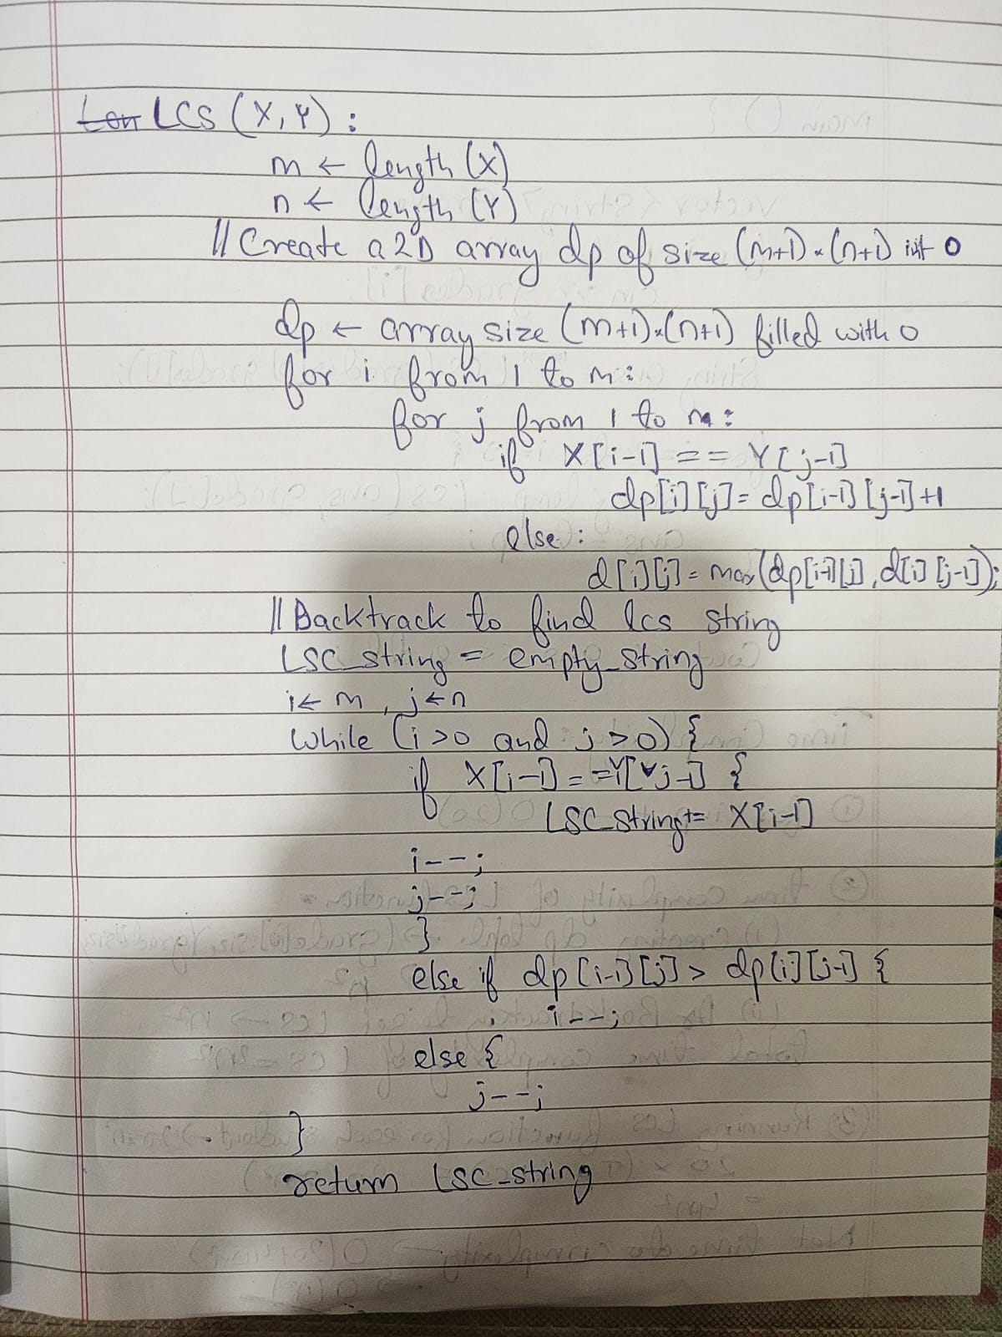

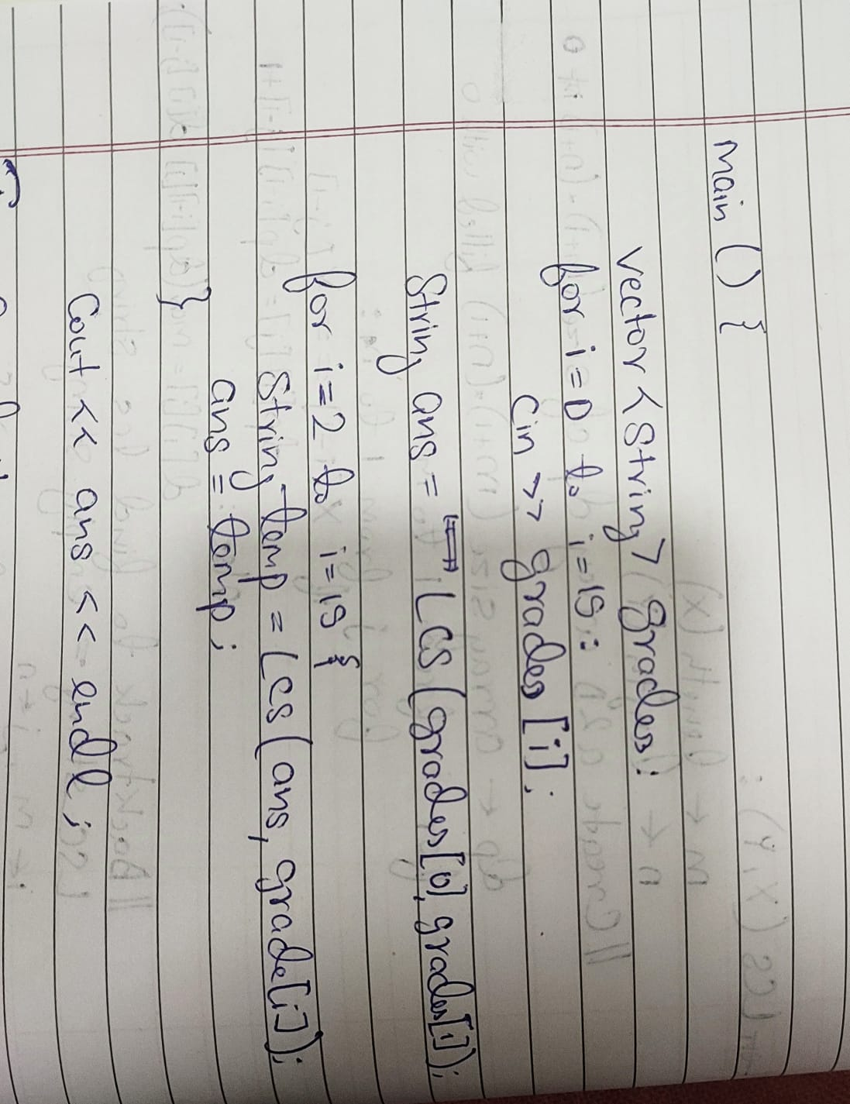

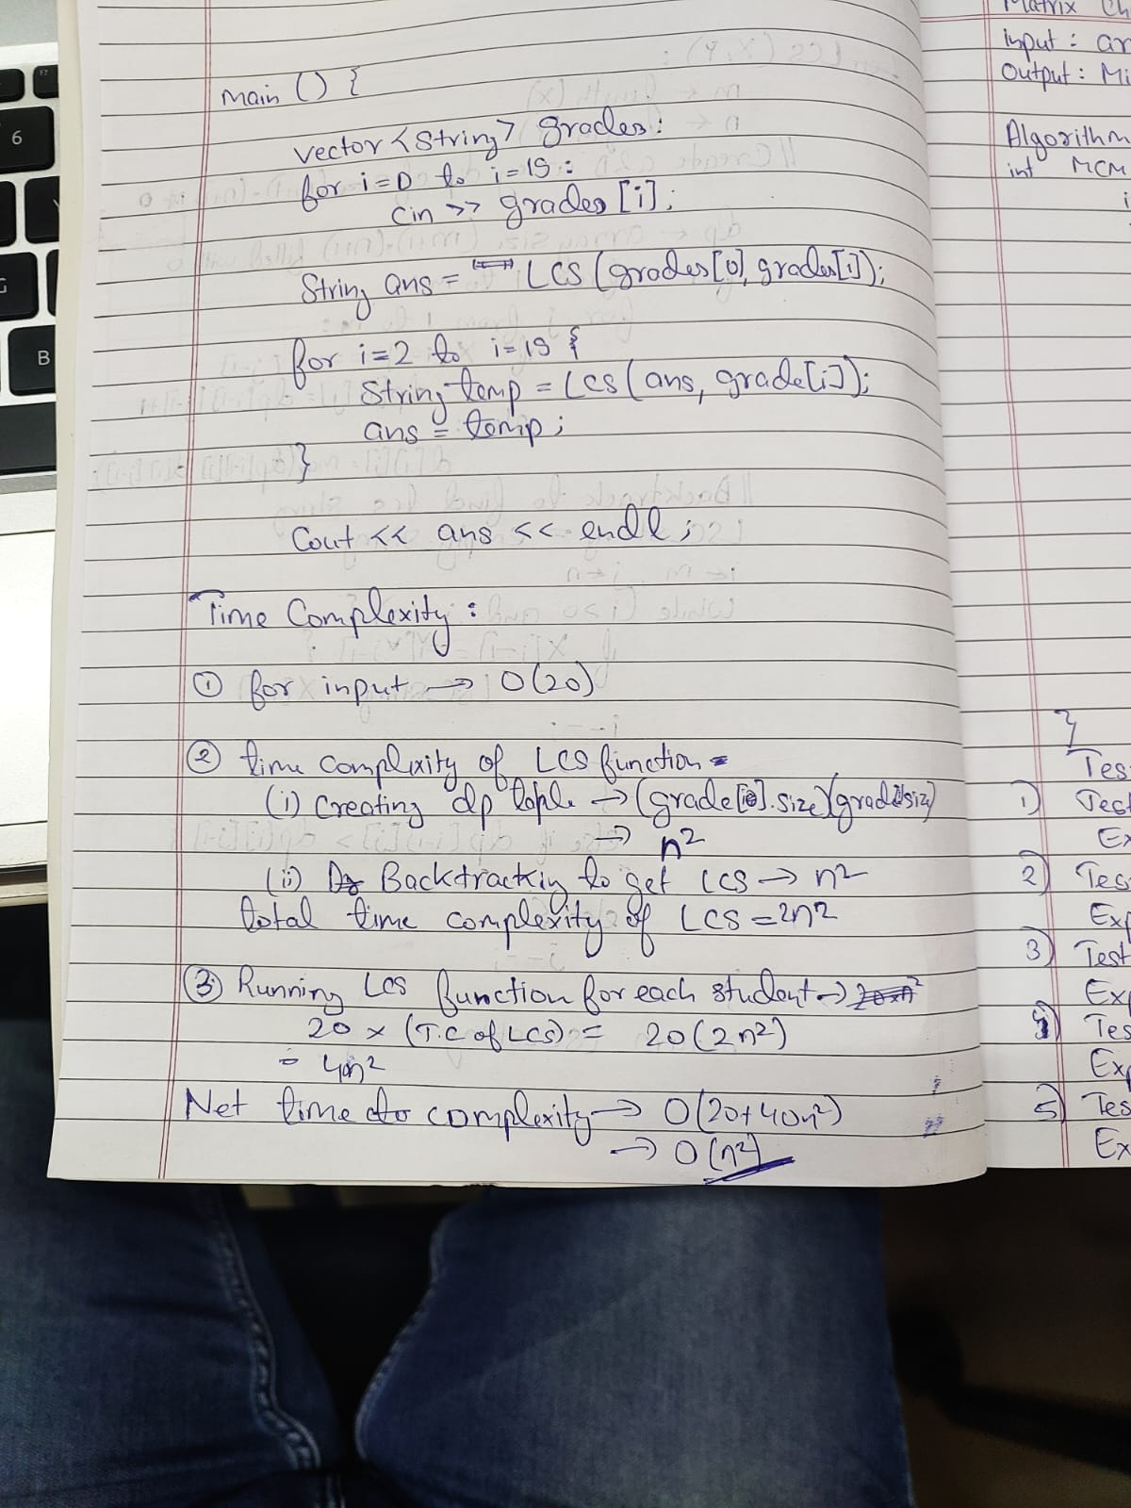

**Code of Longest Common Subsequence**:

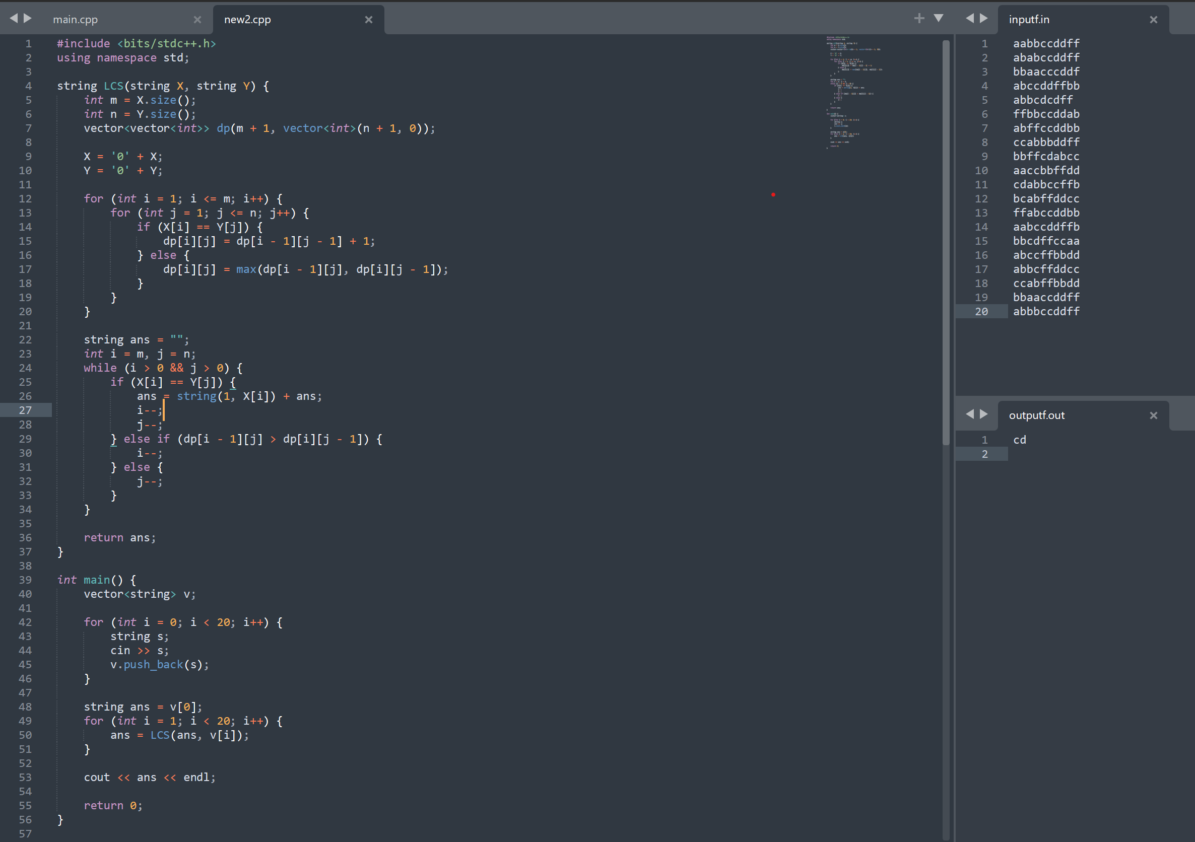

**Matrix Chain Multiplication:**

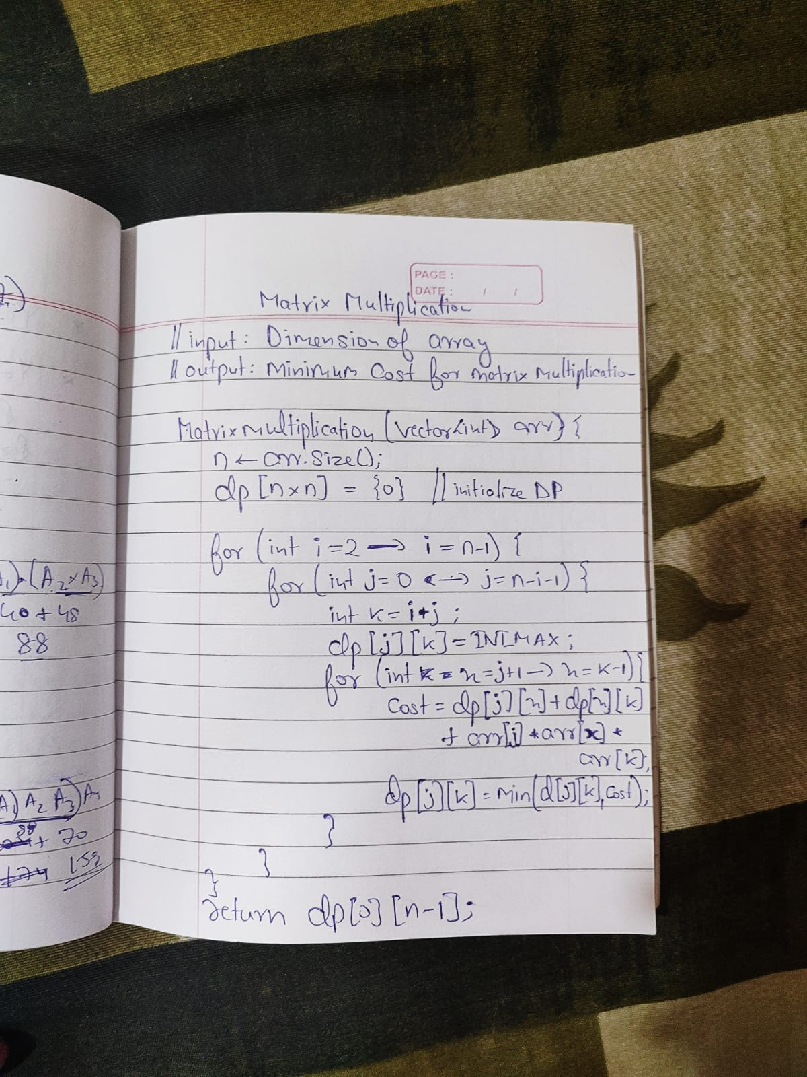

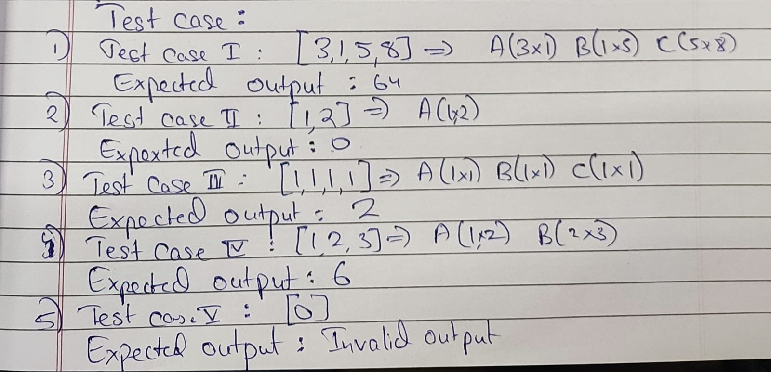

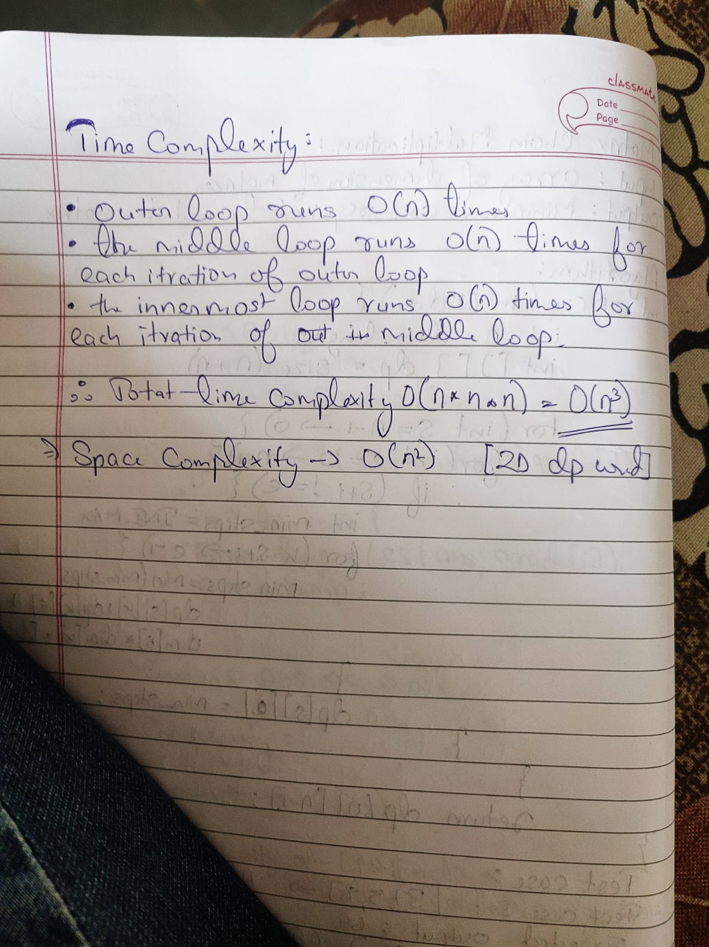

**Code Matrix Chain Multiplication:**

#include <bits/stdc++.h>

using *namespace* std;

*int* matrixMultiplication(vector<*int*> &*arr*) {

*int* n = *arr*.size();

    vector<vector<*int*>> dp(n, vector<*int*>(n, 0));

    for (*int* len = 2; len < n; len++) {

        for (*int* i = 0; i < n - len; i++) {

*int* j = i + len;

            dp[i][j] = INT_MAX;

            for (*int* k = i + 1; k < j; k++) {

*int* cost = dp[i][k] + dp[k][j] + *arr*[i] * *arr*[k] * *arr*[j];

                dp[i][j] = min(dp[i][j], cost);

            }

        }

    }

    return dp[0][n - 1];

}

*int* main() {

    vector<*int*> arr = {5, 4, 3, 2};

    cout << matrixMultiplication(arr);

    return 0;

}

