**Nama : Nila Farihah**

**NIM : A11.2022.14667**

**PRAKTIKUM 1**

**Tugas 1 :**

**datapribadi.java**

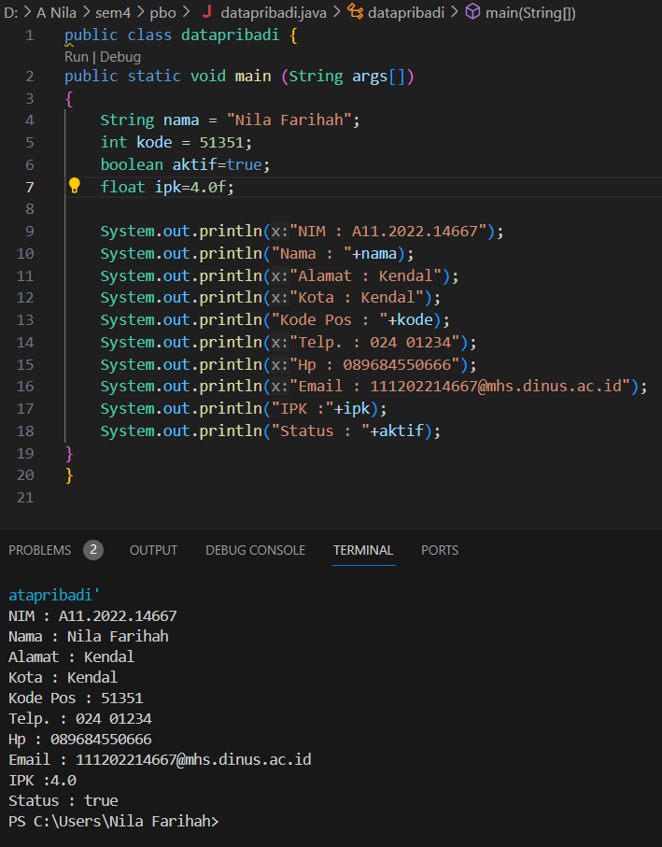

**Source code :**

public class datapribadi {

public static void main (String args[])

{

    String nama = "Nila Farihah";

    int kode = 51351;

    boolean aktif=true;

    float ipk=4.0f;

    System.out.println("NIM : A11.2022.14667");

    System.out.println("Nama : "+nama);

    System.out.println("Alamat : Kendal");

    System.out.println("Kota : Kendal");

    System.out.println("Kode Pos : "+kode);

    System.out.println("Telp. : 024 01234");

    System.out.println("Hp : 089684550666");

    System.out.println("Email : 111202214667@mhs.dinus.ac.id");

    System.out.println("IPK :"+ipk);

    System.out.println("Status : "+aktif);

}

}

**Tugas 2 :**

Luas dan Keliling

1. **Persegi**

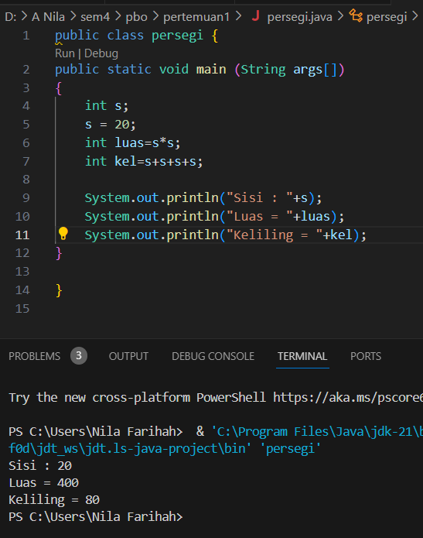

**Source code :**

public class persegi {

public static void main (String args[])

{

    int s;

    s = 20;

    int luas=s*s;

    int kel=s+s+s+s;

    System.out.println("Sisi : "+s);

    System.out.println("Luas = "+luas);

    System.out.println("Keliling = "+kel);

}

}

1. **Segitiga**

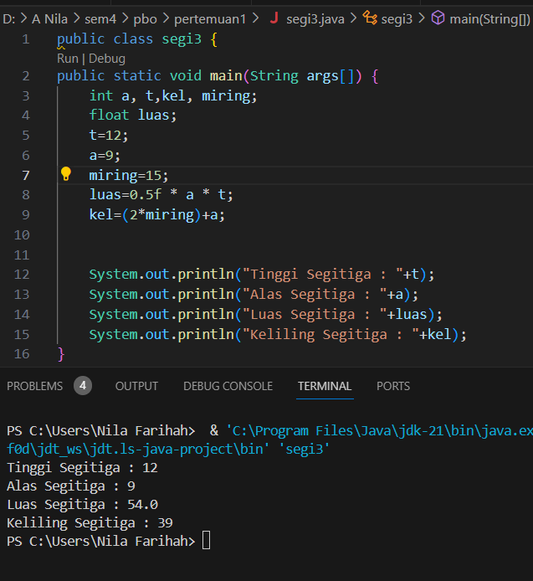

**Source code :**

public class segi3 {

public static void main(String args[]) {

    int a, t,kel, miring;

    float luas;

    t=12;

    a=9;

    miring=15;

    luas=0.5f * a * t;

    kel=(2*miring)+a;

    System.out.println("Tinggi Segitiga : "+t);

    System.out.println("Alas Segitiga : "+a);

    System.out.println("Luas Segitiga : "+luas);

    System.out.println("Keliling Segitiga : "+kel);

}

}

1. **Lingkaran**

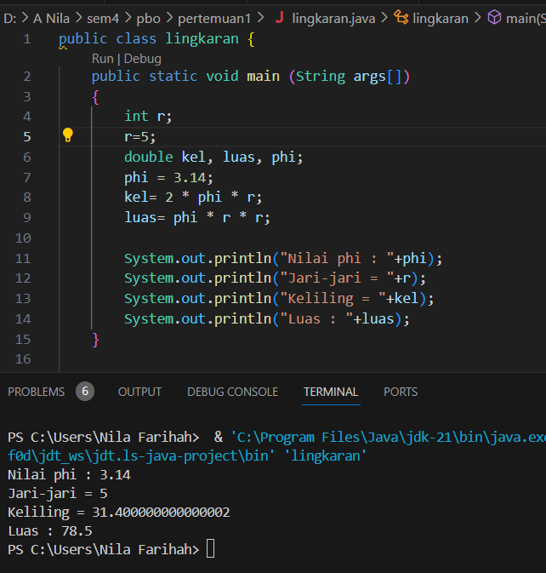

**Source code :**

public class lingkaran {

    public static void main (String args[])

    {

        int r;

        r=5;

        double kel, luas, phi;

        phi = 3.14;

        kel= 2 * phi * r;

        luas= phi * r * r;

        System.out.println("Nilai phi : "+phi);

        System.out.println("Jari-jari = "+r);

        System.out.println("Keliling = "+kel);

        System.out.println("Luas : "+luas);

    }

}

1. **Kubus**

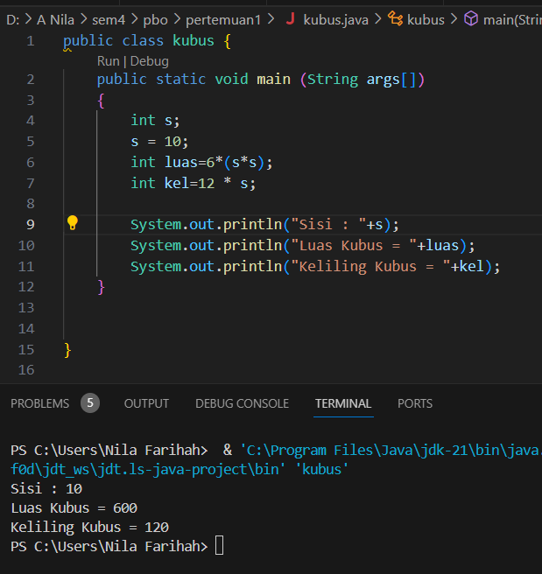

**Source code :**

public class kubus {

    public static void main (String args[])

    {

        int s;

        s = 10;

        int luas=6*(s*s);

        int kel=12 * s;

        System.out.println("Sisi : "+s);

        System.out.println("Luas Kubus = "+luas);

        System.out.println("Keliling Kubus = "+kel);

    }

}