**Mata Kuliah : PBO – TI – S1**

**Pertemuan : 10**

**NIM : A11.2022.14667**

**Nama : Nila Farihah**

**Package pbo**

**Hasil Program :**

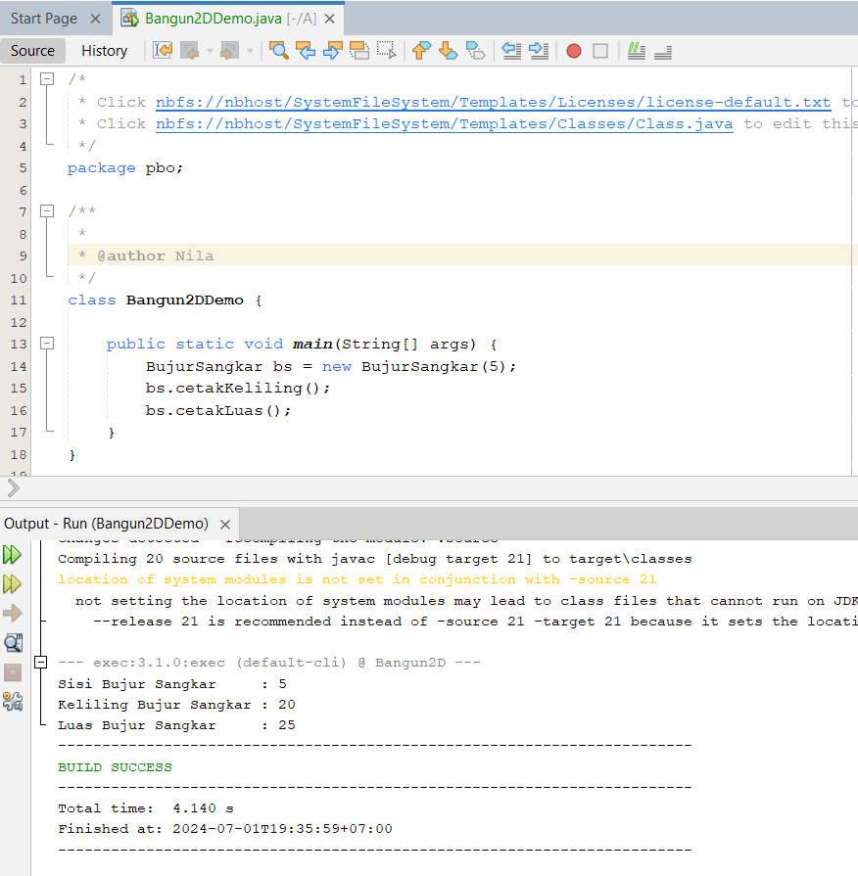

**Kode Program :**

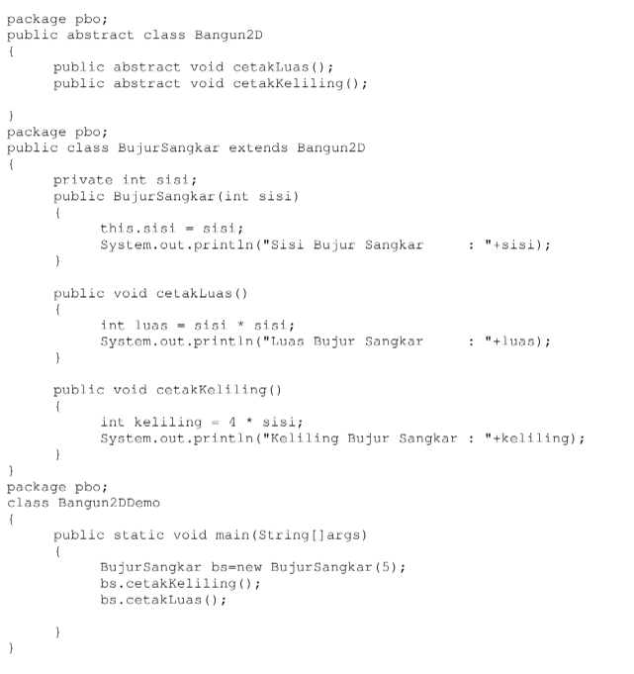

**Latihan 2**

**Hasil Program :**

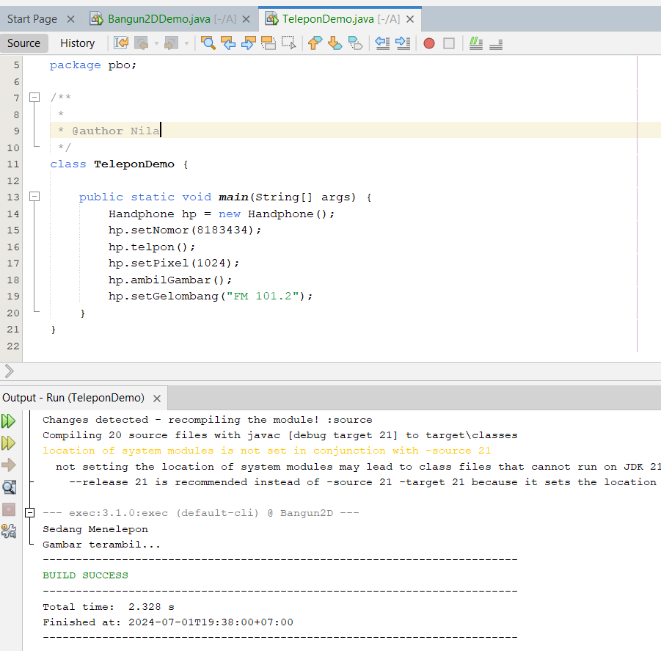

**Code Program :**

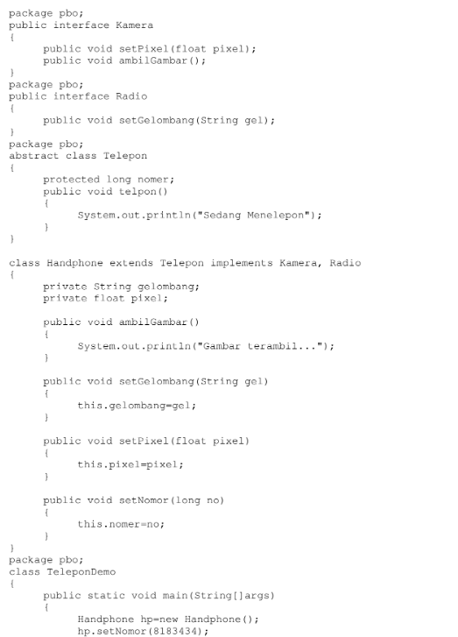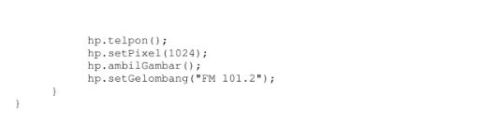

**Latihan 2**

**Hasil Program :**

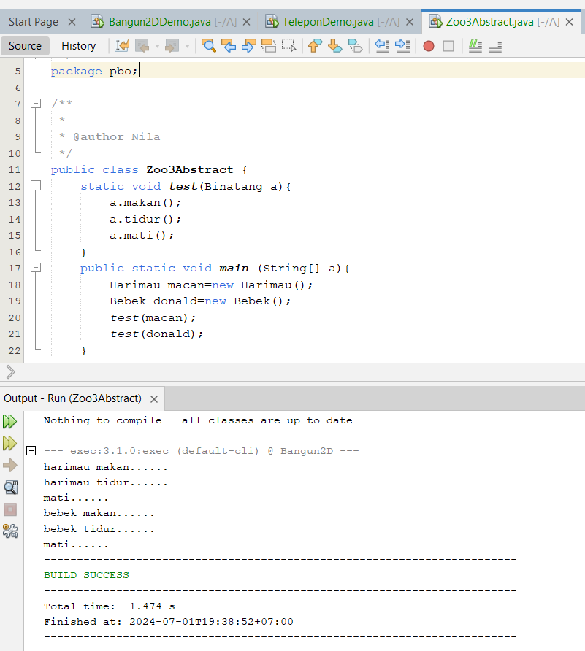

**Code Program :**

**Class Zoo3Abstract.java**

package pbo;

/**

*

* @author Nila

*/

public class Zoo3Abstract {

static void test(Binatang a){

a.makan();

a.tidur();

a.mati();

}

public static void main (String[] a){

Harimau macan=new Harimau();

Bebek donald=new Bebek();

test(macan);

test(donald);

}

}

**Class Binatang.java**

package pbo;

/**

*

* @author Nila

*/

abstract class Binatang{

abstract void makan();

abstract void tidur();

void mati(){

System.out.println("mati......");

}

}

**Class Bebek.java**

package pbo;

/**

*

* @author Nila

*/

class Bebek extends Binatang{

void makan(){

System.out.println("bebek makan......");

}

void tidur(){

System.out.println("bebek tidur......");

}

}

**Class Harimau.java**

package pbo;

/**

*

* @author Nila

*/

class Harimau extends Binatang{

void makan(){

System.out.println("harimau makan......");

}

void tidur(){

System.out.println("harimau tidur......");

}

}

**Latihan 3**

**Hasil Program :**

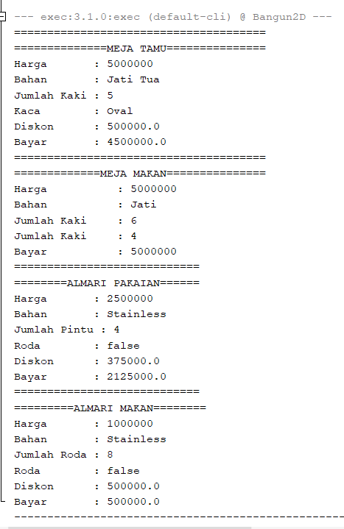

**Code Program :**

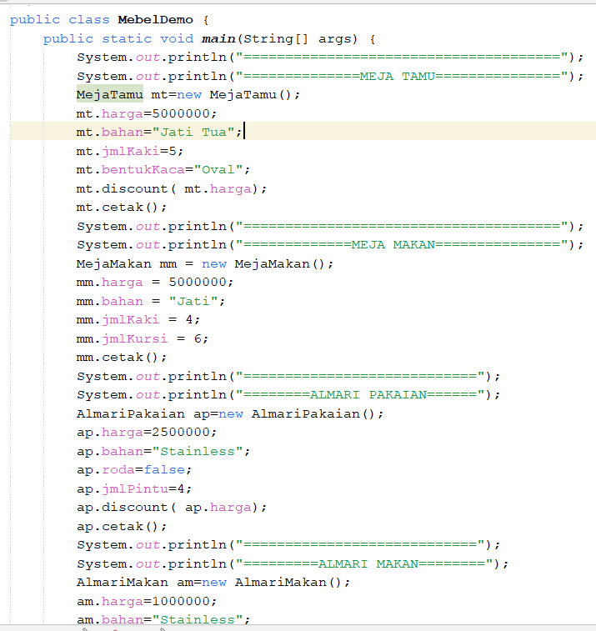

**Class Meja.java**

package pbo;

/**

*

* @author Nila

*/

public class Meja extends Mebel{

public int jmlKaki;

}

**Class MejaMakan.java**

package pbo;

/**

*

* @author Nila

*/

public class MejaMakan extends Meja {

public int jmlKursi;

void cetak() {

System.out.println("Harga\t\t: " + harga);

System.out.println("Bahan\t\t: " + bahan);

System.out.println("Jumlah Kaki\t: " + jmlKursi);

System.out.println("Jumlah Kaki\t: " + jmlKaki);

System.out.println("Bayar\t\t: " + (harga));

}

}

**Class MejaTamu.java**

package pbo;

/**

*

* @author Nila

*/

public class MejaTamu extends Meja implements Discountable{

public String bentukKaca;

float diskon;

public void discount(int harga){

diskon=0.1f*harga;

}

void cetak(){

System.out.println("Harga : "+harga);

System.out.println("Bahan : "+bahan);

System.out.println("Jumlah Kaki : "+jmlKaki);

System.out.println("Kaca : "+bentukKaca);

System.out.println("Diskon : "+diskon);

System.out.println("Bayar : "+(harga-diskon));

}

}

**Class Almari.java**

package pbo;

/**

*

* @author Nila

*/

public class Almari extends Mebel{

boolean roda;

}

**Class AlmariMakan.java**

package pbo;

/**

*

* @author Nila

*/

public class AlmariMakan extends Almari implements Discountable{

int jmlRoda;

float diskon;

public void discount(int harga){

diskon=0.20f*harga;

}

void cetak(){

System.out.println("Harga : "+harga);

System.out.println("Bahan : "+bahan);

System.out.println("Jumlah Roda : "+jmlRoda);

System.out.println("Roda : "+roda);

System.out.println("Diskon : "+diskon);

System.out.println("Bayar : "+(harga-diskon));

}

}

**Class AlmariPakaian.java**

package pbo;

/**

*

* @author Nila

*/

public class AlmariPakaian extends Almari implements Discountable{

int jmlPintu;

float diskon;

public void discount(int harga){

diskon=0.15f*harga;

}

void cetak(){

System.out.println("Harga : "+harga);

System.out.println("Bahan : "+bahan);

System.out.println("Jumlah Pintu : "+jmlPintu);

System.out.println("Roda : "+roda);

System.out.println("Diskon : "+diskon);

System.out.println("Bayar : "+(harga-diskon));

}

}

**Class MebelDemo.java**

package pbo;

/**

*

* @author Nila

*/

public class MebelDemo {

public static void main(String[] args) {

System.out.println("======================================");

System.out.println("==============MEJA TAMU===============");

MejaTamu mt=new MejaTamu();

mt.harga=5000000;

mt.bahan="Jati Tua";

mt.jmlKaki=5;

mt.bentukKaca="Oval";

mt.discount( mt.harga);

mt.cetak();

System.out.println("======================================");

System.out.println("=============MEJA MAKAN===============");

MejaMakan mm = new MejaMakan();

mm.harga = 5000000;

mm.bahan = "Jati";

mm.jmlKaki = 4;

mm.jmlKursi = 6;

mm.cetak();

System.out.println("============================");

System.out.println("========ALMARI PAKAIAN======");

AlmariPakaian ap=new AlmariPakaian();

ap.harga=2500000;

ap.bahan="Stainless";

ap.roda=false;

ap.jmlPintu=4;

ap.discount( ap.harga);

ap.cetak();

System.out.println("============================");

System.out.println("=========ALMARI MAKAN========");

AlmariMakan am=new AlmariMakan();

am.harga=1000000;

am.bahan="Stainless";

am.roda=false;

am.jmlRoda=8;

am.discount( ap.harga);

am.cetak();

}

}