**Mata Kuliah : PBO – TI – S1**

**Pertemuan : 2**

**NIM : A11.2022.14667**

**Nama : Nila Farihah**

**Hasil Program :**

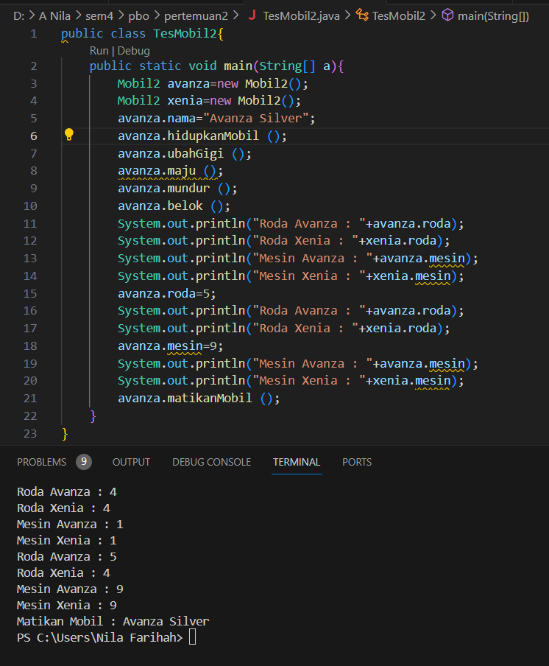

**Kode Program :**

**File “Mobil2.java”**

public class Mobil2{

    int roda=4;

    int body=1;

    static int mesin=1;

    String nama;

    static void maju(){

        System.out.println("Maju.....");

    }

    void mundur(){

        System.out.println("Mundur.....");

    }

    void belok(){

        System.out.println("Belok.....");

    }

    void hidupkanMobil(){

        System.out.println("Hidupkan Mobil : "+nama);

    }

    void matikanMobil(){

        System.out.println("Matikan Mobil : "+nama);

    }

    void ubahGigi(){

        System.out.println("Ubah Gigi : "+nama);

    }

}

**File “TesMobil2.java”**

public class TesMobil2{

    public static void main(String[] a){

        Mobil2 avanza=new Mobil2();

        Mobil2 xenia=new Mobil2();

        avanza.nama="Avanza Silver";

        avanza.hidupkanMobil ();

        avanza.ubahGigi ();

        avanza.maju ();

        avanza.mundur ();

        avanza.belok ();

        System.out.println("Roda Avanza : "+avanza.roda);

        System.out.println("Roda Xenia : "+xenia.roda);

        System.out.println("Mesin Avanza : "+avanza.mesin);

        System.out.println("Mesin Xenia : "+xenia.mesin);

        avanza.roda=5;

        System.out.println("Roda Avanza : "+avanza.roda);

        System.out.println("Roda Xenia : "+xenia.roda);

        avanza.mesin=9;

        System.out.println("Mesin Avanza : "+avanza.mesin);

        System.out.println("Mesin Xenia : "+xenia.mesin);

        avanza.matikanMobil ();

    }

}

**Hasil Program :**

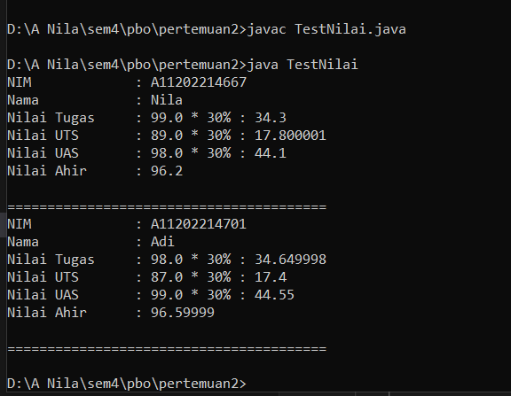

**Kode Program :**

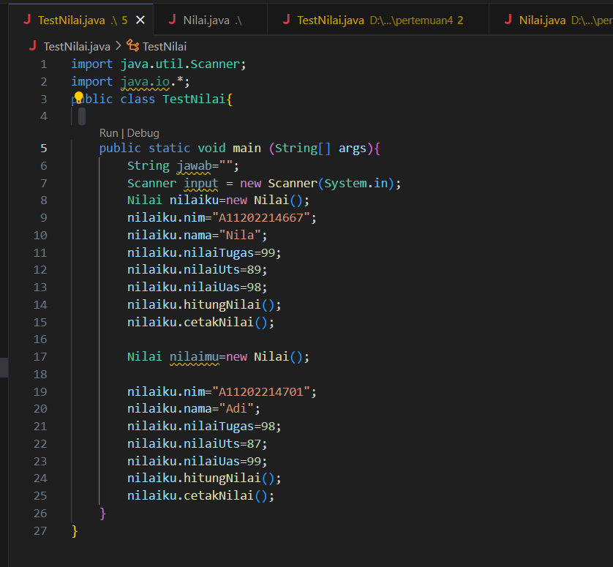

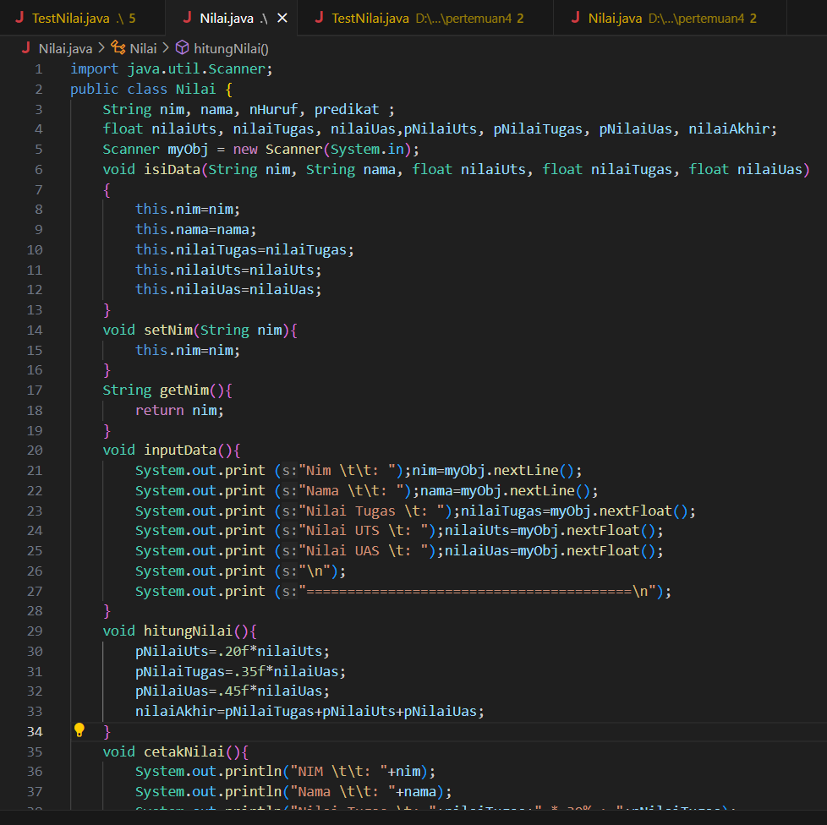

**File “Nilai.java”**

import java.util.Scanner;

public class Nilai {

    String nim, nama, nHuruf, predikat ;

    float nilaiUts, nilaiTugas, nilaiUas,pNilaiUts, pNilaiTugas, pNilaiUas, nilaiAkhir;

    Scanner myObj = new Scanner(System.in);

    void isiData(String nim, String nama, float nilaiUts, float nilaiTugas, float nilaiUas)

    {

        this.nim=nim;

        this.nama=nama;

        this.nilaiTugas=nilaiTugas;

        this.nilaiUts=nilaiUts;

        this.nilaiUas=nilaiUas;

    }

    void setNim(String nim){

        this.nim=nim;

    }

    String getNim(){

        return nim;

    }

    void inputData(){

        System.out.print ("Nim \t\t: ");nim=myObj.nextLine();

        System.out.print ("Nama \t\t: ");nama=myObj.nextLine();

        System.out.print ("Nilai Tugas \t: ");nilaiTugas=myObj.nextFloat();

        System.out.print ("Nilai UTS \t: ");nilaiUts=myObj.nextFloat();

        System.out.print ("Nilai UAS \t: ");nilaiUas=myObj.nextFloat();

        System.out.print ("\n");

        System.out.print ("========================================\n");

    }

    void hitungNilai(){

        pNilaiUts=.20f*nilaiUts;

        pNilaiTugas=.35f*nilaiUas;

        pNilaiUas=.45f*nilaiUas;

        nilaiAkhir=pNilaiTugas+pNilaiUts+pNilaiUas;

    }

    void cetakNilai(){

        System.out.println("NIM \t\t: "+nim);

        System.out.println("Nama \t\t: "+nama);

        System.out.println("Nilai Tugas \t: "+nilaiTugas+" * 30% : "+pNilaiTugas);

        System.out.println("Nilai UTS \t: "+nilaiUts+" * 30% : "+pNilaiUts);

        System.out.println("Nilai UAS \t: "+nilaiUas+" * 30% : "+pNilaiUas);

        System.out.println("Nilai Ahir \t: "+nilaiAkhir);

        System.out.print ("\n");

        System.out.print ("========================================\n");

    }

}

**File “TestNilai.java”**

import java.util.Scanner;

import java.io.*;

public class TestNilai{

    public static void main (String[] args){

        String jawab="";

        Scanner input = new Scanner(System.in);

        Nilai nilaiku=new Nilai();

        nilaiku.nim="A11202214667";

        nilaiku.nama="Nila";

        nilaiku.nilaiTugas=99;

        nilaiku.nilaiUts=89;

        nilaiku.nilaiUas=98;

        nilaiku.hitungNilai();

        nilaiku.cetakNilai();

        Nilai nilaimu=new Nilai();

        nilaiku.nim="A11202214701";

        nilaiku.nama="Adi";

        nilaiku.nilaiTugas=98;

        nilaiku.nilaiUts=87;

        nilaiku.nilaiUas=99;

        nilaiku.hitungNilai();

        nilaiku.cetakNilai();

    }

}